

**Requirement & Design Specification**

**Goods Exchange Application for students at FU**

1. **Introduction**

**1.1Purpose**

The purpose of this document is to provide a detailed description of the functionalities and features of the Goods Exchange Application for students at FU. This application is designed to facilitate the exchange and management of products and tools among students, enabling efficient transactions and interactions. The system caters to various user roles including guests, buyers, sellers, administrators, and moderators, each with specific access and functionalities to ensure a seamless and secure user experience.

**1.2 Document Conventions**

This document describes the online purchasing management system, user classification and main functions of each type.

**Visitors**: limited access, only view product catalog.

**Buyers**: search, filter products, purchase, interact with sellers (comments, reviews).

**Seller**: post products, manage posts, process orders, customer care.

**Administrator**: manage users, product categories, policies, reports.

**Moderator**: censors products, handles violations.

In addition, the document also presents the conventions used in the document (typography, lists, references, tables, languages, typography) to ensure consistency and ease of understanding.

**1.3 Project Scope and Product Features**

The web application is designed specifically to facilitate the exchange and trading of products among FPTU students. Its key features include:

* **Product Purchase and Chat**: Buyers can directly communicate with sellers through an integrated chat feature on the website. This allows for seamless discussions and negotiations. Once an agreement is reached, an invoice is generated directly on the platform to confirm the transaction.
* **Product Listing for Sale**: Users can easily list their products for sale. Each listing undergoes review and moderation by a dedicated team to ensure quality and compliance before it becomes publicly visible.
* **Manage Listed Products**: Sellers can track the approval status of their listed products, helping them manage their sales effectively and stay updated on their product’s status.
* **Purchase Additional Listing Slots**: To enhance product visibility and increase sales opportunities, sellers can buy additional listing slots. This feature helps maximize exposure and promotes better sales prospects.
* **User Reviews**: The platform allows buyers to rate sellers and vice versa. This rating system builds a transparent and trustworthy trading community, where users can make informed decisions based on the reviews of others.
* **Report Issues**: If users encounter any problems with listed products or suspect any rule violations, they can report the products. The moderation team will review and address these reports promptly to maintain the platform's integrity and reliability

**1.4 Project Scope and Product Features**

 Student exchange platforms, e-commerce best practices, FU systems, regulations, and software development standards.

1. **Overall Description**

#### 2.1 Product Perspective

The Goods Exchange Application for students at FU is a web and mobile-based platform designed to facilitate the buying, selling, and exchanging of products and tools among students. This application serves as a virtual marketplace tailored specifically for the university community, providing a secure and user-friendly environment for transactions.

**2.2 User Classes and Characteristics**

|  |  |
| --- | --- |
| Guest | limited access to system features (mobile and web app). |
| Buyer | Person who uses the application to search, view information and buy products and tools from sellers. They can search for products by category or keyword, filter products. In addition, buyers can interact with the product by commenting, contacting the seller, rating and responding to transactions. |
| Seller | Is a person who uses the application to sell their products and goods. They can post product information, manage posts. Additionally, they can interact with customers, view their transaction history and status. |
| Administrator | A privileged user who can manage the entire system. |
| Moderator | Is the person who has the right to review the product, review violation reports from users, after successfully reviewing the violator will be banned. |

**2.3 Operating environment**

**Software Environment:**

* This refers to the software platform on which the application will run. Here are some options to consider:
  + **Mobile Operating System (OS):** Android, iOS (depending on whether you want a native app for each or a cross-platform solution).
  + **Web Application Framework:** There are many options depending on the desired features and development language. Some popular choices include: C# ,Node.js (JavaScript).
  + **Database:** This will store all the product information, user data, and transaction details. Popular choices include MySQL, PostgreSQL, MongoDB, depending on the data structure and scalability needs.

**2. Hardware Environment:**

* This refers to the minimum hardware specifications required to run the application smoothly. You'll need to consider:
  + **For Mobile App:** Minimum RAM, storage space, and operating system version supported by the target devices (phones/tablets).
  + **For Web App:** Server specifications like CPU cores, RAM, and storage capacity to handle the expected user load.

**2.4 Design and Implementation Constraints**

**Security:** The system must ensure the confidentiality, integrity, and availability of user and item data. Measures should be taken to protect against unauthorized access, data breaches, and other security threats.

**Scalability:** The system should be able to handle a growing number of users and items without performance degradation. It should be designed to support a large number of transactions and user interactions efficiently.

**Usability:** The user interface should be intuitive and easy to navigate for all user roles, including students who are listing items, browsing items, and making exchanges. The design should focus on a seamless user experience.

**Compliance:** The system must comply with relevant legal and regulatory requirements for data protection, including GDPR or equivalent local laws. It should also adhere to any university-specific policies regarding online transactions and student interactions.

**2.5 Assumptions and Dependencies**

- Users have access to the internet and own a device (computer, smartphone, or tablet) that supports modern web browsers or mobile applications.

- Users have basic computer literacy to navigate and use the web application.

-Users will adhere to the application’s terms of service and community guidelines.

- The provides accurate and up-to-date information for integration into the system.

**III. System Features**

Based on the user classification and functional requirements described previously, the online shopping system will have the following main features:

**3.1. General features**

**Friendly interface:** Easy to use for all types of users, both on mobile and web.

**Language**: Supports main language (Vietnamese) and can optionally add other languages.

**Product Search:** Users can search for products by category, keyword, or other filters (such as brand, price).

**Shopping Cart:** Buyers can add products to the shopping cart to pay later.

**Payment:** The system integrates popular payment methods (e-wallet, credit/debit card, bank transfer).

**Security:** Ensure safety of user information and transactions**.**

**IV.Use Cases**

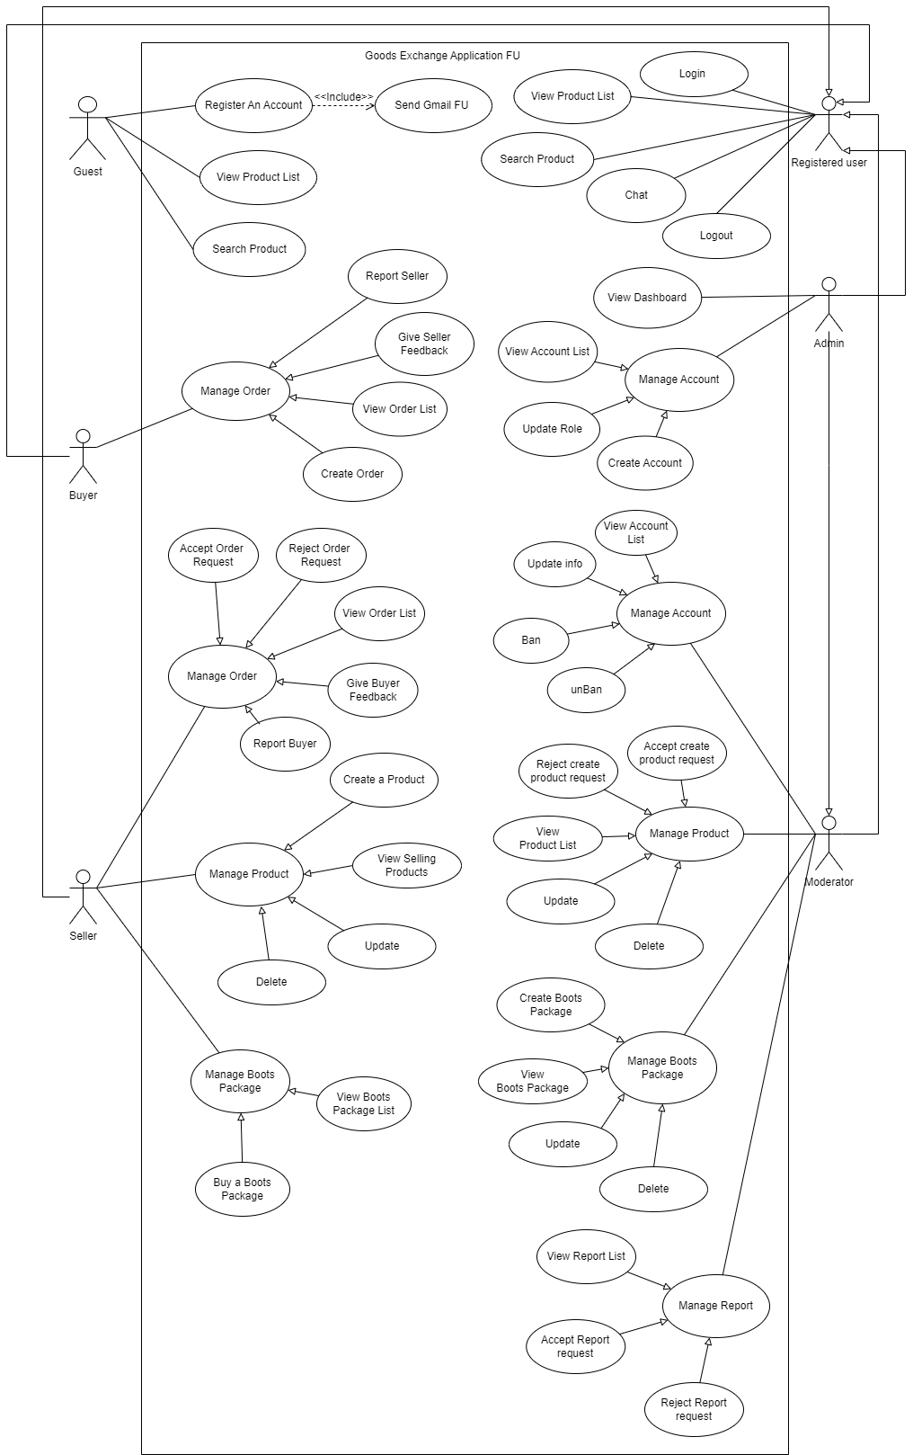

**4.1 Use Cases for Guest**

**1. Browse Products Description:** A guest can browse the product categories and see available listings without registering or logging in.

* **Steps:**
  1. The guest accesses the online shopping system (mobile app or website).
  2. The system displays the main categories of products.exclamation
  3. The guest can navigate through the categories and subcategories to see specific products.
  4. The system displays a list of products with basic information like image, title, and price.
  5. (Optional) The guest can view a filtered list of products based on criteria like price range or brand (if available for guests).
* **Success:** The guest can see a variety of products offered on the platform.

**2. View Product Details**

* **Description:** A guest can view detailed information about a specific product without registering.
* **Steps:**
  1. The guest navigates to the product page of a particular item.
  2. The system displays detailed information about the product, including:
     + Description
     + Images
     + Specifications
     + Reviews (if available publicly)
  3. (Optional) The guest can see additional information like variations, sizes, or colors (if applicable).
* **Success:** The guest gains a thorough understanding of the product's features and offerings.

**4.2 Use Cases for Buyer**

**1. Search for Products (Tìm kiếm Sản phẩm)**

* **Description:** The buyer can search for specific products by keyword or filter them based on various criteria.
* **Steps:**
  1. The buyer accesses the online shopping system.
  2. The buyer enters a keyword or phrase in the search bar.
  3. (Optional) The buyer refines the search using filters like category, brand, price range, or other available options.
  4. The system displays a list of products matching the search criteria.
* **Success:** The buyer finds a list of relevant products based on their search query.

**2. View Product Details (Xem Chi Tiết Sản Phẩm)**

* **Description:** Similar to the guest use case, the buyer can view detailed information about a product.
* **Steps:**
  1. The buyer navigates to the product page of a particular item.
  2. The system displays detailed information about the product, including:
     + Description
     + Images
     + Specifications
     + Reviews from other buyers
     + Seller information (optional)
  3. (Optional) The buyer can see additional information like variations, sizes, or colors (if applicable).
* **Success:** The buyer gains a thorough understanding of the product's features and offerings.

**3. Add Product to Cart (Thêm Sản Phẩm vào Giỏ Hàng)**

* **Description:** The buyer can add products they intend to purchase to their shopping cart.
* **Steps:**
  1. The buyer navigates to the product page of a desired item.
  2. The buyer selects the desired quantity (if applicable).
  3. The buyer clicks the "Add to Cart" button.
  4. The system adds the product to the buyer's shopping cart and displays a confirmation message.
* **Success:** The chosen product is added to the buyer's cart for future checkout.

**4. View and Manage Cart (Xem và Quản lý Giỏ Hàng)**

* **Description:** The buyer can view the contents of their shopping cart, modify quantities, or remove unwanted items.
* **Steps:**
  1. The buyer accesses their shopping cart.
  2. The system displays a list of products added to the cart, including:
     + Product image
     + Product name
     + Quantity
     + Unit price
     + Total price (quantity x unit price)
  3. The buyer can edit the quantity of each item.
  4. The buyer can remove unwanted items from the cart.
* **Success:** The buyer can review and modify the items in their cart before proceeding to checkout.

**5. Checkout and Purchase (Thanh Toán và Mua Hàng)**

* **Description:** The buyer completes the purchase process by providing their shipping information, choosing a payment method, and confirming the order.
* **Steps:**
  1. The buyer proceeds to checkout from their shopping cart.
  2. The buyer enters their shipping information (name, address, phone number).
  3. The buyer selects a preferred shipping method (if available).
  4. The buyer chooses a payment method (credit card, debit card, e-wallet, etc.).
  5. The buyer reviews the order summary (items, quantities, prices, shipping cost, total amount).
  6. The buyer confirms the order by placing the final order.
  7. The system processes the payment and creates a confirmed order.
* **Success:** The buyer successfully completes the purchase, and the seller receives the order details.

**6. Track Order Status (Theo Dõi Trạng Thái Đơn Hàng)**

* **Description:** The buyer can track the progress of their order after purchase.
* **Steps:**
  1. The buyer accesses their order history.
  2. The buyer selects a specific order.
  3. The system displays the current status of the order (processing, shipped, delivered, etc.).
  4. (Optional) The buyer can see additional information like tracking details (if available).
* **Success:** The buyer gains visibility into the delivery timeline of their purchase.

**7. Rate and Review Products (Đánh Giá Sản Phẩm)**

* **Description:** The buyer can leave a review and rating for products they have purchased.
* **Steps:**
  1. The buyer accesses their order history.
  2. The buyer selects a specific completed order.
  3. The system displays an option to rate and review the product(s).
  4. The buyer provides a star rating and writes a review about their experience with the product.
  5. The buyer submits the review.
* **Success:** The buyer shares their feedback on the product, which can be helpful for other buyers.