HPLC

Anni Djurhuus

24 January 2017

### Analysis of HPLC data for Enrique

## Loading required package: RColorBrewer

#### Dendrograms

The samples cluster weirdly with seascapes...

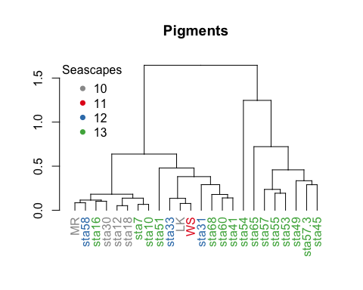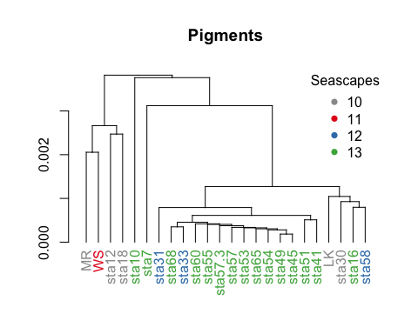

#### Ordination plots

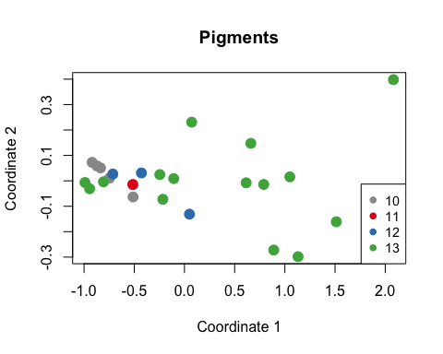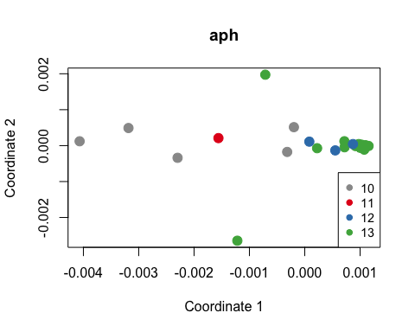

#   
# deug.dudi <- dudi.pca(aph_hydro[2:400], center = TRUE, scale = TRUE, scan = FALSE)  
# g1 <- s.class(deug.dudi$li, aph_hydro$round_avg_seascape)  
# g2 <- s.arrow(deug.dudi$c1, lab = names(aph_hydro[,400:416]))  
#   
#   
#   
# G1 <- rbindADEg(cbindADEg(g1, g2, plot = FALSE), cbindADEg(g3, g4, plot = FALSE), plot = TRUE)  
#   
# G2 <- s1d.hist(deug.dudi$tab, breaks = seq(-45, 35, by = 5), type = "density", xlim = c(-40, 40),   
# right = FALSE, ylim = c(0, 0.1), porigin.lwd = 2)  
#   
# } else {  
# par(mfrow = c(2, 2))  
# s.class(deug.dudi$li, deug$result, cpoint = 1)  
# s.arrow(deug.dudi$c1, lab = names(deug$tab))  
# s.class(deug.dudi1$li, deug$result, cpoint = 1)  
# s.corcircle(deug.dudi1$co, lab = names(deug$tab), full = FALSE, box = TRUE)  
# par(mfrow = c(1, 1))  
#   
# # for interpretations  
# par(mfrow = c(3, 3))  
# par(mar = c(2.1, 2.1, 2.1, 1.1))  
# for(i in 1:9) {  
# hist(deug.dudi$tab[,i], xlim = c(-40, 40), breaks = seq(-45, 35, by = 5),   
# prob = TRUE, right = FALSE, main = names(deug$tab)[i], xlab = "", ylim = c(0, 0.10))  
# abline(v = 0, lwd = 3)  
# }  
# par(mfrow = c(1, 1))  
# }

Console~/Documents/Projects/FK_HPLC/HPLC/

Console R Markdown

~/Documents/Projects/FK_HPLC/HPLC/