**Module 2: Individual Contribution 1**

**Attendance**

| **Dates** | **Attendance** |
| --- | --- |
| 9/14/2020 | Work from home |
| 9/16/2020 | In-Person |
| 9/18/2020 | Zoom meeting |

**Group Meetings**

| **Date** | **Meeting Length** | **Discussed About** | **Software Used** |
| --- | --- | --- | --- |
| 9/14/2020 | 30 minutes | Discussion with the Design Data team about the tasks for assigning  and  getting a clear idea of their current work update. | Zoom |
| 09/16/2020 | 30 minutes |  |  |

**Half-Day 1**

September 14th, 2020

* We were instructed by our Unit leader to discuss and work with the Design data team about how and what they are working on and what tasks to assign them.
* We have assigned tasks to the Design Data team to work ER diagram entities and its attributes and also to create Use case diagram for each entity.
* Jira link -<http://cs04.nwmissouri.edu/browse/FIT-64>
* We have assigned Validation Criteria for the required attributes of the entities and to check the relation of all the entities so that they can start working on sample data.
* I hosted a zoom meeting to discuss with the Design Data team about the next Sprint.
* Jira Link  - <http://cs04.nwmissouri.edu/browse/FIT-85>

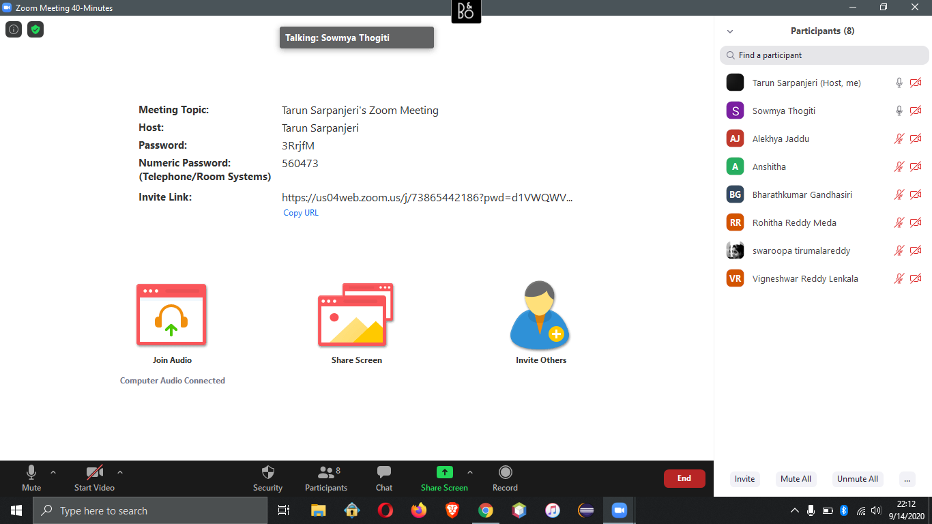

**Half-Day 2**

September 16th, 2020

* We had an in-person class. Dr.Badami briefed us on updating the tasks as User story using the template :   As a <typer of user>, I want to <do something>, so that <reason>. We have revised and started to update all the tasks and also planning the Sprint 1 tasks.
* We have assigned the Design Data team to create and validate the Sample data and also asked them to plan the testing the sample data and connect to the database.
* Jira Link-<http://cs04.nwmissouri.edu/browse/FIT-97>
* We

**Half-Day 3**

September 18th, 2020

* We assigned tasks to the Design Data team to work with firebase for validating and testing sample data and also to ensure that the data can be used for future development.
* Jira Link- <http://cs04.nwmissouri.edu/browse/FIT-94>
* We have assigned tasks to work on SQL Queries .