**Project Proposal**

**Team members:**

1. Annie Samarpitha Chandolu
2. Vineetha Yenugula
3. Alekhya Jaddu
4. Bhanu Prakash Thota

**Application Name:** Event Expo

**Description:**

EventExpo app allows users to reserve tickets for all kinds of events which include sports, harvesting, kayaking, painting, and many more. EventExpo allows users to host events. The major advantage of using the EventExpo app is to handle all the events together at one place where users can switch to different pages inside the app rather than opening a different app for each type of event resulting(results in) good user experience by using EventExpo App. Sign-Up the EventExpo and let the events add wings to your daily life.

**Functional requirements (Activities):**

**USER:**

**Login:**

This is the welcome page of the app. Users have to log in with username and password to access the events.

**Registration:**

If the user is using our app for the first time, then they have to sign-up with their email id and have a unique user id.

**Home Page:**

Once the user logs in, where the user can find the list of events where he can get the event details. And can add the events to the cart.

**Cart:**

The users can review their order in the cart page.

**Share Event:**

Users can share events with their friends through text messages, WhatsApp, etc.

**Payment (Booking confirmation):**

Users can finish their orders by paying. They can pay through either debit/credit card or electronic cheque or PayPal.

**Booking History:**

Users can view their bookings or previous order on the order history page.

**Profile update:**

Users can update their profile with their most recent details on our profile page. They can also reset their password on this page.

**About App:**

Users can view the basic information about our app on the about page.

**ADMIN:**

**Admin Login:**

Username and password are admin credentials these are unique, and these credentials are given by the developers.

In the admin login page, the admin needs to fill the required fields like username and password.

Click login.

**Admin Home page:**

In the Admin home page, we have options like

* Adding a new event,
* Maintaining the events,
* Check for the particular bookings of the registered users
* Logout.

**Add Event- Admin:**

In this page, the admin can add an event by giving fields like event name, event date, time and price.

**Event maintained Page (Admin):**

In this page admin can edit the events which are previously added to the database like changing the event name, event date, time and price or he can delete the event.

**Check for registered users to the events:**

Admin can see the details of customer event bookings.

**Logout:**

Admin can logout from the application.

**Data persistence:**

For live data, we are storing the data into the Realtime database of firebase, from where we can retrieve the data throughout the application.

**Future enhancements:**

**Limiting to a certain number of seats:**

We are planning to add a feature where we can acknowledge users regarding the number of seats are available.

**Wishlist:**

This is where the user can sort his interesting events and add them to the wish list immediately**.**

**Sync with Calendar:**

Here we are planning to add a new feature to sync our application with the calendar.

**WorkFlow for User:**

User uses the login page to access the EventExpo App, we have provided the functionality for user to signup if User is not a registered with EventExpo. And, also if user forgets password by providing the user id/email-id he can change or create a new password. After successful login, User enters Home Screen where he can search or find a particular event that the User is interested in and make a booking or reserve the ticket for a particular time or date. Upon selecting an event, EventExpo shows the in detail description of the selected event and after reading user can continue next for booking. In the booking page, EventExpo requests for the user details such as User's address, email, and phone number. Then User can check for a payment that EventExpo listed out like through PayPal, Credit, or Electronic cheque. After successful payment, the User's event will be booked. Users can see the booked events in the settings provided in EventExpo app under Order History. If the user wishes logout after successful order, we have provided the logout option in settings.

**Workflow for Admins:**

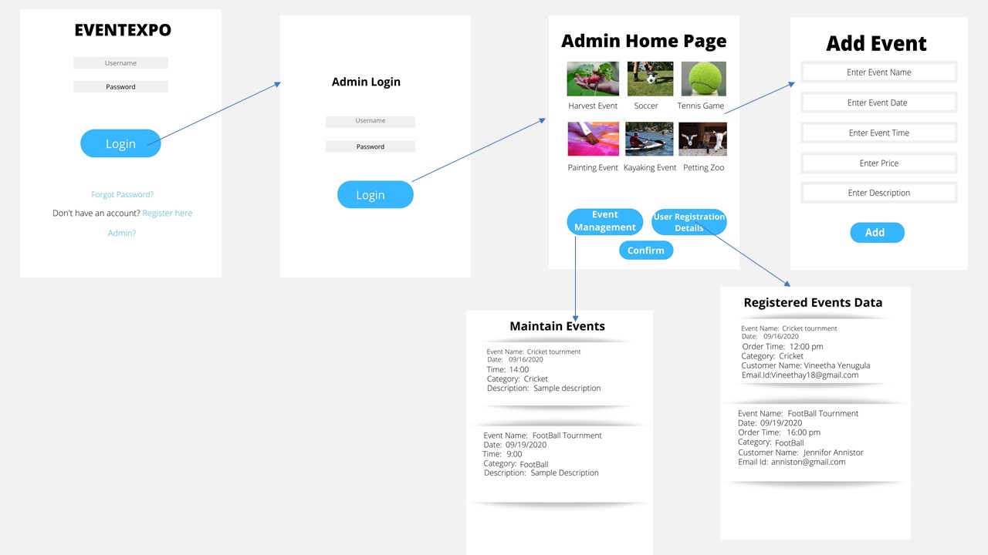

We have provided an admin hyperlink in the user login page where the admin can log in and manage the events. After login, the admin can able to see the Home page with different events to organize like sports that include cricket, soccer as of now, harvesting, kayaking, and painting. EventExpo app under admin login on the Homepage has two buttons Maintain Events and User Registration Details. Under Maintain Events admin can organize the events or edit or delete as per the daily schedule. Under User Registration Details, Admin can able to see the user booking details and events booked by users. Admin has the right to edit the User Details or cancel the request if any illegal bookings/activities are done. Every page has the save button, where the admin can save his changes after editing details or organizing the events.