MVP 3 Submission Module 5:

1. Hosted Application Link - [https://exalted-legacy-290621.uc.r.appspot.com/ (Links to an external site.)](https://exalted-legacy-290621.uc.r.appspot.com/)
2. Code Repository Link - [https://github.com/harishThadka/happyHealth (Links to an external site.)](https://github.com/harishThadka/happyHealth)
3. Code Contribution page:

Recent commits

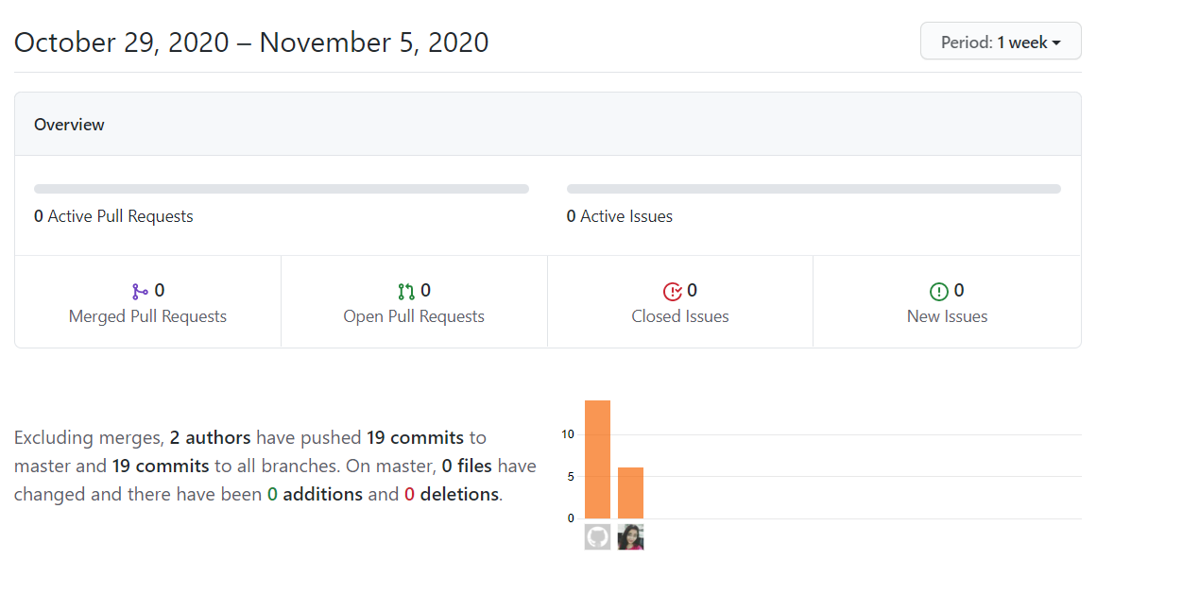

Overall Sprint 3 commits:

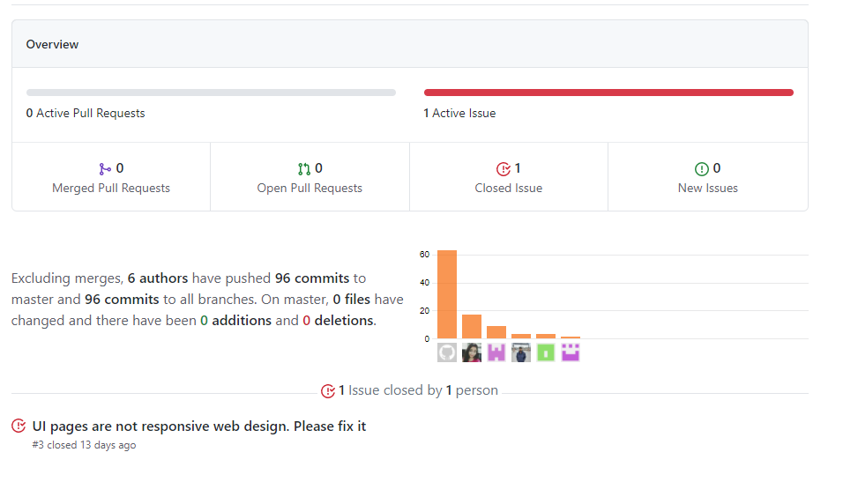

1. & 5. Issue Tracking System and Jira Project Planning:

We are using JIRA software tool only for issue tracking and Project planning. As of now we have encountered 22 defects in our development and we have 22 Bugs created in Jira. Below is the filtered list of all Bugs.

[http://cs04.nwmissouri.edu/browse/FIT-251?filter=10004&jql=project%20%3D%20FIT%20AND%20issuetype%20%3D%20Bug%20ORDER%20BY%20Rank%20ASC (Links to an external site.)](http://cs04.nwmissouri.edu/browse/FIT-251?filter=10004&jql=project%20%3D%20FIT%20AND%20issuetype%20%3D%20Bug%20ORDER%20BY%20Rank%20ASC)

The Sprint Planning Team (Ravi Teja) are responsible for managing each user stories across the teams.

Documented and commented the design specifications of the project requirements

<https://github.com/annie0sc/gdp-happy-health>

Sketches useful for the design:

Web UI

<https://xd.adobe.com/view/1dfb8c5e-6714-428e-6813-ceed7f8de535-6bca/screen/2d4265b0-0c13-4b9d-ba94-4dd6701156f2/>

Mobile UI

<https://xd.adobe.com/view/64cbfb4c-2c05-40eb-5c30-bae44fa3b9d4-12fa/screen/fab92490-6d21-4829-9a52-9728726feba3/>

Admin Dashboard Mobile

<https://app.moqups.com/SgvoYP22gt/view/page/a78a4832f>

User Work Flow

<https://app.moqups.com/k6nkHjQMFS/view/page/a6678e7ce>

User Activity Page

<https://app.moqups.com/GuIKhiidrT/edit/page/a75b6af1b>

1. Accepted Stories in Sprint 3:

After successfully closing the Sprint 2, below are the accepted and created stories for sprint 3,

[http://cs04.nwmissouri.edu/browse/FIT-268?jql=project%20%3D%20FIT%20AND%20status%20in%20(%22In%20Progress%22%2C%20%22To%20Do%22%2C%20Done)%20AND%20Sprint%20%3D%2013%20ORDER%20BY%20priority%20DESC%2C%20updated%20DESC (Links to an external site.)](http://cs04.nwmissouri.edu/browse/FIT-268?jql=project%20%3D%20FIT%20AND%20status%20in%20(%22In%20Progress%22%2C%20%22To%20Do%22%2C%20Done)%20AND%20Sprint%20%3D%2013%20ORDER%20BY%20priority%20DESC%2C%20updated%20DESC)

[(Links to an external site.)](http://cs04.nwmissouri.edu/browse/FIT-268?jql=project%20%3D%20FIT%20AND%20status%20in%20(%22In%20Progress%22%2C%20%22To%20Do%22%2C%20Done)%20AND%20Sprint%20%3D%2013%20ORDER%20BY%20priority%20DESC%2C%20updated%20DESC)

2. Completed Stories and ready for acceptance in Sprint 3:

Below link contains the list of completed stories in sprint 3

[http://cs04.nwmissouri.edu/browse/FIT-373?jql=project%20%3D%20FIT%20AND%20status%20%3D%20%22To%20Do%22%20AND%20Sprint%20%3D%2013%20ORDER%20BY%20priority%20DESC%2C%20updated%20DESC (Links to an external site.)](http://cs04.nwmissouri.edu/browse/FIT-373?jql=project%20%3D%20FIT%20AND%20status%20%3D%20%22To%20Do%22%20AND%20Sprint%20%3D%2013%20ORDER%20BY%20priority%20DESC%2C%20updated%20DESC)

Below link contains the list of ready for acceptance stories in sprint 3

[http://cs04.nwmissouri.edu/browse/FIT-268?jql=project%20%3D%20FIT%20AND%20status%20%3D%20%22In%20Progress%22%20AND%20Sprint%20%3D%2013%20ORDER%20BY%20priority%20DESC%2C%20updated%20DESC (Links to an external site.)](http://cs04.nwmissouri.edu/browse/FIT-268?jql=project%20%3D%20FIT%20AND%20status%20%3D%20%22In%20Progress%22%20AND%20Sprint%20%3D%2013%20ORDER%20BY%20priority%20DESC%2C%20updated%20DESC)

3. How the Client should “check off” or mark each criteria accepted and/or enter their comments:

We have created an excel sheet as an interactive page where client can check the user stories and acceptance criteria and can "check off" on each story. Also client can provide feedback for each task.

The following Google sheet is the list of stories that has been completed in development and been accepted by the Client:

<https://docs.google.com/spreadsheets/d/1Ztjragt3ltlkSMRf9_hS7lgt1h1qGwB_IZ2Po-Sja9I/edit#gid=0>