1. Research into one's compliment and two's compliment to see how computers can encode negative numbers for computation.  Please uses examples to explain the inadequateness of one's compliment for negative integers and how tow's compliment can correct the problems
2. When we plus -3 and 3(or others can make answer zero), it would like 1100(-3)+0011(3), then we get 1111, it is negative zero, which is not logical.

If we change to 2’s compliment, it would be 1101+0011, and we would get (1)0000, equals to zero.

1. When we plus two negative numbers such as -3 and -4, it would like 1100+1011, the answer is (1)0111, which is 7; however, the answer is -7.

If we use two’s compliment, it would be 1101+1100, and we get (1)1001, is 7.

2.Design a 2's complementer, using Boolean algebra and logic gates, and add it to the adder lectured in the class.

Its truth table

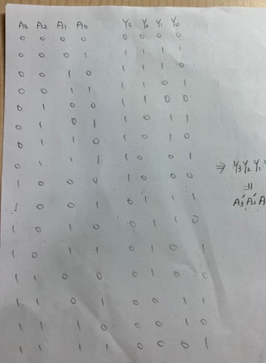

And we could get Y3Y2Y1Y0=A3’A2’A1’A0’+1

Thus ,the complimenter plus the adder would like:

