# Final Project

## Introduction

In this report we develop machine-learning models to optimize a charitable organization’s direct marketing campaign. Our goal is two-fold: to identify likely donors using a classification model in order to maximize the net profit from the mailings, and to estimate the gift amounts from donors using a prediction model. We created several classification models, including logistic regression, logistic regression general additive model (GAM), linear discriminant analysis (LDA), quadratic discriminant analysis (QDA), k-nearest neighbors (KNN), decision tree, boosted trees, random forests, and support vector machines (SVM), in order to determine which model best identifies likely donors. We also created several prediction models, including least squares regression, best subset selection with k-fold cross-validation, principal components regression, partial least squares, ridge regression, and lasso regression in order to predict the amount of donations.

## Data Exploration

The data we are using for this report is the charity data set. This data set contains 3984 training observations, 2018 validation observations, and 2007 test observations. The data has been weighted in order to make the training and validation samples each contain roughly an equivalent number of donors and non-donors. The charity data set includes two response variables, donr (donor) and damt (donation amount), for the classification models and prediction models, respectively. It also contains 20 predictor variables, including the geographic regions of previous donors, whether the donor is a homeowner or not, the number of children the donor has, the donor’s income, the donor’s gender, the amounts of previous donations, and various other wealth, income, and donation factors that may help create strong classification and prediction machine-learning models.

Prior to developing any models, we examined our data in order to see if there were any missing values or abnormalities in the data. Although the data set did not contain any missing values, we noticed that several of the variables might benefit from transformations. We decided to apply logarithmic transformations to seven right-skewed variables: avhv, incm, inca, tgif, lgif, rgif, and agif. The top row of **Figure 1** shows the variables prior to transformation, while the bottom row shows the variables after transformation.[1] As the figure shows, the logarithmic transformation helped normalize the distributions of these seven variables.





Figure : Transformation of Variables

After transforming our variables, we created a correlation matrix to gain further insight into the data. **Figure 2** shows a visualization of the correlation matrix, while **Table 1** shows the values of the most statistically significant correlations.

|  |  |  |
| --- | --- | --- |
| Variable1 | Variable2 | Correlation |
| damt | donr | 0.9817018 |
| tgif | npro | 0.8734276 |
| rgif | lgif | 0.8512241 |
| inca | avhv | 0.8484572 |
| inca | incm | 0.8296747 |
| agif | lgif | 0.8294224 |
| plow | incm | -0.8120381 |
| agif | rgif | 0.7706645 |
| plow | inca | -0.7510141 |
| incm | avhv | 0.7304313 |
| plow | avhv | -0.7187952 |
| damt | chld | -0.5531045 |
| donr | chld | -0.5326077 |

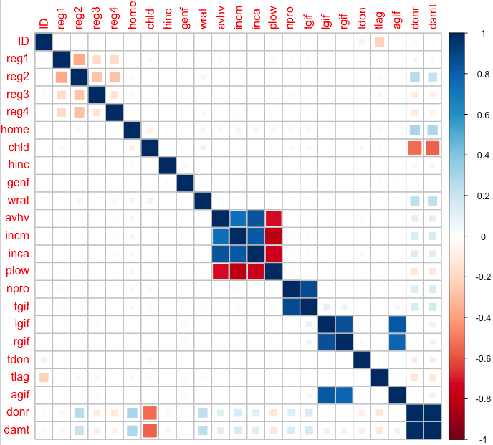

Figure : Correlation Matrix Table 1: Significant Correlations

As **Figure 2** and **Table 1** reveal, certain variables have strong correlations. For instance, tgif (dollar amount of lifetime gifts to date) has a very strong positive correlation with npro (lifetime number of promotions received to date). Some variables, such as plow (percent categorized as “low income” in potential donor's neighborhood) and incm (median family income in potential donor's neighborhood in $ thousands), have a strong negative correlation. The correlations are something we bear in mind as we create our classification and prediction models.

## Classification Models and Analysis

# Model Technique 1: Logistic Regression

The first classification technique we used is logistic regression, a simple and robust technique for two response classes that is easily interpretable and applicable. The first of four logistic models includes all independent variables; the second model utilizes only those variables which are significant at p=0.05; the third model includes all independent variables as well as additional quadratic terms for numerical variables; and the fourth model was created using backward subset selection on the third model. The backward subset selection resulted in a 19 variable model. We used these 19 variables, shown in **Table X**, for the fourth model and subsequent model testing as a comparison against models fit using all original variables. The most profitable model was the fourth model, yielding $11,649.50 in donations through 1,302 mailings. **Table X** depicts the classification results and number of mailings for each of the four models.

|  |  |  |
| --- | --- | --- |
| Variable | Estimate | Signif. |
| (Intercept) | 0.91854 | *** |
| reg1 | 0.65734 | *** |
| reg2 | 1.49913 | *** |
| home | 1.39021 | *** |
| chld | -2.40428 | *** |
| I(hinc^2) | -1.09579 | *** |
| genf | -0.08635 |  |
| wrat | 0.49074 | *** |
| I(wrat^2) | -0.41909 | *** |
| incm | 0.54076 | *** |
| inca | 0.11863 |  |
| I(inca^2) | 0.00213 |  |
| plow | -0.06942 |  |
| tgif | 0.64033 | *** |
| I(tgif^2) | -0.07046 | . |
| lgif | -0.23234 | * |
| I(rgif^2) | 0.03872 |  |
| tdon | -0.30501 | *** |
| tlag | -0.54866 | *** |
| agif | 0.16075 |  |

|  |  |  |  |  |
| --- | --- | --- | --- | --- |
| Model | Validation Class | | | |
|  | 0 | 1 | Number of Mailings |
| Model 1:  All independent variables | 0 | 600 | 21 | 1397 |
| 1 | 419 | 978 |
| Model 2:  All significant independent variables | 0 | 418 | 17 | 1583 |
| 1 | 601 | 982 |
| Model 3:  All independent variables and additional terms | 0 | 675 | 13 | 1330 |
| 1 | 344 | 986 |
| Model 4: Backward subset selection | 0 | 670 | 14 | 1302 |
| 1 | 349 | 985 |

Table X: Backward Subset Table X: Classification Matrix with Mailings

Selection Coefficients

# Model Technique 2: Logistic General Additive Model

The GAM approach to modeling creates a function for each variable, allowing non-linearity in the model. This approach can be used for classification problems easily with a logistic model. The first logistic GAM model is fitted using all independent variables, and the second model fitted uses the 19 variables from the backward subset selection logistic model. The first model yields a profit of $11,381.00 with 1,400 mailings, and the second model outperforms the first, yielding a profit of $11,649.50 with 1,302 mailings. **Table X** depicts the classification results and number of mailings for both models. Also, the second model coefficients are identical to the logistic regression model from the previous section.

|  |  |  |  |  |
| --- | --- | --- | --- | --- |
| Model | Validation Class | | | |
|  | 0 | 1 | Number of Mailings |
| Model 1:  All independent variables | 0 | 597 | 21 | 1400 |
| 1 | 422 | 978 |
| Model 2:  19 backward subset selection variables | 0 | 700 | 16 | 1302 |
| 1 | 319 | 983 |

Table X: GAM Classification Matrix with Mailings

# Model Technique 3: Linear Discriminant Analysis

LDA is a classification method similar to logistic regression that utilizes Bayes’ theorem as a classifier, and while it is theoretically more complex than the logistic model, in application it is similar in interpretability. The first LDA model is fit using all independent variables, yielding a profit of $11,643.50 from 1,363 mailings. A second LDA model fit using the 19 variables from the backward subset selection logistic model yields a slightly lower profit of $11,639.50 from 1,336 mailings. The classification results and number of mailings for each model are in **Table X**.

|  |  |  |  |  |
| --- | --- | --- | --- | --- |
| Model | Validation Class | | | |
|  | 0 | 1 | Number of Mailings |
| Model 1:  All independent variables | 0 | 647 | 8 | 1363 |
| 1 | 372 | 991 |
| Model 2:  19 backward subset selection variables | 0 | 670 | 12 | 1336 |
| 1 | 349 | 987 |

Table X: LDA Classification Matrix with Mailings

Trade-offs exists between the two LDA models constructed. While the first model is more profitable, fewer individuals are correctly classified. The second model is less profitable, but fewer mailings are sent, and a greater number of individuals are correctly identified.

# Model Technique 4: Quadratic Discriminant Analysis

QDA is a classification method almost identical to LDA, except that the covariance matrix is assumed to be specific to each class. This technique can have a more flexible fit and tends to perform well on large datasets. The first QDA model is fit using all independent variables, followed by a second model utilizing the 19 variables from the backward subset selection method used in prior sections of this study. Both models perform significantly worse than the previous models. **Table X** shows the classification results and number of mailings for each model. The second model required 1,421 mailings and yielded $11,136.00 in profits, so it required more mailings for fewer profits than the first model that had a profit of $11,229.50 from 1,396 mailings.

|  |  |  |  |  |
| --- | --- | --- | --- | --- |
| Model | Validation Class | | | |
|  | 0 | 1 | Number of Mailings |
| Model 1:  All independent variables | 0 | 590 | 32 | 1396 |
| 1 | 429 | 967 |
| Model 2:  19 backward subset selection variables | 0 | 560 | 37 | 1421 |
| 1 | 459 | 962 |

Table X: QDA Classification Matrix with Mailings

# Model Technique 5: K-Nearest Neighbor Classification

Although not necessarily the most interpretable of algorithms, the KNN classification method is strong as it is one of the few completely non-parametric methods available for classification. Since there is little information known about the exact decision boundary for whether or not an individual is a donor or not, this technique is certainly one that should be tested. For this process, three models are fit utilizing different values of K: 1, 10 and 100. Although the classifier with K = 100 performs the best, we somewhat expected this since it will more likely have a much higher bias towards the training data set. Despite this, the performance on the validation data still does better than the other two classifiers, maximizing profit at $11,299.50 through 1,390 mailings.

|  |  |  |  |  |
| --- | --- | --- | --- | --- |
| Model | Validation Class | | | |
|  | 0 | 1 | Number of Mailings |
| K = 1 | 0 | 738 | 164 | 1116 |
| 1 | 281 | 835 |
| K = 10 | 0 | 709 | 59 | 1250 |
| 1 | 310 | 940 |
| K = 100 | 0 | 600 | 28 | 1390 |
| 1 | 419 | 971 |

Table X: KNN Classification Matrix with Mailings

In **Table X** above, we can observe that although the number of correctly classified individuals goes up, so does the number of incorrectly classified individuals. This larger profit ultimately results in a lot more wasted mailings as well.

# Model Technique 6: Decision Tree

Tree-based methods are simple and useful for interpretation, which is why we decided to use a simple decision tree to classify whether or not an individual is a donor. Since the process of building a decision tree includes a technique for pruning the resulting tree, all 20 predictor variables are passed in for model fitting. Pruning the tree ensures the original tree is not limited in performance due to over-fitting by the training data. The initial decision tree fit results in 1,362 mailings and a profit of $11,413.50. It is shown in **Figure X**.

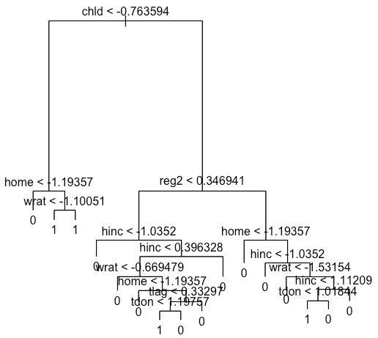 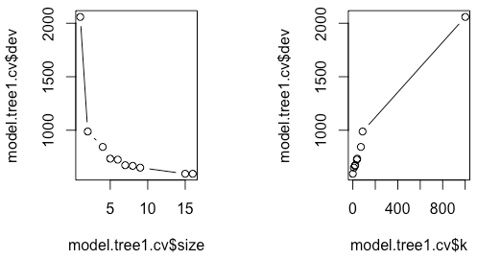

Figure X: Decision Tree Figure X: Decision Tree Plots

Although **Figure X** demonstrates that the best decision tree is of size 10, the resulting tree from fitting that model is the exact same as the original decision tree model fit, capping this technique off at a $11,413.50 profit.

# Model Technique 7: Random Forest

Having observed that the single, pruned decision tree still has not maximized profit, we decided to try a method for aggregating several decision trees to enhance the performance of a single tree. Although three common techniques can achieve this—bagging, boosting, and random forests—the first of two techniques we tested for this analysis is the random forest method. The model fit results in only 1,040 total mailings, maxing out its profit at $11,028.00. Although this technique is demonstrating that it is not the best in terms of profit, **Figure X** below is incredibly useful in that it provide a clear visualization of the variables that are contributing the most to whether or not an individual will donate or not.

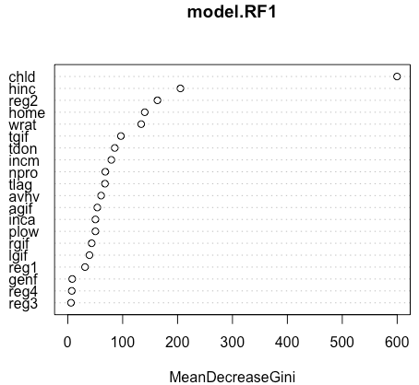

Figure X: Mean Decrease in Gini Plot

# Model Technique 8: Boosted Tree

With the resultant random forest performing so poorly in contrast to the individual decision tree, we attempted one additional multiple tree aggregation method. This method, referred to as boosting, learns more slowly and tends to reduce the likelihood of over-fitting as well. The boosted tree results in a total of 1,344 mailings, soaring the resulting profit to $11,594.50. Of all the tree-based classification methods we used, this is by far the best performer. In **Figure X** below, we can observe a similar visualization of the variables based on their relative influence on the classification of whether or not an individual is a donor or not.

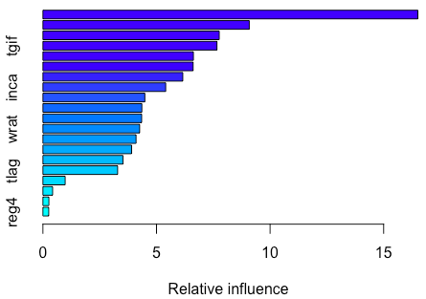

Figure X: Relative Influence Plot

**Table X** below shows that the most important variable is how many children the potential donor has, which is similar to the conclusion of the other two tree-based models.

|  |  |
| --- | --- |
| Variable | Relative Influence |
| chld | 16.5050114 |
| agif | 9.0830404 |
| avhv | 7.7627473 |
| tgif | 7.661529 |
| hinc | 6.6249256 |
| npro | 6.6128775 |
| incm | 6.1582047 |
| inca | 5.4056824 |
| tdon | 4.4863957 |
| plow | 4.3549452 |
| lgif | 4.3471496 |
| wrat | 4.2586813 |
| reg2 | 4.1002435 |
| rgif | 3.9026428 |
| home | 3.5211727 |
| tlag | 3.2892911 |
| reg1 | 0.9795926 |
| genf | 0.4274159 |
| reg3 | 0.2622024 |
| reg4 | 0.2562489 |

Table X: Variable Relative Influence

# Model Technique 9: Support Vector Machine

The classifier we tested on this data is the SVM. We first ran the SVM without any tuning utilizing a linear kernel and then ran it utilizing cross-validation to determine optimal parameters while also utilizing a more likely applicable radial kernel. As expected, the first model tanks in comparison to all previously fit classification models with a maximal profit of $10,459, mostly due to suggesting far too many mailings at 2,013. The tuned model using the radial kernel performs substantially better, raking in a potential profit of $11,536 on the validation data through only 1,336 mailings.

## Regression Models and Analysis

# Model Technique 1: Least Squares Regression

We fit several least squares regression models by finding the models with the best Adjusted R-Squared, Mallows’ Cp, or BIC values. The model with the best Adjusted R-Squared value contained 15 predictors; the model with the best Mallows’ Cp contained 14 predictors; and the model with the best BIC contained 11 predictors. **Table X** below is a comparison of how each of these least squares regression models performed on the validation data.

|  |  |  |
| --- | --- | --- |
| Model | MPE | Standard Error |
| Adjusted R-Squared | 1.508110 | 0.1570488 |
| Mallows' Cp | 1.508530 | 0.1568465 |
| BIC | 1.527695 | 0.1596775 |

Table X: Least Squares Regression Model Comparison

In terms of MPE, the Adjusted R-Squared model outperformed the other two models. However, the Mallows’ Cp model has a nearly identical MPE and is a simplier model than the Adjusted R-Squared model since it uses one fewer predictor. It also has a slightly better Standard Error. For these reasons, we will consider the Mallows’ Cp model the best least squares regression model.

|  |  |  |  |  |  |
| --- | --- | --- | --- | --- | --- |
| Variable | Estimate | Std. Error | t value | Pr(>|t|) | Signif. |
| (Intercept) | 14.18091 | 0.04033 | 351.616 | < 2e-16 | *** |
| reg2 | -0.0564 | 0.02848 | -1.98 | 0.0478 | * |
| reg3 | 0.33532 | 0.03221 | 10.41 | < 2e-16 | *** |
| reg4 | 0.66223 | 0.03305 | 20.036 | < 2e-16 | *** |
| home | 0.22695 | 0.05556 | 4.085 | 0.0000459 | *** |
| chld | -0.5956 | 0.03424 | -17.394 | < 2e-16 | *** |
| hinc | 0.51062 | 0.03645 | 14.009 | < 2e-16 | *** |
| genf | -0.05967 | 0.02613 | -2.283 | 0.0225 | * |
| incm | 0.43912 | 0.04425 | 9.924 | < 2e-16 | *** |
| plow | 0.39674 | 0.04788 | 8.287 | < 2e-16 | *** |
| tgif | 0.20163 | 0.02673 | 7.543 | 6.93E-14 | *** |
| lgif | 0.38867 | 0.05856 | 6.637 | 4.13E-11 | *** |
| rgif | 0.47472 | 0.05093 | 9.321 | < 2e-16 | *** |
| tdon | 0.0711 | 0.03205 | 2.218 | 0.0266 | * |
| agif | 0.38598 | 0.04847 | 7.963 | 2.81E-15 | *** |
| Signif. codes: 0 ‘***’ 0.001 ‘**’ 0.01 ‘*’ 0.05 ‘.’ 0.1 ‘ ’ 1 | | | | | |

Table X: Coefficients for Mallows’ Cp Model

**Table X** shows the coefficient estimates for the Mallows’ Cp model. We can see that all of the predictors are statistically significant.

# Model Technique 2: Best Subset Regression with K-Fold Cross Validation

For this model, we used 20-fold cross-validation to find the best subset selection model with the lowest mean cross-validation error. **Figure X** shows that the model with 18 variables has the lowest mean cross-validation error.

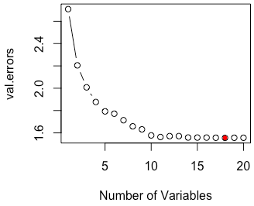

Figure X: Best Subset Selection Using Cross-Validation

**Table X** shows the model coefficients. All the variables except reg1, wrat, inca, and tlag are statistically significant.

|  |  |  |  |  |  |
| --- | --- | --- | --- | --- | --- |
| Variable | Estimate | Std. Error | t value | Pr(>|t|) | Signif. |
| (Intercept) | 14.18688 | 0.0436 | 325.424 | < 2e-16 | *** |
| reg1 | -0.03719 | 0.0362 | -1.027 | 0.3044 |  |
| reg2 | -0.08488 | 0.03932 | -2.159 | 0.031 | * |
| reg3 | 0.31578 | 0.03701 | 8.531 | < 2e-16 | *** |
| reg4 | 0.64187 | 0.03808 | 16.854 | < 2e-16 | *** |
| home | 0.22316 | 0.05568 | 4.008 | 0.0000636 | *** |
| chld | -0.59284 | 0.03487 | -17.001 | < 2e-16 | *** |
| hinc | 0.51069 | 0.03654 | 13.975 | < 2e-16 | *** |
| wrat | 0.02196 | 0.03807 | 0.577 | 0.5641 |  |
| genf | -0.05986 | 0.02614 | -2.29 | 0.0222 | * |
| incm | 0.41271 | 0.05625 | 7.338 | 3.16E-13 | *** |
| inca | 0.03616 | 0.04951 | 0.73 | 0.4652 |  |
| plow | 0.40391 | 0.04952 | 8.157 | 6.03E-16 | *** |
| tgif | 0.20043 | 0.02677 | 7.488 | 1.05E-13 | *** |
| lgif | 0.38749 | 0.05862 | 6.611 | 4.91E-11 | *** |
| rgif | 0.47543 | 0.05096 | 9.329 | < 2e-16 | *** |
| tdon | 0.07232 | 0.03208 | 2.255 | 0.0243 | * |
| tlag | 0.02516 | 0.0309 | 0.814 | 0.4157 |  |
| agif | 0.38728 | 0.0485 | 7.985 | 2.36E-15 | *** |
| Signif. codes: 0 ‘***’ 0.001 ‘**’ 0.01 ‘*’ 0.05 ‘.’ 0.1 ‘ ’ 1 | | | | | |

Table X: Coefficients for Best Subset Selection Using Cross-Validation

# Model Technique 3: Principal Components

In order to choose the number of principal components, we looked at **Figure X**. The lowest MSEP value is around 20 components, but the “elbow” of the plot appears around 5 components. We decided to fit models using 5, 15, and 20 components to determine the optimal number of components.

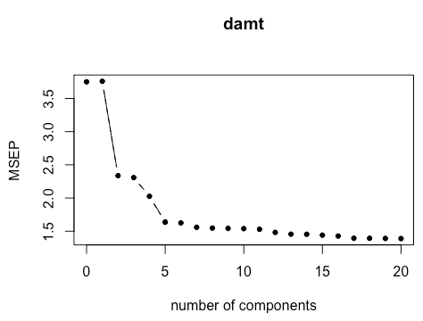

Figure X: Principal Components Plot

In **Table X**, we can see that the model using 20 principal components performed best as it had the smallest MPE. However, we could choose the model containing 15 components if simplicity was a priority rather than having a slightly better MPE.

|  |  |  |
| --- | --- | --- |
| Number of Components | MPE | Standard Error |
| 5 | 1.812705 | 0.1688532 |
| 15 | 1.598671 | 0.1607489 |
| 20 | 1.556378 | 0.1612150 |

Table X: Principal Components Model Comparison

# Model Technique 4: Partial Least Squares

Similar to the principal components method, the partial least squares technique requires us to select the number of components that we think are appropriate based on the following plot.

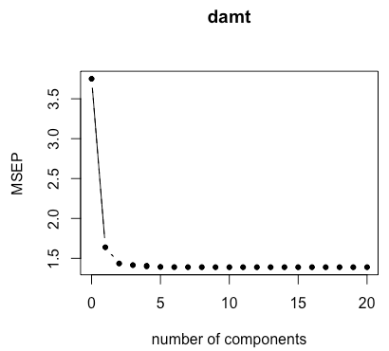

Figure X: Partial Least Squares Plot

Looking **Figure X**, we can see that there is a large drop down to 3 components but not much movement after that. This leads us to believe that 3 components are enough. The results for this model are in **Table X** below.

|  |  |  |
| --- | --- | --- |
| Number of Components | MPE | Standard Error |
| 3 | 1.592151 | 0.1613484 |

Table X: Partial Least Squares Results

# Model Technique 5: Ridge Regression

For the ridge regression model, we first needed to select the best lambda. In **Figure X**, we can see the MSE is smallest when log(Lambda) is smallest. The first vertical line from the left of the plot signifies the smallest MSE, while the second vertical line represents one standard deviation from the minimum MSE. The number 20 at the top of the plot indicates that all 20 predictor variables are present in the model regardless of the lambda value.

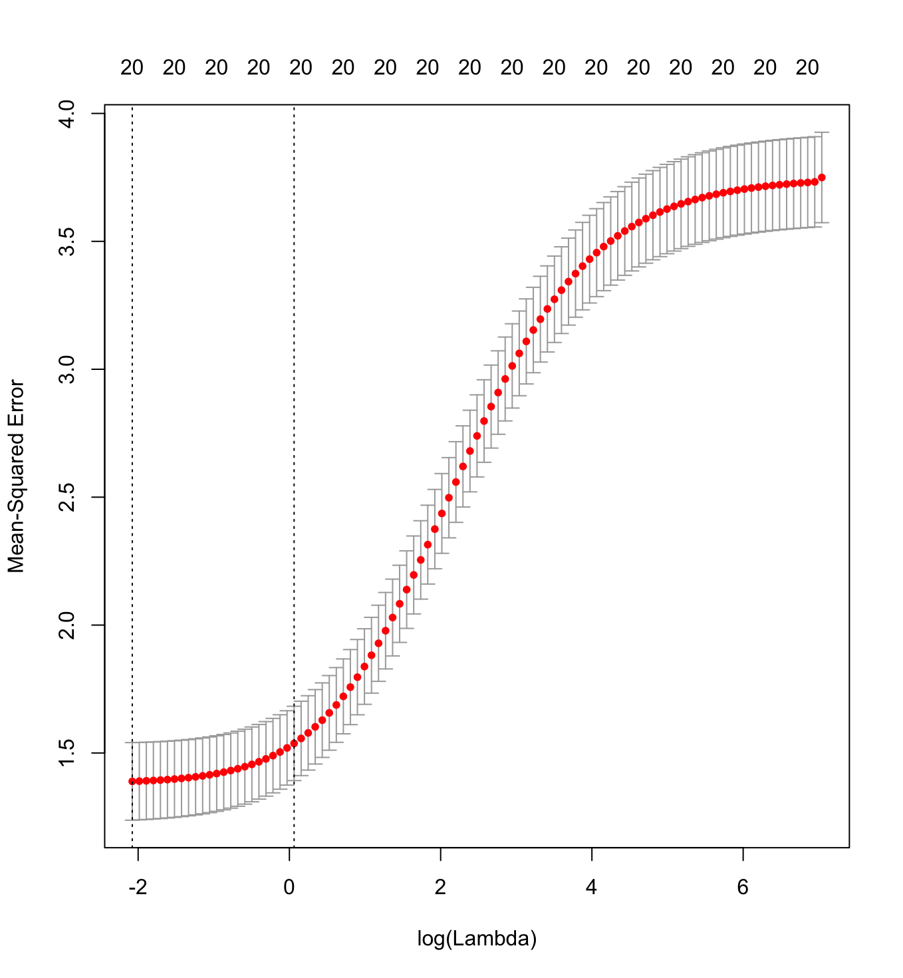

Figure X: Ridge Regression Cross-Validation Plot

We set the best lambda equal to 0.1252296 to estimate the coefficients in **Table X.**

|  |  |
| --- | --- |
| Variable | Estimate |
| (Intercept) | 14.22344033 |
| reg1 | -0.06495925 |
| reg2 | -0.12240428 |
| reg3 | 0.28014764 |
| reg4 | 0.58541542 |
| home | 0.20548728 |
| chld | -0.54971631 |
| hinc | 0.47980195 |
| genf | -0.05763863 |
| wrat | 0.01231801 |
| avhv | -0.01751383 |
| incm | 0.3023943 |
| inca | 0.06359597 |
| plow | 0.30357092 |
| npro | 0.02575266 |
| tgif | 0.16534 |
| lgif | 0.39461843 |
| rgif | 0.44561459 |
| tdon | 0.0708772 |
| tlag | 0.02834013 |
| agif | 0.38205327 |

Table X: Coefficient Estimates

We then used this model to make the predictions and compute the errors in **Table X**.

|  |  |
| --- | --- |
| MPE | Standard Error |
| 1.592151 | 0.1613484 |

Table X: Ridge Regression Results

# Model Technique 6: Lasso

The last regression model technique we used is lasso. Looking at the second vertical line from the left in **Figure X**, one can see that the number of predictors in the model is 10, as denoted by the number at the top of the plot.

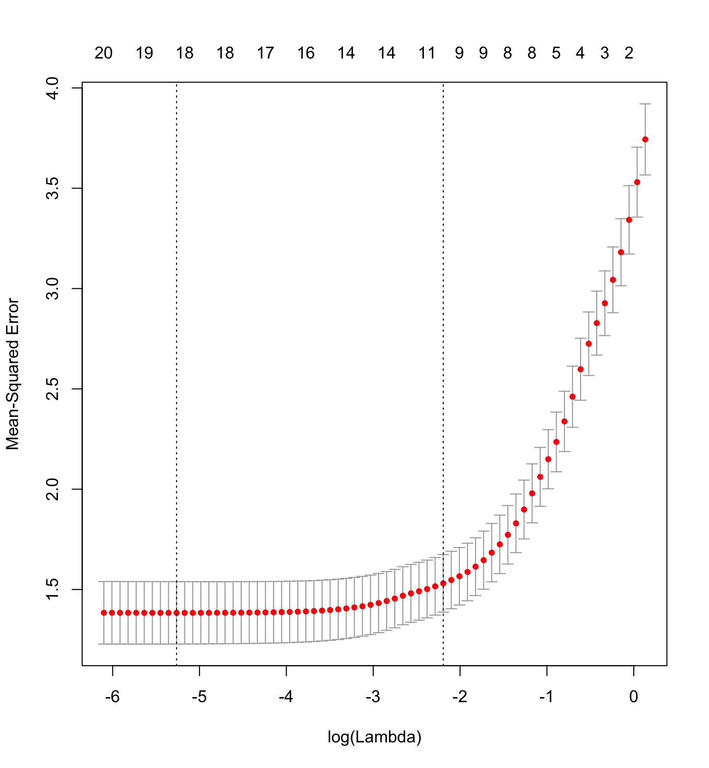

Figure X: Lasso Cross-Validation Plot

We selected the best lambda using cross-validation. In this case the best lambda is 0.005174504, which produces the coefficient estimates shown in **Table X.**

|  |  |
| --- | --- |
| Variable | Estimate |
| (Intercept) | 14.33842866 |
| reg1 | . |
| reg2 | -0.051092397 |
| reg3 | 0.203743788 |
| reg4 | 0.525828946 |
| home | . |
| chld | -0.430556714 |
| hinc | 0.338995574 |
| genf | . |
| wrat | . |
| avhv | . |
| incm | 0.005835249 |
| inca | . |
| plow | . |
| npro | . |
| tgif | 0.076711998 |
| lgif | 0.380005233 |
| rgif | 0.399168041 |
| tdon | . |
| tlag | . |
| agif | 0.332079318 |

Table X: Coefficient Estimates

Using this lambda, we make the predictions and compute the errors shown in **Table X**.

|  |  |
| --- | --- |
| MPE | Standard Error |
| 1.562046 | 0.1613484 |

Table X: Lasso Results

## Results

# Classification Models REREAD WRITE-UP BELOW IN CASE ANYTHING CHANGED

As discussed, there have been a total of nine classification techniques tested on this data to determine which model is the best for classifying individuals as donors. Utilizing the number of mailings and their estimated profit on the validation data set as decision metrics, the best model is the one that maximizes profits but minimizes extraneous mailings. Although a little surprising, the model with the best performance on the validation data is the logistic model that uses a subset of predictors based on a backwards selection variable technique. The GAM model results in the same model fit via the original logistic model with backward selection. The logistic regression model boasts the additional benefit of being highly interpretable as well. Therefore, this model will used to classify individuals on the test set on whether or not they are donors.

|  |  |  |
| --- | --- | --- |
| **# Mailings** | **Profit** | **Modeling Type** |
| 1397 | $11,387.00 | Log1 |
| 1583 | $11,073.00 | Log 1a |
| 1302 | $11,649.50 | Log 1b |
| 1396 | $11,389.00 | Log GAM1 |
| 1302 | $11,649.50 | Log GAM1a |
| 1363 | $11,642.50 | LDA1 |
| 1336 | $11,639.50 | LDA1a |
| 1396 | $11,229.50 | QDA |
| 1421 | $11,107.00 | QDA1a |
| 1116 | $9,875.50 | KNN |
| 1250 | $11,130.00 | KNN1a |
| 1390 | $11,299.50 | KNN1b |
| 1362 | $11,413.50 | Unaltered Tree & Pruned Tree |
| 1487 | $11,381.00 | Tree with subset vars |
| 1308 | $11,565.00 | Boosted Tree |
| 1055 | $11,099.50 | RF |
| 2013 | $10,459.50 | Linear SVM (untuned) |
| 1366 | $11,536.00 | Radial SVM (tuned) |

# Regression Models

|  |  |  |
| --- | --- | --- |
| Model | Test MPE | Standard Error of Test MPE |
| 1 | 1.508530 | 0.1568465 |
| 2 | 1.555443 | 0.1611711 |
| 3 | 1.556378 | 0.1612150 |
| 4 | 1.592151 | 0.1613484 |
| 5 | 1.592151 | 0.1613484 |
| 6 | 1.562046 | 0.1613484 |

Table X: Regression Results

A total of six regression model techniques were used on the charity data to determine the best model for predicting the donation amount. When comparing the model techniques in **Table X** above, Model 1, least squares regression with best Mallow’s CP, far outperformed the other options in terms of Mean Prediction Error and Standard Error of the Test Mean Prediction Error. In terms of simplicity, Model 1 fell in the middle of the pack with 14 predictors, while Model 6 was able to cut the predictors down by half of the original total to 10. Overall, due to outperforming it’s competitors in accuracy and maintaining a relatively simple composition, Model 1, least squares regression with best Mallow’s CP, is our best regression model for predicting donation amounts.

## Conclusion

After fitting various machine learning modeling techniques, including least squares regression, best subset selection using BIC, best subset selection using 10-fold cross validation, ridge regression using 10-fold cross validation, and lasso using 10-fold cross validation, I discovered that the lasso model using 10-fold cross validation performed best in predicting the progression of diabetes one year after baseline. This model contained the predictor variables sex, bmi, map, hdl, ltg, and glu. Before deploying the model, I recommend further model testing and consulting a diabetes expert to determine if the predictors included in the model make medical sense. If the model performs well in additional tests and receives the approval of a medical expert, it should be safe to deploy the model on new data.

## Appendix A: R Code

1. Please note: we kept the transformed variable names the same as the original variable names for our models, but we added a “.t” to the end of each variable name in Figure 1 to clearly distinguish between the original and transformed variables.