aim1_outcome_exp

Wanjing Chen

2024-04-08

library(stringr)  
library(dplyr)

##   
## Attaching package: 'dplyr'

## The following objects are masked from 'package:stats':  
##   
## filter, lag

## The following objects are masked from 'package:base':  
##   
## intersect, setdiff, setequal, union

library(ggplot2)  
library(knitr)

var_full <- readRDS("processed_meta.rds")  
scd_data_yr3_label <- readRDS("cleaned_scd_data.rds")  
naming_vec <- readRDS("var_labels.RDS")  
df_lst <- readRDS("cleaned_categorized_dfsubset.RDS")  
source("R/var_cat_test.R")  
source("R/var_cat_plot.R")

outcome_df <- df_lst$Outcomes |>  
 select_at(vars(-starts_with("INT")))  
  
pred_disease_df <- df_lst$`Disease-related`  
pred_patient_df <- df_lst$`Patient-related`  
pred_transp_df <- df_lst$`Tranplant-related`

cat_disease_df <- pred_disease_df %>%  
 select(where(~ !is.numeric(.)))  
   
cat_patient_df <- pred_patient_df %>%  
 select(where(~ !is.numeric(.)),   
 -DUMMYID)  
  
cat_transp_df <- pred_transp_df %>%  
 select(where(~ !is.numeric(.)),  
 YEARTX)

dat1 <- cat_test(outcome_df, cat_disease_df)  
dat2 <- cat_test(outcome_df, cat_patient_df)

## Warning in chisq.test(tbl, correct = F): Chi-squared approximation may be  
## incorrect  
  
## Warning in chisq.test(tbl, correct = F): Chi-squared approximation may be  
## incorrect  
  
## Warning in chisq.test(tbl, correct = F): Chi-squared approximation may be  
## incorrect  
  
## Warning in chisq.test(tbl, correct = F): Chi-squared approximation may be  
## incorrect

dat3 <- cat_test(outcome_df, cat_transp_df)

## Warning in chisq.test(tbl, correct = F): Chi-squared approximation may be  
## incorrect  
  
## Warning in chisq.test(tbl, correct = F): Chi-squared approximation may be  
## incorrect  
  
## Warning in chisq.test(tbl, correct = F): Chi-squared approximation may be  
## incorrect  
  
## Warning in chisq.test(tbl, correct = F): Chi-squared approximation may be  
## incorrect  
  
## Warning in chisq.test(tbl, correct = F): Chi-squared approximation may be  
## incorrect

dat1[[2]]$Outcome <- naming_vec[tolower(dat1[[2]]$Outcome)]  
dat1[[2]]$Explanatory <- naming_vec[tolower(dat1[[2]]$Explanatory)]  
  
  
  
  
dat2[[2]]$Outcome <- naming_vec[tolower(dat2[[2]]$Outcome)]  
dat2[[2]]$Explanatory <- naming_vec[tolower(dat2[[2]]$Explanatory)]  
  
dat2[[2]] |> mutate(p_adj = p.adjust(Pvalue, "fdr"))|>  
 filter(p_adj <= 0.05) |>  
 #filter(Pvalue <= 0.05) |>  
 filter(!str_detect(Explanatory, "Cases from")) |>  
 knitr::kable()

| Outcome | Explanatory | Method | Pvalue | p_adj |
| --- | --- | --- | --- | --- |
| Survival status at last contact | Age Categories (Years) | Fisher | 0.001 | 0.0105000 |
| Event-free survival (Graft failure or death are the events) | Age Categories (Years) | Fisher | 0.004 | 0.0387692 |
| Death without graft failure | Age Categories (Years) | Fisher | 0.001 | 0.0105000 |
| Death without graft failure | Race | Fisher | 0.005 | 0.0420000 |
| Death without acute graft versus host disease, grades II-IV | Age Categories (Years) | Fisher | 0.001 | 0.0105000 |
| Death without chronic graft-vs-host disease | Age Categories (Years) | Fisher | 0 | 0.0000000 |
| Secondary malignancy | Age Categories (Years) | Fisher | 0 | 0.0000000 |
| Secondary malignancy | Karnofsky/Lansky score at HCT | Fisher | 0.001 | 0.0105000 |
| Secondary malignancy | HCT-comorbidity index | Fisher | 0.005 | 0.0420000 |

dat3[[2]]$Outcome <- naming_vec[tolower(dat3[[2]]$Outcome)]  
dat3[[2]]$Explanatory <- naming_vec[tolower(dat3[[2]]$Explanatory)]  
  
dat3[[2]] |> mutate(p_adj = p.adjust(Pvalue, "fdr"))|>  
 filter(p_adj <= 0.05) |>  
 #filter(Pvalue <= 0.05) |>  
 filter(!str_detect(Explanatory, "Cases from"))|>  
 knitr::kable()

| Outcome | Explanatory | Method | Pvalue | p_adj |
| --- | --- | --- | --- | --- |
| Survival status at last contact | Donor type | Chisq | 0 | 0.0000000 |
| Event-free survival (Graft failure or death are the events) | Donor type | Chisq | 0 | 0.0000000 |
| Event-free survival (Graft failure or death are the events) | Graft type | Chisq | 0 | 0.0000000 |
| Event-free survival (Graft failure or death are the events) | Conditioning intensity | Chisq | 0.006 | 0.0204878 |
| Event-free survival (Graft failure or death are the events) | Conditioning regimen | Fisher | 0 | 0.0000000 |
| Event-free survival (Graft failure or death are the events) | GVHD prophylaxis | Fisher | 0 | 0.0000000 |
| Event-free survival (Graft failure or death are the events) | Donor-recipient HLA matching | Chisq | 0 | 0.0000000 |
| Event-free survival (Graft failure or death are the events) | Year of Transplant Categories (Year) | Fisher | 0.001 | 0.0042424 |
| Event-free survival (Graft failure or death are the events) | Year of Translplant (Year) | Fisher | 0 | 0.0000000 |
| Graft failure | Donor type | Chisq | 0 | 0.0000000 |
| Graft failure | Graft type | Chisq | 0 | 0.0000000 |
| Graft failure | Conditioning intensity | Chisq | 0 | 0.0000000 |
| Graft failure | Conditioning regimen | Fisher | 0 | 0.0000000 |
| Graft failure | GVHD prophylaxis | Fisher | 0 | 0.0000000 |
| Graft failure | Donor-recipient HLA matching | Chisq | 0 | 0.0000000 |
| Graft failure | Year of Transplant Categories (Year) | Fisher | 0.011 | 0.0320833 |
| Graft failure | Year of Translplant (Year) | Fisher | 0.005 | 0.0179487 |
| Death without graft failure | Donor type | Chisq | 0 | 0.0000000 |
| Neutrophil engraftment | Donor type | Fisher | 0 | 0.0000000 |
| Neutrophil engraftment | Graft type | Fisher | 0.005 | 0.0179487 |
| Neutrophil engraftment | Donor-recipient HLA matching | Fisher | 0.008 | 0.0248889 |
| Platelet recovery | Donor type | Chisq | 0 | 0.0000000 |
| Platelet recovery | Graft type | Chisq | 0.008 | 0.0248889 |
| Platelet recovery | Conditioning intensity | Fisher | 0 | 0.0000000 |
| Platelet recovery | Conditioning regimen | Fisher | 0 | 0.0000000 |
| Platelet recovery | Donor-recipient HLA matching | Chisq | 0 | 0.0000000 |
| Death without platelet recovery | Donor type | Fisher | 0 | 0.0000000 |
| Acute graft versus host disease, grades II-IV | Donor type | Chisq | 0 | 0.0000000 |
| Acute graft versus host disease, grades II-IV | Graft type | Chisq | 0 | 0.0000000 |
| Acute graft versus host disease, grades II-IV | Conditioning intensity | Chisq | 0.009 | 0.0273913 |
| Acute graft versus host disease, grades II-IV | Conditioning regimen | Fisher | 0 | 0.0000000 |
| Acute graft versus host disease, grades II-IV | ATG/Alemtuzumab given as conditioning regimen/GVHD prophylaxis | Chisq | 0 | 0.0000000 |
| Acute graft versus host disease, grades II-IV | GVHD prophylaxis | Fisher | 0.012 | 0.0336000 |
| Acute graft versus host disease, grades II-IV | Donor-recipient HLA matching | Chisq | 0 | 0.0000000 |
| Acute graft versus host disease, grades II-IV | Recipient CMV serostatus | Chisq | 0.012 | 0.0336000 |
| Acute graft versus host disease, grades II-IV | Year of Transplant Categories (Year) | Fisher | 0.016 | 0.0430769 |
| Death without acute graft versus host disease, grades II-IV | Donor type | Fisher | 0.007 | 0.0227907 |
| Chronic graft-vs-host disease | Donor type | Chisq | 0 | 0.0000000 |
| Chronic graft-vs-host disease | Graft type | Chisq | 0.001 | 0.0042424 |
| Chronic graft-vs-host disease | Conditioning intensity | Chisq | 0 | 0.0000000 |
| Chronic graft-vs-host disease | Conditioning regimen | Fisher | 0 | 0.0000000 |
| Chronic graft-vs-host disease | ATG/Alemtuzumab given as conditioning regimen/GVHD prophylaxis | Chisq | 0.005 | 0.0179487 |
| Chronic graft-vs-host disease | GVHD prophylaxis | Fisher | 0 | 0.0000000 |
| Death without chronic graft-vs-host disease | Donor type | Chisq | 0 | 0.0000000 |
| Death without chronic graft-vs-host disease | Graft type | Fisher | 0.011 | 0.0320833 |
| Post-transplant lymphoproliferative disorder (PTLD) | Donor type | Fisher | 0.015 | 0.0411765 |
| Post-transplant lymphoproliferative disorder (PTLD) | GVHD prophylaxis | Fisher | 0.004 | 0.0155556 |
| Secondary malignancy | Graft type | Fisher | 0.006 | 0.0204878 |
| Secondary malignancy | Conditioning intensity | Fisher | 0 | 0.0000000 |
| Secondary malignancy | Conditioning regimen | Fisher | 0.002 | 0.0082353 |
| Secondary malignancy | GVHD prophylaxis | Fisher | 0.003 | 0.0120000 |
| Secondary malignancy | Donor-recipient HLA matching | Fisher | 0.007 | 0.0227907 |

cat_plot(outcome_df, cat_disease_df, naming_vec)

## [[1]]  
## [[1]][[1]]

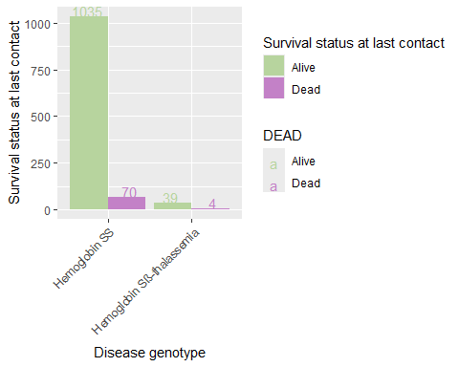

##   
##   
## [[2]]  
## [[2]][[1]]

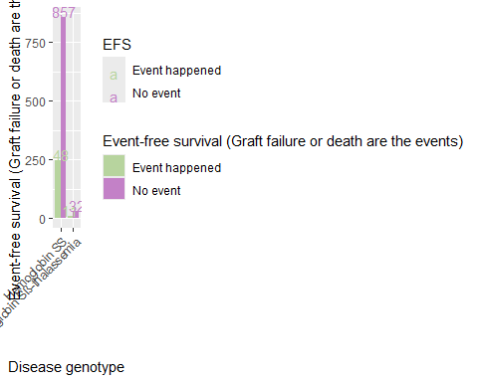

##   
##   
## [[3]]  
## [[3]][[1]]

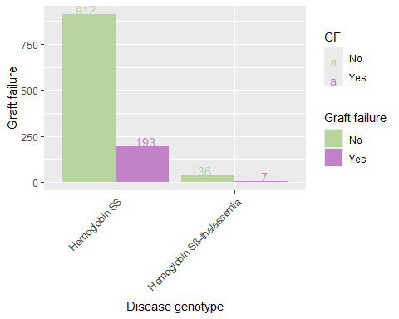

##   
##   
## [[4]]  
## [[4]][[1]]

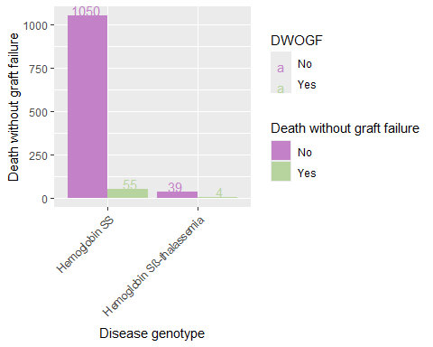

##   
##   
## [[5]]  
## [[5]][[1]]

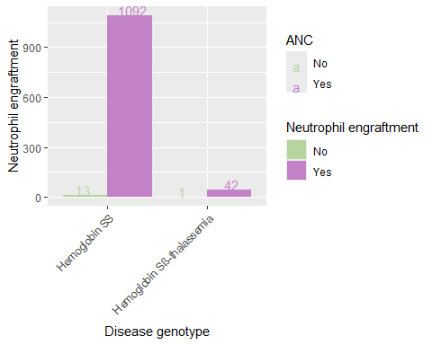

##   
##   
## [[6]]  
## [[6]][[1]]

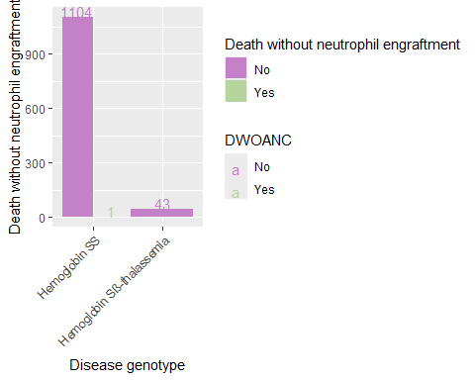

##   
##   
## [[7]]  
## [[7]][[1]]

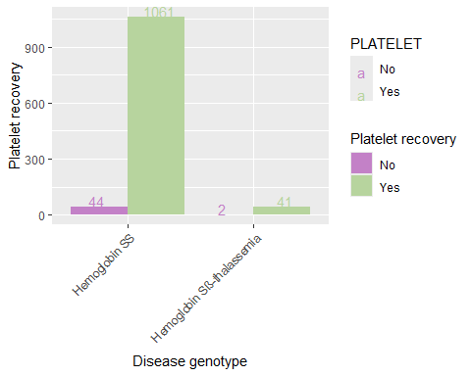

##   
##   
## [[8]]  
## [[8]][[1]]

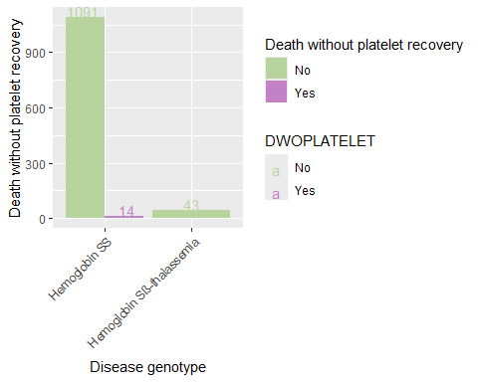

##   
##   
## [[9]]  
## [[9]][[1]]

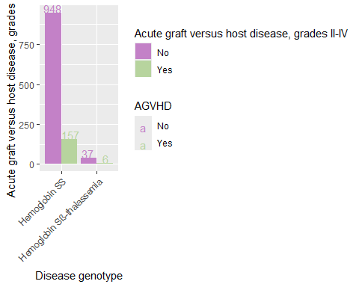

##   
##   
## [[10]]  
## [[10]][[1]]

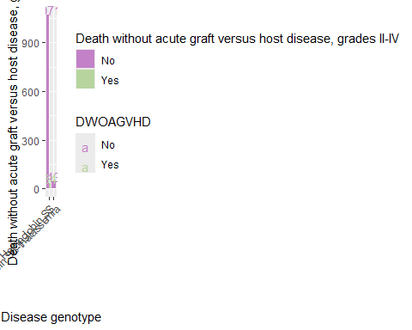

##   
##   
## [[11]]  
## [[11]][[1]]

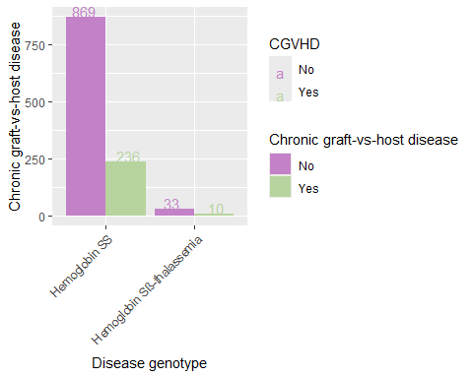

##   
##   
## [[12]]  
## [[12]][[1]]

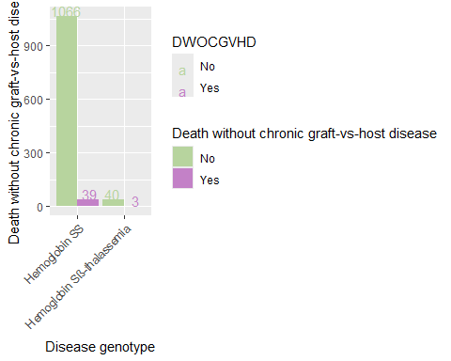

##   
##   
## [[13]]  
## [[13]][[1]]

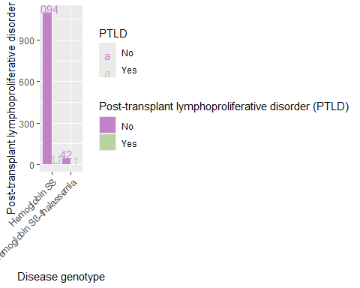

##   
##   
## [[14]]  
## [[14]][[1]]

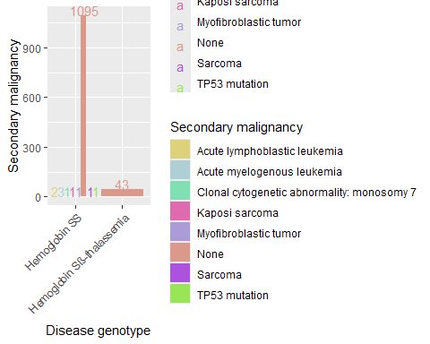

cat_plot(outcome_df, cat_patient_df, naming_vec)

## [[1]]  
## [[1]][[1]]

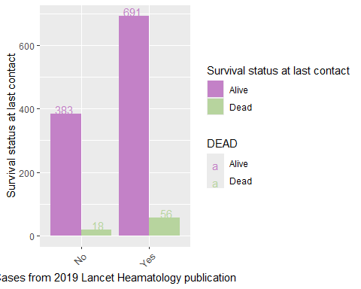

##   
## [[1]][[2]]

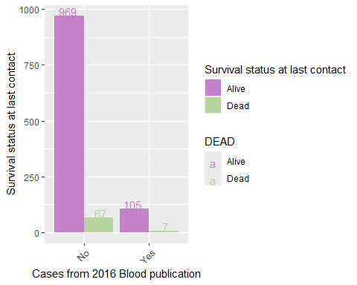

##   
## [[1]][[3]]

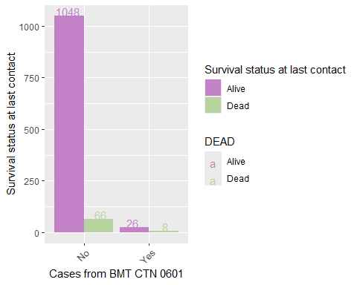

##   
## [[1]][[4]]

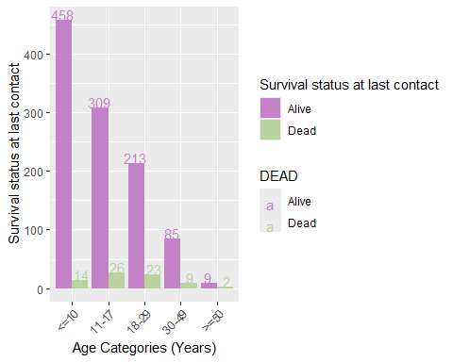

##   
## [[1]][[5]]

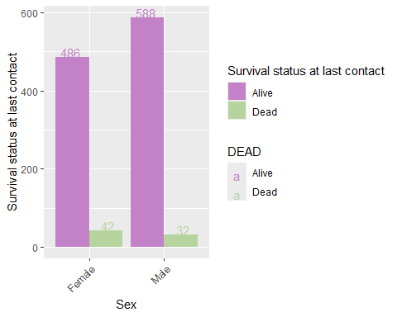

##   
## [[1]][[6]]

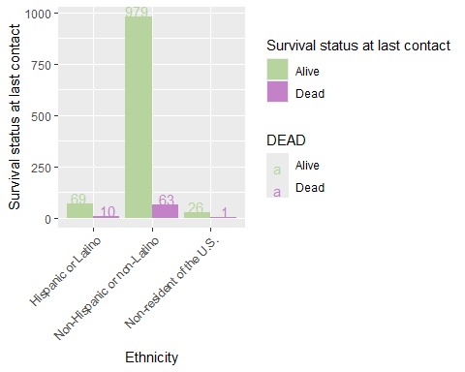

##   
## [[1]][[7]]

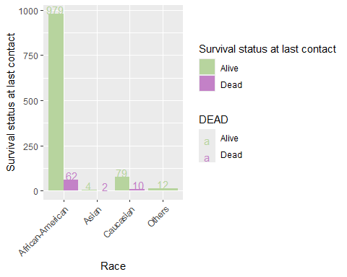

##   
## [[1]][[8]]

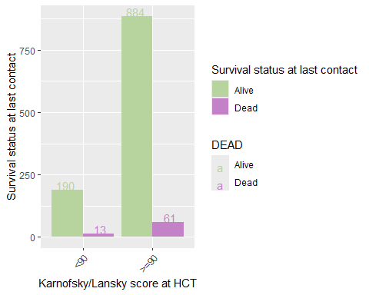

##   
## [[1]][[9]]

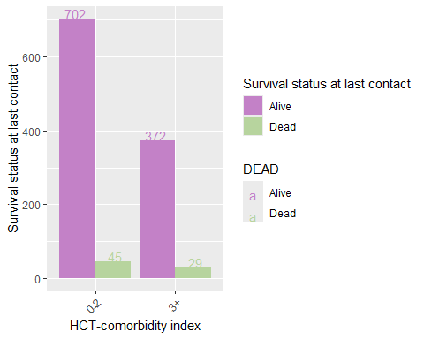

##   
##   
## [[2]]  
## [[2]][[1]]

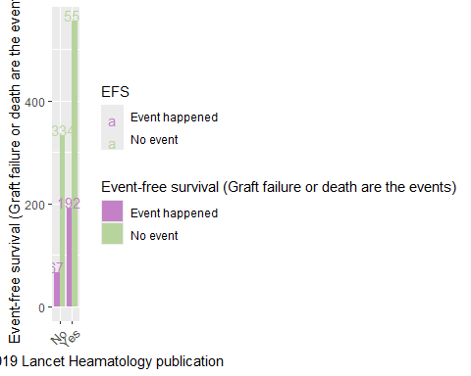

##   
## [[2]][[2]]

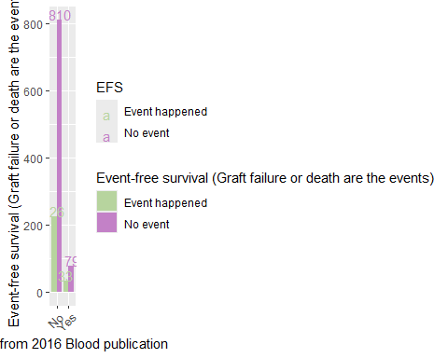

##   
## [[2]][[3]]

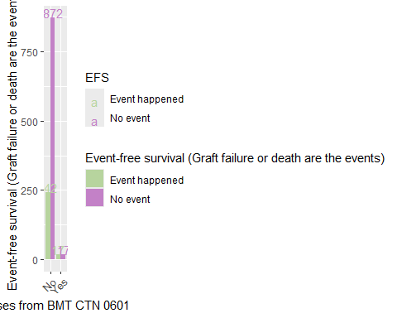

##   
## [[2]][[4]]

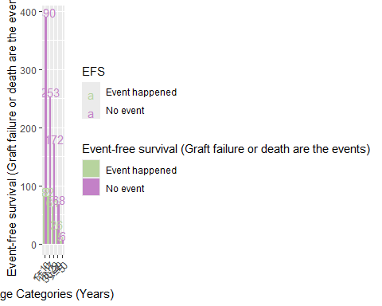

##   
## [[2]][[5]]

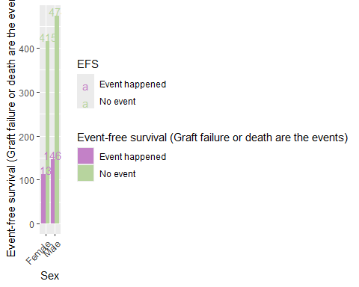

##   
## [[2]][[6]]

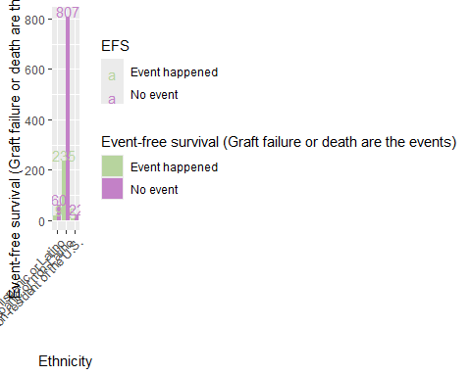

##   
## [[2]][[7]]

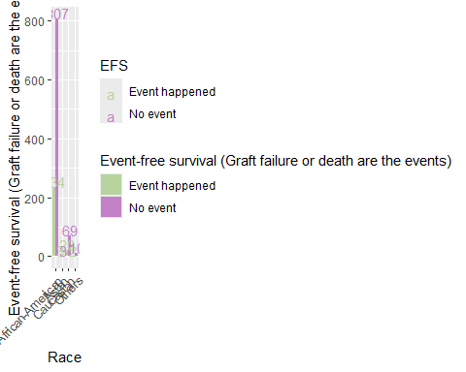

##   
## [[2]][[8]]

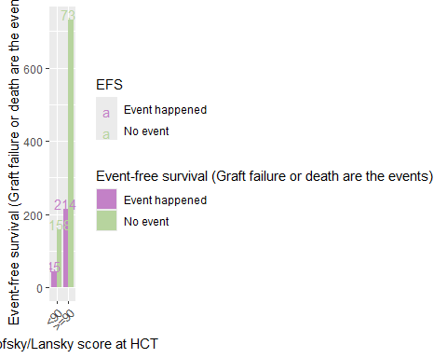

##   
## [[2]][[9]]

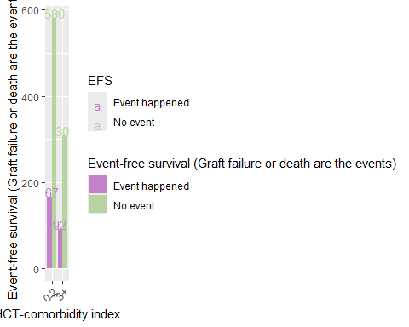

##   
##   
## [[3]]  
## [[3]][[1]]

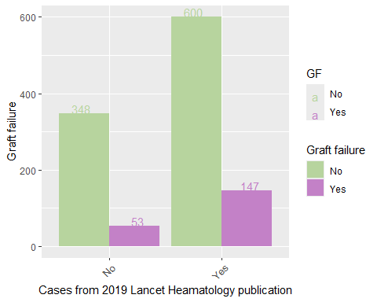

##   
## [[3]][[2]]

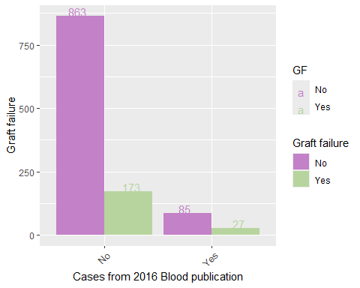

##   
## [[3]][[3]]

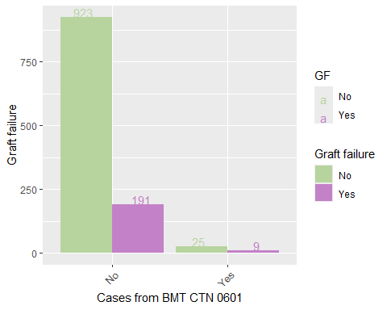

##   
## [[3]][[4]]

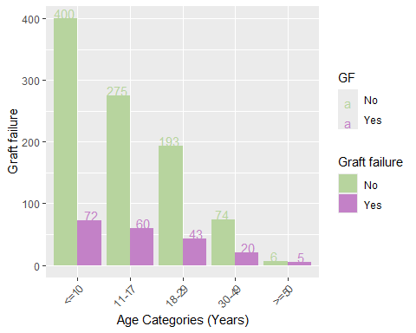

##   
## [[3]][[5]]

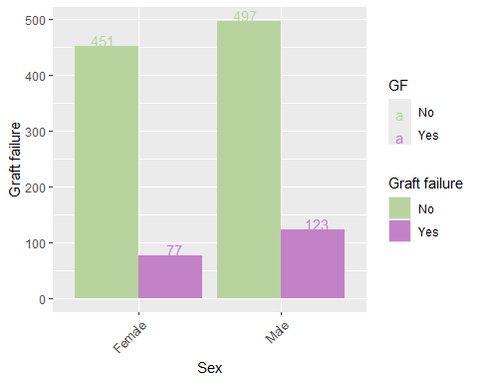

##   
## [[3]][[6]]

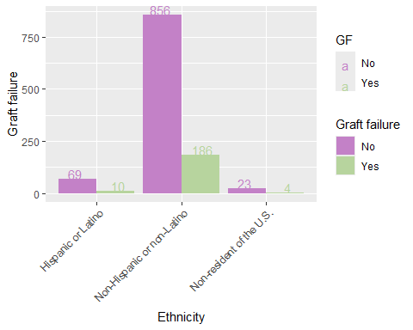

##   
## [[3]][[7]]

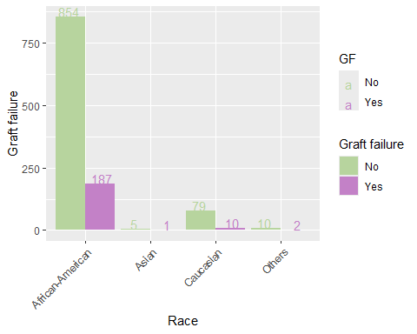

##   
## [[3]][[8]]

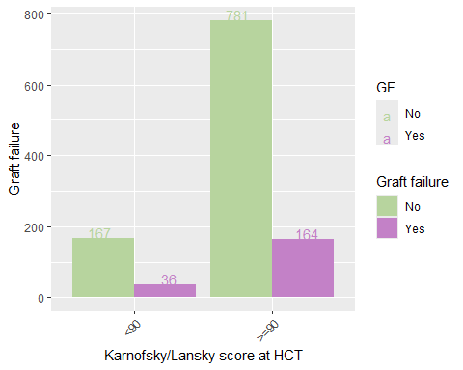

##   
## [[3]][[9]]

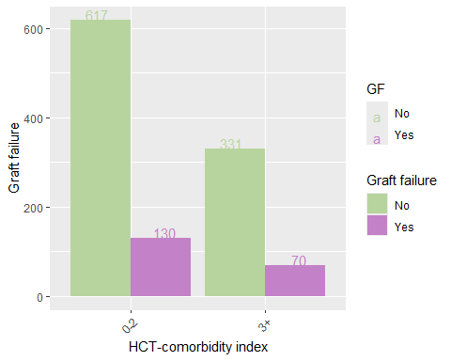

##   
##   
## [[4]]  
## [[4]][[1]]

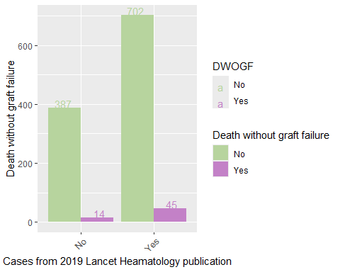

##   
## [[4]][[2]]

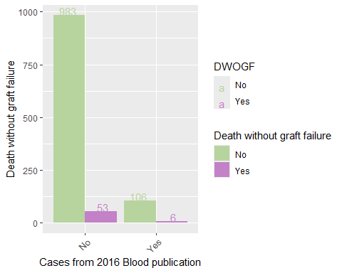

##   
## [[4]][[3]]

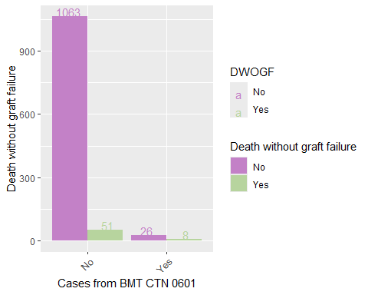

##   
## [[4]][[4]]

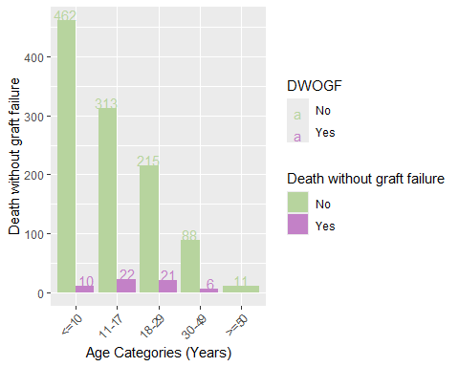

##   
## [[4]][[5]]

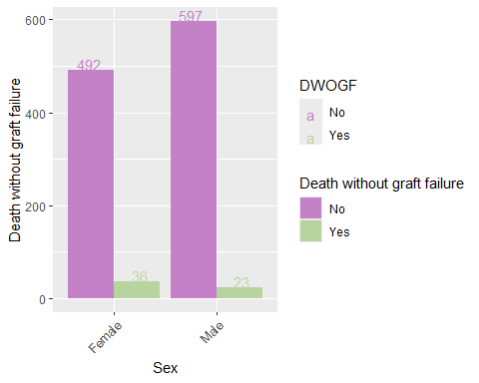

##   
## [[4]][[6]]

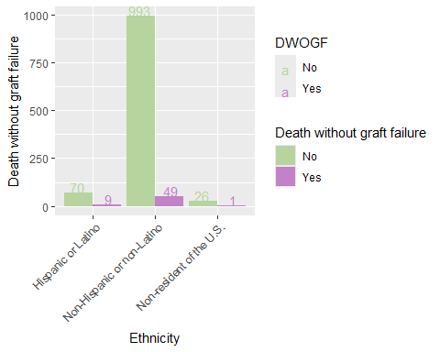

##   
## [[4]][[7]]

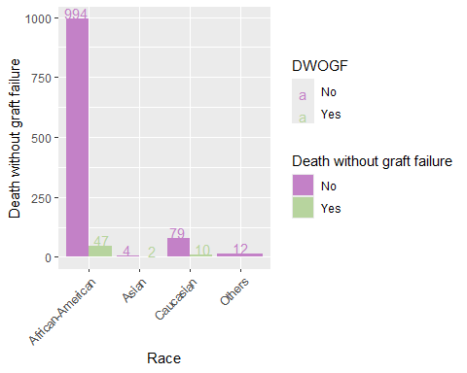

##   
## [[4]][[8]]

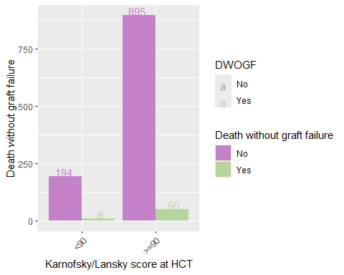

##   
## [[4]][[9]]

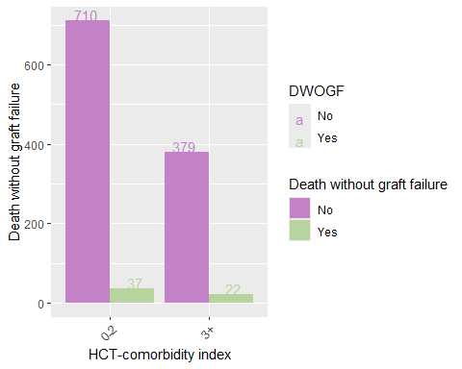

##   
##   
## [[5]]  
## [[5]][[1]]

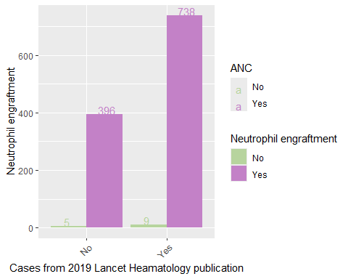

##   
## [[5]][[2]]

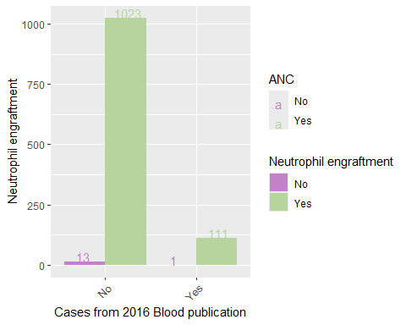

##   
## [[5]][[3]]

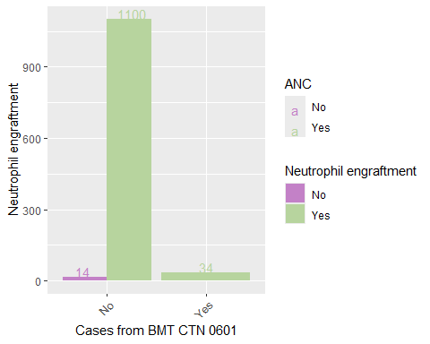

##   
## [[5]][[4]]

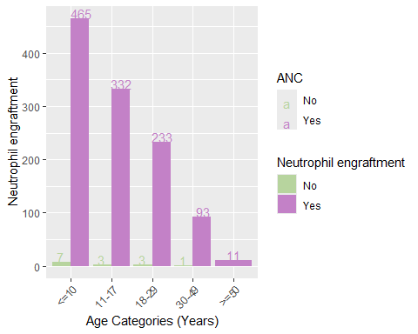

##   
## [[5]][[5]]

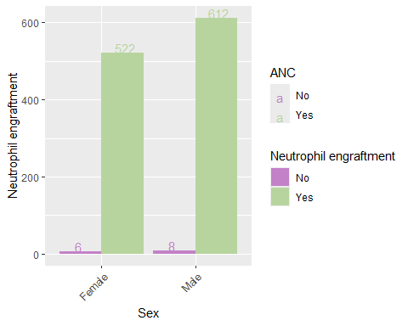

##   
## [[5]][[6]]

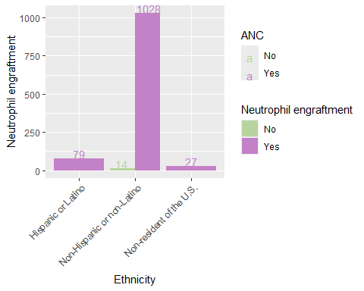

##   
## [[5]][[7]]

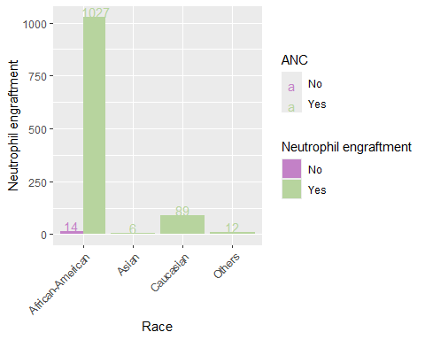

##   
## [[5]][[8]]

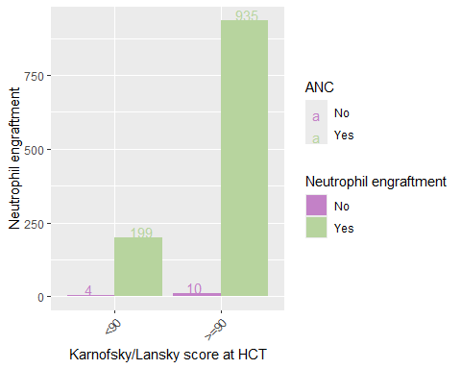

##   
## [[5]][[9]]

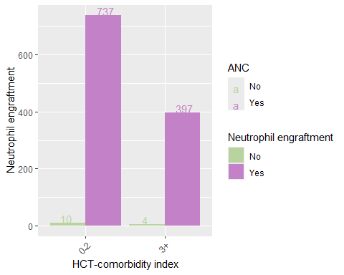

##   
##   
## [[6]]  
## [[6]][[1]]

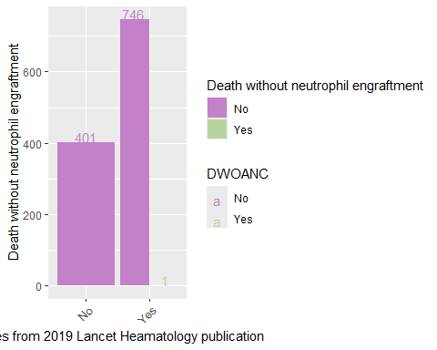

##   
## [[6]][[2]]

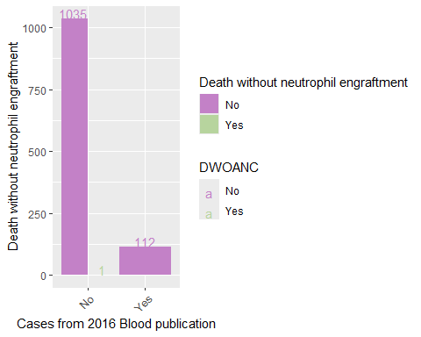

##   
## [[6]][[3]]

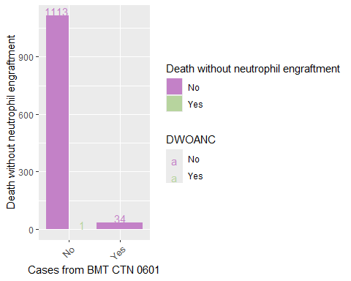

##   
## [[6]][[4]]

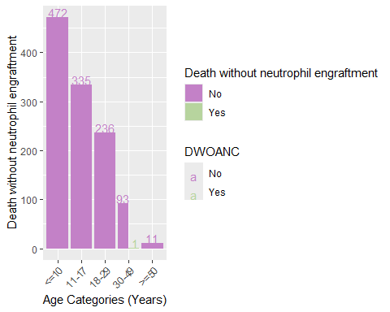

##   
## [[6]][[5]]

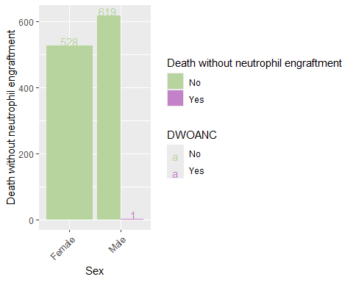

##   
## [[6]][[6]]

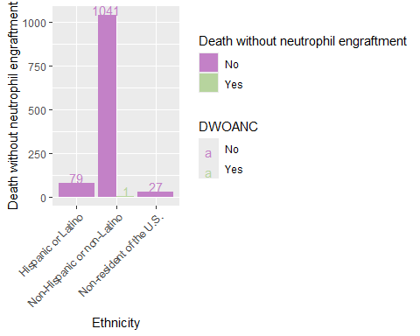

##   
## [[6]][[7]]

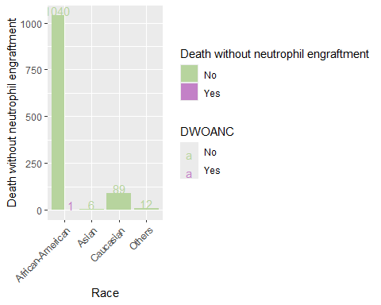

##   
## [[6]][[8]]

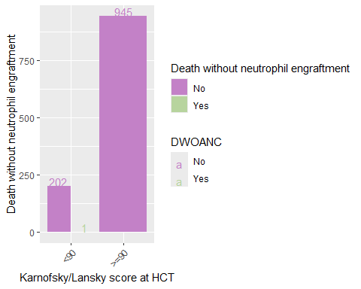

##   
## [[6]][[9]]

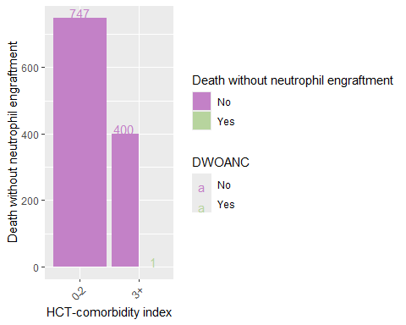

##   
##   
## [[7]]  
## [[7]][[1]]

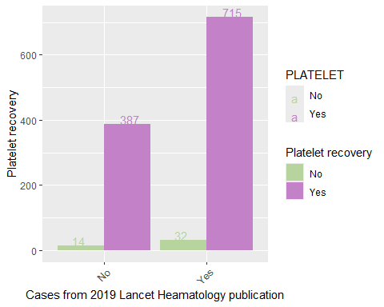

##   
## [[7]][[2]]

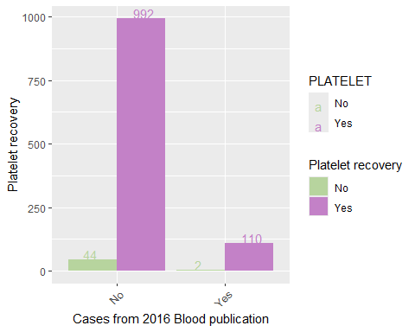

##   
## [[7]][[3]]

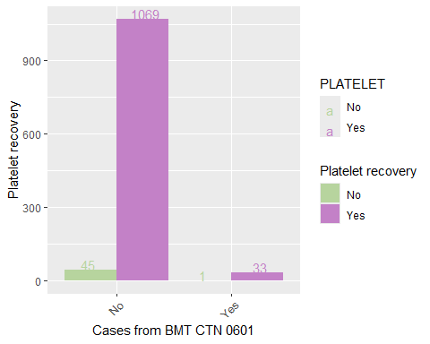

##   
## [[7]][[4]]

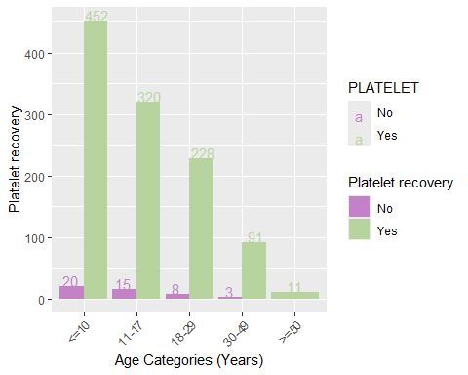

##   
## [[7]][[5]]

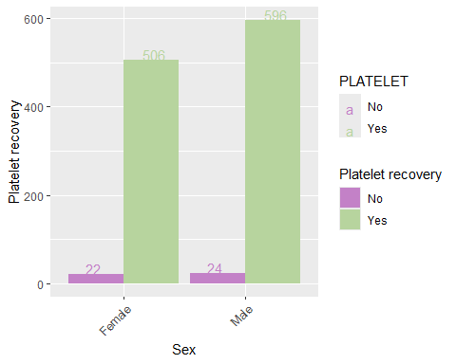

##   
## [[7]][[6]]

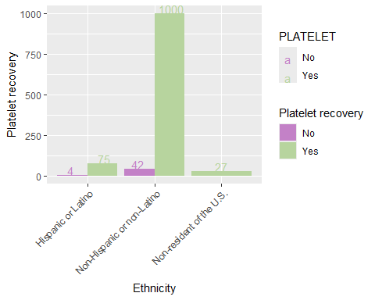

##   
## [[7]][[7]]

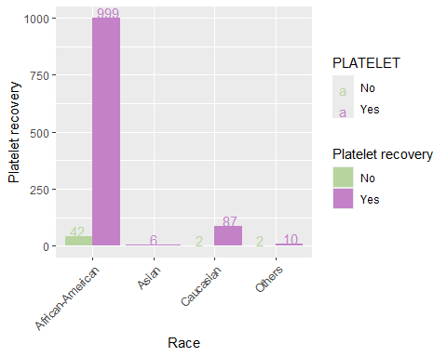

##   
## [[7]][[8]]

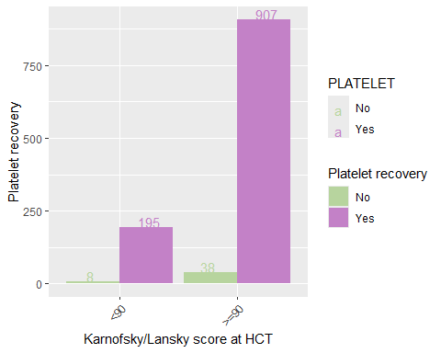

##   
## [[7]][[9]]

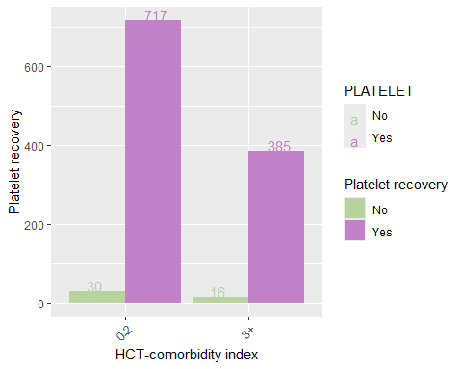

##   
##   
## [[8]]  
## [[8]][[1]]

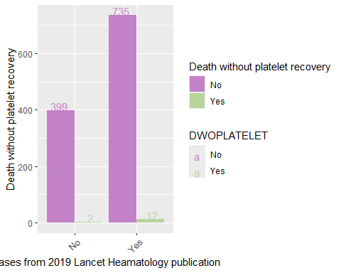

##   
## [[8]][[2]]

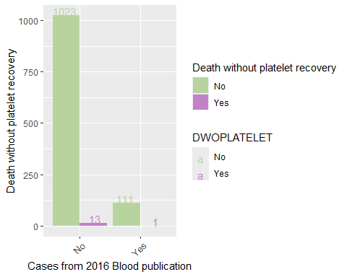

##   
## [[8]][[3]]

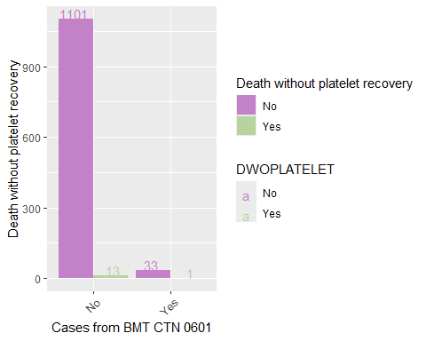

##   
## [[8]][[4]]

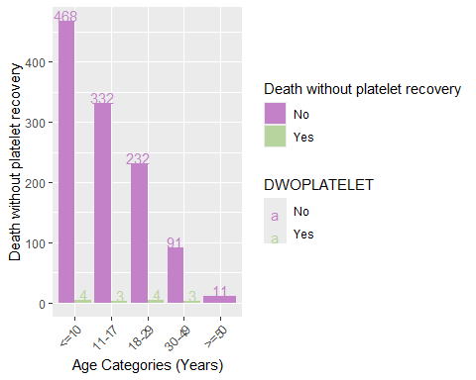

##   
## [[8]][[5]]

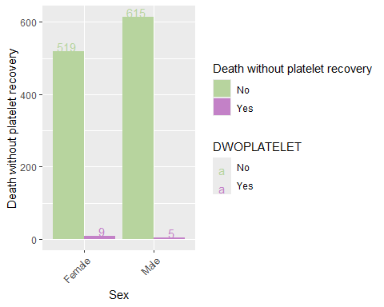

##   
## [[8]][[6]]

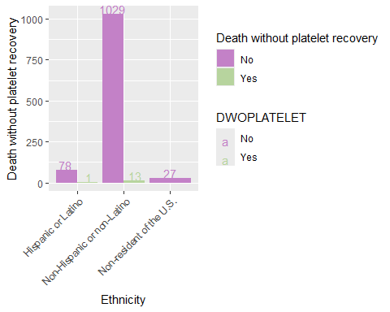

##   
## [[8]][[7]]

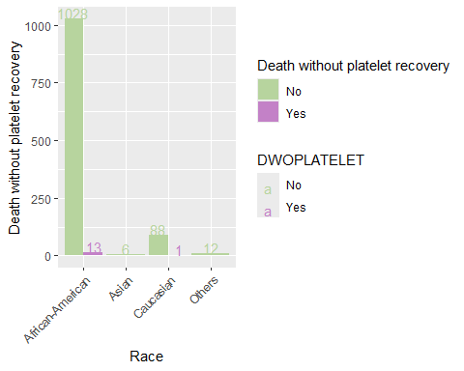

##   
## [[8]][[8]]

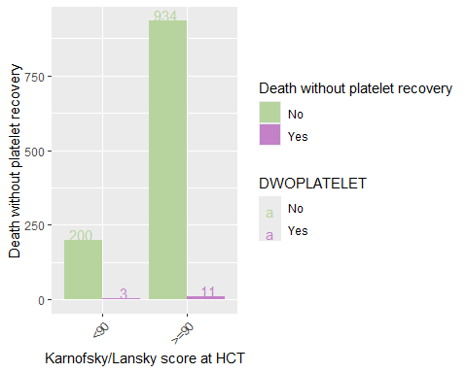

##   
## [[8]][[9]]

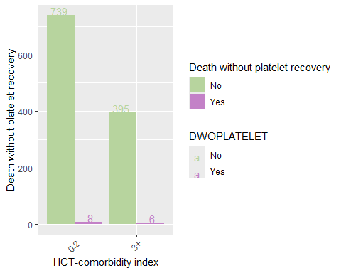

##   
##   
## [[9]]  
## [[9]][[1]]

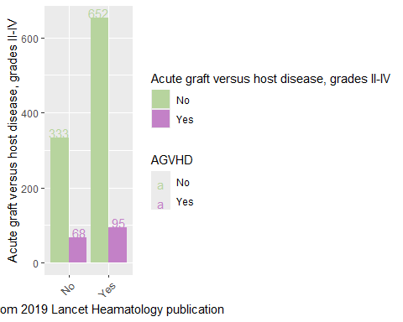

##   
## [[9]][[2]]

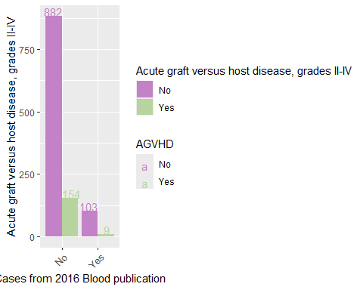

##   
## [[9]][[3]]

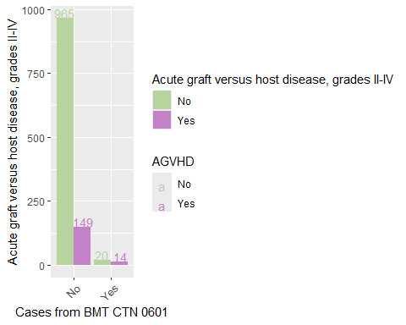

##   
## [[9]][[4]]

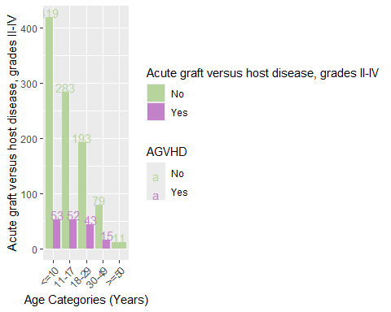

##   
## [[9]][[5]]

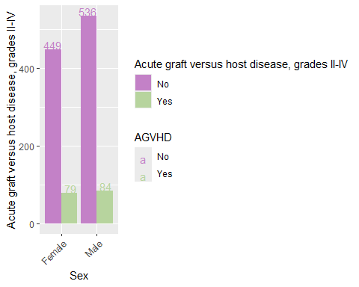

##   
## [[9]][[6]]

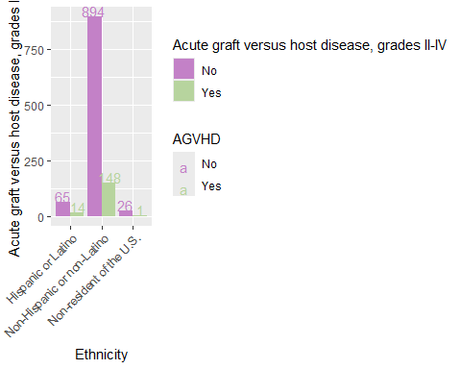

##   
## [[9]][[7]]

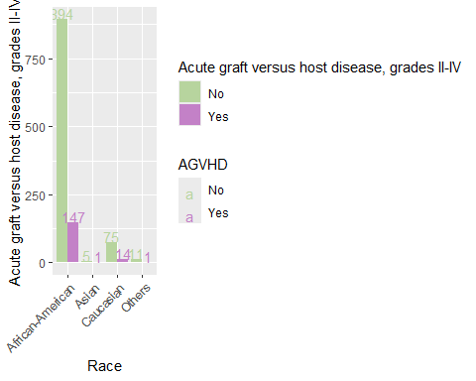

##   
## [[9]][[8]]

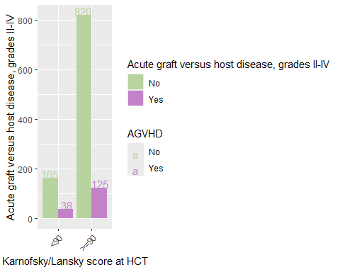

##   
## [[9]][[9]]

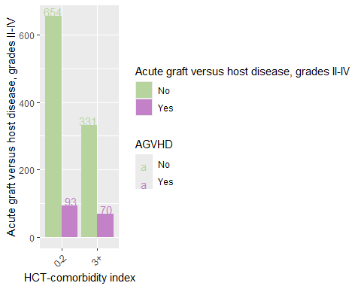

##   
##   
## [[10]]  
## [[10]][[1]]

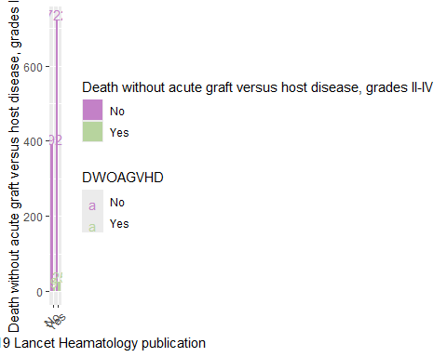

##   
## [[10]][[2]]

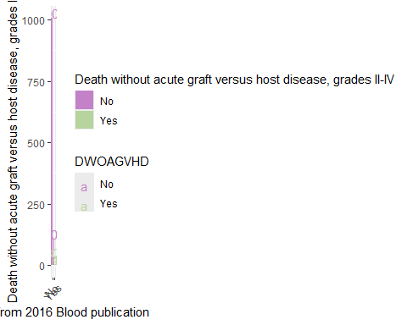

##   
## [[10]][[3]]

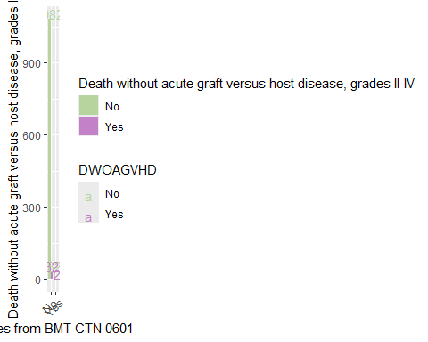

##   
## [[10]][[4]]

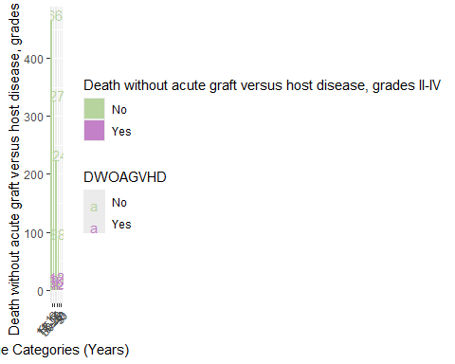

##   
## [[10]][[5]]

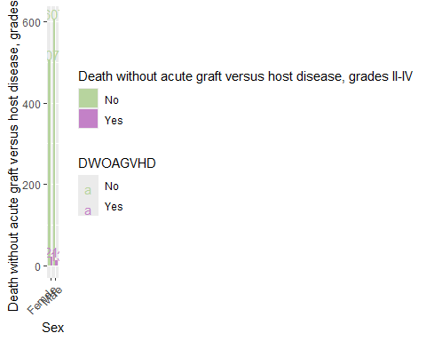

##   
## [[10]][[6]]

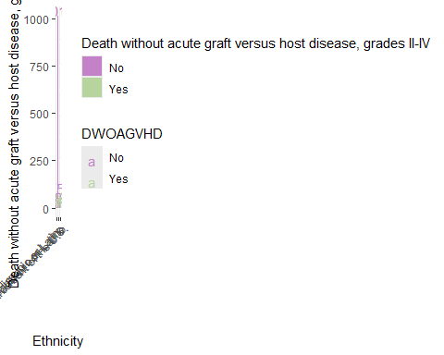

##   
## [[10]][[7]]

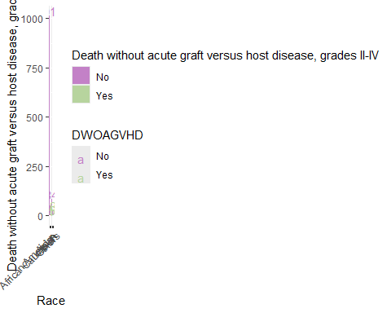

##   
## [[10]][[8]]

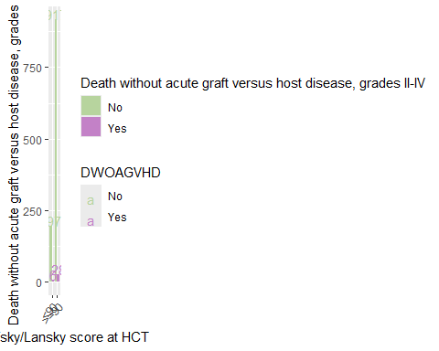

##   
## [[10]][[9]]

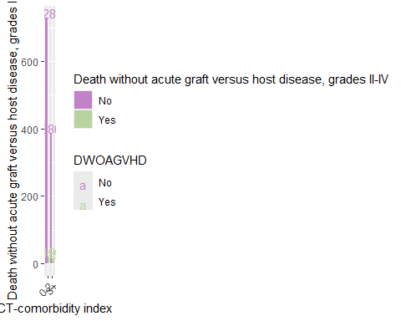

##   
##   
## [[11]]  
## [[11]][[1]]

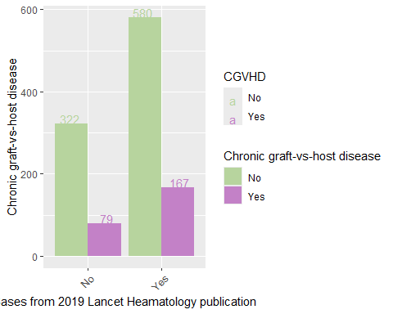

##   
## [[11]][[2]]

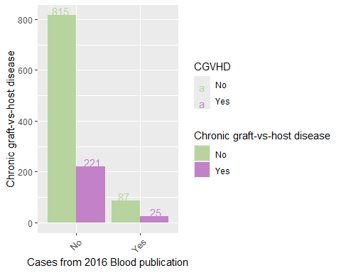

##   
## [[11]][[3]]

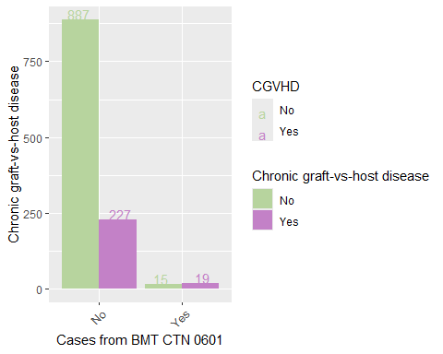

##   
## [[11]][[4]]

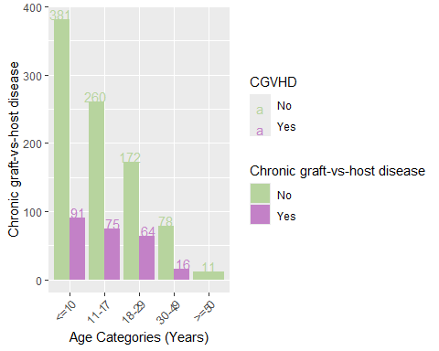

##   
## [[11]][[5]]

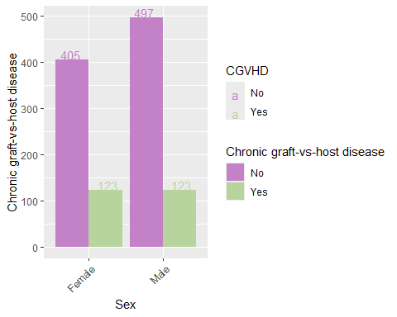

##   
## [[11]][[6]]

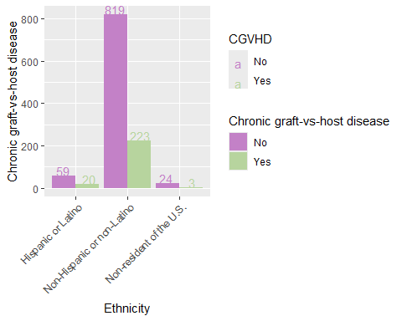

##   
## [[11]][[7]]

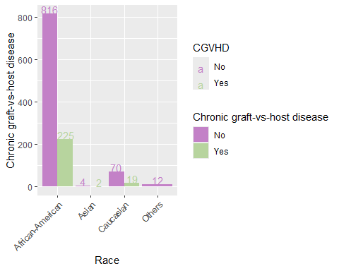

##   
## [[11]][[8]]

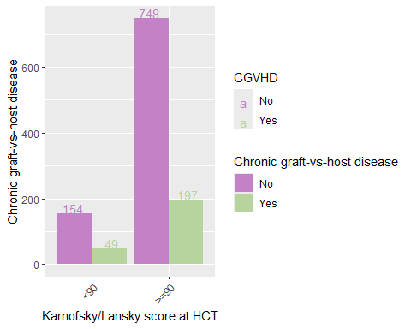

##   
## [[11]][[9]]

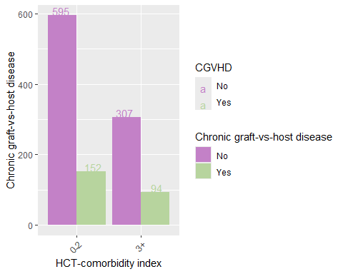

##   
##   
## [[12]]  
## [[12]][[1]]

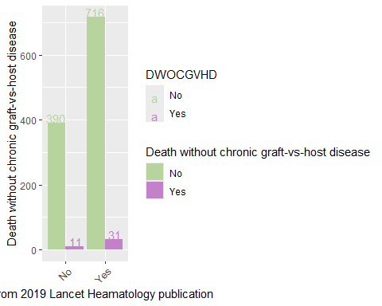

##   
## [[12]][[2]]

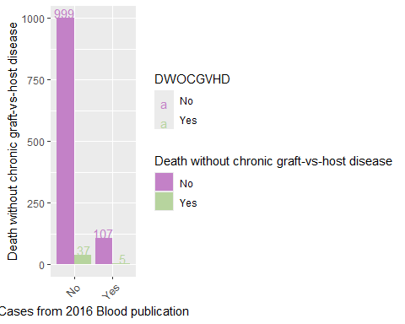

##   
## [[12]][[3]]

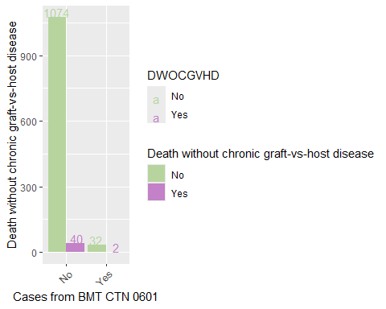

##   
## [[12]][[4]]

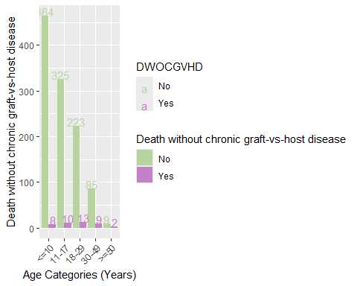

##   
## [[12]][[5]]

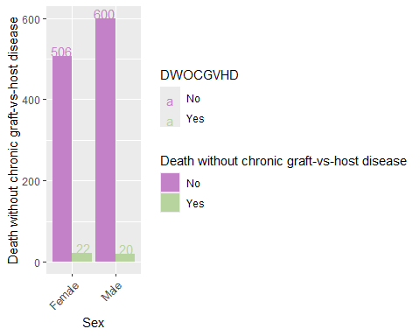

##   
## [[12]][[6]]

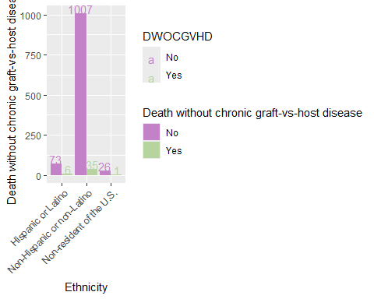

##   
## [[12]][[7]]

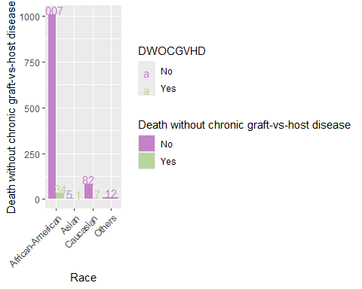

##   
## [[12]][[8]]

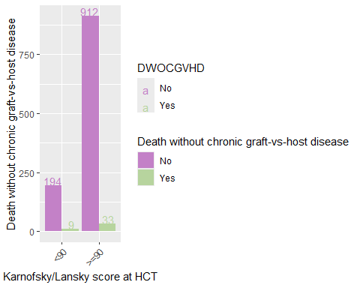

##   
## [[12]][[9]]

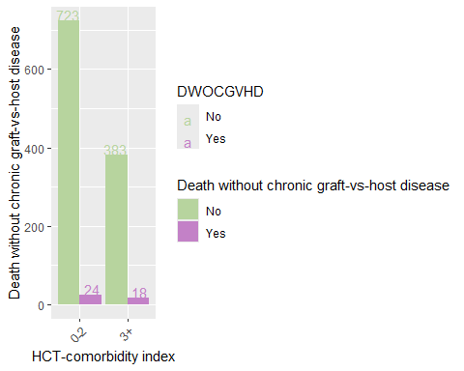

##   
##   
## [[13]]  
## [[13]][[1]]

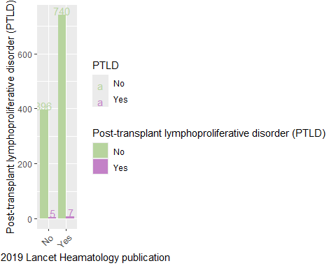

##   
## [[13]][[2]]

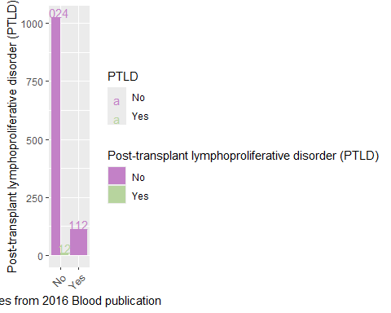

##   
## [[13]][[3]]

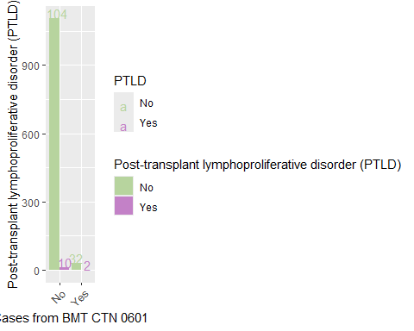

##   
## [[13]][[4]]

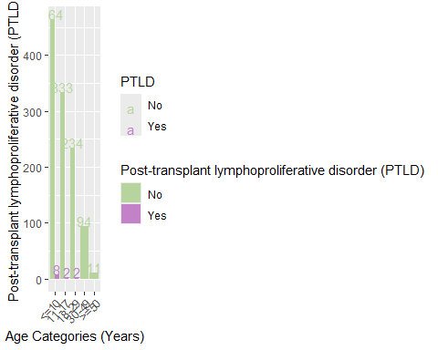

##   
## [[13]][[5]]

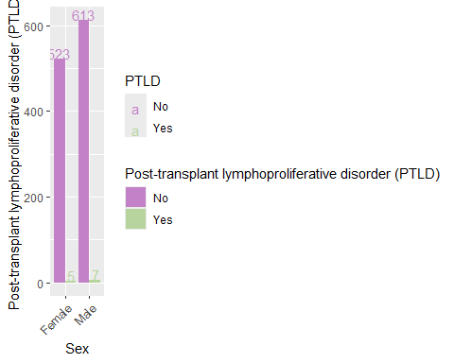

##   
## [[13]][[6]]

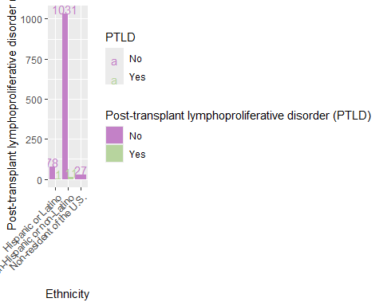

##   
## [[13]][[7]]

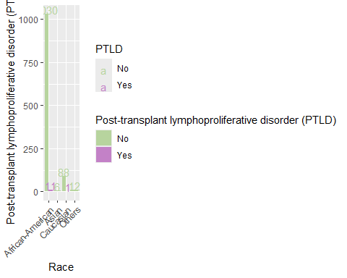

##   
## [[13]][[8]]

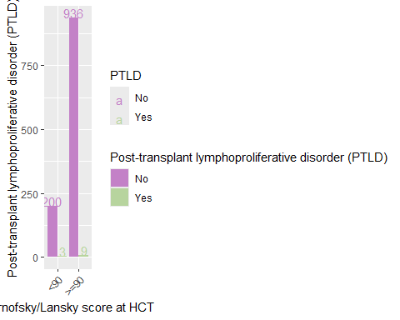

##   
## [[13]][[9]]

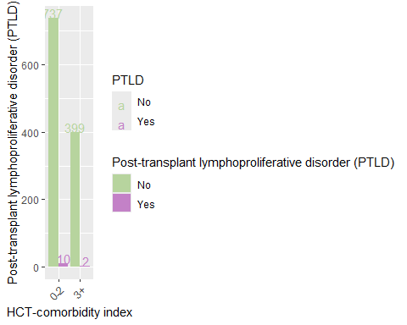

##   
##   
## [[14]]  
## [[14]][[1]]

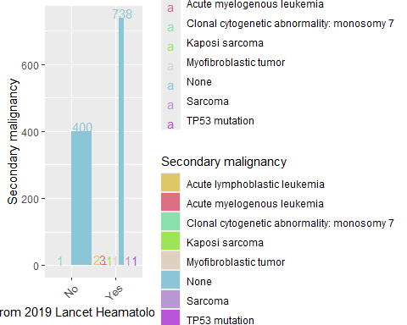

##   
## [[14]][[2]]

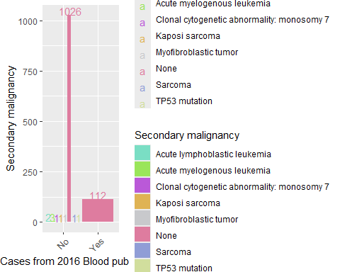

##   
## [[14]][[3]]

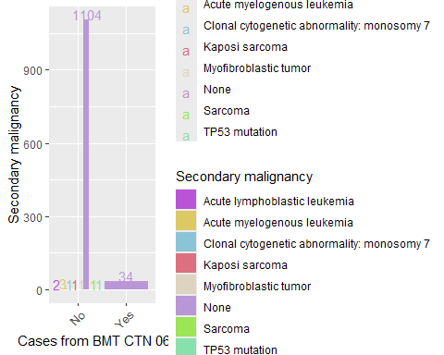

##   
## [[14]][[4]]

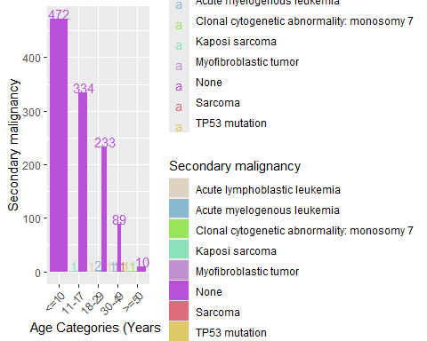

##   
## [[14]][[5]]

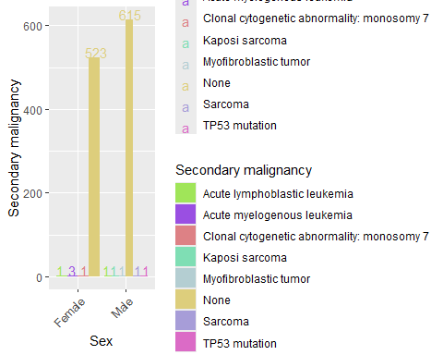

##   
## [[14]][[6]]

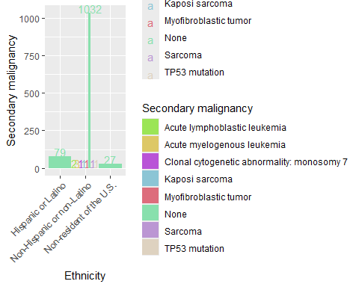

##   
## [[14]][[7]]

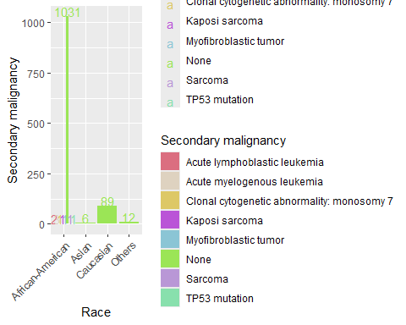

##   
## [[14]][[8]]

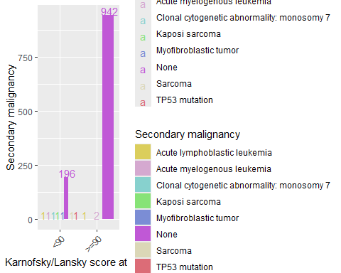

##   
## [[14]][[9]]

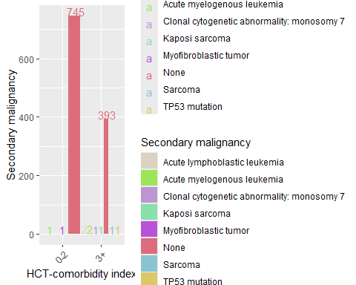

cat_plot(outcome_df, cat_transp_df, naming_vec)

## [[1]]  
## [[1]][[1]]

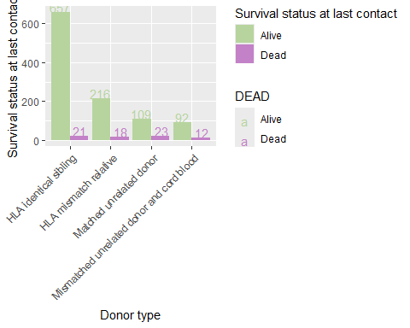

##   
## [[1]][[2]]

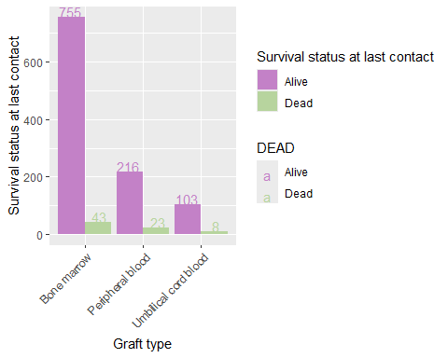

##   
## [[1]][[3]]

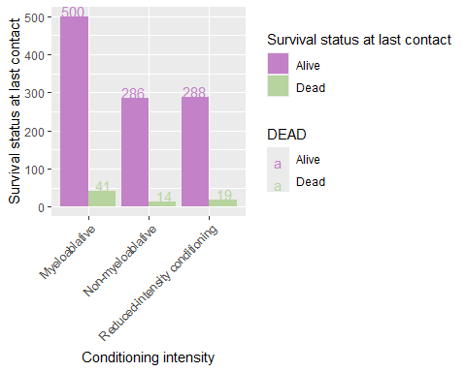

##   
## [[1]][[4]]

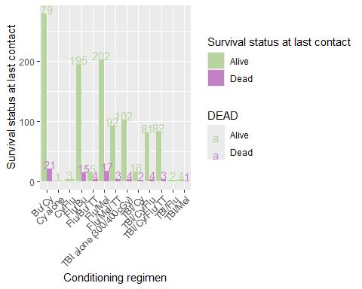

##   
## [[1]][[5]]

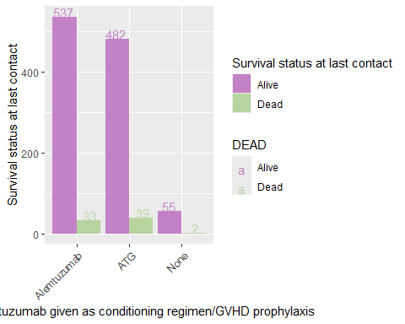

##   
## [[1]][[6]]

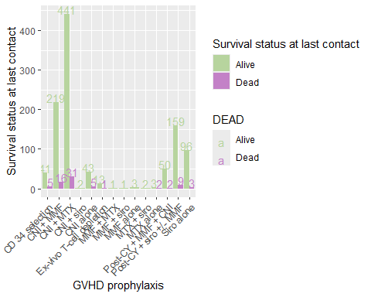

##   
## [[1]][[7]]

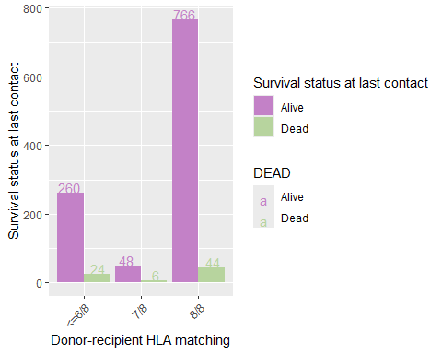

##   
## [[1]][[8]]

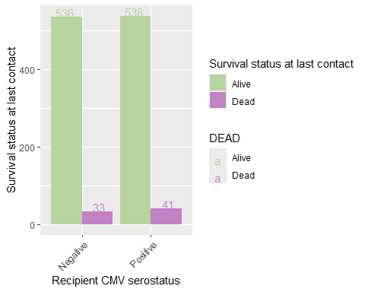

##   
## [[1]][[9]]

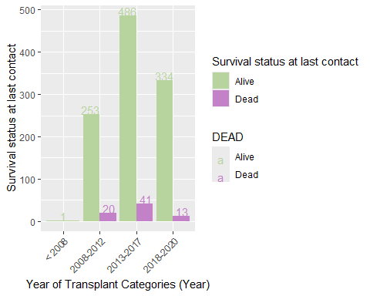

##   
## [[1]][[10]]

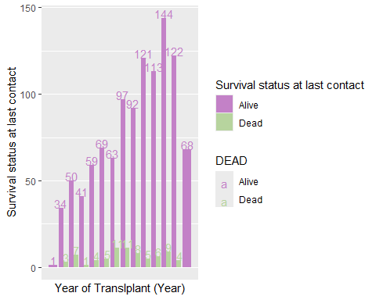

##   
##   
## [[2]]  
## [[2]][[1]]

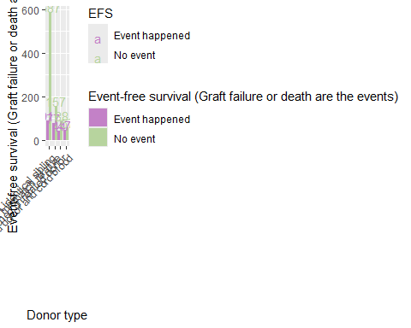

##   
## [[2]][[2]]

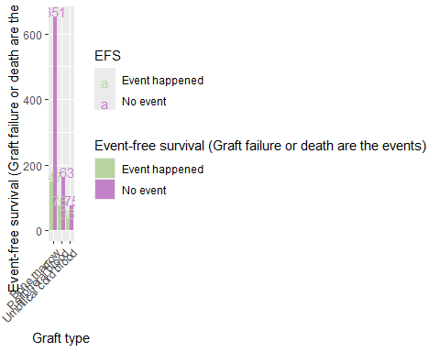

##   
## [[2]][[3]]

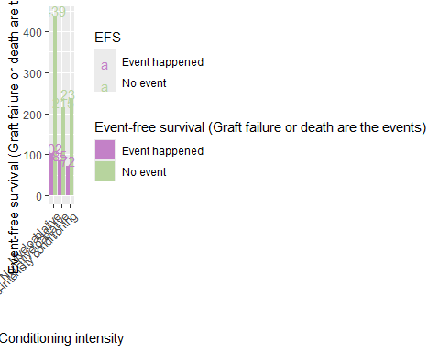

##   
## [[2]][[4]]

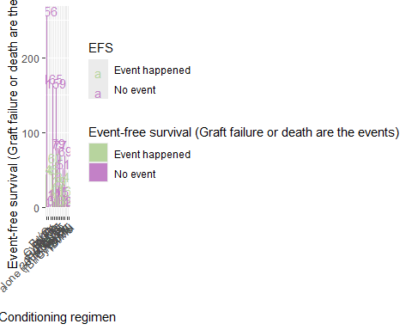

##   
## [[2]][[5]]

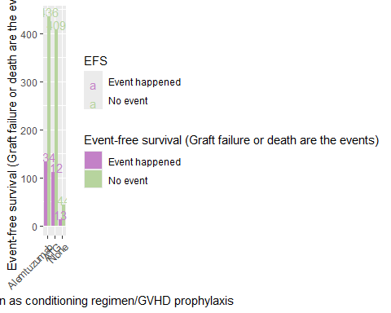

##   
## [[2]][[6]]

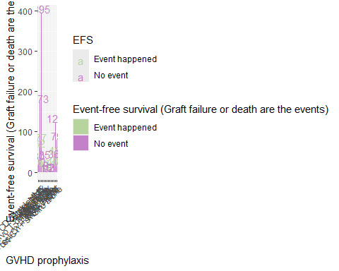

##   
## [[2]][[7]]

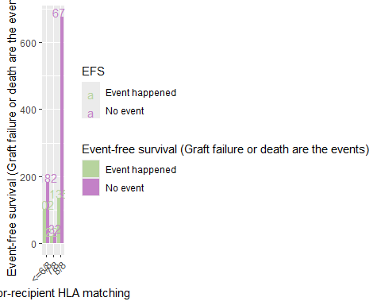

##   
## [[2]][[8]]

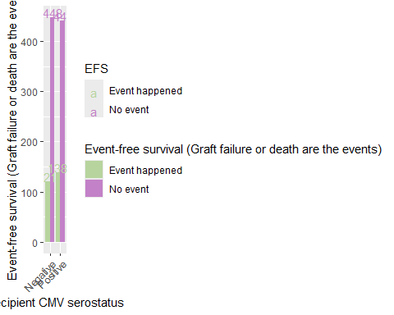

##   
## [[2]][[9]]

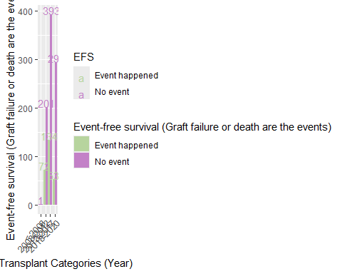

##   
## [[2]][[10]]

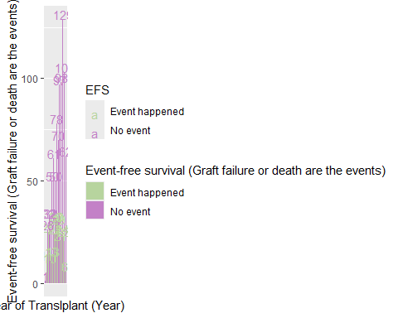

##   
##   
## [[3]]  
## [[3]][[1]]

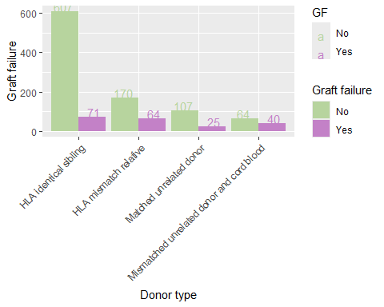

##   
## [[3]][[2]]

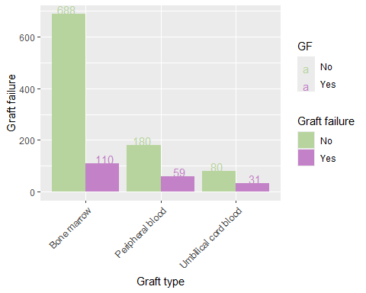

##   
## [[3]][[3]]

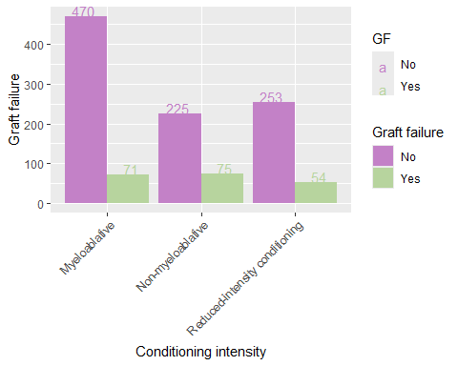

##   
## [[3]][[4]]

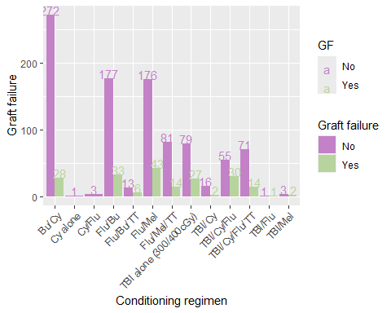

##   
## [[3]][[5]]

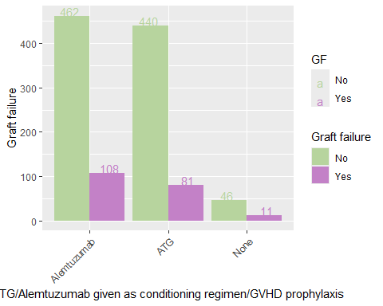

##   
## [[3]][[6]]

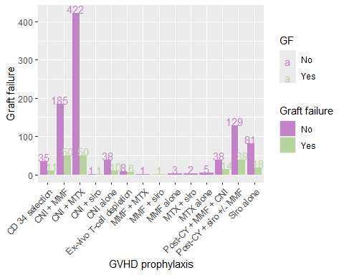

##   
## [[3]][[7]]

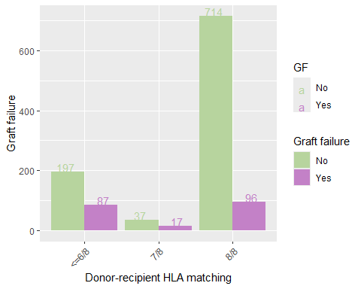

##   
## [[3]][[8]]

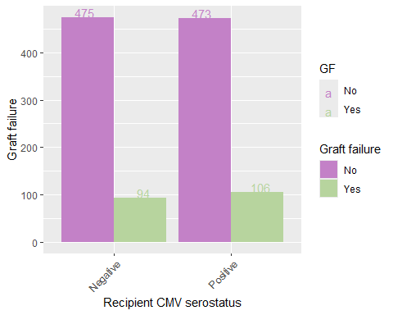

##   
## [[3]][[9]]

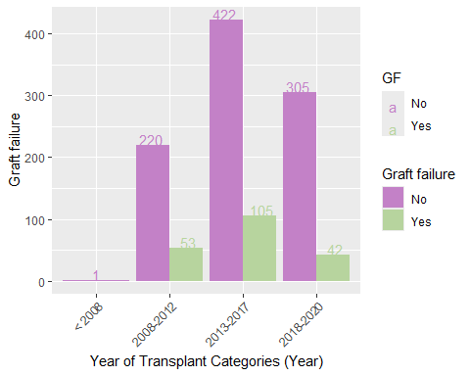

##   
## [[3]][[10]]

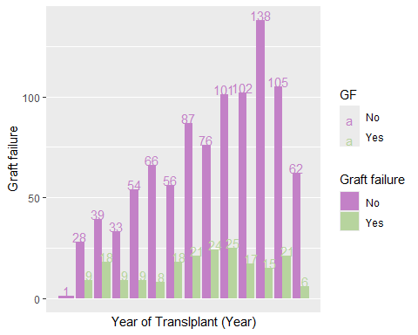

##   
##   
## [[4]]  
## [[4]][[1]]

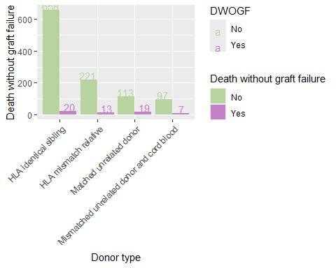

##   
## [[4]][[2]]

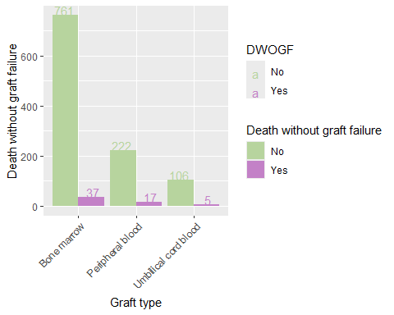

##   
## [[4]][[3]]

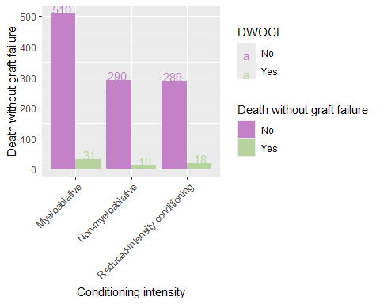

##   
## [[4]][[4]]

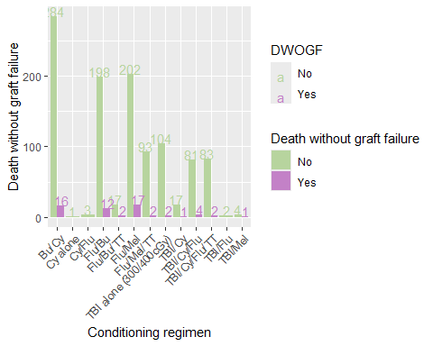

##   
## [[4]][[5]]

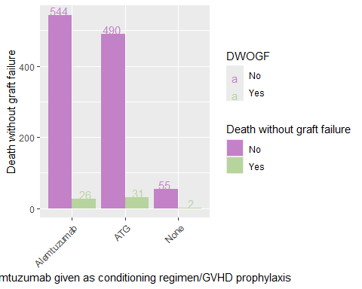

##   
## [[4]][[6]]

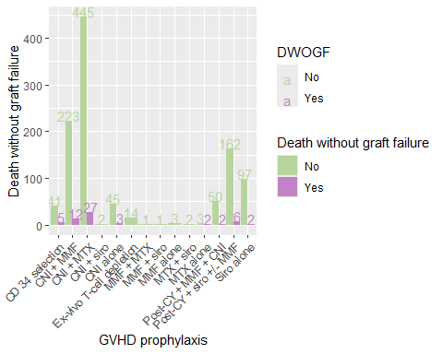

##   
## [[4]][[7]]

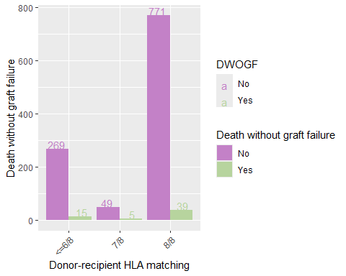

##   
## [[4]][[8]]

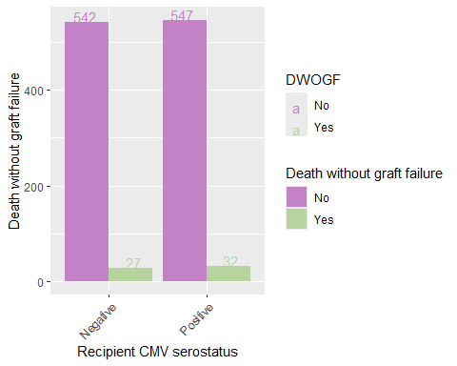

##   
## [[4]][[9]]

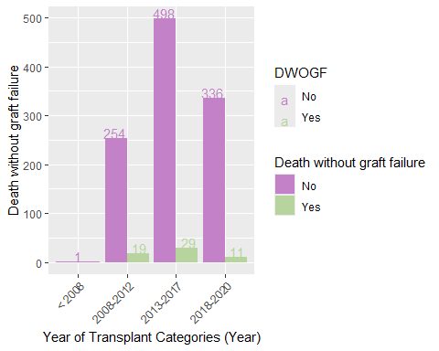

##   
## [[4]][[10]]

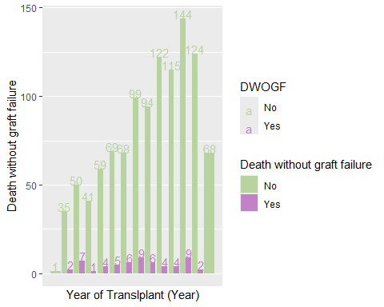

##   
##   
## [[5]]  
## [[5]][[1]]

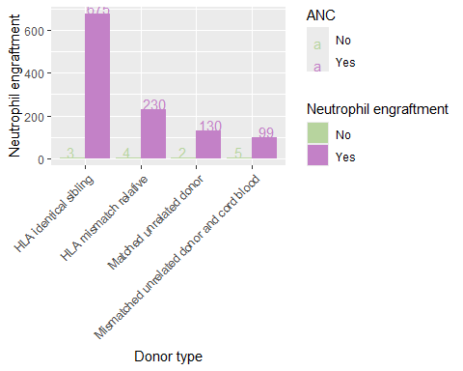

##   
## [[5]][[2]]

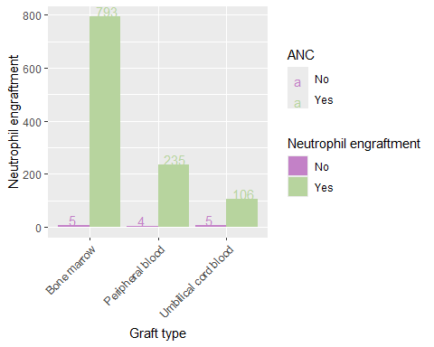

##   
## [[5]][[3]]

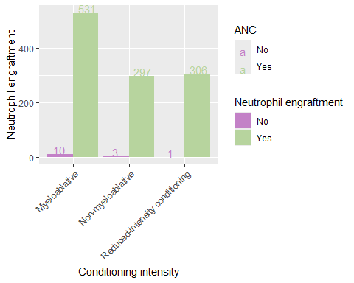

##   
## [[5]][[4]]

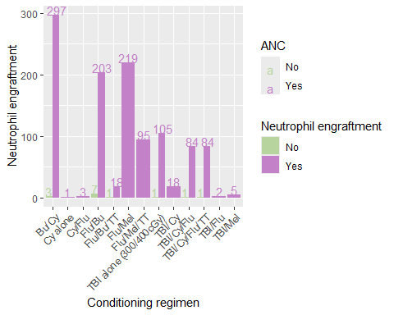

##   
## [[5]][[5]]

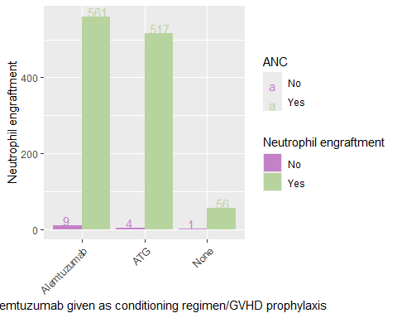

##   
## [[5]][[6]]

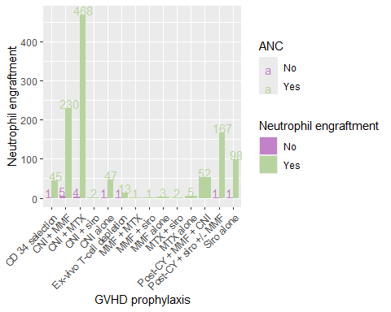

##   
## [[5]][[7]]

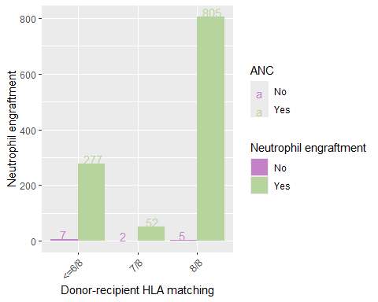

##   
## [[5]][[8]]

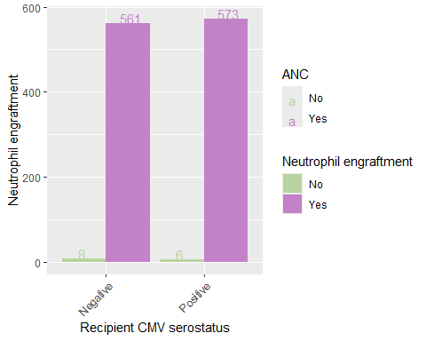

##   
## [[5]][[9]]

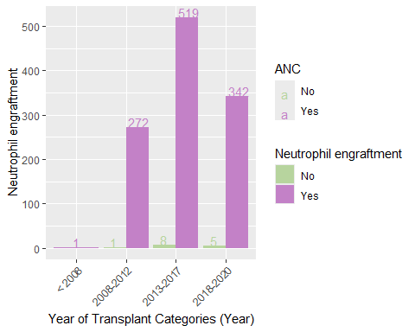

##   
## [[5]][[10]]

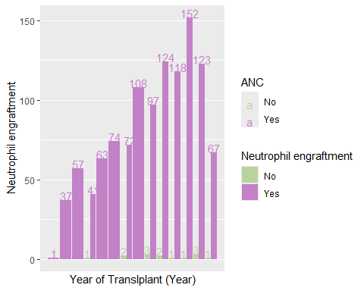

##   
##   
## [[6]]  
## [[6]][[1]]

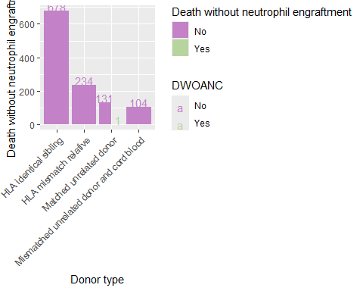

##   
## [[6]][[2]]

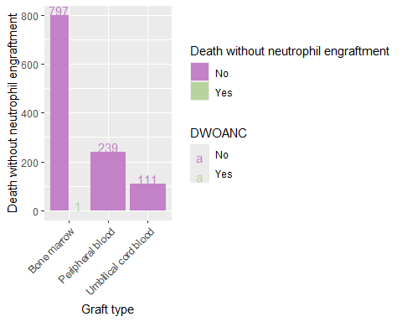

##   
## [[6]][[3]]

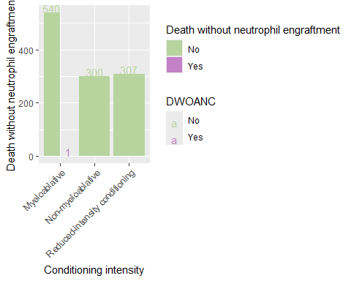

##   
## [[6]][[4]]

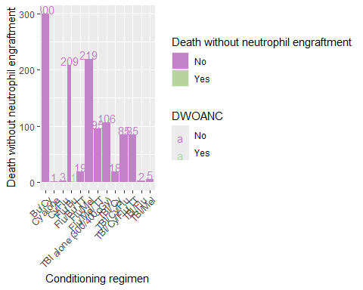

##   
## [[6]][[5]]

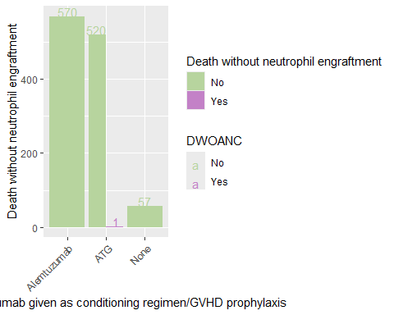

##   
## [[6]][[6]]

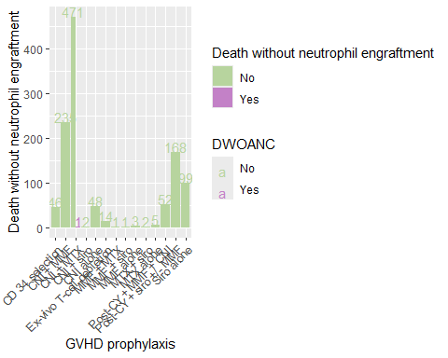

##   
## [[6]][[7]]

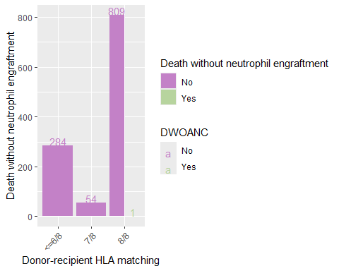

##   
## [[6]][[8]]

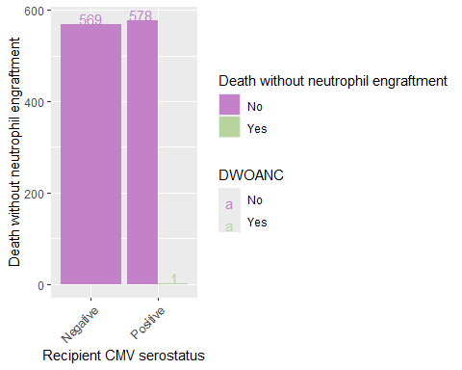

##   
## [[6]][[9]]

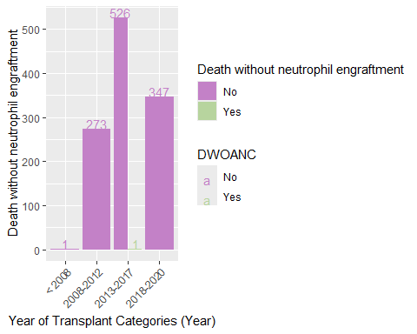

##   
## [[6]][[10]]

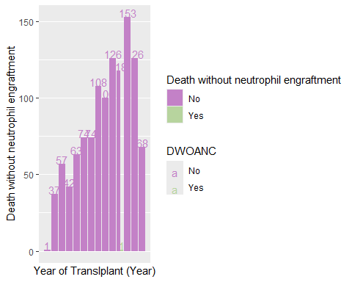

##   
##   
## [[7]]  
## [[7]][[1]]

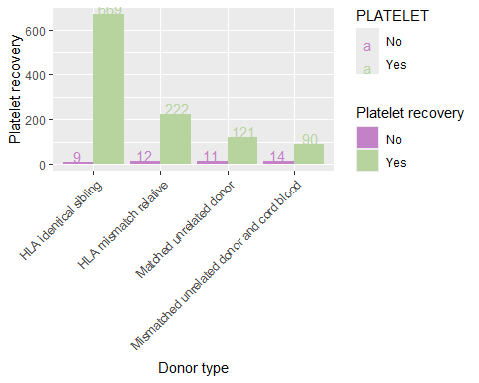

##   
## [[7]][[2]]

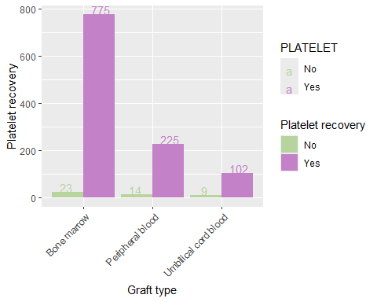

##   
## [[7]][[3]]

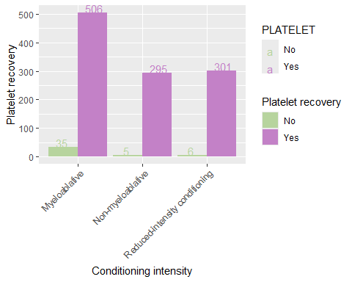

##   
## [[7]][[4]]

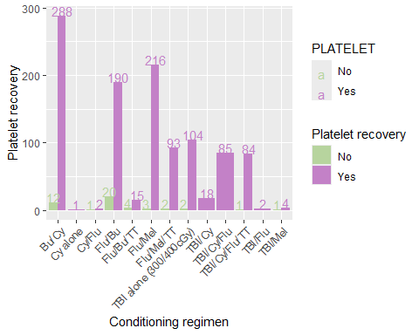

##   
## [[7]][[5]]

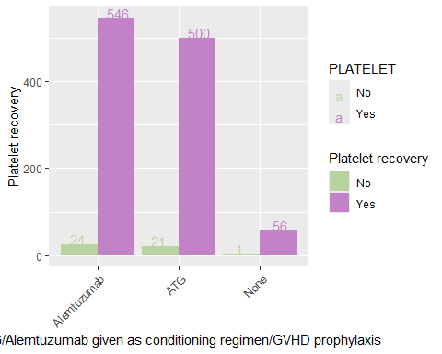

##   
## [[7]][[6]]

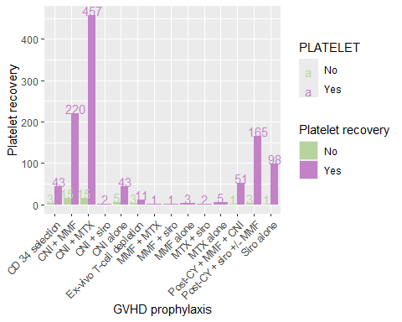

##   
## [[7]][[7]]

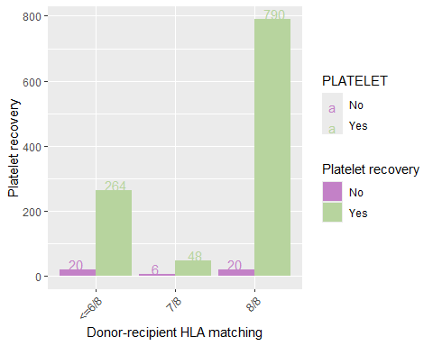

##   
## [[7]][[8]]

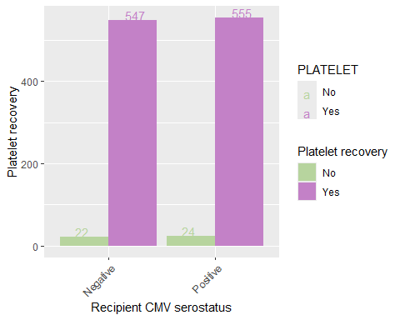

##   
## [[7]][[9]]

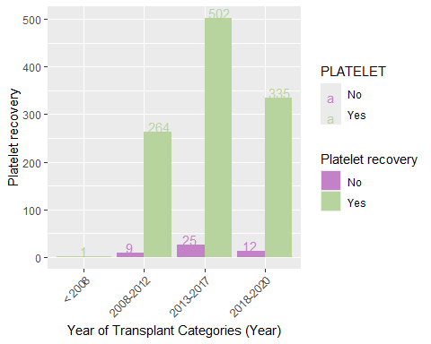

##   
## [[7]][[10]]

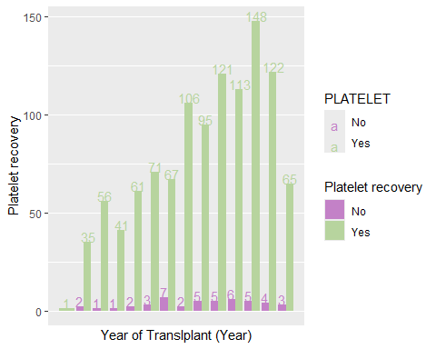

##   
##   
## [[8]]  
## [[8]][[1]]

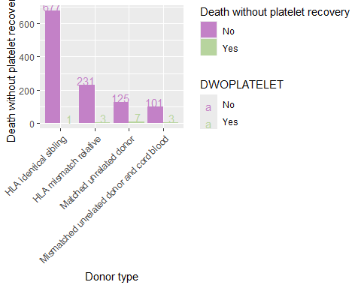

##   
## [[8]][[2]]

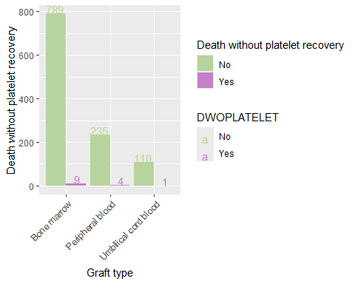

##   
## [[8]][[3]]

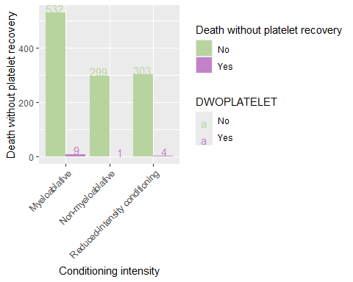

##   
## [[8]][[4]]

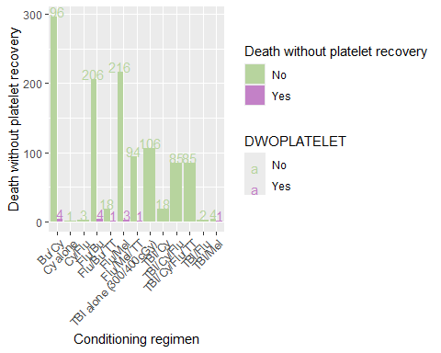

##   
## [[8]][[5]]

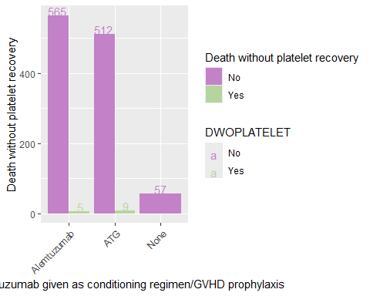

##   
## [[8]][[6]]

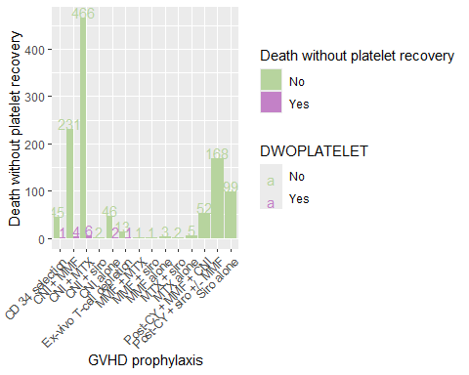

##   
## [[8]][[7]]

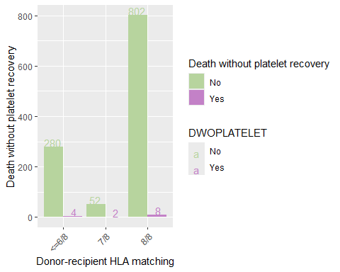

##   
## [[8]][[8]]

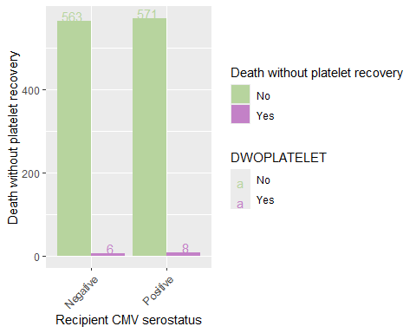

##   
## [[8]][[9]]

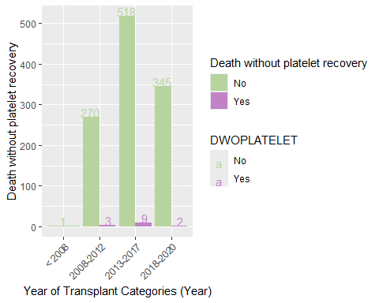

##   
## [[8]][[10]]

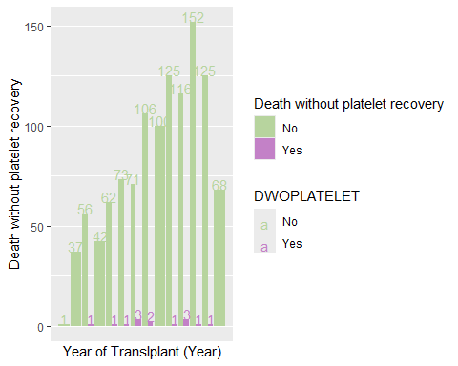

##   
##   
## [[9]]  
## [[9]][[1]]

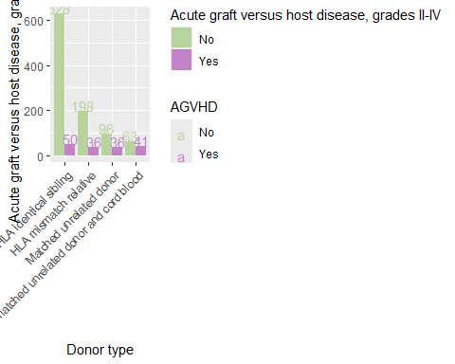

##   
## [[9]][[2]]

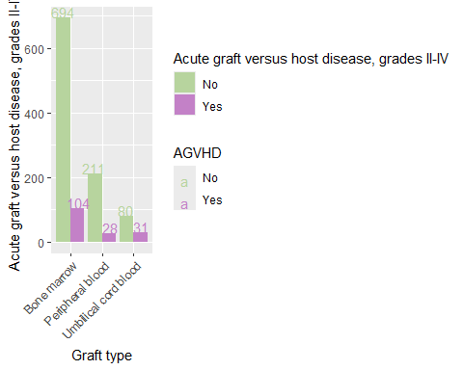

##   
## [[9]][[3]]

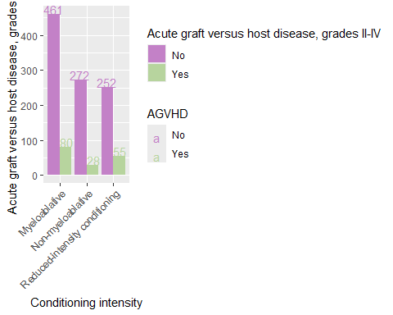

##   
## [[9]][[4]]

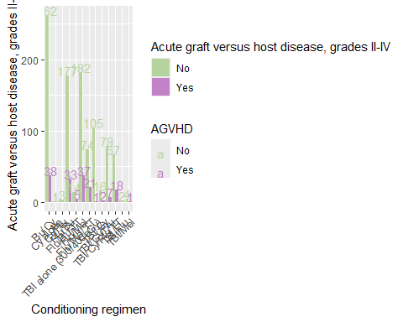

##   
## [[9]][[5]]

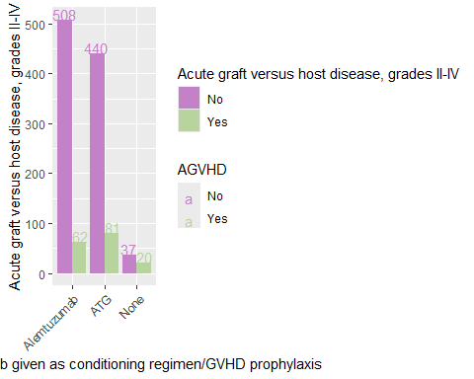

##   
## [[9]][[6]]

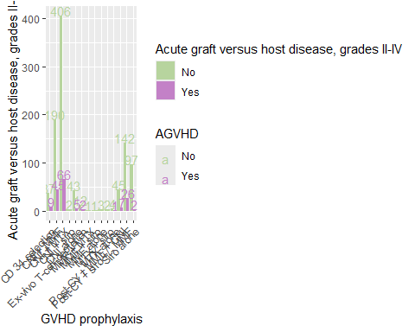

##   
## [[9]][[7]]

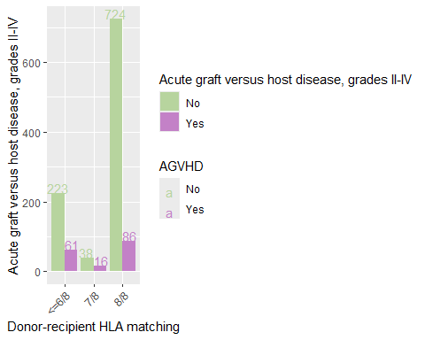

##   
## [[9]][[8]]

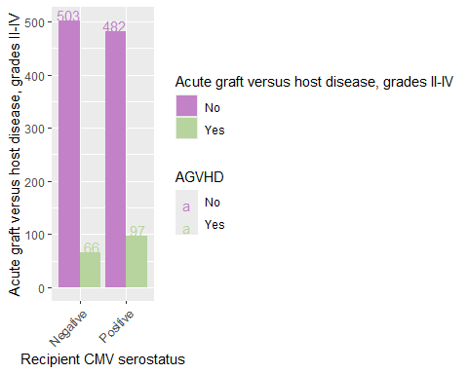

##   
## [[9]][[9]]

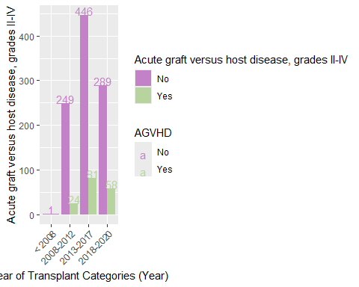

##   
## [[9]][[10]]

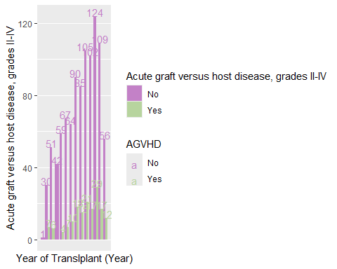

##   
##   
## [[10]]  
## [[10]][[1]]

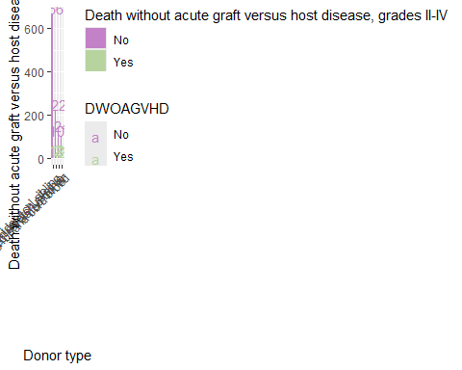

##   
## [[10]][[2]]

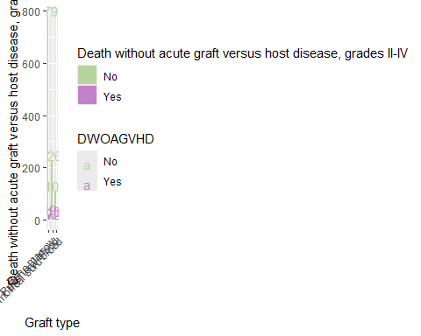

##   
## [[10]][[3]]

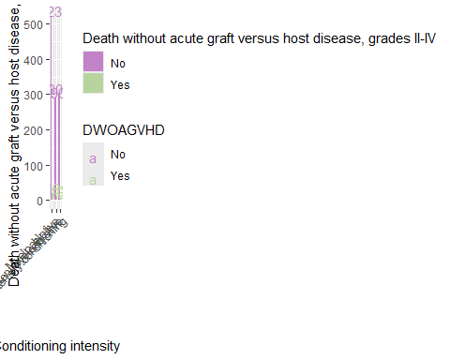

##   
## [[10]][[4]]

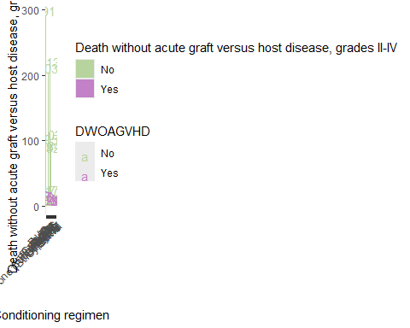

##   
## [[10]][[5]]

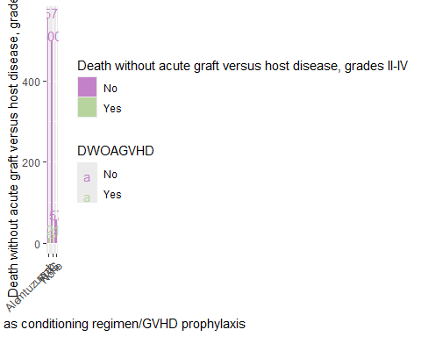

##   
## [[10]][[6]]

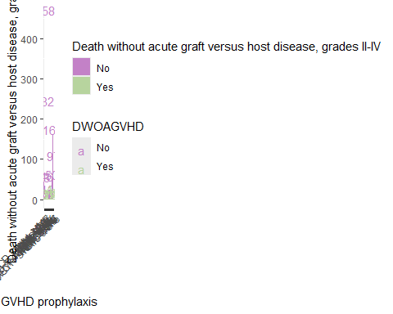

##   
## [[10]][[7]]

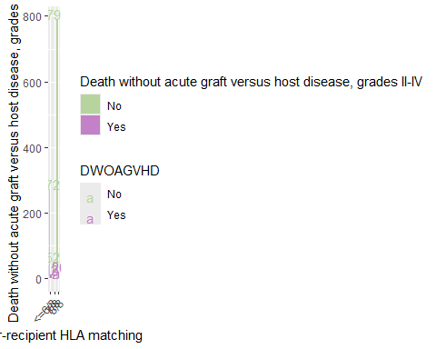

##   
## [[10]][[8]]

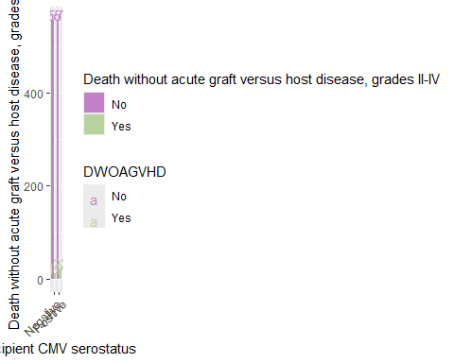

##   
## [[10]][[9]]

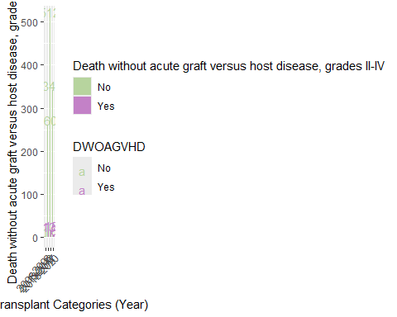

##   
## [[10]][[10]]

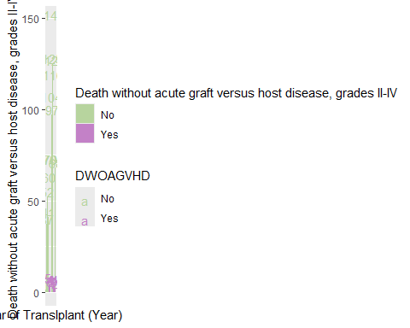

##   
##   
## [[11]]  
## [[11]][[1]]

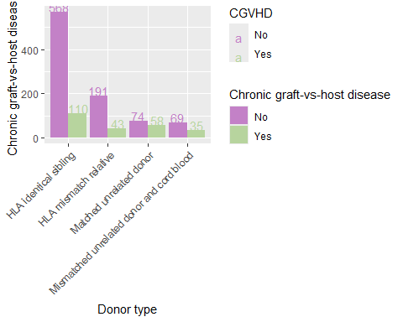

##   
## [[11]][[2]]

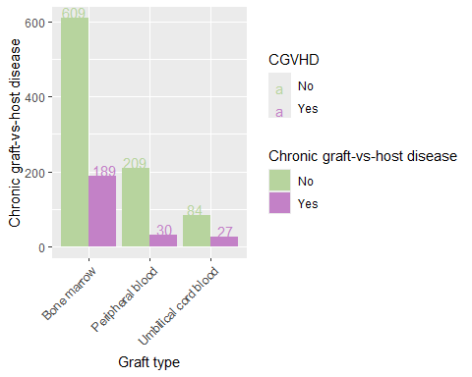

##   
## [[11]][[3]]

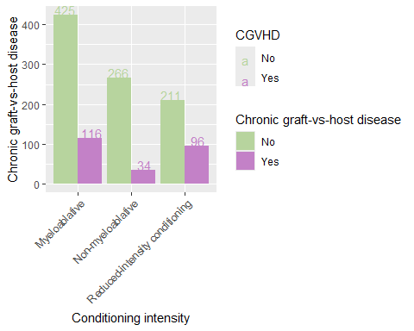

##   
## [[11]][[4]]

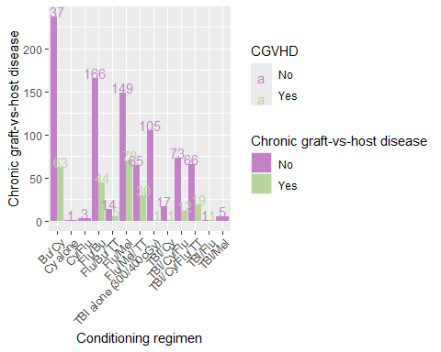

##   
## [[11]][[5]]

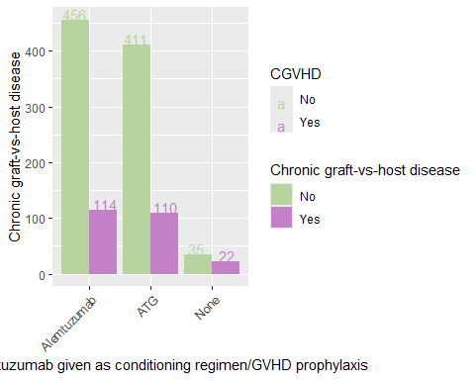

##   
## [[11]][[6]]

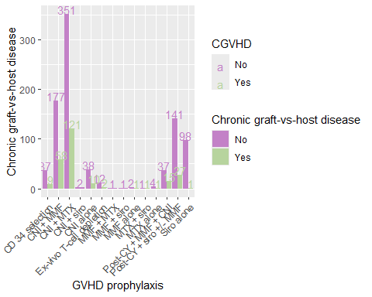

##   
## [[11]][[7]]

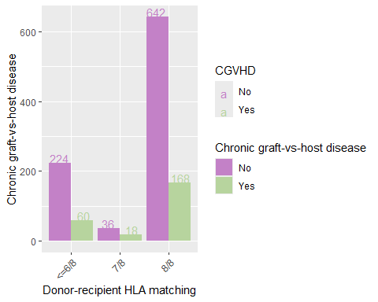

##   
## [[11]][[8]]

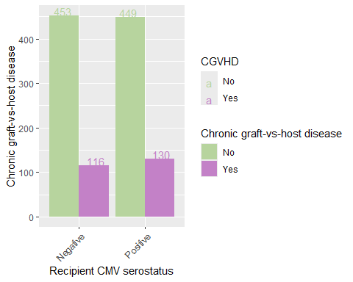

##   
## [[11]][[9]]

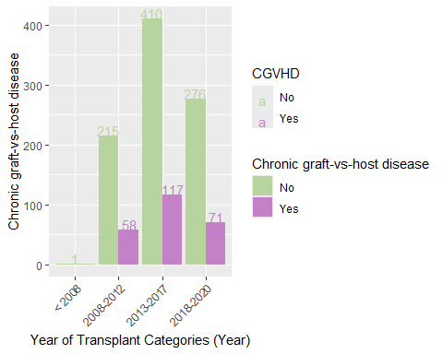

##   
## [[11]][[10]]

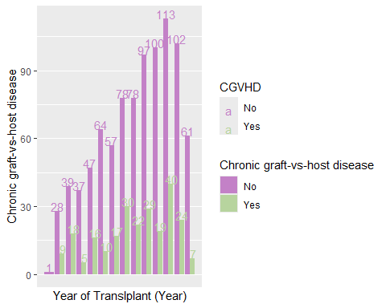

##   
##   
## [[12]]  
## [[12]][[1]]

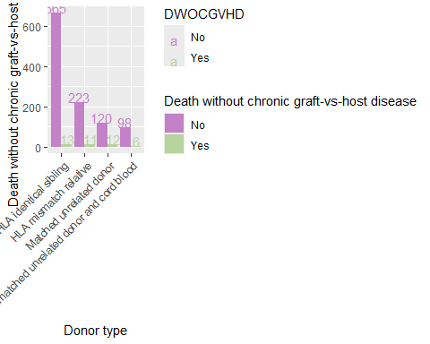

##   
## [[12]][[2]]

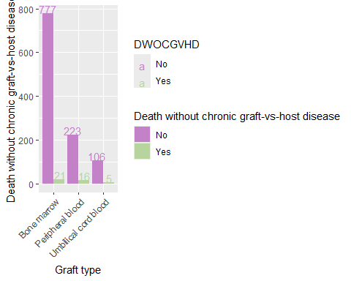

##   
## [[12]][[3]]

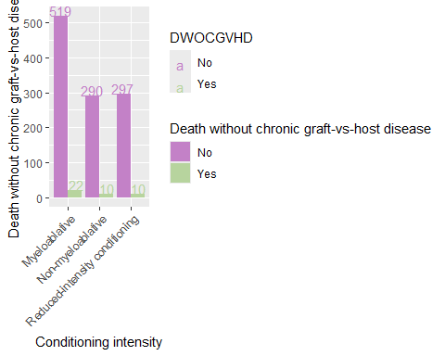

##   
## [[12]][[4]]

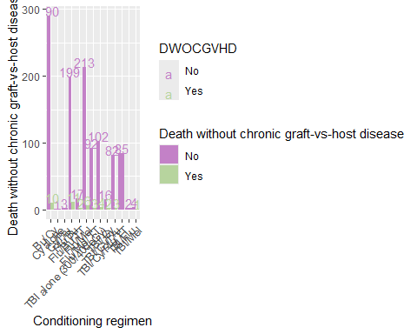

##   
## [[12]][[5]]

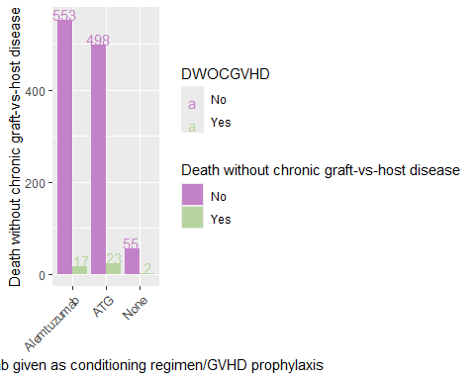

##   
## [[12]][[6]]

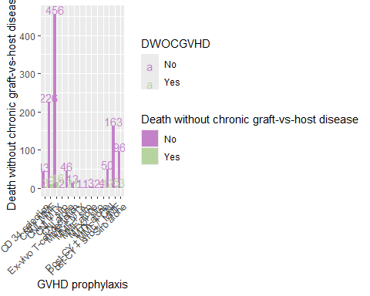

##   
## [[12]][[7]]

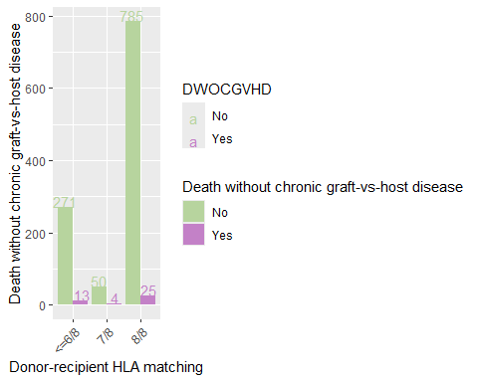

##   
## [[12]][[8]]

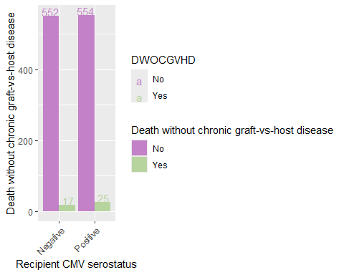

##   
## [[12]][[9]]

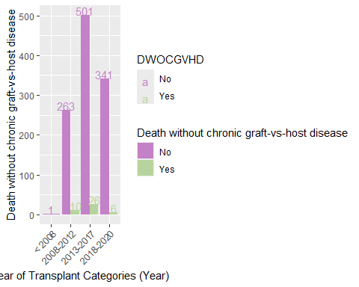

##   
## [[12]][[10]]

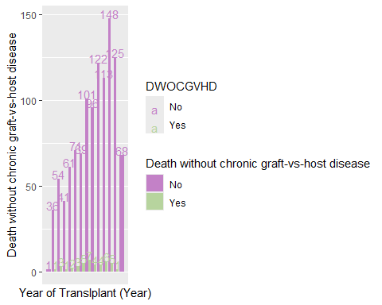

##   
##   
## [[13]]  
## [[13]][[1]]

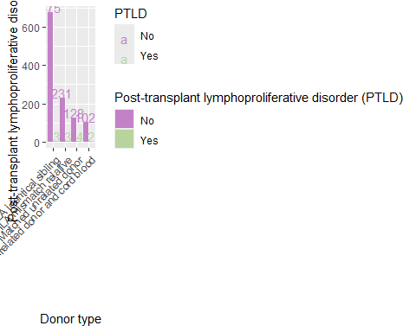

##   
## [[13]][[2]]

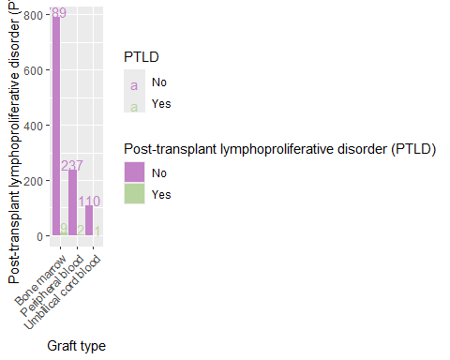

##   
## [[13]][[3]]

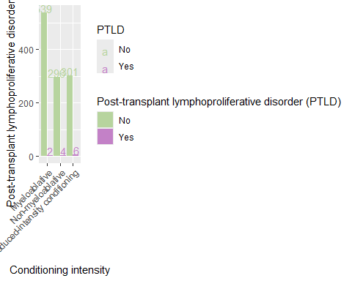

##   
## [[13]][[4]]

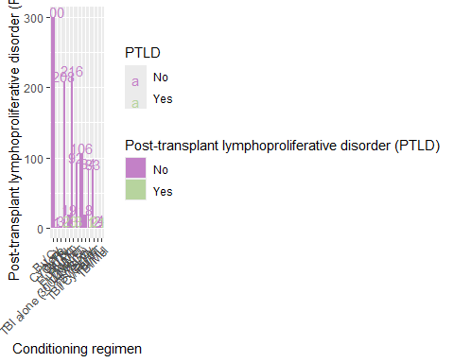

##   
## [[13]][[5]]

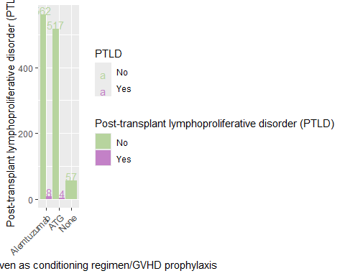

##   
## [[13]][[6]]

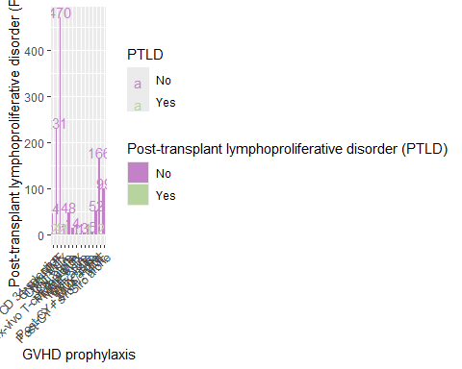

##   
## [[13]][[7]]

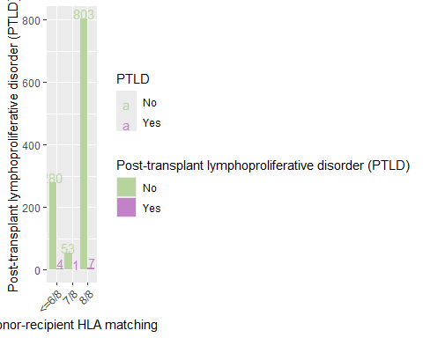

##   
## [[13]][[8]]

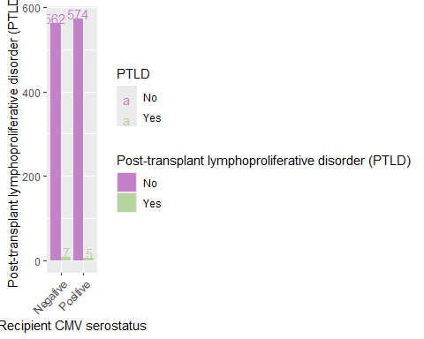

##   
## [[13]][[9]]

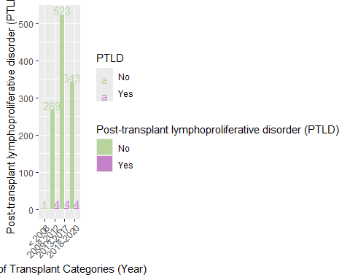

##   
## [[13]][[10]]

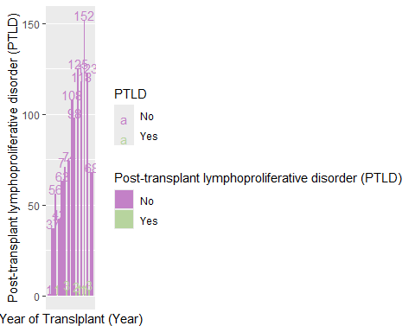

##   
##   
## [[14]]  
## [[14]][[1]]

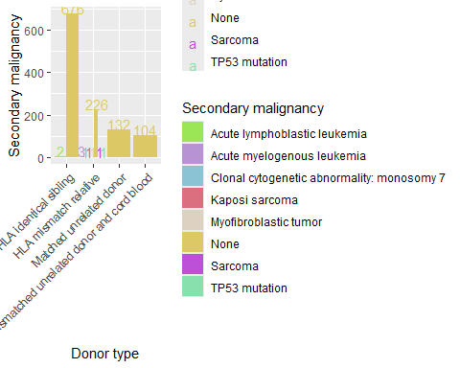

##   
## [[14]][[2]]

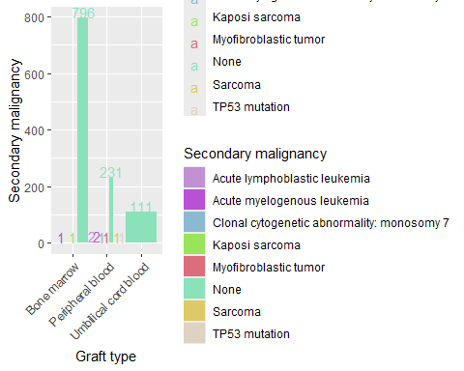

##   
## [[14]][[3]]

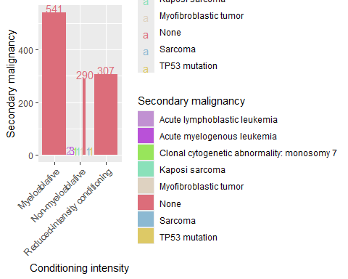

##   
## [[14]][[4]]

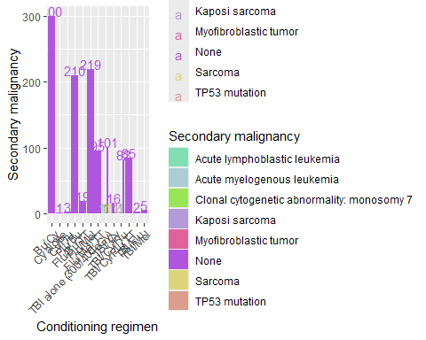

##   
## [[14]][[5]]

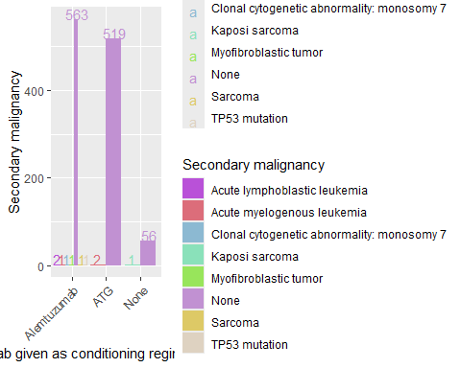

##   
## [[14]][[6]]

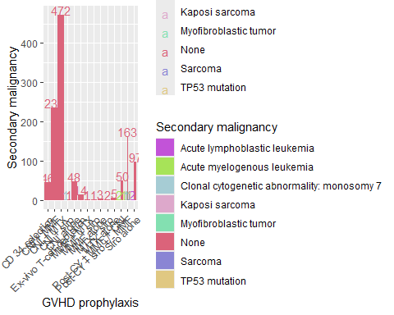

##   
## [[14]][[7]]

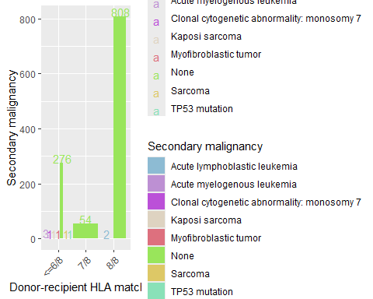

##   
## [[14]][[8]]

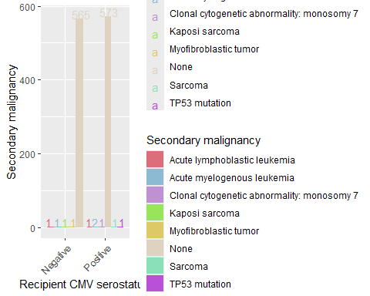

##   
## [[14]][[9]]

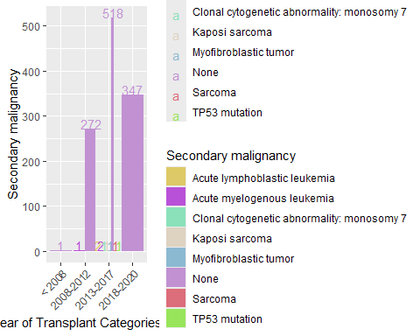

##   
## [[14]][[10]]

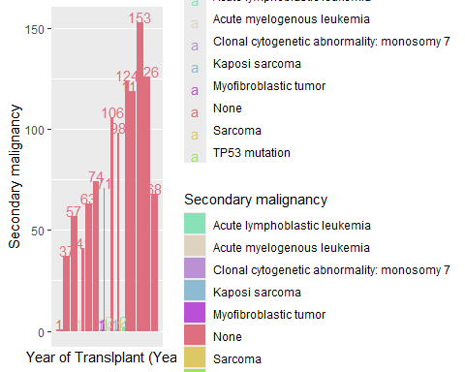

num_disease_df <- pred_disease_df %>%  
 select(where(~ is.numeric(.)))  
   
num_patient_df <- pred_patient_df %>%  
 select(where(~ is.numeric(.)),   
 -DUMMYID)  
  
num_transp_df <- pred_transp_df %>%  
 select(where(~ is.numeric(.)),   
 -YEARTX) #YEARTX should be seen as categorical  
  
  
num_df <- cbind(outcome_df,   
 num_patient_df)  
  
  
lapply(colnames(outcome_df), function(out_i){  
 dt <- num_df[ , c(out_i, "AGE")]  
  
 ret1 <- dt |>  
 group_by(!!sym(out_i))|>  
 summarize(Total_num = n(),  
 Avg_age = mean(AGE),   
 Med_age = median(AGE))  
  
   
 ret2 <- ggplot(dt) +   
 geom_density(aes(x = AGE, fill = !!sym(out_i)),   
 alpha = 0.3)   
   
 list(ret1, ret2)  
})

## [[1]]  
## [[1]][[1]]  
## # A tibble: 2 × 4  
## DEAD Total_num Avg_age Med_age  
## <chr> <int> <dbl> <dbl>  
## 1 Alive 1074 14.2 12  
## 2 Dead 74 18.8 17  
##   
## [[1]][[2]]

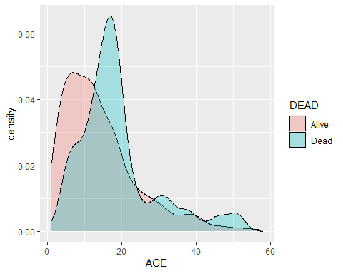

##   
##   
## [[2]]  
## [[2]][[1]]  
## # A tibble: 2 × 4  
## EFS Total_num Avg_age Med_age  
## <chr> <int> <dbl> <dbl>  
## 1 Event happened 259 16.7 15  
## 2 No event 889 13.9 12  
##   
## [[2]][[2]]

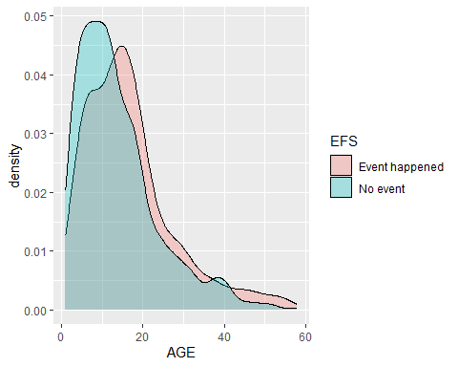

##   
##   
## [[3]]  
## [[3]][[1]]  
## # A tibble: 2 × 4  
## GF Total_num Avg_age Med_age  
## <chr> <int> <dbl> <dbl>  
## 1 No 948 14.1 12  
## 2 Yes 200 16.4 14  
##   
## [[3]][[2]]

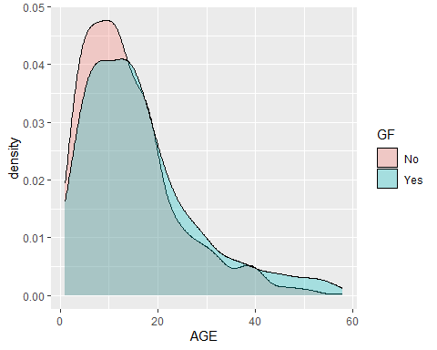

##   
##   
## [[4]]  
## [[4]][[1]]  
## # A tibble: 2 × 4  
## DWOGF Total_num Avg_age Med_age  
## <chr> <int> <dbl> <dbl>  
## 1 No 1089 14.4 12  
## 2 Yes 59 17.7 17  
##   
## [[4]][[2]]

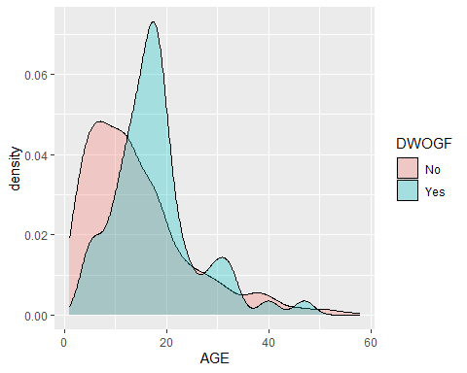

##   
##   
## [[5]]  
## [[5]][[1]]  
## # A tibble: 2 × 4  
## ANC Total_num Avg_age Med_age  
## <chr> <int> <dbl> <dbl>  
## 1 No 14 13.6 10  
## 2 Yes 1134 14.5 12  
##   
## [[5]][[2]]

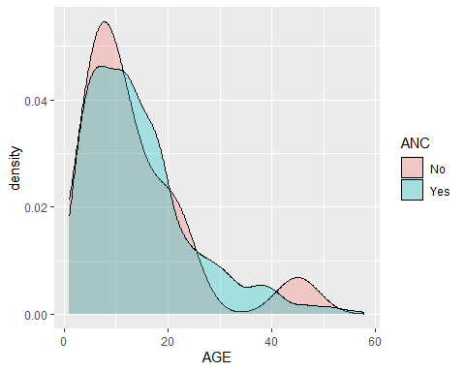

##   
##   
## [[6]]  
## [[6]][[1]]  
## # A tibble: 2 × 4  
## DWOANC Total_num Avg_age Med_age  
## <chr> <int> <dbl> <dbl>  
## 1 No 1147 14.5 12  
## 2 Yes 1 45 45  
##   
## [[6]][[2]]

## Warning: Groups with fewer than two data points have been dropped.

## Warning in max(ids, na.rm = TRUE): no non-missing arguments to max; returning  
## -Inf

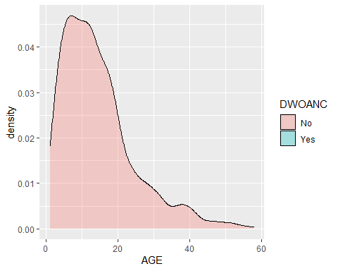

##   
##   
## [[7]]  
## [[7]][[1]]  
## # A tibble: 2 × 4  
## PLATELET Total_num Avg_age Med_age  
## <chr> <int> <dbl> <dbl>  
## 1 No 46 13.9 12  
## 2 Yes 1102 14.6 12  
##   
## [[7]][[2]]

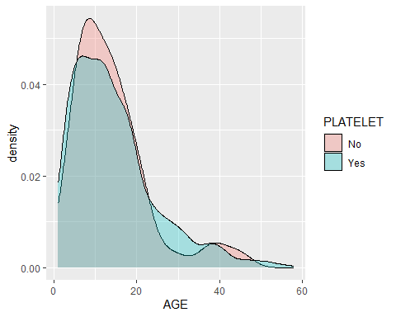

##   
##   
## [[8]]  
## [[8]][[1]]  
## # A tibble: 2 × 4  
## DWOPLATELET Total_num Avg_age Med_age  
## <chr> <int> <dbl> <dbl>  
## 1 No 1134 14.5 12  
## 2 Yes 14 19.7 17  
##   
## [[8]][[2]]

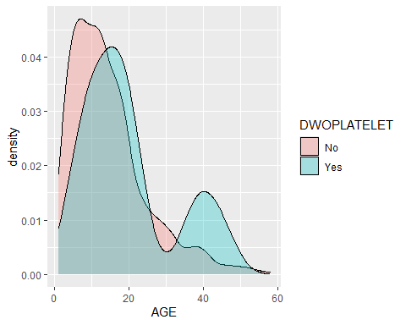

##   
##   
## [[9]]  
## [[9]][[1]]  
## # A tibble: 2 × 4  
## AGVHD Total_num Avg_age Med_age  
## <chr> <int> <dbl> <dbl>  
## 1 No 985 14.4 12  
## 2 Yes 163 15.5 13  
##   
## [[9]][[2]]

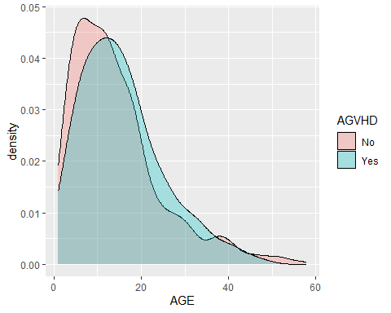

##   
##   
## [[10]]  
## [[10]][[1]]  
## # A tibble: 2 × 4  
## DWOAGVHD Total_num Avg_age Med_age  
## <chr> <int> <dbl> <dbl>  
## 1 No 1114 14.3 12  
## 2 Yes 34 22.1 19  
##   
## [[10]][[2]]

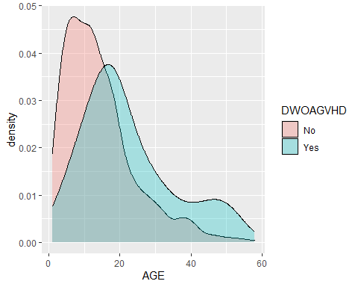

##   
##   
## [[11]]  
## [[11]][[1]]  
## # A tibble: 2 × 4  
## CGVHD Total_num Avg_age Med_age  
## <chr> <int> <dbl> <dbl>  
## 1 No 902 14.5 12  
## 2 Yes 246 14.8 13  
##   
## [[11]][[2]]

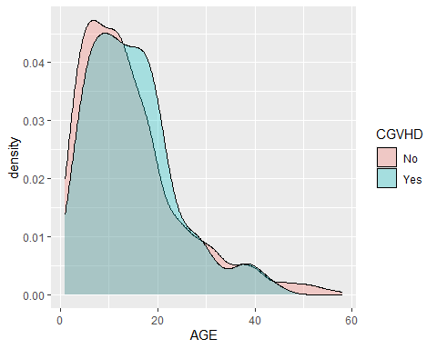

##   
##   
## [[12]]  
## [[12]][[1]]  
## # A tibble: 2 × 4  
## DWOCGVHD Total_num Avg_age Med_age  
## <chr> <int> <dbl> <dbl>  
## 1 No 1106 14.3 12   
## 2 Yes 42 21.2 18.5  
##   
## [[12]][[2]]

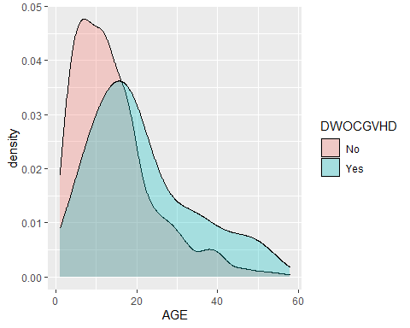

##   
##   
## [[13]]  
## [[13]][[1]]  
## # A tibble: 2 × 4  
## PTLD Total_num Avg_age Med_age  
## <chr> <int> <dbl> <dbl>  
## 1 No 1136 14.6 12.5  
## 2 Yes 12 10 9.5  
##   
## [[13]][[2]]

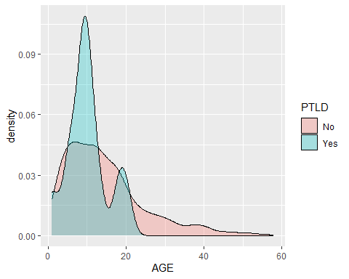

##   
##   
## [[14]]  
## [[14]][[1]]  
## # A tibble: 8 × 4  
## SCDMAL_FINAL Total_num Avg_age Med_age  
## <chr> <int> <dbl> <dbl>  
## 1 Acute lymphoblastic leukemia 2 29 29  
## 2 Acute myelogenous leukemia 3 23.3 20  
## 3 Clonal cytogenetic abnormality: monosomy 7 1 56 56  
## 4 Kaposi sarcoma 1 11 11  
## 5 Myofibroblastic tumor 1 37 37  
## 6 None 1138 14.4 12  
## 7 Sarcoma 1 42 42  
## 8 TP53 mutation 1 37 37  
##   
## [[14]][[2]]

## Warning: Groups with fewer than two data points have been dropped.

## Warning: Groups with fewer than two data points have been dropped.  
## Groups with fewer than two data points have been dropped.  
## Groups with fewer than two data points have been dropped.  
## Groups with fewer than two data points have been dropped.

## Warning in max(ids, na.rm = TRUE): no non-missing arguments to max; returning  
## -Inf  
  
## Warning in max(ids, na.rm = TRUE): no non-missing arguments to max; returning  
## -Inf  
  
## Warning in max(ids, na.rm = TRUE): no non-missing arguments to max; returning  
## -Inf  
  
## Warning in max(ids, na.rm = TRUE): no non-missing arguments to max; returning  
## -Inf  
  
## Warning in max(ids, na.rm = TRUE): no non-missing arguments to max; returning  
## -Inf

