**Cat Chaser**

1) UI Design

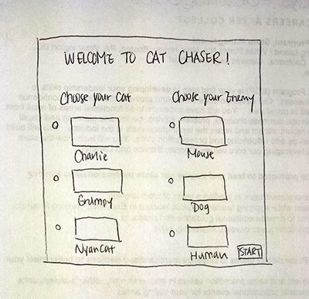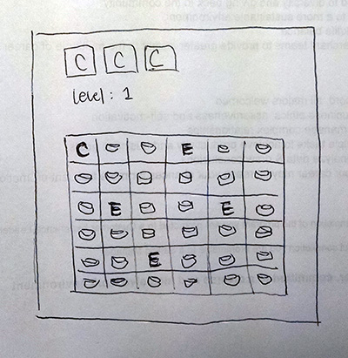

The main window interface will allow users to choose their Cat and Enemy characters, which will be radio buttons. The title and “Choose your…” texts will be QLabels, and at the right bottom there will be a push button for the user to start the game after selecting the characters.

2) Logic

The Cat Chaser game is a toned down version of Pac Man. The user can pick from 3 different cat characters as well as 3 different enemies for the game. The Cat will need to finish all the cat food that appears in the grid while avoiding the randomly moving enemy icons. If the Cat gets caught by one of the enemies, it loses a life. If the Cat is able to finish all the food without being caught by the enemies, the user gets to the next level. As the level progresses, the number and speed of the enemies increase.

Instead of C and E, I will replace those with the Cat and Enemy images.