**QUESTION 1**

a)

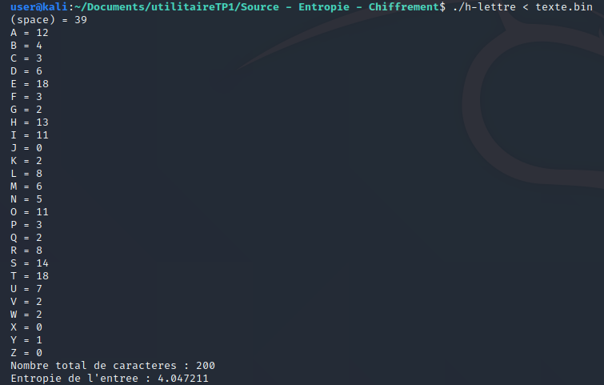

b)

c)

H(S) = Σ 1/27 log21/(1/27) = 27*1/76 * log10(27)/log102 = log10(27)/log102 = 4.75 bits

(on peut vérifier : 2 4.7 = 25.99)