Annika F & Abby V
5/24/2017
READ THE EVENTS 1
PRINT THE 5TH EVENT TO CHECK THE READING OF THE DATA 1
INITIALIZE SOME ARRAYS TO ZERO 2
DIAGNOSTICS 2
DiMuon INVARIANT MASS - LOOP OVER THE EVENTS 3
INVESTIGATE THE IMPACT OF IMPOSING MuQuality SELECTIONS CRITERIA (CUTS) 3
FOR EACH EVENT TRANSFORM TO THE REST FRAME OF THE DiMuon SYSTEM 4
TRANSFORM TO THE DiMuon REST FRAME - LOOP OVER THE EVENTS 4
Histograms 4
%DiMuon2017.m
%
% This program is being created to analyze CMS dimuon events
% GOAL: Find overall mass of Jpsi particle
clear; clc; close all;

READ THE EVENTS
%
% Read event number, muon quality and 4-momenta data from
% the Comma Separated Value (.csv) file
%
istart=5; % First row is 0; therefore, sixth row is 5
Nevents=2000; % Number of events to read
EvtNum = csvread('IPPW Trinity 2017.csv',istart,1,[istart,1,istart+Nevents-1,1]);
MuQuality = csvread('IPPW Trinity 2017.csv',istart,2,[istart,2,istart+Nevents-1,2]);
P4Mu1 = csvread('IPPW Trinity 2017.csv',istart,3,[istart,3,istart+Nevents-1,6]);
P4Mu2 = csvread('IPPW Trinity 2017.csv',istart,7,[istart,7,istart+Nevents-1,10]);

PRINT THE 5TH EVENT TO CHECK THE READING OF THE DATA
% disp(EvtNum(5))
% disp(MuQuality(5))
% disp(P4Mu1(5,1:4))
% disp(P4Mu2(5,1:4))

INITIALIZE SOME ARRAYS TO ZERO
P4Mu1RF=zeros(2000,4);
P4Mu2RF=zeros(2000,4);

DIAGNOSTICS
%
% Diagnostic Plots: Histogram all 10 input variables
% in one Figure using subplots
%
figure('Name','Diagnostic Plot: 10 original input vars')
subplot(3,4,1)
histogram(EvtNum)
title('Event Numbers')
% subplot(3,4,2)
subplot(3,4,3)
histogram(MuQuality,4)
title('Quality of Muon Data')
% subplot(3,4,4)
subplot(3,4,5)
histogram(P4Mu1(:,1))
title('E1 Energy (GeV)')
subplot(3,4,6)
histogram(P4Mu1(:,2))
title('X-component for P1 (GeV/c)')
subplot(3,4,7)
histogram(P4Mu1(:,3))
title('Y-component for P1 (GeV/c)')
subplot(3,4,8)
histogram(P4Mu1(:,4))
title('Z-component for P1 (GeV/c)')
subplot(3,4,9)
histogram(P4Mu1(:,1))
title('E2 Energy (GeV)')
subplot(3,4,10)
histogram(P4Mu1(:,2))
title('X-component for P2 (GeV/c)')
subplot(3,4,11)
histogram(P4Mu1(:,3))
title('Y-component for P2 (GeV/c)')
subplot(3,4,12)
histogram(P4Mu2(:,4))
title('Z-component for P2 (GeV/c)')

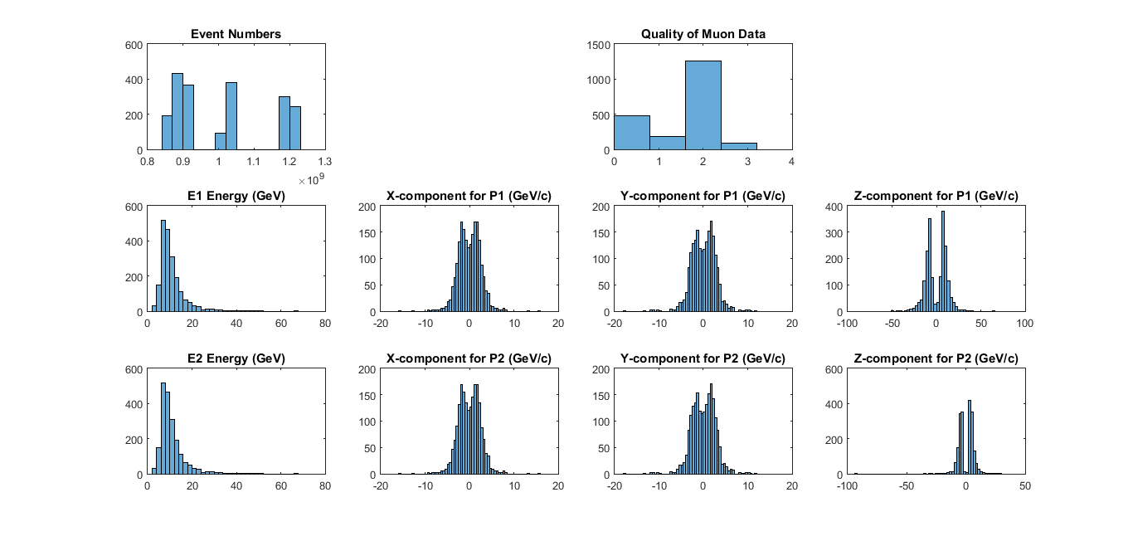

DiMuon INVARIANT MASS - LOOP OVER THE EVENTS
%
% For each event calculate the DiMuon System's Energy (Esys),
% 3-momentum (P3sys=[Px,Py,Pz]) and invariant mass
%
Esys=P4Mu1(:,1)+P4Mu2(:,1);
P3sys=[P4Mu1(:,2)+P4Mu2(:,2) , P4Mu1(:,3)+P4Mu2(:,3) , P4Mu1(:,4)+P4Mu2(:,4)];
Minv=sqrt(Esys.^2-sum(P3sys.^2,2));
Psys=sqrt(P3sys(:,1).^2+P3sys(:,2).^2+P3sys(:,3).^2);
% Histogram Esys, Psys (the magnitude of the 3-momentum)and the DiMuon
% invariant mass in one Figure using subplots
%
figure
subplot(3,1,1)
histogram(Esys)
title('Energy of the System (GeV)')
subplot(3,1,2)
histogram(Psys)
title('Magnitude of the 3-momentum (GeV/c)')
subplot(3,1,3)
histogram(Minv)
title('Invariant Mass (GeV/c^2)')

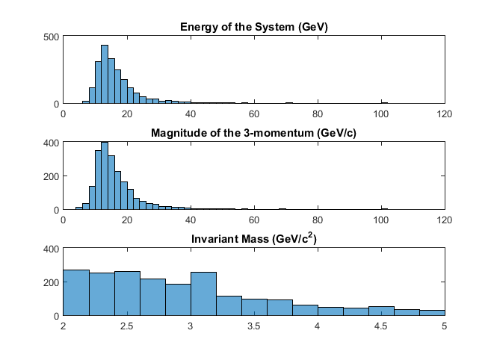
INVESTIGATE THE IMPACT OF IMPOSING MuQuality SELECTIONS CRITERIA (CUTS)
ON THE DiMuon INVARIANT MASS DISTRIBUTION
%
% Histogram the DiMuon invariant mass for MuQuality >=0, MuQuality >=1,
% MuQuality >=2 and MuQuality >=3. Arrange the four histograms in
% one Figure using subplots.
%
IM0=find(MuQuality==0);
IM1=find(MuQuality==1);
IM2=find(MuQuality==2);
IM3=find(MuQuality==3);
figure('Name','Invariant mass for Dimuon events seperated by quality')
subplot(2,2,1)
histogram(Minv(IM0),0:0.33:7)
title('Invariant Mass by Quality: Quality 0 (GeV/c^2)')
subplot(2,2,2)
histogram(Minv(IM1),0:0.33:7)
title('Quality 1 (GeV/c^2)')
subplot(2,2,3)
histogram(Minv(IM2),0:0.33:7)
title('Quality 2 (GeV/c^2)')
subplot(2,2,4)
histogram(Minv(IM3),0:0.33:7)
title('Quality 3 (GeV/c^2)')

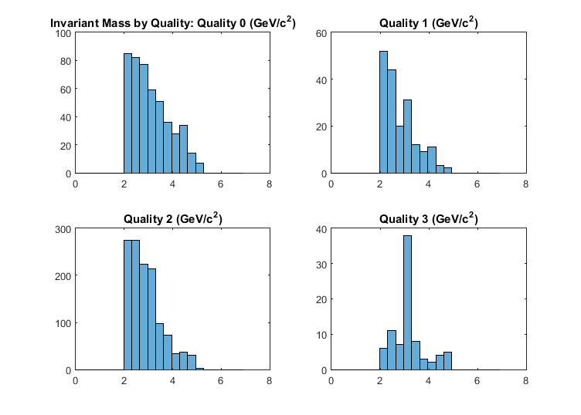

FOR EACH EVENT TRANSFORM TO THE REST FRAME OF THE DiMuon SYSTEM
1. TO CALCULATE THE DiMuon INVARIANT MASS IN THE REST FRAMEb 2. TO INVESTIGATE THE RELATIONSHIPS BETWEEN THE COMPONENTS OF THE 4-MOMENTUM OF THE FIRST MUON, [E1,px1,py1,pz1], WITH THAT OF THE SECOND MUON, [E2,px2,py2,pz2], IN THE REST FRAME
Bsys=[P3sys(:,1)./Esys,P3sys(:,2)./Esys,P3sys(:,3)./Esys];
%
B=sqrt(Bsys(:,1).^2+Bsys(:,2).^2+Bsys(:,3).^2);
Gam=sqrt(1./(1-B.^2));
% For the Lorentz Transformation ( http://en.wikipedia.org/wiki/Lorentz_transformation )
% we need to calculate the following quantities for the DiMuon Rest Frame:
% The DiMuon system's velocity: Bsys=(Bx,By,Bz)=P3sys/Esys;
% B=sqrt(Bx^2+By^2+Bz^2) and Gam=sqrt(1/(1-B^2))
%

TRANSFORM TO THE DiMuon REST FRAME - LOOP OVER THE EVENTS
for i=1:Nevents
LorTrans=[Gam(i) -Gam(i)*B(i) 0 0; -Gam(i)*B(i) Gam(i) 0 0; 0 0 1 0; 0 0 0 1];
P4Mu1RF(i,:)=P4Mu1(i,:)*LorTrans;
P4Mu2RF(i,:)=P4Mu2(i,:)*LorTrans;
end
EsysRF=P4Mu1RF(:,1)+P4Mu2RF(:,1);
P3sysRF=[P4Mu1RF(:,2)+P4Mu2RF(:,2) , P4Mu1RF(:,3)+P4Mu2RF(:,3) , P4Mu1RF(:,4)+P4Mu2RF(:,4)];
MinvRF=sqrt(EsysRF.^2-sum(P3sysRF.^2,2));

Histograms
Diagnostic Plots: Histogram all 10 input variables in the DiMuon Rest Frame in one Figure using subplots
figure('Name','Initial vars adjusted for Rest Frame')
subplot(3,4,1)
histogram(EvtNum)
title('Event Numbers')
% subplot(3,4,2)
subplot(3,4,3)
histogram(MuQuality,4)
title('Quality of Muon Data')
% subplot(3,4,4)
subplot(3,4,5)
histogram(P4Mu1RF(:,1))
title('E1 Energy Rest Frame (GeV)')
subplot(3,4,6)
histogram(P4Mu1RF(:,2))
title('X-component for P1 in RF (GeV/c)')
subplot(3,4,7)
histogram(P4Mu1RF(:,3))
title('Y-component for P1 in RF (GeV/c)')
subplot(3,4,8)
histogram(P4Mu1RF(:,4))
title('Z-component for P1 in RF (GeV/c)')
subplot(3,4,9)
histogram(P4Mu1RF(:,1))
title('E2 Energy in RF (GeV)')
subplot(3,4,10)
histogram(P4Mu1RF(:,2))
title('X-component for P2 in RF (GeV/c)')
subplot(3,4,11)
histogram(P4Mu1RF(:,3))
title('Y-component for P2 in RF (GeV/c)')
subplot(3,4,12)
histogram(P4Mu2RF(:,4))
title('Z-component for P2 in RF (GeV/c)')
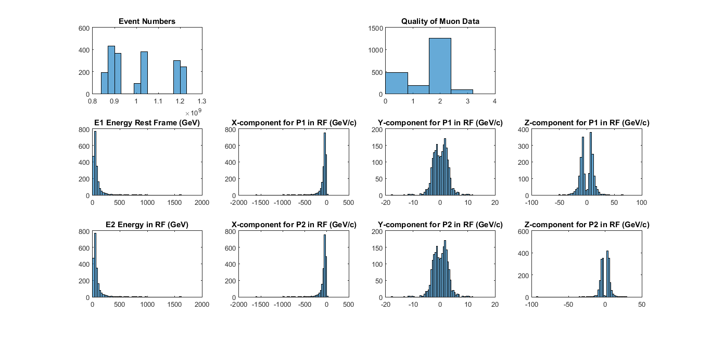
%
% Histogram Esys, Psys (the magnitude of the 3-momentum)and the invariant
% mass of the DiMuon System in the DiMuon Rest Frame in one Figure using
% subplots
PsysRF=sqrt(P3sysRF(:,1).^2+P3sysRF(:,2).^2+P3sysRF(:,3).^2);
figure
subplot(3,1,1)
histogram(EsysRF)
title('Energy of the System Rest Frame (GeV)')
subplot(3,1,2)
histogram(PsysRF)
title('Magnitude of the 3-momentum in Rest Frame (GeV/c)')
subplot(3,1,3)
histogram(MinvRF)
title('Invariant Mass in Rest Frame (GeV/c^2)')
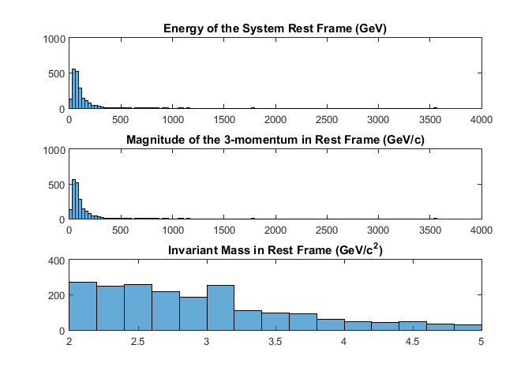
%
% Histogram the DiMuon Invariant mass in the DiMuon Rest Frame
% for MuQuality >=0, MuQuality >=1, MuQuality >=2 and MuQuality >=3.
% Arrange the four histograms in one Figure using subplots
%
figure
subplot(2,2,1)
histogram(MinvRF(IM0),0:0.33:7)
title('Invariant Mass by Quality in Rest Frame: Quality 0 (GeV/c^2)')
subplot(2,2,2)
histogram(MinvRF(IM1),0:0.33:7)
title('Quality 1 in RF (GeV/c^2)')
subplot(2,2,3)
histogram(MinvRF(IM2),0:0.33:7)
title('Quality 2 in RF (GeV/c^2)')
subplot(2,2,4)
histogram(MinvRF(IM3),0:0.33:7)
title('Quality 3 in RF (GeV/c^2)')
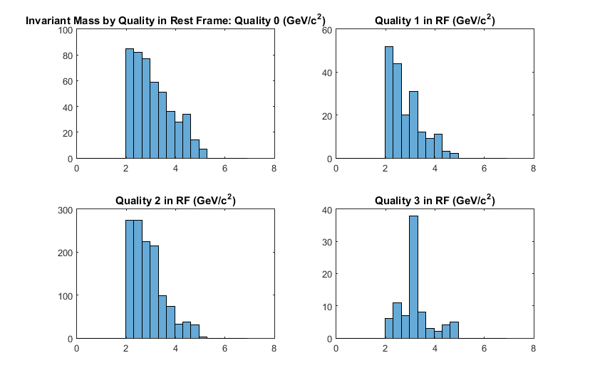
Published with MATLAB® R2015a

