README.Rmd

# Introduction

The goal of this package is to segment events in a CNV’s profile based on the $log_{2}$ ratio and the genomic position using a regression tree approach. A $log_{2}$ ratio above zero means that there is a amplification in copy number in the sample genome compared to the reference genome. On the other hand, if the $log_{2}$ ratio is below zero then there is a deletion in the copy number in the sample genome compared to the reference genome.

This package provides a way to segment a CNV’s profile and visualize the segmentation of individual chromosomes and the full genome.

## Installation

To install the most updated version of this package use the following:

install.packages("devtools")  
library(devtools)  
devtools::install_github("annikacleven/regtreeseg")

## Resources

The regtreeseg vignette includes sample code on how to use each of the segmenting functions. The vignette also dives into optional operations of the functions and more details on the complexity parameter used to segment the genomic data. The vignette is available upon download of the package.

## Overview

Using a regression tree approach set up in the ‘rpart’ package, CNV $log_{2}$ ratio data can be segmented with multiple approaches. In the regression tree approaches the response variable is the $log_{2}$ ratio and the explanatory variable is the genomic location. Therefore the data is partitioned into segments that predict the $log_{2}$ ratio for the genomic positions in each segment. In regtreeseg, the regression trees use the complexity parameter optimized to have the minimum cross validation error. The complexity parameter is the minimum increase in the $R^{2}$ that the split in the regression tree must create for the split to be included. The innovation of this package is using an iteration of regression trees to create a regression tree that catches all events in the CNV profile. Beyond the iteration, an option to weight points farther from the $log_{2}$ ratio of 0 is available.

There are three segmentation methods in this package:

1. Segmentation using an optimal complexity parameter (cp)
2. Segmentation using an optimal cp value and 3 regression tree iterations
3. Segmentation using an optimal cp value, 3 regression tree iterations, and weighting

Each of the segmentation methods in this package follow a general path.

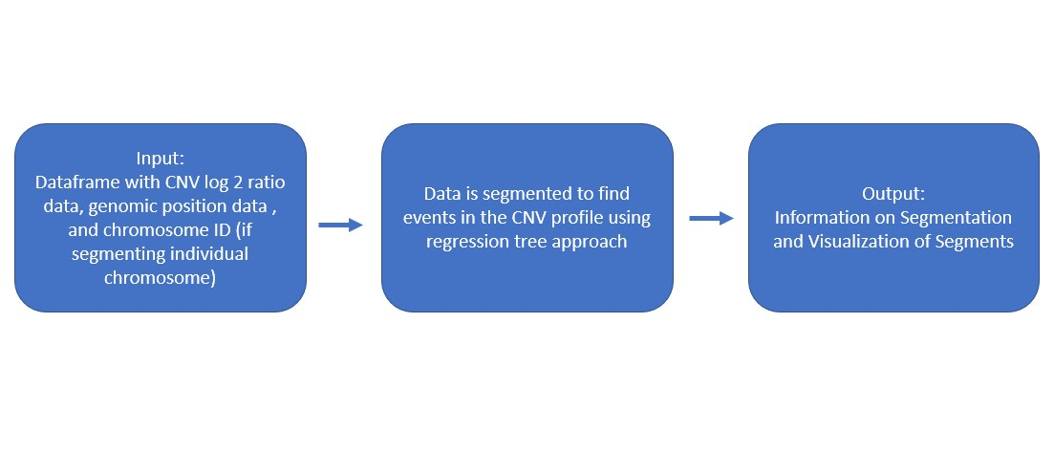

The use of an iterative regression tree approach allows for the tree to catch events in the CNV profile on the first round and then catch other less prominent events in the next iterations. This approach identifies more CNV events, than a single regression tree.

To begin the iterative regression tree approach, the data is segmented using a regression tree with the optimal complexity parameter (unless specified otherwise). The predictions from this regression tree are the first iteration (pred1). Then the residual error is calculated. Using the optimal complexity parameter (cp) for this residual data a regression tree is fitted to the data. This regression tree predicts the spikes in the residual error with an explanatory variable of the genomic location (pred2). Then the predictions from the initial regression tree (pred1) and the second regression tree (pred2) are added together to create a new prediction. Then a third iteration follows. The residuals are calculated from the combined prediction of pred1+pred2 and using the cpopt another regression tree is fitted to this residual data (pred3). Then the predictions from each iteration are added together (pred1+pred2+pred3) for the final prediction.

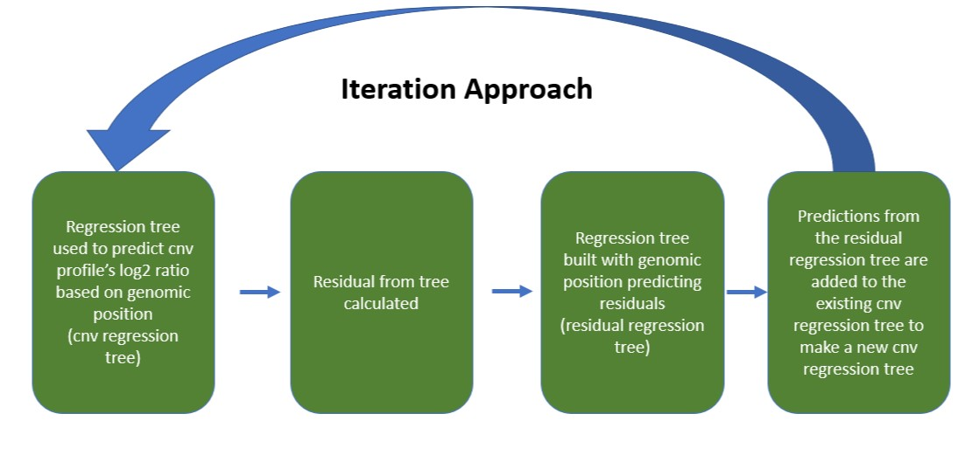

The functions in this package segment either a single chromosome or the full genome. When segmenting the full genome each chromosome is segmented separately and then each chromosome’s segmentation is included in a full report.

## Demonstration

More detailed instructions on how to execute each of the segmentation methods can be viewed in the vignette. Here a description of the flow of the function and an example of how to use the iterative regression tree approach with optimal cp values for a single chromosome is provided.

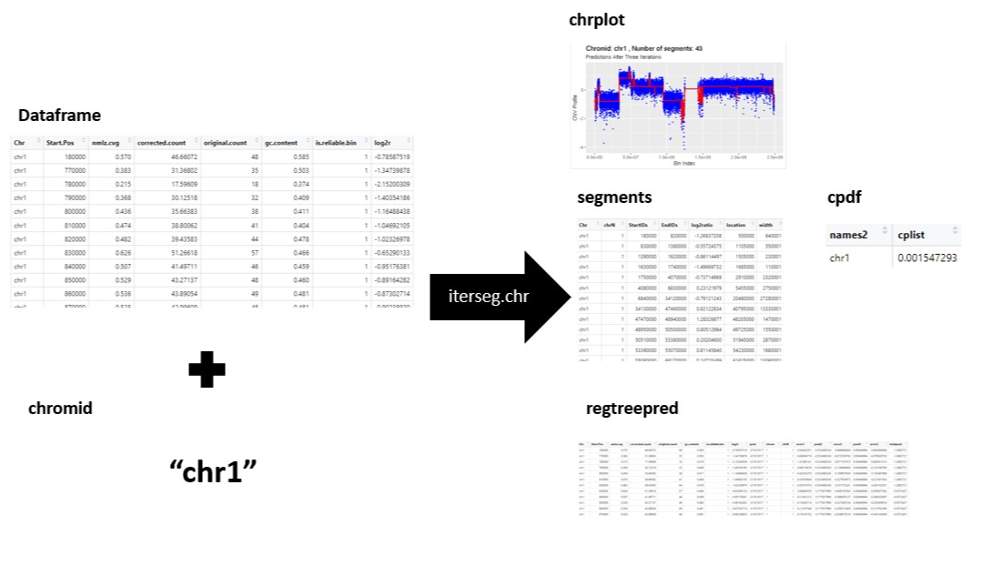

library(regtreeseg)  
data("chr3sample")  
demo <- iterseg.chr(chr3sample, chromid = "chr3")  
demo$chrplot  
demo$segments

A screenshot of the chrplot is shown below:

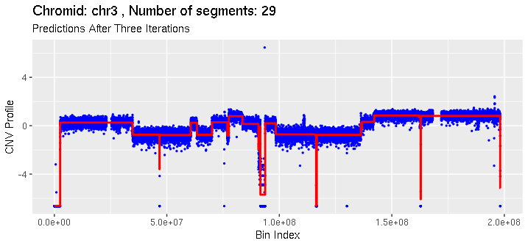

## Dataframe input specification

The inputs of these functions require a dataframe that has column names specifically labeled as “Start.Pos”, “log2r”, and “Chr”. The “Start.Pos” column is the bin index or genomic location which the log2ratio comes from. The “log2r” column is the log2ratio that between the sample genome ad the reference genome. The “Chr” column is the chromosome of interest. The chromosomes should be labeled exactly as “chr1”, “chr2”, “chr22”, “chrX”, “chrY”.