Chrome-Postman API Testing

1. Manually set up your credentials and open Chrome DevTools (F12) -> Network.
   1. Check “Preserve log” as needed.
2. Trigger the API request in Chrome.
3. Find the request in the network logs and copy it as cURL (bash).

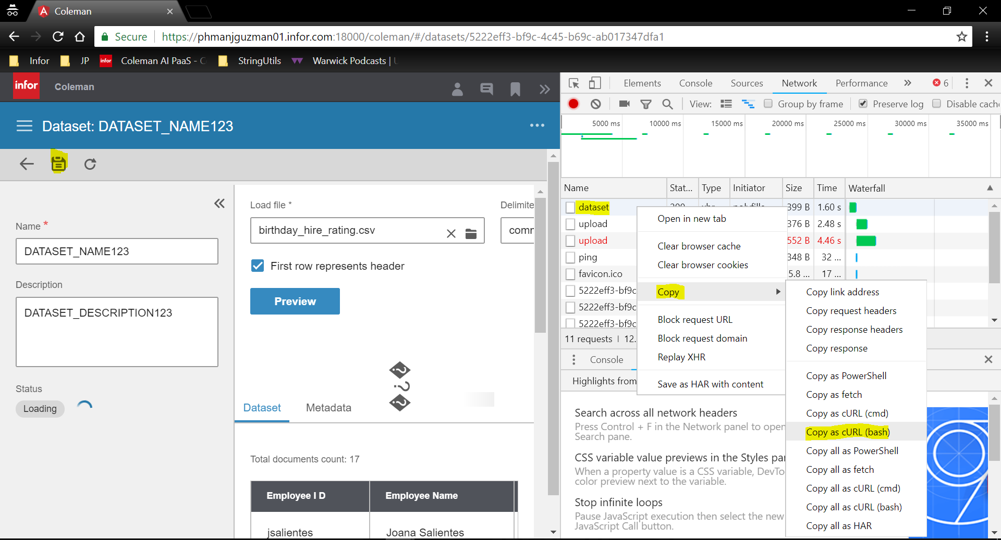

1. To skip certificate validation, include the --insecure flag in the cURL command.
   1. Changes in the request can be made here or in the Postman GUI.

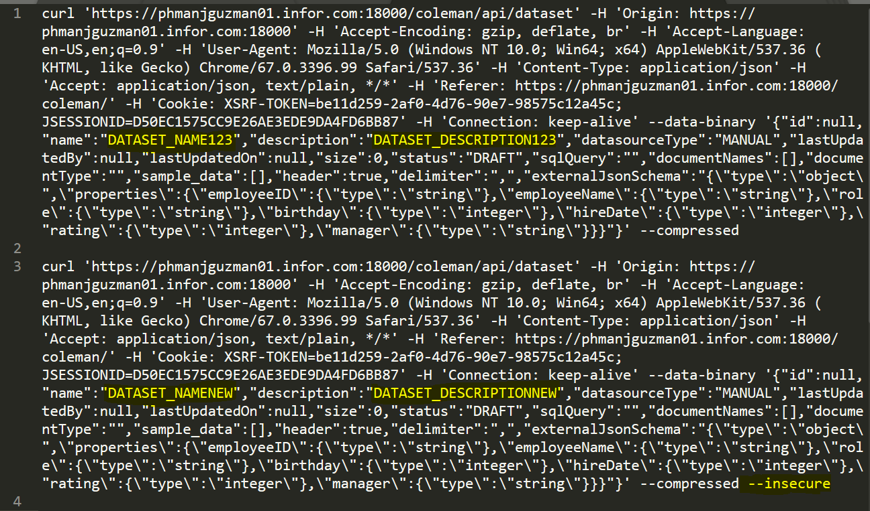

1. Import the request to Postman as a cURL command.

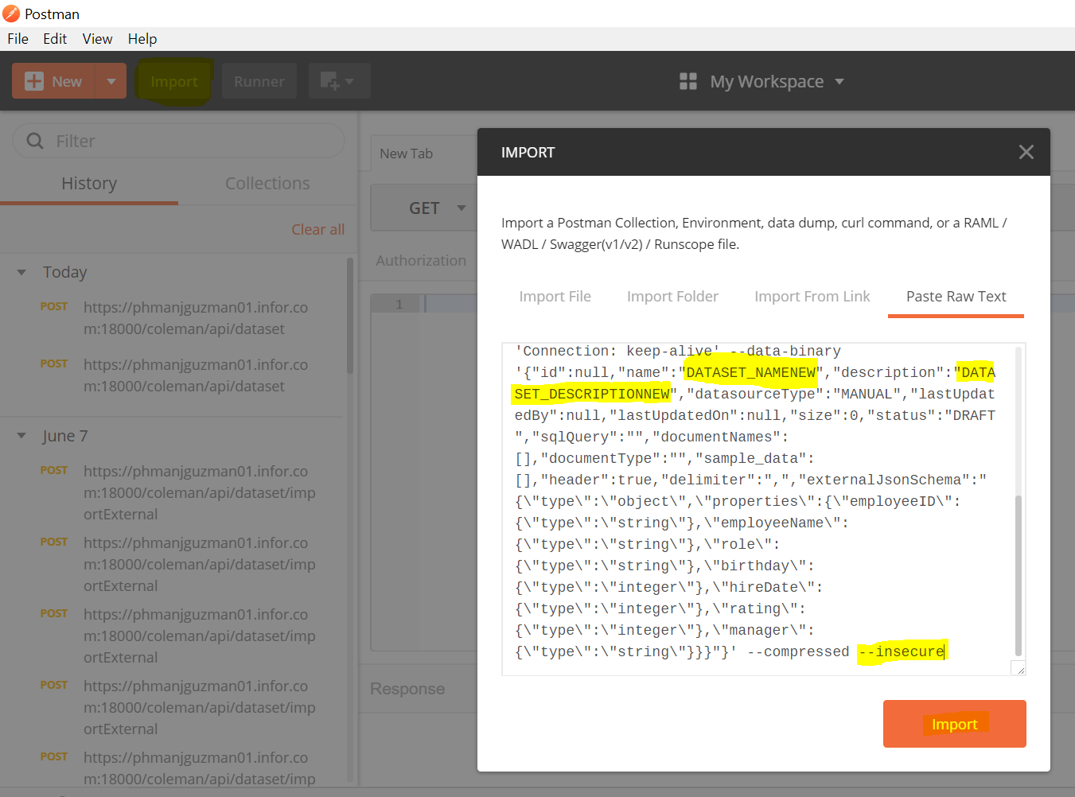

1. This should imitate the behavior of requests that are given directly by your Chrome session.

