SourceTree Guide

# Setup

1. **Add Repository**
   1. Clone the project repository locally, then add it as a repository in SourceTree

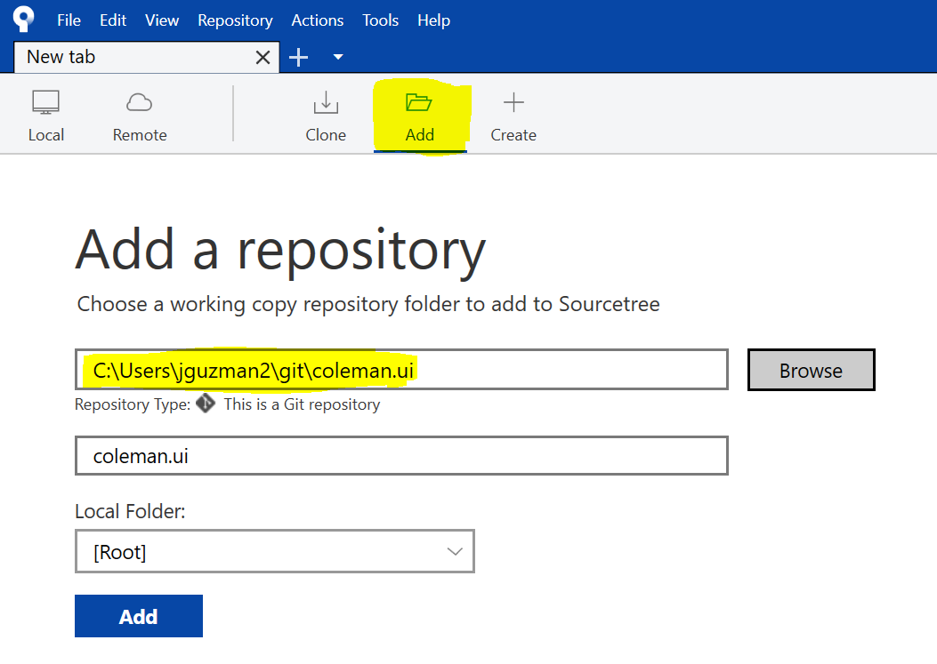

1. **Setup Credentials**
   1. In [Tools -> Options], set your default user information and SSH client config
      1. The SSH key must be the private key pair of the public key that has been uploaded in your GitLab account’s 'Profile Settings'.

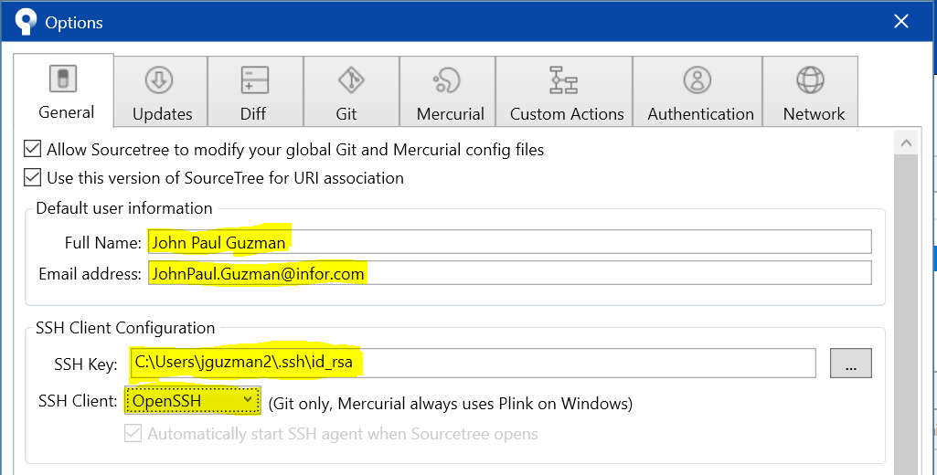

# Branch Checkout

1. **If there is no local copy of the branch, get a copy and checkout from REMOTES**

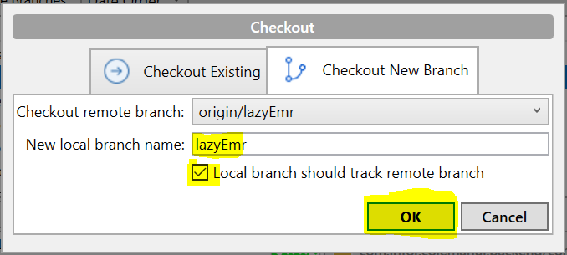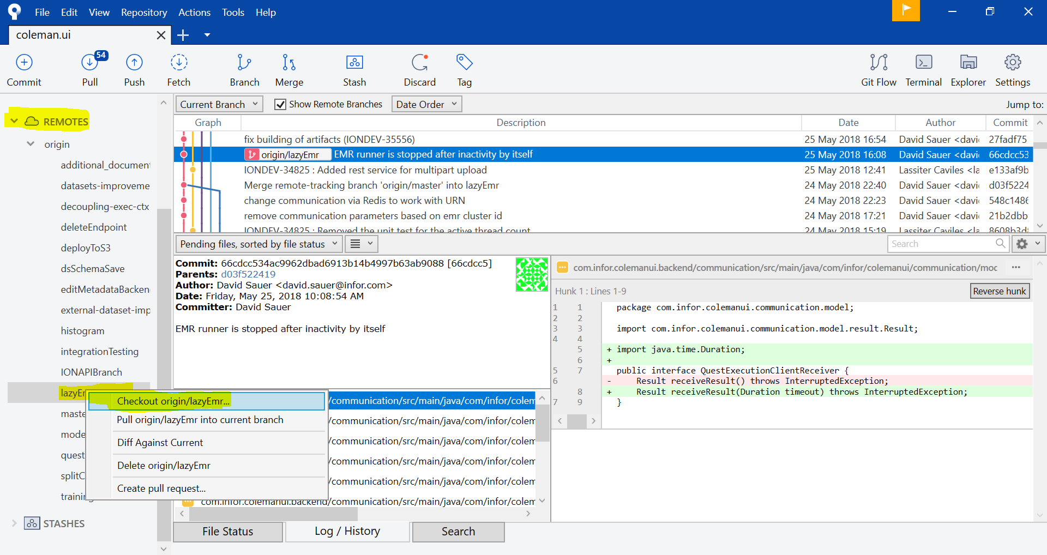

1. **If there is a local copy of the branch, checkout from BRANCHES**

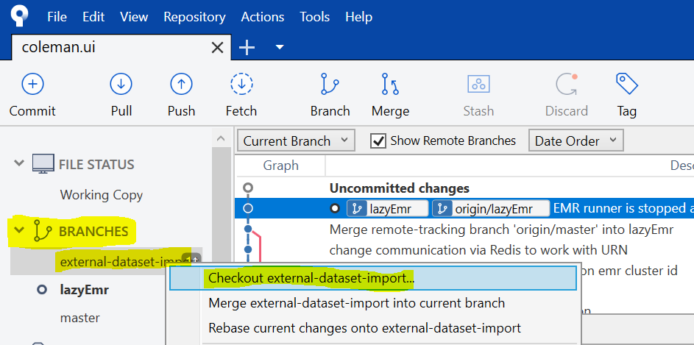

# Check in

1. **Stage the Changes to be Committed**
   1. Select Uncommitted changes
   2. Select the files to be staged

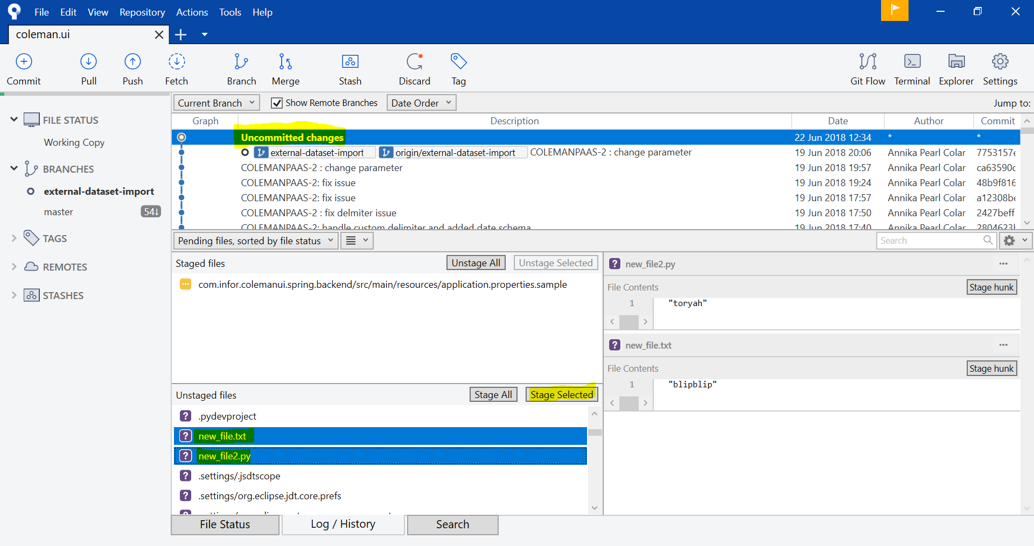

1. **Create a New Commit**

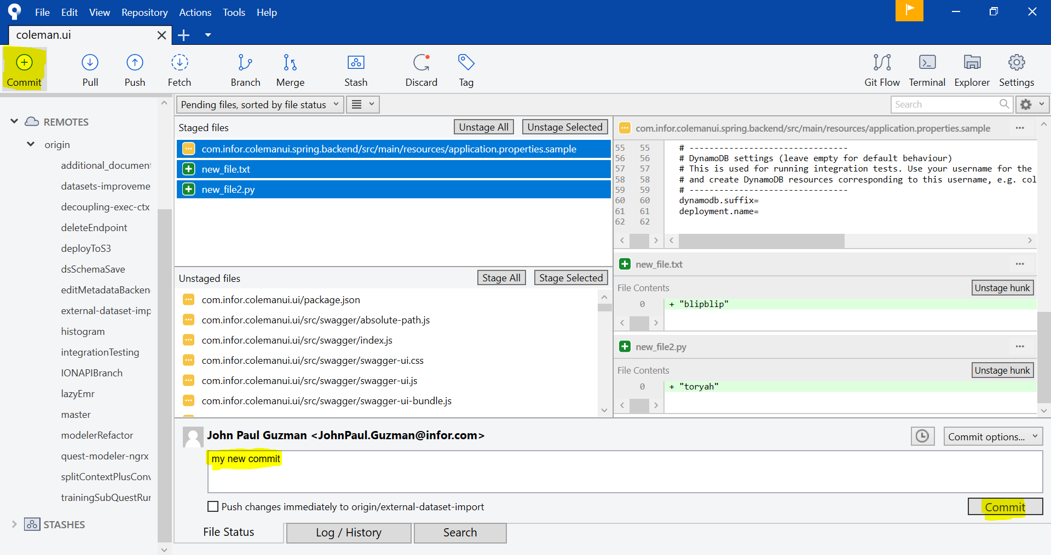

1. **Push Commits**

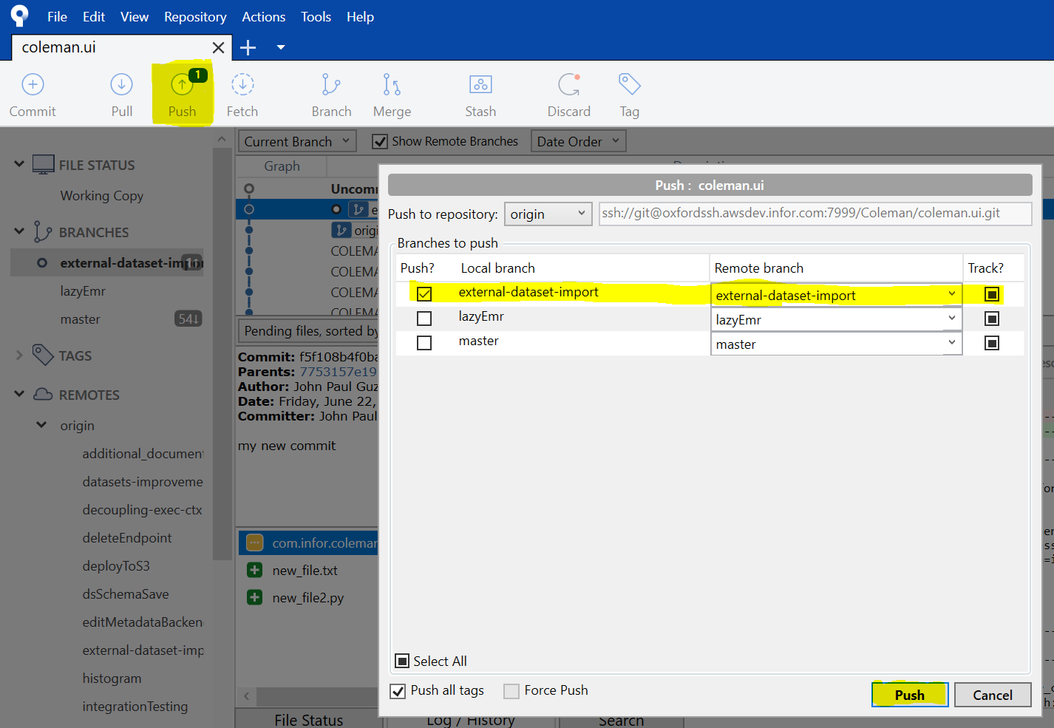

1. **Check for Remote Changes**

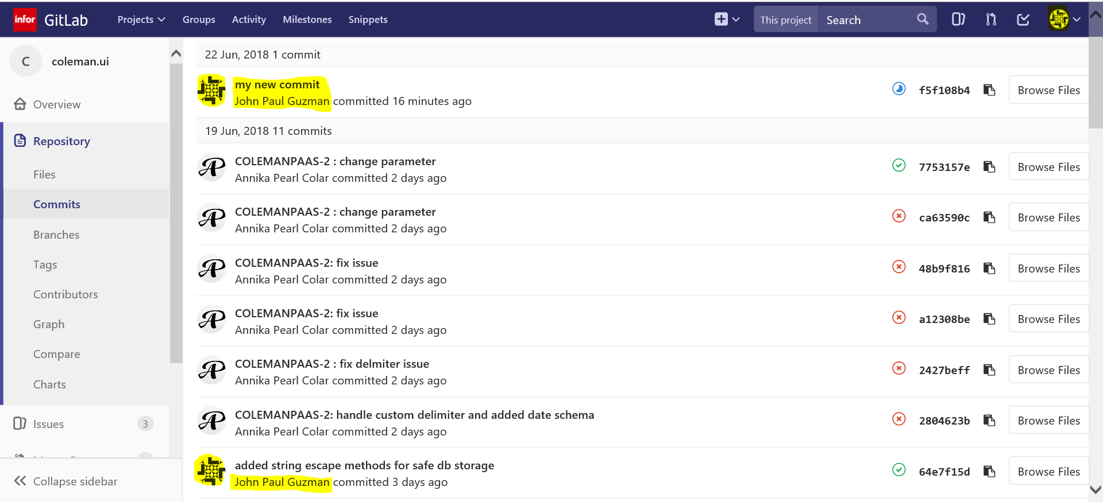

# Additional Notes

* Use Git Bash for dangerous or complex operations (e.g., using force push or merge strategies)
* Inputs for multiple-item select – hold down Ctrl + Left-Click
* Inputs for refresh display – F5
* File diffs are displayed when 1 or 2 commits or files are selected
* “Discard” means unstage and remove the changes made to the file
* “Remove” means delete the actual file