МІНІСТЕРСТВО ОСВІТИ І НАУКИ УКРАЇНИ

НАЦІОНАЛЬНИЙ ТЕХНІЧНИЙ УНІВЕРСИТЕТ УКРАЇНИ

„КИЇВСЬКИЙ ПОЛІТЕХНІЧНИЙ ІНСТИТУТ”

НАВЧАЛЬНО-НАУКОВИЙ КОМПЛЕКС

„ІНСТИТУТ ПРИКЛАДНОГО СИСТЕМНОГО АНАЛІЗУ”

**Лабораторна робота №1**

**З курсу «**ПРОЕКТУВАННЯ ІНФОРМАЦІЙНИХ СИСТЕМ**»**

**Скласти опис передпроектної документації (Software Requirement Specifications)**

**Виконала:**

**студентка 4 курсу**

**групи ДА-51**

**Мекшун Ганна**

**Київ 2015**

**Мета роботи**: вивчити основні етапи створення передпроектної документації (SRS).

**Задача**: використати приклад SRS для створення передпроектної документації згідно індивідуальної темі для виконання лабораторних робіт.

Information processing system MyBook

Software Requirements Specification

v1.0

14.10.2018

Hanna Mekshun

Lead Software Engineer

Prepared for

PAIS course, KPI, IASA

Instructor: Konstantin Kharchenko

October 2018

# Revision History

|  |  |  |  |
| --- | --- | --- | --- |
| **Date** | **Description** | **Author** | **Comments** |
| 14.10.2018 | Version 1.0 | Hanna Mekshun |  |

# Document Approval

The following Software Requirements Specification has been accepted and approved by the following:

|  |  |  |  |
| --- | --- | --- | --- |
| **Signature** | **Printed Name** | **Title** | **Date** |
|  | Hanna Mekshun | Lead Software Eng. |  |
|  | Konstantin Kharchenko | Instructor |  |
|  | Anna Grechko | Instructor |  |

**Table of Contents**

1. Introduction 4

1.1 Purpose 4

1.2 Scope 4

1.3 Definitions, Acronyms, and Abbreviations 4

1.4 References 4

1.5 Overview 4

2. General Description 4

2.1 Product Perspective 5

2.2 Product Functions 5

2.3 User Characteristics 5

2.4 General Constraints 5

2.5 Assumptions and Dependencies 5

3. Specific Requirements 5

3.1 External Interface Requirements 5

3.1.1 User Interfaces 5

3.1.2 Hardware Interfaces 5

3.1.3 Software Interfaces 5

3.1.4 Communications Interfaces 5

3.2 Functional Requirements 5

3.3 Use Cases 6

3.3.1 Use Case №1 User sign in 6

3.3.2 Use Case №2 User register 6

3.3.3 Use Case №3 User search books via criteria 6

3.3.4 Use Case №4 User watch one of his lists 6

3.3.5 Use Case №5 User add new books into one of his list 6

3.4 Classes / Objects 6

3.4.1 <Class Book> 6

3.4.2 <Class Library> 6

3.4.3 <Class UsersRoom> 6

3.4.4 <Class User> 6

3.5 Non-Functional Requirements 6

3.5.1 Performance 6

3.5.2 Reliability 6

3.5.3 Availability 6

3.5.4 Security 6

3.5.5 Maintainability 6

3.5.6 Portability 7

3.6 Design Constraints 7

3.7 Logical Database Requirements 7

4. Analysis Models 7

4.1 Use case diagram 7

5. Change Management Process 7

A. Appendices 7

A.1 Application tests 7

Test 1 7

Test 2 8

Test 3 8

Test 4 8

Test 5 8

Test 6 8

# 1. Introduction

This is a software requirements specification. This document should contain all of the information needed by a software engineer.

## 1.1 Purpose

*The purpose of this document is to prepare software requirements specification of “MyBook” app.*

## 1.2 Scope

*The software name: MyBook.*

*This app will give access to the create list of books, which you have been reading. You can add read book to the data base, write a comment to it and rate it. You can also specify the date of the beginning and end of reading the book. This application is your reader's diary.*

## 1.3 Definitions, Acronyms, and Abbreviations

*MyBook - the name of this project.*

*User – a person, which have a profile in the System.*

*Database - some data about read books*

## 1.4 References

* *IEEE. IEEE Std 830-1998 IEEE Recommended Practice for Software Requirements Specifications. IEEE Computer Society, 1998.*
* *“Методичні вказівки до виконання лабораторних робіт для студентів напряму підготовки 6.050101 «Комп'ютерні науки», спеціальностей 8.05010102 «Інформаційні технології проектування» та 8.05010103 «Системне проектування» денної та заочної форм навчання”, Dph Konstantin Kharchenko*

## 1.5 Overview

*SRS document is organized in the next way: general description, requirements, analysis model, tests.*

# 2. General Description

## 2.1 Product Perspective

*In the future can be created new version, that allows you create a rating of read books, keep track of the number of read pages per month. Also in the next versions it is possible to implement the system of recommendation of books on the basis of read.*

## 2.2 Product Functions

This software will have those main parts:

1. For creating new item;
2. For watching your lists.

## 2.3 User Characteristics

All people, who like reading, can use this app.

## 2.4 General Constraints

*Internet connection is required*

## 2.5 Assumptions and Dependencies

This is Web app can be runnable in the Internet Explorer (>8 version), FireFox, Opera, Safari and Chrome browsers.

# 3. Specific Requirements

## 3.1 External Interface Requirements

Web-interface via browser on the Web-site of this System;

Holding data in the local storage.

## 3.2 Functional Requirements

This section describes specific features of the software project.

User can watch his lists and add new books.

## 3.3 Use Cases

### 3.3.1 Use Case №1 User watch his list

User can watch his list of read books.

### 3.3.2 Use Case №2 User add new books into his list

User can add new books into his list.

### 3.3.3 Use Case №3 User delete book from his list

User can add delete book from his list.

### 3.3.4 Use Case №4 User edit book in his list

User can edit description and rate of books in his list.

## 3.4 Classes / Objects

### 3.4.1 <Object Book>

*This object should contain all parameters of book, as name, author, description, dates of reading and rate*

### 3.4.2 < Object BooksList>

*This object should represent the library, that contain list of all books.*

## 3.5 Non-Functional Requirements

### 3.5.1 Performance

There are no performance constrain.

### 3.5.2 Reliability

Code should have 20% coverage by unit-test.

### 3.5.3 Availability

This app should have 100% availability.

### 3.5.4 Security

There is not any security requirement.

### 3.5.5 Maintainability

*Application restart will solve all problems, created by Internet-connection problems.*

### 3.5.6 Portability

*This code must run on any PC, laptop or mobile phone, internet access.*

## 3.6 Design Constraints

There is not any design constrain.

## 3.7 Logical Database Requirements

Will be local storage for holding data

# 4. Analysis Models

## 4.1 Use case diagram

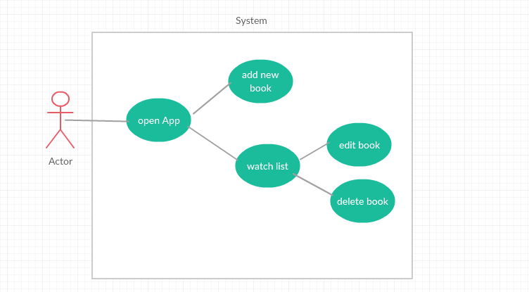

# 5. Change Management Process

Only Hanna Mekshun can submit changes to this document.

# A. Appendices

## A.1 Application tests

|  |  |  |
| --- | --- | --- |
| **Action** | **Respond** | **System State** |
| 1. The user lists watched | The user sees all his lists. | Lists shown. |
| 1. The user add book to the list. | The book with appropriate criteria will be added into the list. | The book is in the list. |
| 1. The user change information about book | The book with new information will be updated in the list. | The book with updated info is in the list. |
| 1. The user delete book | The book will be deleted from list | The book isn’t in the list. |

## ВИСНОВОК:

## Було вивчено основні етапи створення передпроектної документації (SRS).