In EC2 instance installation packages

1. sudo apt-get update
2. sudo apt install docker.io -y
3. sudo apt install docker-compose -y

After using the ec2 installation steps we create the docker file , build and deploy scripts.

git clone https://github.com/rvsp/reactjs-demo.git git remote remove origin

git add .

git commit -m "first commit" git checkout -b master

git remote add origin <https://github.com/annith29/Capstone.git>git push origin master

git checkout

git commit -m "last commit" git push origin dev

git checkout master git merge

Jenkins

Adding the credentials to the server.

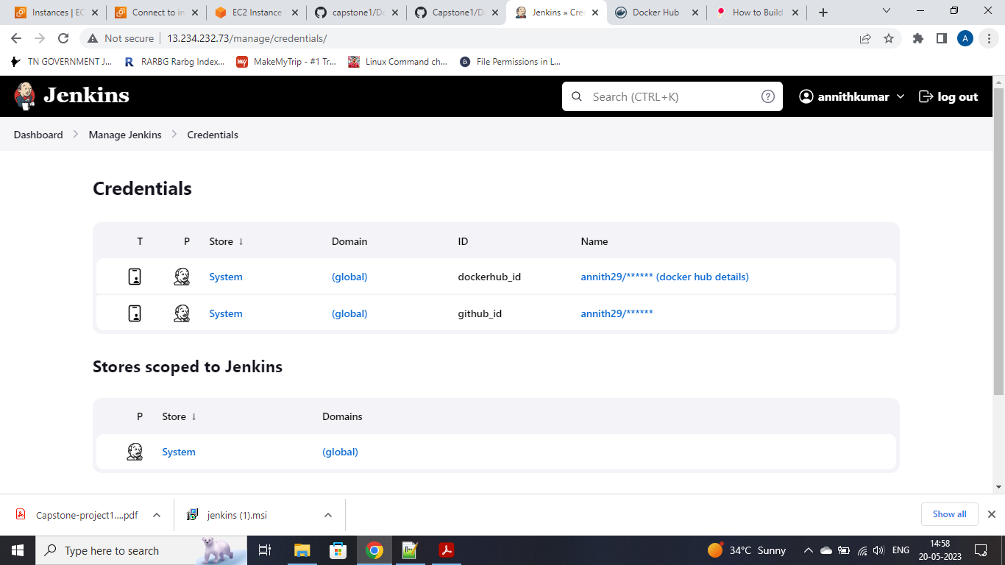

Tried connecting the servers through Jenkins window

