Use Case Specification

DMT/RM01/TMP

|  |  |
| --- | --- |
| Project Code | PROJECT_AMS_Approve/Reject_Request |
| Project Name | Asset Management System |

|  |  |  |
| --- | --- | --- |
| Prepared/Modified by | Role | Date of Preparation |
| Anusha Godaba | Test Engineer | 27/09/2018 |
| Reviewed by | Role | Date of Review |
| Shashi Kumar | SME |  |
| Approved by | Role | Date of Approval |
| Shubhangi Gurav | Test Manager |  |
| Circulation List |  | Version Number of the template: |
| Version Number | 1 |  |

<<Customer>> REVIEW HISTORY

<<Customer comments on the Use case along with the signed off is tracked here>>

|  |  |  |  |  |  |  |
| --- | --- | --- | --- | --- | --- | --- |
| Version | <<Version number>> |  |  |  |  |  |
| Date | <<Date of Review>> |  |  |  |  |  |
| Reviewed by | << Reviewer Name>> |  |  |  |  |  |
| Reviewed UI Specification doc | << Whether UI Specification doc is reviewed >> |  |  |  |  |  |
| All Open Queries/issues closed | << Whether all the open queries and issues resolved>> |  |  |  |  |  |
| Agreement on Assumptions | <<Whether all the assumptions have been agreed upon by the customer>> |  |  |  |  |  |
| Sign Off | <<Signature>> |  |  |  |  |  |

Disclaimer:

The scope of the project ‘<<Project Name>>’ is restricted to the contents of this signed off use case.

TABLE OF CONTENTS

1.Use Case Name: <<Use Case Name>> 4

2.Actor(s) 4

3.Preconditions 4

4.Flow of Events 4

4.1 Basic Flow 4

4.2 Alternative Flows 5

4.2.1 Alternate Flow 1 5

4.3 Sub Flows 6

4.3.1 Sub Flow 1 6

5.Post Conditions 6

6.Special Requirements 7

7.Extension Points 7

<Name of extension point> 7

8.Business Rules 7

9.Diagrams 8

Use Case Diagram 8

Activity Diagram 9

10.Scenarios 10

Success Scenarios 10

Failure Scenarios 10

11.Issues 10

12.UI Specifications 10

13.Inter System Dependencies 11

14.Integration with an already existing System of the <<Customer>> 11

15.Assumptions 11

REVISION HISTORY OF THE WORK PRODUCT…………………………….. .. 12

Use Case Name: Asset Management System Approve/Reject Request

Use Case ID: Asset Management System Website

1.0

**Brief Description**: For Admin this screen shows the requests which are approved or rejected

1.Admin

2.Asset Management Sysytem

Preconditions.

1. Website should be accessible by Admin by visiting the website on the browser
2. The person viewing the screen in for Asset Management System should be Admin.

Flow of Events

4.1 Basic Flow

**Name:** Successful Request of Approve/Reject in Asset Management System

1. Admin login into the website
2. Admin clicks on Approve/Reject link
3. Admin clicks on approved/rejected
4. System displays the message “Successfully Approved/Rejected”

Exception Flow 1: unsuccessfull Approve/Reject in Asset Management System due To not selecting anything

1.Admin login into the website

2.Admin clicks on Approve/Reject link

3.Admin clicks on approved/rejected

4.System displays the message “Please Approve/Reject the fields”

Exception Flow 2: unsuccessfull Approve/Reject in Asset Management System due To Web Server Down

1.Admin login into the website

2.Admin clicks on Approve/Reject link

3.Admin clicks on approved/rejected

4.System displays the message “Web Server Down”

Exception Flow 3: unsuccessfull Approve/Reject in Asset Management System due To Database Connectivity Error

1.Admin login into the website

2.Admin clicks on Approve/Reject link

3.Admin clicks on approved/rejected

4.System displays the message “Database Connectivity Error”

Exception Flow 4: unsuccessfull Approve/Reject in Asset Management System due To Network Connectivity Error

1.Admin login into the website

2.Admin clicks on Approve/Reject link

3.Admin clicks on approved/rejected

4.System displays the message “Network Connectivity Error”

Post Conditions

| Flow Name | Post Condition |
| --- | --- |
| Successful search in Asset Management System | System displays the message “Successfully Approved/Rejected” |
| Unsuccessful Approve/Reject Asset Management System Registration due to not selecting any fields | System displays the error message “Please Approve/Rejecte the required fields” |
| Web Server Down | The system should display an error message to the user regarding web server unavailability problem. |
| Database Connectivity Error | The system should display an error message to the user regarding the database connectivity problem. |
| Network Connectivity Error | The system should display an error message to the user regarding the network connectivity problem. |

Special Requirements

Performance

The Admin should receive a mail regarding all the details have been approved/rejected

Availability

* 1. Application is up and running 24*7.

Business Rules

| Business Rule Name | Business Rule Description | System action (if BR fails) |
| --- | --- | --- |
| BR01 | All fields must be selected | Error message is displayed if any field is not selected |

Diagrams

Use Case Diagram

* 1. For Successful Registration of Hotel Booking Management System
     1. Admin

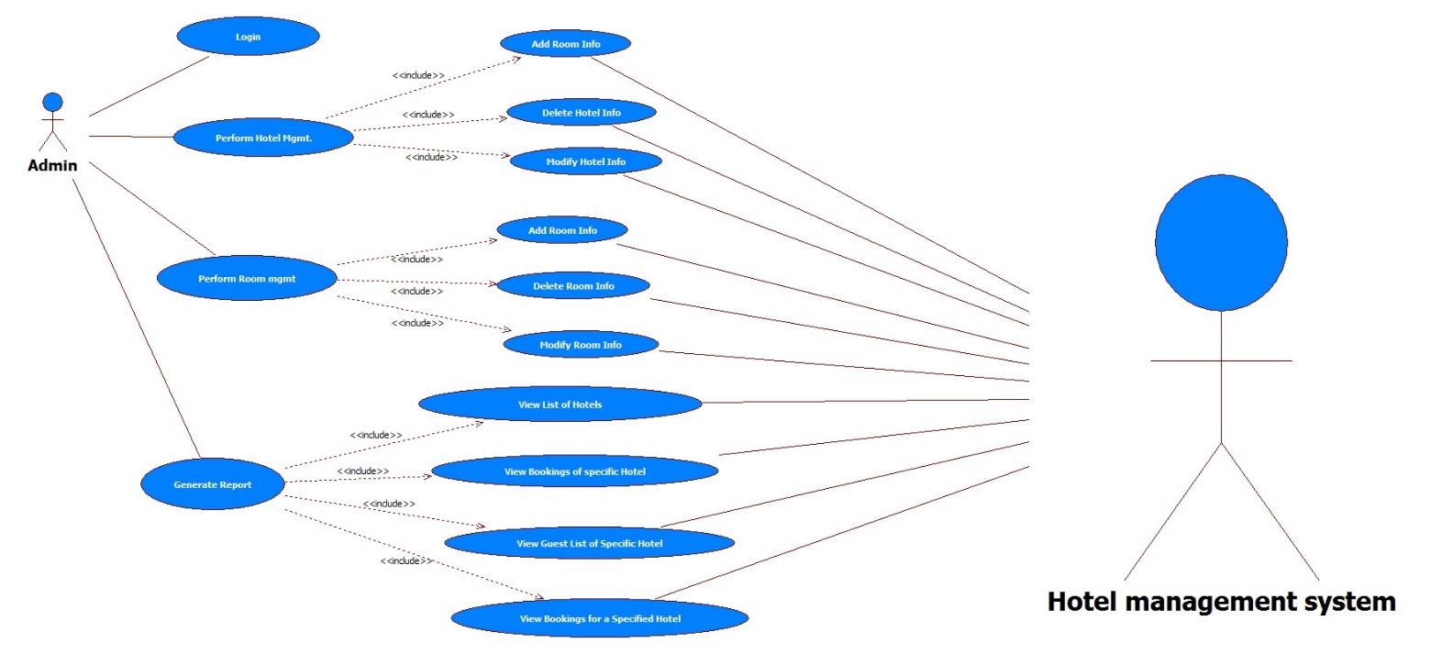

Manager

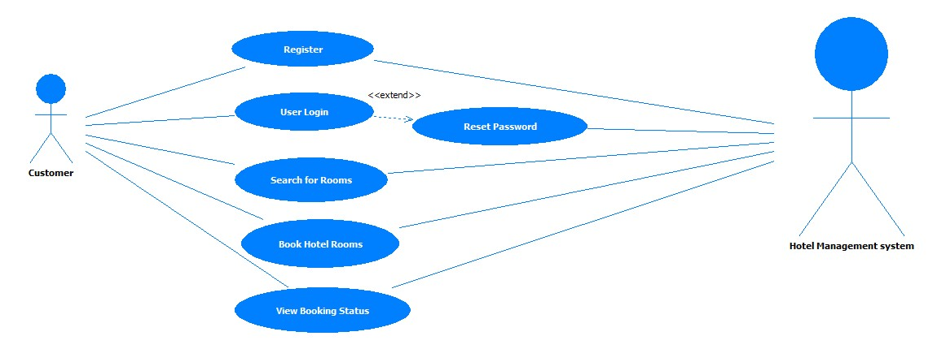

Scenarios

Success Scenarios

* Successfully approve/reject of assets in Asset Management System

Failure Scenarios

* Failed Search in Asset Management System for not selecting any fields

Issues

1. What is to be done if web server is down?
2. What is to be done if the Approve/Reject link does not get opened?
3. What is to be done if there is data connectivity error?
4. What is to be done if the form is not getting submitted even after entering valid field details without any alerts for errors?

Assumptions

1.Admin can easily approve/reject the assets.

2.Admin has selected and entered all the fields.

REVISION HISTORY OF THE WORK PRODUCT

<to be maintained by projects>

|  |  |  |  |  |  |
| --- | --- | --- | --- | --- | --- |
| # | Date | Version # | Section Changed | Details of changes made | Approved By |
| 1 |  |  |  |  |  |
| 2 |  |  |  |  |  |