Use Case Specification

DMT/RM01/TMP

|  |  |
| --- | --- |
| Project Code | PROJECT_AMS_LoginForm |
| Project Name | Asset Management System |

|  |  |  |
| --- | --- | --- |
| Prepared/Modified by | Role | Date of Preparation |
| Anusha Godaba | Test Engineer | 27/09/2018 |
| Reviewed by | Role | Date of Review |
| Shashi Kumar | SME |  |
| Approved by | Role | Date of Approval |
| Shubhangi Gurav | Test Manager |  |
| Circulation List |  | Version Number of the template: |
| Version Number | 1 |  |

<<Customer>> REVIEW HISTORY

<<Customer comments on the Use case along with the signed off is tracked here>>

|  |  |  |  |  |  |  |
| --- | --- | --- | --- | --- | --- | --- |
| Version | <<Version number>> |  |  |  |  |  |
| Date | <<Date of Review>> |  |  |  |  |  |
| Reviewed by | << Reviewer Name>> |  |  |  |  |  |
| Reviewed UI Specification doc | << Whether UI Specification doc is reviewed >> |  |  |  |  |  |
| All Open Queries/issues closed | << Whether all the open queries and issues resolved>> |  |  |  |  |  |
| Agreement on Assumptions | <<Whether all the assumptions have been agreed upon by the customer>> |  |  |  |  |  |
| Sign Off | <<Signature>> |  |  |  |  |  |

Disclaimer:

The scope of the project ‘<<Project Name>>’ is restricted to the contents of this signed off use case.

TABLE OF CONTENTS

1.Use Case Name: <<Use Case Name>> 4

2.Actor(s) 4

3.Preconditions 4

4.Flow of Events 4

4.1 Basic Flow 4

4.2 Alternative Flows 5

4.2.1 Alternate Flow 1 5

4.3 Sub Flows 6

4.3.1 Sub Flow 1 6

5.Post Conditions 6

6.Special Requirements 7

7.Extension Points 7

<Name of extension point> 7

8.Business Rules 7

9.Diagrams 8

Use Case Diagram 8

Activity Diagram 9

10.Scenarios 10

Success Scenarios 10

Failure Scenarios 10

11.Issues 10

12.UI Specifications 10

13.Inter System Dependencies 11

14.Integration with an already existing System of the <<Customer>> 11

15.Assumptions 11

REVISION HISTORY OF THE WORK PRODUCT…………………………….. .. 12

Use Case Name: Asset Management System User Login

Use Case ID: Asset Management System Website

1.0

**Brief Description**: This usecase describes the process for “User Login” on the Asset Management Website

Actor(s)

1.Admin

2.Manager

3. Hotel Management System

Preconditions.

1. Website should be accessible by the user by visiting the website on the browser
2. The person logging in for Asset Management System should be either admin or manager.

Flow of Events

4.1 Basic Flow

**Name:** Successful Login of Asset Management System

1. User enters Name
2. User enters Password
3. User clicks on Submit button
4. System displays the message “Successful Login”
   1. Alternative Flows

1. User clicks on sign up button

2. User adds the various details

3. User enters Name

4. User enters Password

5. User clicks on Submit button

4. System displays the message “Successful Login”

Alternate Flow 1:Successfull Login in Asset Management System

Exception Flow 1: unsuccessfull Login in Asset Management System due To invalid Username

1. User enters Name
2. User enters Password
3. User clicks on Submit button
4. System displays the message “Invalid Username”

Exception Flow 2 :unsuccessful Login in Asset Management System due to invalid password

1. User enters Name
2. User enters Password
3. User clicks on Submit button
4. System displays the message “Invalid Password”

Exception Flow 3 :unsuccessful Login in Asset Management System due to webserverdown

1. User enters Name
2. User enters Password
3. User clicks on Submit button
4. System displays the message “Web Server Down”

Exception Flow 4 :unsuccessful Login in Asset Management System due to Database Connectivity Error

1. User enters Name
2. User enters Password
3. User clicks on Submit button
4. System displays the message “Database Connectivity Error”

Exception Flow 5 :unsuccessful Login in Asset Management System due to Network Connectivity Error

1. User enters Name
2. User enters Password
3. User clicks on Submit button
4. System displays the message “Network Connectivity Error”

Post Conditions

| Flow Name | Post Condition |
| --- | --- |
| Successful Login in Asset Management System | System displays the message “Logged in Successfully” |
| Unsuccessful Login in Asset Management System Login due to invalid Adminname | System displays the error message “Enter valid Username” |
| Unsuccessful Login Asset Management System due to invalid password | System displays the error message “Enter correct password” |
| Web Server Down | The system should display an error message to the User regarding web server unavailability problem. |
| Database Connectivity Error | The system should display an error message to the User regarding the database connectivity problem. |
| Network Connectivity Error | The system should display an error message to the User regarding the network connectivity problem. |

Special Requirements

Performance

The User should receive a mail regarding all the details entered after successful Login.

Availability

* 1. Application is up and running 24*7.

Business Rules

| Business Rule Name | Business Rule Description | System action (if BR fails) |
| --- | --- | --- |
| BR01 | All fields must be selected | Error message is displayed if any field is not selected |
| BR02 | Valid Username must be entered | Error message is displayed if invalid |
| BR03 | Valid password must be entered | Error message should be displayed if invalid |

Diagrams

Use Case Diagram

* 1. For Successful Registration of Asset Management System
     1. Admin

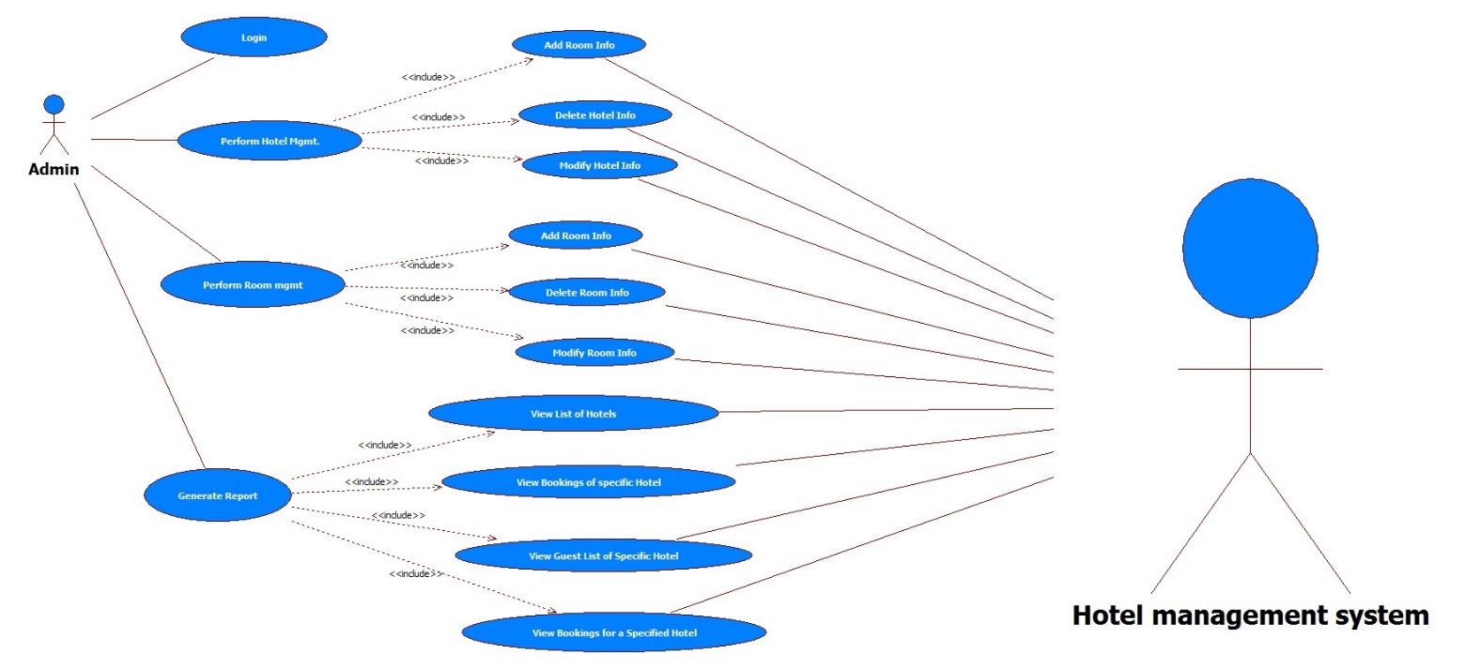

Manager

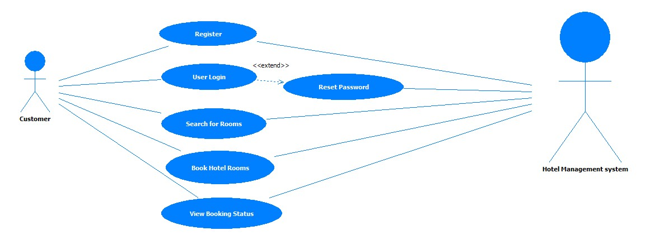

Scenarios

Success Scenarios

* Successful Login in Asset Management System

Failure Scenarios

* Failed Login in Asset Management System for entering invalid Username
* Failed Login in Asset Management System for not entering invalid password

Issues

1. What is to be done if web server is down?
2. What is to be done if the Asset Management link does not get opened?
3. What is to be done if there is data connectivity error?
4. What is to be done if the form is not getting submitted even after entering valid field details without any alerts for errors?

Extension Points

Extension in Alternate FLOW 1:

In step 1, of alternative flow 1 if the User clicks on Submit Button

1. The User can enter all the details again.

Assumptions

1.User can easily login.

2.The User has selected and entered all the fields.

REVISION HISTORY OF THE WORK PRODUCT

<to be maintained by projects>

|  |  |  |  |  |  |
| --- | --- | --- | --- | --- | --- |
| # | Date | Version # | Section Changed | Details of changes made | Approved By |
| 1 |  |  |  |  |  |
| 2 |  |  |  |  |  |