Use Case Specification

DMT/RM01/TMP

|  |  |
| --- | --- |
| Project Code | PRJ_AMS_01 |
| Project Name | Asset Management System |

|  |  |  |
| --- | --- | --- |
| Prepared/Modified by | Role | Date of Preparation |
| Anusha Godaba | Test Engineer | 26/09/18 |
| Reviewed by | Role | Date of Review |
| Manisha Das | SME |  |
| Approved by | Role | Date of Approval |
| Amit Waghmare | Test Manager |  |
| Circulation List |  | Version Number of the template: |
| Version Number | 1 |  |

<<Customer>> REVIEW HISTORY

<<Customer comments on the Use case along with the signed off is tracked here>>

|  |  |  |  |  |  |  |
| --- | --- | --- | --- | --- | --- | --- |
| Version | <<Version number>> |  |  |  |  |  |
| Date | <<Date of Review>> |  |  |  |  |  |
| Reviewed by | << Reviewer Name>> |  |  |  |  |  |
| Reviewed UI Specification doc | << Whether UI Specification doc is reviewed >> |  |  |  |  |  |
| All Open Queries/issues closed | << Whether all the open queries and issues resolved>> |  |  |  |  |  |
| Agreement on Assumptions | <<Whether all the assumptions have been agreed upon by the customer>> |  |  |  |  |  |
| Sign Off | <<Signature>> |  |  |  |  |  |

Disclaimer:

The scope of the project ‘<<Project Name>>’ is restricted to the contents of this signed off use case.TABLE OF CONTENTS

1. Use case Name 1
2. Actor(s) 1
3. Preconditions 2
4. Flow of events 3
   1. Basic Flow 4
   2. Alternate Flow 1 4
   3. Alternate Flow 2 5
   4. Alternate Flow 3 5
   5. Alternate Flow 4 6
5. Exception Flows
   1. Exception Flow 1 7
   2. Exception Flow 2 7
   3. Exception Flow 3 8
   4. Exception Flow 4 8
6. Post Conditions 9
7. Special Requirements
   1. Performance 10
   2. Availability 11
   3. Business Rules 11
8. Diagrams
   1. Use Case Diagram 12
      1. For Successful Log In 13
9. Scenarios
   1. Success Scenarios 14
   2. Failure Scenarios 14
10. Issues 14
11. Assumptions 15
12. Revision History of the RESERVATIONS 15

Use Case Name: AIRLINE RESERVATION SYSTEM

Use Case ID: AssetLog In

Brief Description: This usecase diagram in an ASSET MANAGEMENT SYSTEM used to search for an asset based on search condition, assign a hardware asset to/from an employee based on request, insert new asset details, modify an existing asset details and display all asset allocation request details.

Actor(s)

1.Administrator

2.Asset Management System

Preconditions.

1. The admin has successfully launched into the admin <http://ndafile:8081/AssetManagementSystem_Spring/>index.html

2. Admin has logged in with a registered ID and password.

Flow of Events

4.1 Basic Flow

Name: Successful Analyse and Update

1. From the Authority log In Page and select Admin option button.
2. Admin enters valid login credentials and clicks on Login button.
3. Admin updates and manages Asset schedules.
4. Admin updates and manages Asset information.
5. Admin generates and views various reports like:
   * + - List of Assets on a particular day.
       - Raising Request of specific Asset
       - Employee list of specific Asset

6. Admin Logs Out.

* 1. Alternative Flows

Alternate Flow 1: Successful Analyse and Update

1. From the Authority log In Page and select Admin option button.
2. Admin enters valid login credentials and clicks on Login button.
3. Admin updates and manages Asset information.
4. Admin generates and views various reports like:
   * + - List of Assets on a particular day, to a particular destination etc
       - Bookings of specific Asset
       - Passenger list of specific Asset
5. Admin Logs Out.

Alternate Flow 2:

Name: Successful Analyse and Update

1. From the Authority log In Page and select Admin option button.
2. Admin enters valid login credentials and clicks on Login button.
3. Admin updates and manages Asset details.
4. Admin Logs Out.
5. Alternate Flow 3:

Exception Flow 1 : unsuccessful Admin log in due to incorrect login credentials

Name: Successful Analyse and Update

1. From the Authority log In Page and select Admin option button.
2. Admin enters Invalid login credentials and clicks on Login button.
3. Admin cannot log in and proper error message is displayed.

Exception Flow 2: Web Server Down

1. From the Authority log In Page and select Admin option button.
2. Admin enters valid login credentials and clicks on Login button.
3. The system displays an error message regarding web server unavailability problem

Exception Flow 3: Database Connectivity Error

1. From the Authority log In Page and select Admin option button.
2. Admin enters valid login credentials and clicks on Login button.
3. Admin updates and manages Asset schedules.
4. Admin updates and manages Asset information.
5. The system displays an error message regarding database connectivity problem.

Exception Flow 4: Network Connectivity Error

1. From the Authority log In Page and select Admin option button.
2. Admin enters valid login credentials and clicks on Login button.
3. The system displays an error message regarding network connectivity problem.

1. Post Conditions

| Flow Name | Post Condition |
| --- | --- |
| Successful Log In | System lets the Admin to login through Authority Login page. |
| Unsuccessful Log In | System displays the error message “Log In Unsuccessful” with a message “Please enter valid information only”. |
| Unsuccessful Log In due to Invlaid User ID | System displays the error message “Log In Unsuccessful” with a message “Please enter a valid User ID”. |
| Unsuccessful Log In due to Unmatched Password format | System displays the error message “Log In Unsuccessful” with a message “Please enter the correct password”. |
| Web Server Down | The system should display an error message to the user regarding web server unavailability problem |
| Database Connectivity Error | The system should display an error message to the user regarding the database connectivity problem |
| Network Connectivity Error | The system should display an error message to the user regarding the network connectivity problem |

7 Special Requirements

Performance

The application maintains the Event Log File in an XML format to log the details about unsuccessful login attempts to the website.

The system must automatically log out the user after a period of inactivity for 10 minutes.

Availability

* 1. Application is up and running 24*7.

Business Rules

| Business Rule Name | Business Rule Description | System action (if BR fails) |
| --- | --- | --- |
| BR03 | 1. User Name should accept user id. 2. User ID should be registered in Airline Rreservation System. | Error message if criteria not met. |
| BR04 | Password must be between 6-8 characters. | Error message if criteria not met or fireld left blank. |

Diagrams

1. Use Case Diagram
   1. For Successful Log In

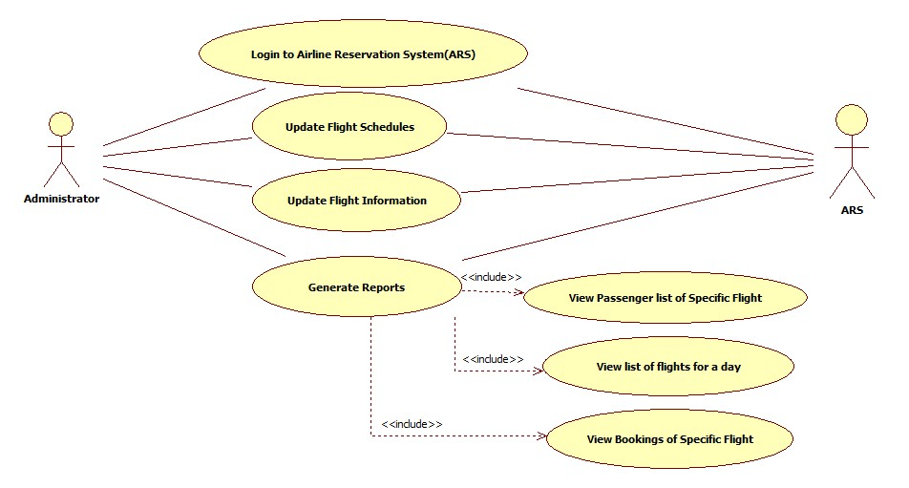

1. Scenarios

Success Scenarios

* Successful Log In

Failure Scenarios

* Failed submission of unsuccessful Log In due to entering invalid User ID.
* Failed submission of unsuccessful Log In due to entering unmatched password.
* Failed submission of unsuccessful Log In due to web server down.
* Failed submission of unsuccessful Log In due to database connectivity error.
* Failed submission of unsuccessful Log In due to netwok connectivity error.

1. Issues
2. What is to be done if web server is down?
3. What is to be done if there is data connectivity error?

Assumptions

1. Only registered users can avail this service.

REVISION HISTORY OF THE RESERVATIONS.

<to be maintained by projects>

|  |  |  |  |  |  |
| --- | --- | --- | --- | --- | --- |
| # | Date | Version # | Section Changed | Details of changes made | Approved By |
| 1 |  |  |  |  |  |
| 2 |  |  |  |  |  |