EXPERIENCE IN AKIRACHIX



In Akirachix we have started everything from scratch. With no discrimination of the information one knows as a person. We are currently studying different courses for example Introduction to computers, HTML and CSS, Life Skills, Entrepreneurship, Graphic Design, Hardware Electronics, Hardware Design, Python.

**INTRODUCTION TO COMPUTERS**

In introduction to computers we have learnt on how to use a computer, we also learnt about parts of a computer. Typing practices have been ongoing and they are really helping. We learnt about domains, how to know if a site is legit or not, how to send professional emails.

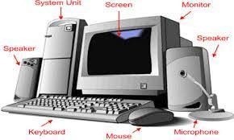

**Hardware Design**

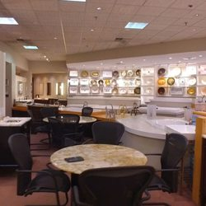

In this unit we are learning about Design Thinking and processes, sketching (2D), Design thinking, Sketching (3D), Design thinking lab, Sketching, Introduction to Digital Design.

In Introduction to Hardware and Design we learnt about the product design process which includes: definition stage, Research, Ideation, Prototyping, Selection, Implementation, Learning.

We have also learnt about the key principles and mindset of Design Thinking. They include: Human centered, collaborative teamwork, learning by doing, embracing experimentation, understanding patterns relationships and system, visual and show. Modules of Design Thinking include inspiration, ideation, and implementation.

**ELECTRONICS**

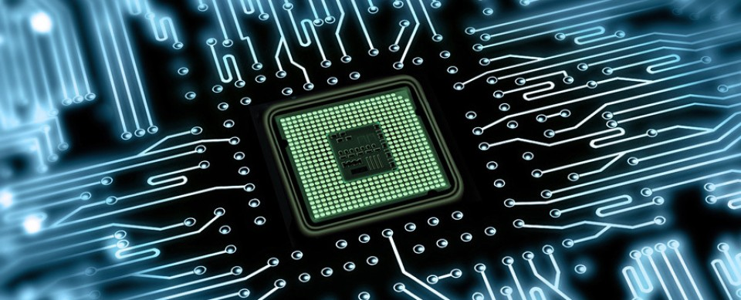

Comprises of components + Physics + Circuits. I have electric current, resistor, Kirchhoff Voltage Law, series, Voltage divider, and Resistance in parallel.

**LIFE SKILLS**

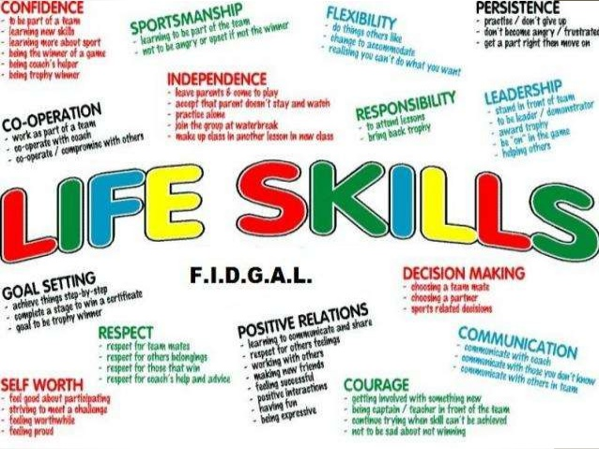

In life skills we wrote our 2018 story, we drew visual boards which are our inspirations, we were grouped into groups of three. The three people our accountability partners. We have also been able to discuss about our SWOTs.

**GRAPHIC DESIGN**

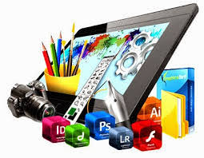

Art or skill of combining text and pictures in advertisements, magazines or books.

In Graphic Design we have learnt about colors, pen tool, drawing using Adobe illustrator. We have also learnt that we can express feelings or something using pictures.

**PYTHON**



In Python we have learnt about variables and strings. We have also learnt how it stores data through strings and variables.

**HTML and CSS**

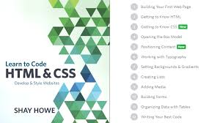

In HTML and CSS we made our first site using attributes. The attributes include href, title, width, alt, br, pre, p and many more. Opening tabs and closing tabs seemed too essential in this section.

**ENTREPRENEURSHIP**

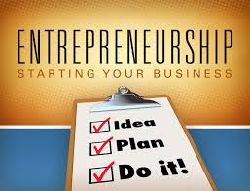

Entrepreneurship is the process of designing, launching and running a new business, which is often initially a small business. The people who create these businesses are called entrepreneurs.

We learnt about characteristics of entrepreneurs. Entrepreneur is an individual who undertakes the creation, organization, ownership, and risk of a business. Most entrepreneurs and born and others made.

Through this class we have learnt about different companies, who funded them and from where, their main customers, what they do. Lately we saw a clip about a foldable phone which has a storage of 1 Gigabyte (Samsung S10) and sooner a foldable Huawei was released.

**CONCLUSION**

So far the experience has been fine and wonderful.