**R-PLOT Assignment (Team:**, Himanshi Manglunia, Kalpita Raut, Ann Laura Walker**)**

1. **Category: Completion Rate**

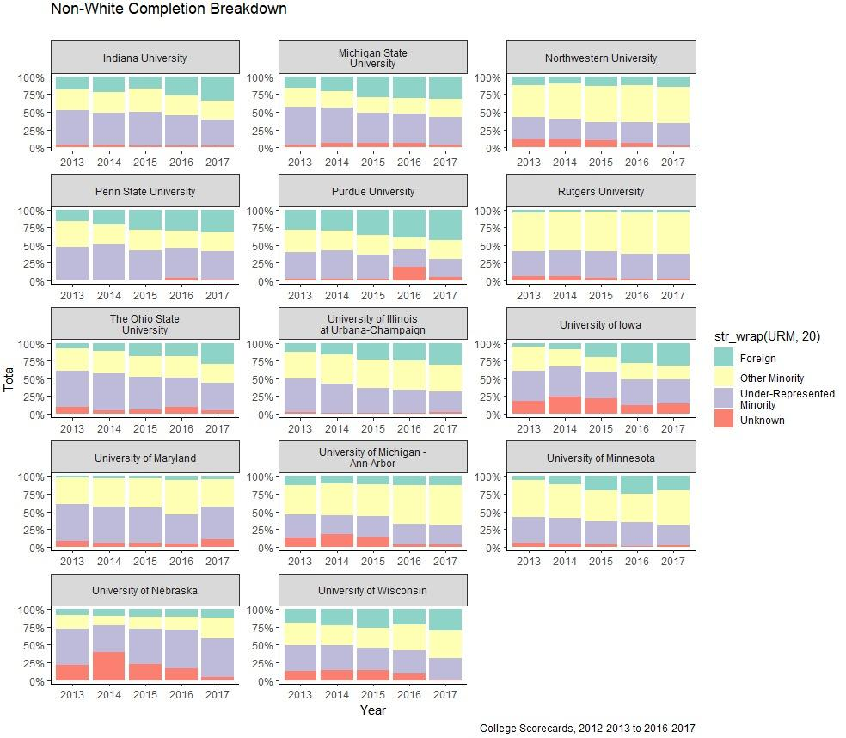

**Fig1. Completion Rate between the Big Ten Universities based on Student’s Minorities**

**Plot Description**:

This plot analyzes the proportion of minorities to their respective completion rate from 2013 till 2017 based on student minorities. The number of full-time, first-time, degree/certificate-seeking undergraduates used by the institution to calculate completion rate within 150 percent of normal time, included in the IPEDS Graduation Rates component. This metric is based on the number of full-time, first-time, degree/certificate-seeking undergraduates who initially enrolled in the fall term (for institutions that primarily follow an academic year calendar system) or any time during the academic year (for institutions that primarily follow a continuous enrolment or program-based calendar system).

1. **Category: Debt**

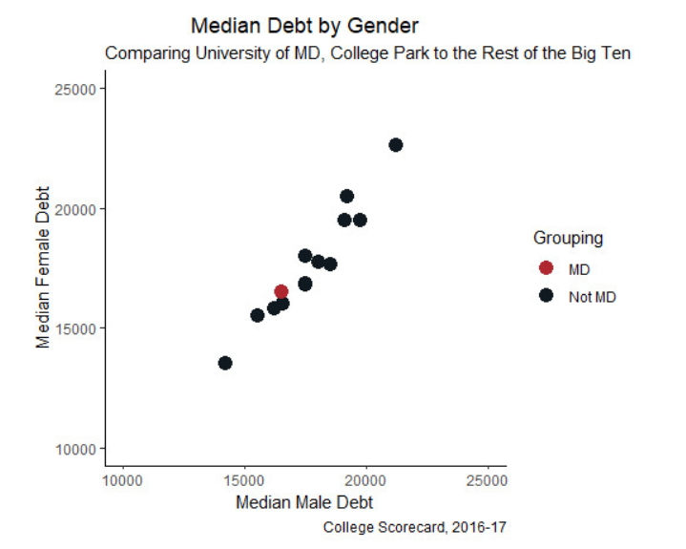

**Fig2. Median Debt by Gender**

**Plot Description:**

This plot describes the median debt of male and female students in the other Big Ten institutions as compared with University of Maryland, College Park from 2016-2017. The focus of this plot is to gather insight into the median debt of the students of University of Maryland which explains why the other institutes are grouped as ‘Not UMD’ (including other institute names would have made for a text heavy mess). From this plot, we observe that the median debt of the male as well as female students at the University of Maryland is approximately between $15,000 to $20,000.

**3. Category: Repayment**

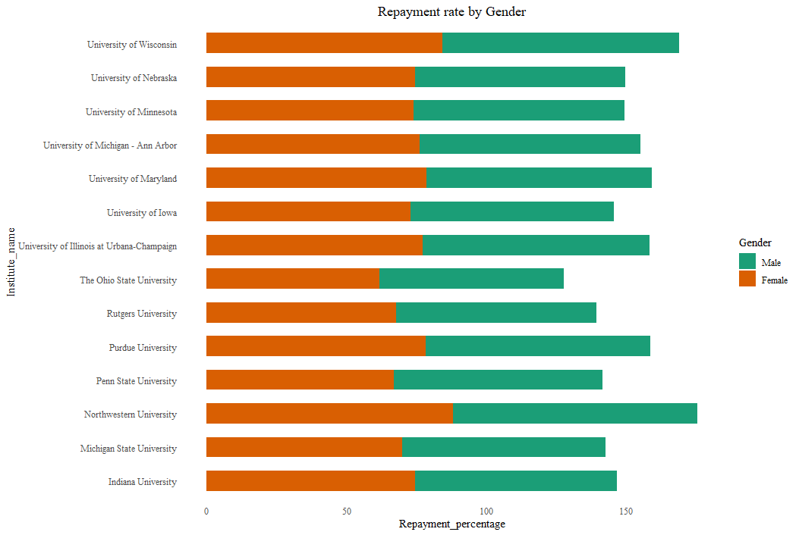**Fig3. Repayment rate( 3 years) for all Big Ten institutions**

**Plot Description:**

Repayment rate depicts the fraction of borrowers at an institution who are not in default on their federal loans and who are making progress in paying them down (i.e. have paid down at least $1 in the initial balance on their loans) after entering repayment. The rates are available for 1, 3, 5, and 7 years after entering repayment. The plot above depicts the repayment rate of 3 years of the students from all the BIG TEN institutions categorized on the basis of gender.