ANDROID
CARS ACTIVITY
By: Ann Mariya T K(23UBC120)

1.activity_main.xml
<?xml version="1.0" encoding="utf-8"?>
<LinearLayout
xmlns:android="http://schemas.android.com/apk/res/android"
android:layout_width="match_parent"
android:layout_height="match_parent"
android:orientation="vertical"
android:padding="20dp"
android:gravity="center">

<EditText
android:id="@+id/etStudent"
android:hint="Enter Student Name"
android:layout_width="match_parent"
android:layout_height="wrap_content"/>

<EditText
android:id="@+id/etBook"
android:hint="Enter Book Name"
android:layout_width="match_parent"
android:layout_height="wrap_content"
android:layout_marginTop="15dp"/>

<Button
android:id="@+id/btnIssue"
android:text="Issue Book"
android:layout_width="match_parent"
android:layout_height="wrap_content"
android:layout_marginTop="20dp"/>

</LinearLayout>

2. MainActivity.java
package com.example.libraryapp;

import android.content.Intent;
import android.os.Bundle;
import android.view.View;
import android.widget.Button;
import android.widget.EditText;

import androidx.appcompat.app.AppCompatActivity;

public class MainActivity extends AppCompatActivity {

EditText etStudent, etBook;
Button btnIssue;

@Override
protected void onCreate(Bundle savedInstanceState) {
super.onCreate(savedInstanceState);
setContentView(R.layout.activity_main);

etStudent = findViewById(R.id.etStudent);
etBook = findViewById(R.id.etBook);
btnIssue = findViewById(R.id.btnIssue);

btnIssue.setOnClickListener(new View.OnClickListener() {
@Override
public void onClick(View v) {

String student = etStudent.getText().toString();
String book = etBook.getText().toString();

Intent intent = new Intent(MainActivity.this, ResultActivity.class);
intent.putExtra("student_name", student);
intent.putExtra("book_name", book);

startActivity(intent);
}
});
}
}

3. activity_result.xml
<?xml version="1.0" encoding="utf-8"?>
<LinearLayout
xmlns:android="http://schemas.android.com/apk/res/android"
android:layout_width="match_parent"
android:layout_height="match_parent"
android:gravity="center"
android:orientation="vertical"
android:padding="20dp">

<TextView
android:id="@+id/tvResult"
android:textSize="20sp"
android:textStyle="bold"
android:layout_width="wrap_content"
android:layout_height="wrap_content"/>

</LinearLayout>

4. ResultActivity.java
package com.example.libraryapp;

import android.os.Bundle;
import android.widget.TextView;

import androidx.appcompat.app.AppCompatActivity;

public class ResultActivity extends AppCompatActivity {

TextView tvResult;

@Override
protected void onCreate(Bundle savedInstanceState) {
super.onCreate(savedInstanceState);
setContentView(R.layout.activity_result);

tvResult = findViewById(R.id.tvResult);

String student = getIntent().getStringExtra("student_name");
String book = getIntent().getStringExtra("book_name");

tvResult.setText("Book Issued Successfully\n\nStudent: "
+ student + "\nBook: " + book);
}
}

SCREENSHOTS

Before entering the details:
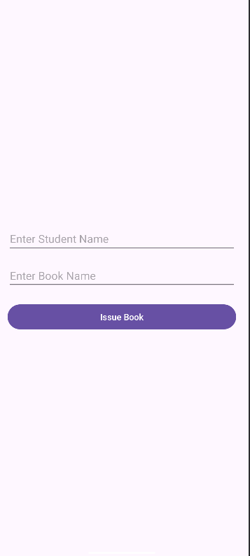

After entering the details:
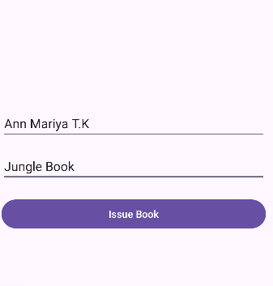

After clicking issue book button:
