**Experiment-4**

**AIM :** Familiarization of LINUX commands.

**CO2 :** Perform system administration tasks.

**PROCEDURE :**

1. **cut -c** : For cutting out sections from each line of files and writing the result to standard input.

$ cut -c 1 (filename)

OUTPUT:

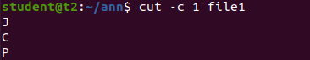

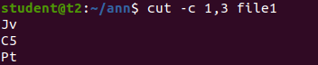

1. **cut -b** : To extract the specific bytes, you need to follow -b option with the list of byte numbers separated by comma. Range of bytes can also be specified using the hyphen(-). It is necessary to specify list of byte numbers otherwise it gives error. **Tabs and backspaces** are treated like as a character of 1 byte.

$ cut -b 2 (filename)

OUTPUT:

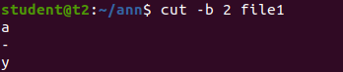

1. **cut -d** :
2. $ cut -d - -f1 file1

OUTPUT:

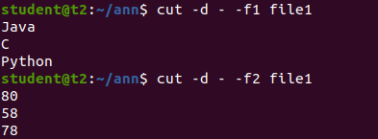

1. $ cut -d ‘ ‘ -f2 file2

OUTPUT:



1. **cut --complement -c** : it complement the output. This option can be used in the combination with other options either with **-f** or with **-c**.

$ cut -- complement -c 1 filename

OUTPUT:

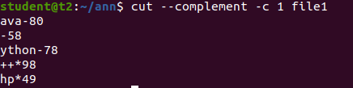

1. **paste** : When invoked without an option paste will read all files given as arguments and horizontally merge the corresponding lines of the files, separated by space.
2. $ paste file2 file2

OUTPUT:

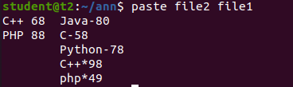

1. $ paste -d ‘%’ mrk1 mrk2 > mrk3

OUTPUT:



1. The > operator will overwrite an existing file.

$ paste file2 > file3

OUTPUT:



1. **cp** : The cp command is to create a copy of the contents of the file or directory specified.

$ cp test1 test 2

OUTPUT:

