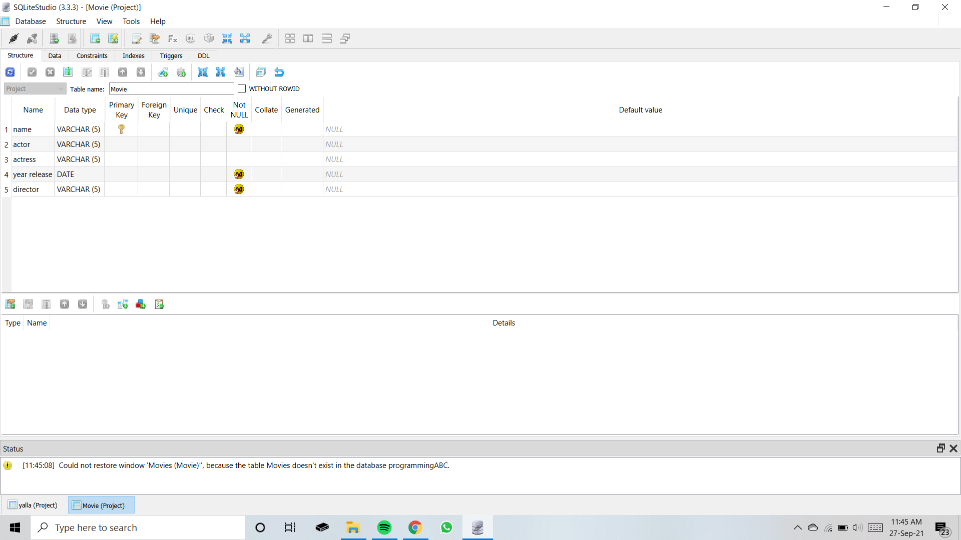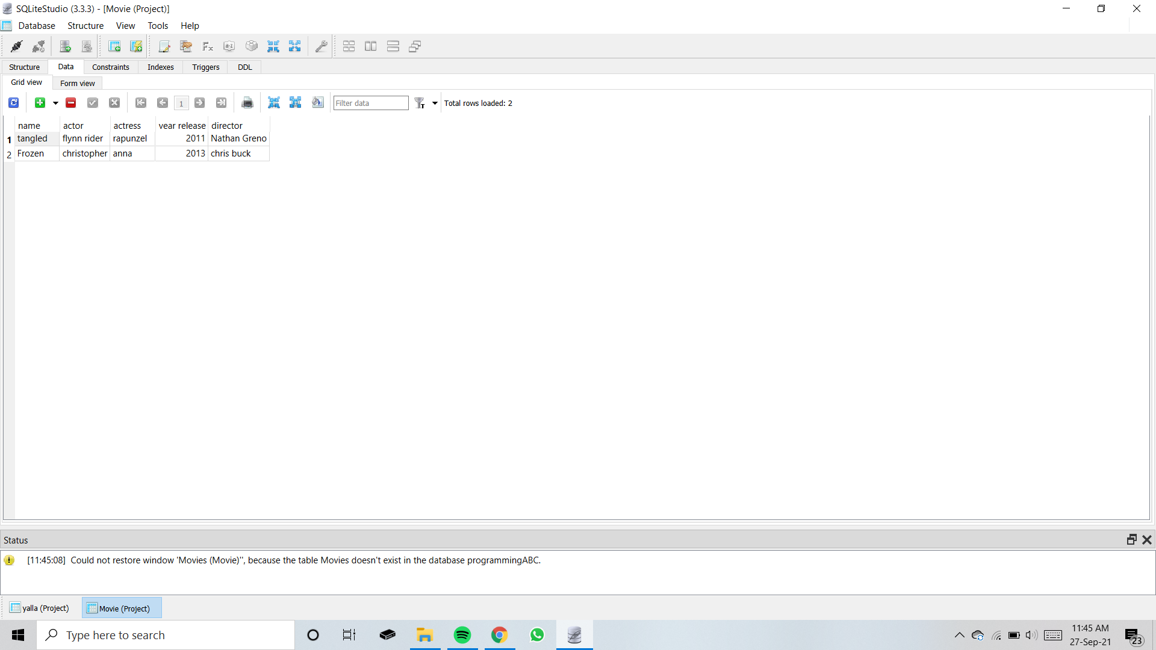

**CODE USED TO RETIREIVE DATA FROM THE DATABASE**

#include <stdio.h>

#include <stdlib.h>

#include <sqlite3.h>

static int callback(void *data, int argc, char **argv, char **azColName){

int i;

fprintf(stderr, "%s: ", (const char*)data);

for(i = 0; i<argc; i++){

printf("%s = %s\n", azColName[i], argv[i] ? argv[i] : "NULL");

}

printf("\n");

return 0;

}

int main(int argc, char* argv[]) {

sqlite3 *db;

char *zErrMsg = 0;

int rc;

char *sql;

const char* data = "Callback function called";

/* Open database */

rc = sqlite3_open("Project.db", &db);

if( rc ) {

fprintf(stderr, "Can't open database: %s\n", sqlite3_errmsg(db));

return(0);

} else {

fprintf(stderr, "Opened database successfully\n");

}

/* Create SQL statement */

sql = "SELECT * from Movie";

/* Execute SQL statement */

rc = sqlite3_exec(db, sql, callback, (void*)data, &zErrMsg);

if( rc != SQLITE_OK ) {

fprintf(stderr, "SQL error: %s\n", zErrMsg);

sqlite3_free(zErrMsg);

} else {

fprintf(stdout, "Operation done successfully\n");

}

sqlite3_close(db);

return 0;

}