Name:Annalakshmi R Roll No:25BAD010 Date:17/7/26 Ex no:01
Slot:A10

Implementation of List using ADT

Aim
To implement the List Abstract Data Type (ADT) in C and perform the basic operations such as Insertion, Deletion, Updation, and Display.
Algorithm (Pseudo Code)
- Start.
- Define a List ADT with an array and its size.
- Read the initial number of elements and create the list.
- Display a menu with the following operations:
  - Insertion
  - Deletion
  - Updation
  - Display
  - Exit
- Read the user's choice.
- Perform the selected operation:
  - Insertion: Insert an element at the specified position.
  - Deletion: Delete an element from the specified position.
  - Updation: Update an element at the specified position.
  - Display: Display all elements of the list.
- Repeat the menu until the user chooses Exit.
- Stop.
Code
#include <stdio.h>

#define MAX 100

struct List
{
int arr[MAX];
int size;
};

void createList(struct List *l, int n)
{
l->size = n;

printf("Enter %d elements:\n", n);

for(int i=0;i<n;i++)
scanf("%d",&l->arr[i]);
}

void insert(struct List *l, int pos, int element)
{
if(l->size == MAX)
{
printf("List is Full\n");
return;
}

for(int i=l->size;i>=pos;i--)
l->arr[i]=l->arr[i-1];

l->arr[pos-1]=element;
l->size++;
}

void delete(struct List *l, int pos)
{
for(int i=pos-1;i<l->size-1;i++)
l->arr[i]=l->arr[i+1];

l->size--;
}

void update(struct List *l, int pos, int element)
{
l->arr[pos-1]=element;
}

void display(struct List l)
{
printf("List Elements:\n");

for(int i=0;i<l.size;i++)
printf("%d ",l.arr[i]);

printf("\n");
}

int main()
{
struct List l;
int n,choice,pos,element;

printf("Enter number of elements: ");
scanf("%d",&n);

createList(&l,n);

do
{
printf("\n1.Insert\n2.Delete\n3.Update\n4.Display\n5.Exit\n");
printf("Enter your choice: ");
scanf("%d",&choice);

switch(choice)
{
case 1:
printf("Enter position and element: ");
scanf("%d%d",&pos,&element);
insert(&l,pos,element);
break;

case 2:
printf("Enter position to delete: ");
scanf("%d",&pos);
delete(&l,pos);
break;

case 3:
printf("Enter position and new element: ");
scanf("%d%d",&pos,&element);
update(&l,pos,element);
break;

case 4:
display(l);
break;

case 5:
printf("Exiting...");
break;

default:
printf("Invalid Choice");
}

}while(choice!=5);

return 0;
}

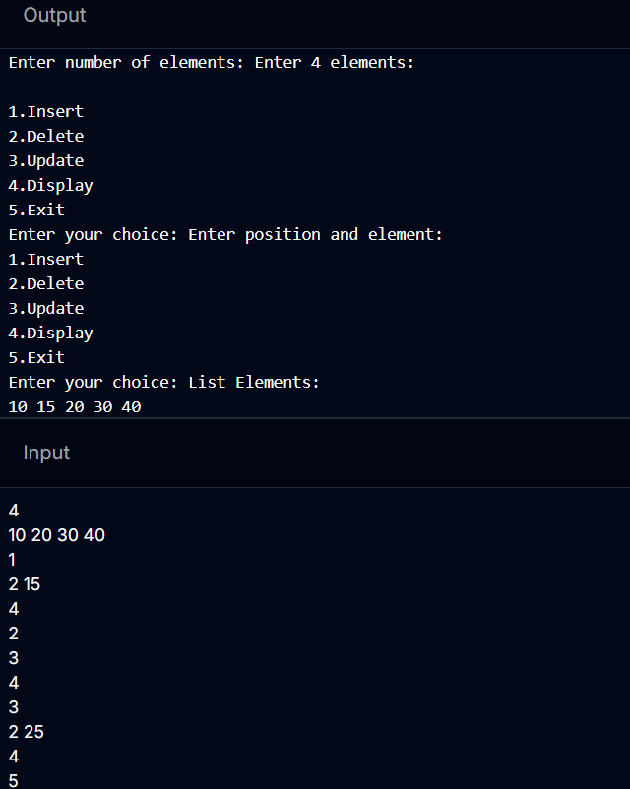
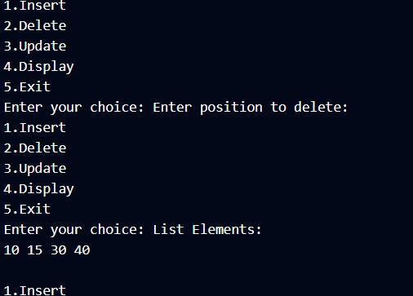
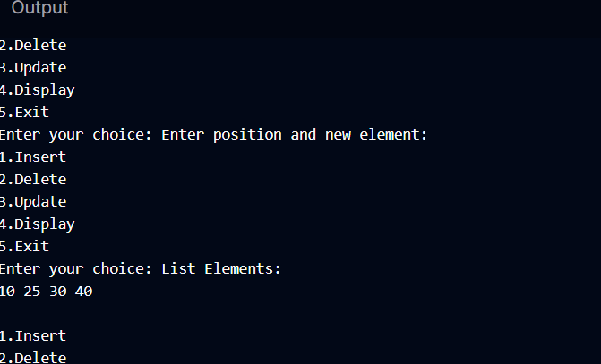
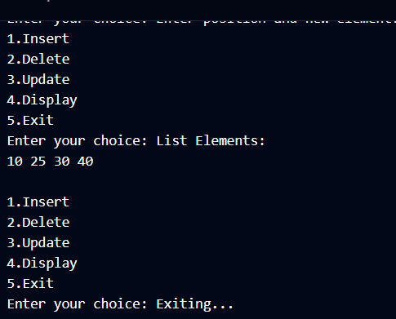

Result
Thus, the List Abstract Data Type (ADT) was successfully implemented in C, and the operations Insertion, Deletion, Updation, and Display were performed successfully.

Ex no:02

Linear Search using ADT
Aim
To implement Linear Search using the List Abstract Data Type (ADT) in C.
Algorithm (Pseudo Code)
- Start.
- Define a List ADT.
- Read the number of elements.
- Create the list.
- Read the search element (key).
- Compare the key with each element one by one.
- If found, return its position.
- Otherwise, display "Element not found."
- Stop.

Code

#include <stdio.h>

#define MAX 100

struct List
{
int arr[MAX];
int size;
};

void createList(struct List *l,int n)
{
l->size=n;

printf("Enter %d elements:\n",n);

for(int i=0;i<n;i++)
{
scanf("%d",&l->arr[i]);
}
}

int linearSearch(struct List l,int key)
{
for(int i=0;i<l.size;i++)
{
if(l.arr[i]==key)
return i;
}

return -1;
}

int main()
{
struct List l;
int n,key,result;

printf("Enter number of elements: ");
scanf("%d",&n);

createList(&l,n);

printf("Enter element to search: ");
scanf("%d",&key);

result=linearSearch(l,key);

if(result!=-1)
printf("Element found at position %d\n",result+1);
else
printf("Element not found.\n");

return 0;
}

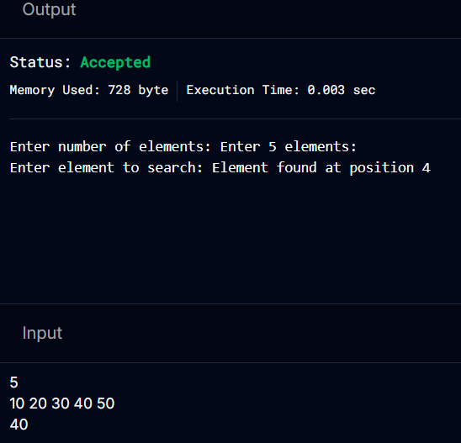

Result
Thus, the Linear Search operation using the List ADT was successfully implemented and the required element was searched correctly.

Ex no:03

Binary Search using ADT

Aim
To implement Binary Search using the List Abstract Data Type (ADT) in C.
Note: The list must be sorted in ascending order.
Algorithm (Pseudo Code)
- Start.
- Define a List ADT.
- Read the number of elements.
- Create a sorted list.
- Read the search element (key).
- Set low = 0 and high = size - 1.
- Find the middle element.
- If the middle element equals the key, return its position.
- If the key is smaller, search the left half.
- If the key is larger, search the right half.
- Repeat until the element is found or the search space becomes empty.
- If not found, display "Element not found."
- Stop.

Code
#include <stdio.h>

#define MAX 100

struct List
{
int arr[MAX];
int size;
};

void createList(struct List *l,int n)
{
l->size=n;

printf("Enter %d sorted elements:\n",n);

for(int i=0;i<n;i++)
{
scanf("%d",&l->arr[i]);
}
}

int binarySearch(struct List l,int key)
{
int low=0;
int high=l.size-1;

while(low<=high)
{
int mid=(low+high)/2;

if(l.arr[mid]==key)
return mid;

else if(key<l.arr[mid])
high=mid-1;

else
low=mid+1;
}

return -1;
}

int main()
{
struct List l;
int n,key,result;

printf("Enter number of elements: ");
scanf("%d",&n);

createList(&l,n);

printf("Enter element to search: ");
scanf("%d",&key);

result=binarySearch(l,key);

if(result!=-1)
printf("Element found at position %d\n",result+1);
else
printf("Element not found.\n");

return 0;
}

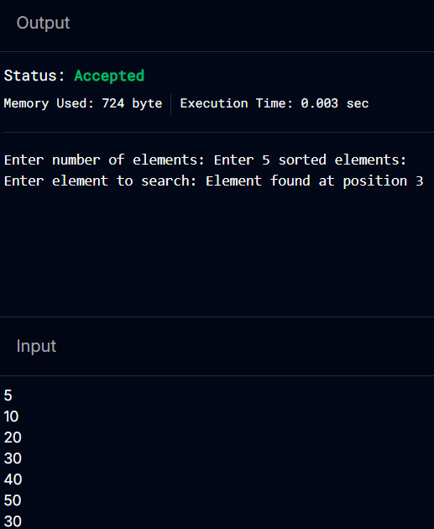

Result
Thus, the Binary Search operation using the List ADT was successfully implemented in C, and the required element was searched efficiently in a sorted list.

