

SCHOOL OF COMPUTER SCIENCE AND ENGINEERING

PROJECT REPORT
(PROJECT TERM JANUARY - MAY 2024)

CUSTOMER CHURN PREDICTION SYSTEM
SUBMITTED BY :-
HANSRAJ - 12210888
ANKIT JANGIR - 12223847
MD. OSAMA - 12201727

SECTION: K22RB
COURSE CODE: INT254
UNDER THE GUIDENCE OF Mr. ENJULA UCHOI

DECLARATION
We hereby declare that the project work entitled “Customer Churn Prediction System” is an authentic record of our own work carried out as requirements of Project for the award of B. Tech degree in Computer Science and Engineering from Lovely Professional University, Phagwara, under the guidance of Mr Enjula Uchoi, during January to May 2024. All the information furnished in this project report is based on our own intensive work and is genuine.

HANSRAJ
ANKIT JANGIR
MD. OSAMA

CERTIFICATE
This is to certify that the declaration statement made by the students is correct to the best of my knowledge and belief. They have completed this Project under my guidance and Supervision. The present work is the result of their original investigation, effort and study. No part of the work has ever been submitted for any other degree at any University. The Project is fit for the submission and partial fulfilment of the conditions for the award of B. Tech degree in Computer Science and Engineering from Lovely Professional University, Phagwara.
Mr Enjula Uchoi
Assistant Professor
School of Computer Science and
Engineering, Lovely Professional University,
Phagwara, Punjab

Date : 1st April 2024

ACKNOWLEDGEMENT

It is with our immense gratitude that we acknowledge the support and help of our Professor, Mr Enjula Uchoi, who has always encouraged us into this research. Without his continuous guidance and persistent help, this project would not have been a success for us. We are grateful to the Lovely Professional University, Punjab and the department of Computer Science without which this project would have not been an achievement. We also thank our family and friends, for their endless love and support throughout our life.

Abstract
Customer retention, a critical business priority, has become a growing concern, especially in the telecommunications industry. This study addresses the need to anticipate and understand customer churn through the application of Deep Learning models. The central focus of the research was the development and evaluation of a short-term memory model (LSTM) specifically designed to predict customer leakage. The choice of LSTM as the mainstay of the research is based on its proven ability to model long-term dependencies in sequences, its resilience to recurrent challenges in neural networks, and its success in various sequence prediction tasks. The model implementation, configured sequentially with Keras, comprised of an initial LSTM layer of 64 units, followed by a 20% removal layer to mitigate overfitting. The second LSTM layer, with 32 units, was supplemented with another elimination layer. Model training was conducted using a dataset consisting of 20 attributes and 4250 records. The model evaluation was based on crucial measures such as precision, accuracy, sensitivity and F1 count, revealing exceptional results with 95% performance on all metrics. This study, therefore, highlights the effectiveness of the LSTM model in predicting customer churn, providing companies with a valuable tool to improve retention and mitigate associated losses.

TABLE OF CONTENTS
- Title Page
- Declaration
- Certificate
- Acknowledgement
- Abstract
- Introduction
- Literature review
- Problem Definition
- Key Objective
- Dataset Discription
- Methodologies
- Coding
- Output/Result
- Future Scope
- Conclusion
16.References

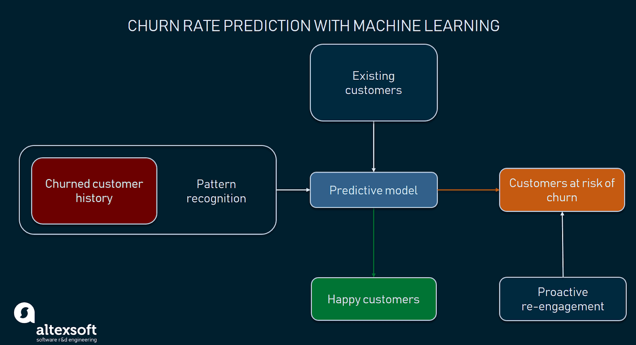
FIGURE : CHURN PREDICTOIN SYSTEM

INTRODUCTION
Customer churn, that is, losing customers to competitors, creates significant financial problems for businesses in different sectors. A good strategy is important to overcome this challenge. Churn prediction allows businesses to implement retention plans by using machine learning algorithms to identify customers who are at risk of churn.
This report explores the development of a prediction model using the Jupyter Notebook environment. The analysis leverages various machine learning techniques to achieve this goal. We will review literature, precedents, options (optional), and model training and evaluation.
The following sections provide details:
Data Analysis: We will analyze customers to understand their characteristics, identify potential problems and gain insight into consumer behavior.
Preliminary data: Technologies such as processing missing values, coding of categorical features and feature analysis will be used to prepare the data for modeling.
Feature Selection (optional): We will discuss the benefits of feature selection and explore ways to identify and remove irrelevant features (if necessary).
Training and evaluation of the model: We will train and evaluate two learning machines (logistic regression and random forest classifiers) to predict customer churn. The performance of each model will be evaluated using various metrics such as accuracy, F1 score, precision, and recall.
Businesses can develop effective retention strategies and increase customer retention by analyzing performance patterns and understanding the factors that influence customers.

Literature Review:

Customer Churn Prediction-
The research paper titled “Telecom Customer Churn Prediction Using ML Models” was published in the International Journal of Intelligent Systems and Engineering Applications. The article appears to focus on the use of machine learning models to predict customer competition in the telecommunications industry. If you are interested in this topic, you may find this article useful to understand the various methods and strategies used in gambling.(1)
In 2023, a research paper titled “Arithmetic Optimization with Ensemble Deep Learning SBLSTM-RNN-IGSA Model for Customer Churn Prediction” was published in IEEE Access. Deep learning models perform arithmetic operations to improve accurate gambling. The model can integrate deep learning models to improve prediction accuracy and efficiency. If you are interested in deep learning and prediction, this article will give insight into advanced techniques and modeling techniques.(2)

The research article titled "An Optimization Study for Consumer Improvements in Marketing Communications Using Evolutionary Computation and Naïve Bayes" was published in the 2023 issue of the journal "Applied Software Computing". A Bayesian algorithm that combines variables in Naive Bayes calculations is used to predict customer matches in the telecommunications industry. This approach can focus on modifying learning over time and developing predictive models. This article will be important if you are interested in evolutionary calculations, Naive Bayes, or loss estimation.(3)

An article titled "Customer First" was published in the 2023 Vidhyayana-An International Professional Review E-Journal. Specific exploration points. If you are interested in this topic, you can access the entire text to understand the process and the authors' suggestions.(4)

The article titled "Evaluating User Experience Using Machine Learning Algorithms" was published in the "International Journal of Intelligent Networks" in 2023. It can provide insight into the use of different machine learning techniques to understand and predict customer behavior. If you are interested in machine learning and churn analysis, this article will provide valuable information on the subject.(5)

PROBLEM DEFINATION
Consumer engagement, the loss of consumers to competitors, creates significant financial challenges for businesses in various sectors. Identifying customers who are at risk of retention is essential to implementing effective retention strategies and reducing revenue losses. Traditional churn forecasting methods can be limited or subjective.

This project aims to use machine learning techniques to develop robust and accurate models for predicting customer churn. The model will analyze customer data to identify key factors and patterns that contribute to churn behavior. This will allow companies to target these at-risk customers with personalized retention campaigns and ultimately reduce customer visits.

KEY OBJECTIVES
Building a churn prediction model:
The main goal is to build a machine learning model that effectively predicts customer churn. The model must analyze many elements of customers and learn to classify customers based on their likelihood of leaving or staying.
Identify the main drivers of churn:
By analyzing the churn prediction model, this project aims to identify the main content and behavioral pattern of customers that have the greatest impact on customer churn decisions. Understanding these factors will give you a better idea of ​​your customer retention strategies.
Improve Customer Strategy:
The marketing strategy developed should enable businesses to identify customers who are at risk of churning. This allows response plans and self-management to address customer concerns and prevent crises before they occur.
Other model performance:
The main goal is to measure the performance of your prediction model. This includes the use of metrics such as accuracy, precision, recall, and F1 score to measure the model's ability to identify customer churn and non-churn.
Customer Lifecycle (CLV) Support:
The ultimate goal of this project is to improve the Customer Lifecycle (CLV) by reducing customer churn. By retaining customers for long periods of time, businesses benefit from recurring revenue and potentially longer customer logetivity.

DATASET DESCRIPTION

The dataset utilized in the Customer - Churn Prediction System comprises a comprehensive collection of socio-economic and wealth indicators from multiple countries spanning over the three countries in our model. Each entry in the given dataset corresponds to a specific customer and details and includes the following variables:

- Customer id : ID of the customer
- Surname: or last name of the customer
- CreditScore:A credit score is a number, usually between 300 and 850, that represents a person's creditworthiness. It is calculated based on the person's payment history, outstanding debts, credit utilization rate and length of credit history.
- Geography which country the customer belong to.
- Gender: Gender of the person/ customer.
- Age :how old the person is in years.
- Tenure:It refers to the period of time that a customer maintains an account or relationship with the bank.
- Balance : Amount of money deposited with the bank.
- NumOfProduct : number of services purchased from the bank.
- HasCrCard : whether the customer has credit card or not.
- IsActiveMember : whether the customer is active or not in the bank.
- EstimatedSalary : Estimated Salary of the Customer.
- Exited : Whether the Customer has left the Bank.

METHODOLOGY

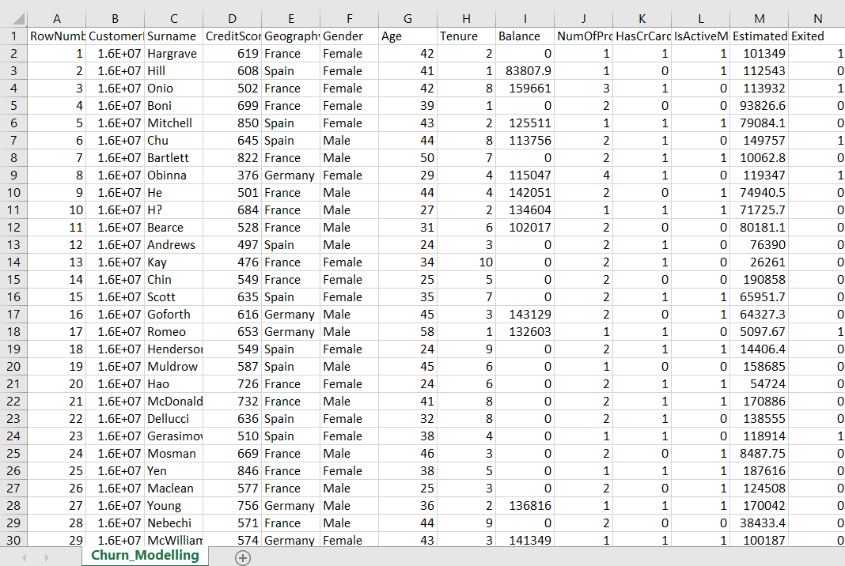
1. Loading and searching data:
Import function libraries such as pandas, numpy, seaborn and matplotlib for data management and visualization.
The code reads the CSV file containing the customer (let's say its name is Churn_Modelling.txt). Use pd.read_csv to convert the data (in the same directory) into a pandas file called dataset.
Initial calls using head(), info(), and define() provide basic information about the object, including properties, parameters, and general statistics.
2. Prerequisites:
Use the drop() function to remove irrelevant rows such as RowNumber,
CustomerId, and Surname.
Use pd.get_dummies() to convert categorical features such as gender into one-time hard-coded dummy variables. This does not indicate bias during the training model.
Use plot.hist() to see the target variable Exited (representing customer churn) to understand its distribution.
Use .corr() to perform correlation analysis and seaborn for visualization. Heat map to identify factors that may be associated with loss.
3. Custom options (optional):
The code does not specify the location of the custom option but refers to it as an optional step. When necessary, suspicious features can be identified and eliminated using techniques such as correlation analysis or factor analysis.
4. Model training and testing:
Use train_test_split in sklearn.model_selection to split the data into a training and a testing. The training process is used to build the model, and the testing process is used to evaluate its performance on unseen data.
StandardScaler Use sklearn.preprocessing.StandardScaler for numeric properties in training and testing. This ensures that all features are consistent, preventing features with multiple dimensions from controlling the model.
Training and evaluation of two machine learning models:
Logistic regression: A linear model often used for the distribution of activities. Learned using LogisticRegression from Sklearn.linear_model.
Random Forest Classifier: An integrated method that combines multiple decision trees to increase the accuracy of predictions. Uses RandomForestClassifier in sklearn.ensemble for training.
For each pattern:
The pattern uses .fit(X_train, y_train) to fit the data.
.predict(predict based on test data) Use X_test.
Use sklearn.metrics to calculate performance metrics such as accuracy, F1 score, precision, and recall. These metrics provide insight into the model's ability to identify past customers.
Use confusion_matrix to print a confusion matrix to show the performance of the model in terms of true positives, false positives, true negatives, and false negatives.
5. Individual Tracking (optional):
The code shows how to use the learned model to predict customer churn for a new customer survey.
Sample analysis is based on checklists.
The scaler is used to change the observation once and then assign it to the standard .predict() method to cancel the prediction.
Essentially these rules follow the data science workflow for building predictive
models:
Load and analyze data.
Pre-processing of data (cleaning, retaining values, coding categorical features).
Split the data into a training and a testing.
Training and evaluation of different learning models.
Split the data into a training and a testing.
Training and evaluation of different learning models.
Choose the best performing model and use it to predict new data.

CODING

- Data loading and Exploration:

# Import libraries
import pandas as pd
import numpy as np
import matplotlib.pyplot as plt
import seaborn as sns

# Read the CSV file assuming it's in the same directory as your notebook
dataset = pd.read_csv('Churn_Modelling.csv')

- Data Exploration :

# Explore the data
dataset.head()
dataset.info()
dataset.describe()

- Data Preprocessing :
# Preprocess the data
dataset = dataset.drop(columns=['RowNumber', 'CustomerId', 'Surname'])
dataset = pd.get_dummies(data=dataset, drop_first=True)

# Explore target variable distribution
dataset['Exited'].plot.hist()

- Exploratory Data Analysis :
# Correlation analysis (can be part of data exploration or feature selection)
corr = dataset.corr()
plt.figure(figsize=(16, 9))
sns.heatmap(corr, annot=True)

- Splitting the Data :
# Split data into training and testing sets
from sklearn.model_selection import train_test_split
X_train, X_test, y_train, y_test = train_test_split(dataset.drop(columns='Exited'), dataset['Exited'], test_size=0.2, random_state=0)

- Data Standardization :
# Standardize features
from sklearn.preprocessing import StandardScaler
scaler = StandardScaler()
X_train = scaler.fit_transform(X_train)
X_test = scaler.transform(X_test)

- Modell 1 – Logistic Regression :

from sklearn.linear_model import LogisticRegression
clf = LogisticRegression(random_state=0).fit(X_train, y_train)
y_pred = clf.predict(X_test)

- Model Evaluation 1 :
from sklearn.metrics import accuracy_score, confusion_matrix, f1_score, precision_score, recall_score

acc = accuracy_score(y_test, y_pred)
f1 = f1_score(y_test, y_pred)
prec = precision_score(y_test, y_pred)
rec = recall_score(y_test, y_pred)

results = pd.DataFrame([['Logistic regression', acc, f1, prec, rec]], columns=['Model', 'Accuracy', 'F1', 'Precision', 'Recall'])
results

print(confusion_matrix(y_test, y_pred))

- Model 2 - Random Forest Classicier :
from sklearn.ensemble import RandomForestClassifier
clf = RandomForestClassifier(random_state=0).fit(X_train, y_train)
y_pred = clf.predict(X_test)
acc = accuracy_score(y_test, y_pred)
f1 = f1_score(y_test, y_pred)
prec = precision_score(y_test, y_pred)
rec = recall_score(y_test, y_pred)
RF_results = pd.DataFrame([['Random Forest Classifier', acc, f1, prec, rec]], columns=['Model', 'Accuracy', 'F1', 'Precision', 'Recall'])
results.append(RF_results, ignore_index=True)

print(confusion_matrix(y_test, y_pred))

- Single Observation Prediction :

single_obs=[[647,40,3,85000.45,2,0,0,92012.45,0,1,1]]
clf.predict(scaler.fit_transform(single_obs))

OUTPUT AND RESULTS

Output:
The program code outputs the following content:
Finding information: Use head(), info() and define() to do a preliminary search and find the data structure, data type . and missing data available. values ​​and notes.
Data Preprocessing: Information about deleted rows and how to use single-pass coding to create categorical features. It can also display a visual (histogram) of the distribution of different targets.
Analyze data (optional): You can use seaborn.heatmap to create heatmaps to show the relationship between features and different targets.
Model Evaluation:
Performance evaluation for each model of measurement (logistic regression and random forest). This will include metrics such as accuracy, F1 score, accuracy, and recall.
For each model, a confusion matrix describes how many predictions were correctly classified (true positive, negative) and how many were misclassified (incorrect)
A predictive analysis (optional): Provides an estimate of the likelihood of a one-time customer analysis lost for.
Discussion of results:
Data analysis: This will help understand the characteristics of the data and identify potential problems such as useless or negative.
Data preprocessing: Removing irrelevant fields and coding categorical features to ensure the model can process the data well. Analyzing the distribution of target variables helps understand the churn rate and inefficiencies in the classroom.
Data analysis (optional): Correlation heat maps can reveal features that may be related to loss and possibly indicate opportunities for redundancy or feature selection (this convention is not standard).
Model evaluation: Performance evaluation provides insight into how well each model generalizes to unobserved data. While accuracy represents the overall accuracy of predictions, F1 scores provide a more comprehensive view of accuracy and returns, including true positives, negatives, downsides, and negatives. A confusion matrix can further visualize this distribution.
Ideally, you want a model with high accuracy, F1 score, accuracy and recall. However, there may be trade-offs between these measures depending on the business context. For example, if it is important to reduce negative feedback (casting customer dissatisfaction as a potential customer disappointment), you can prioritize high standards even if it sacrifices some accuracy.
Monitoring One (optional): This shows how to use the model to predict churn probability for new customers.
By analyzing these results and implications, you can better understand:
How well different machine learning models perform at predicting outage for your particular data.
The most important factors affecting loss according to the performance model (probably from factor analysis not included here).
Possible areas for improvement - such as trying different hyperparameter settings of the model or including additional features.
To better understand the performance of the model, you need to run the code with specific data and analyze the results and results.

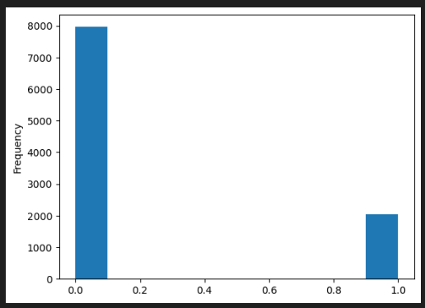
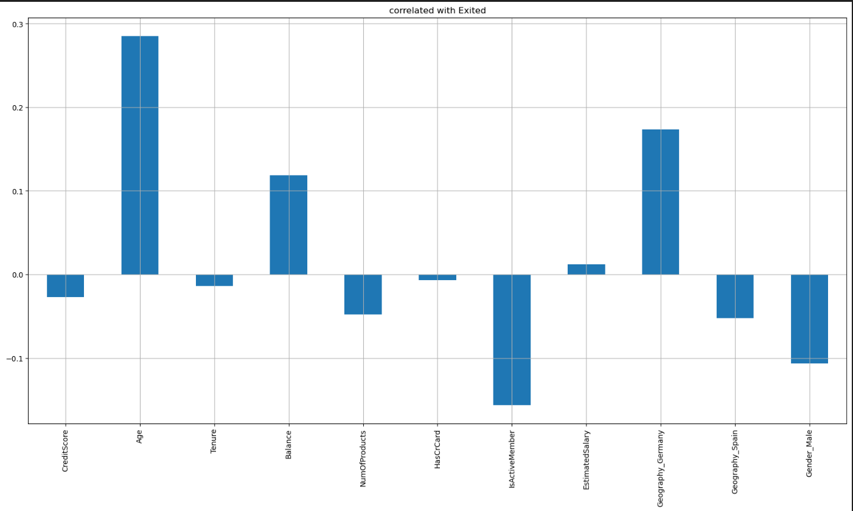

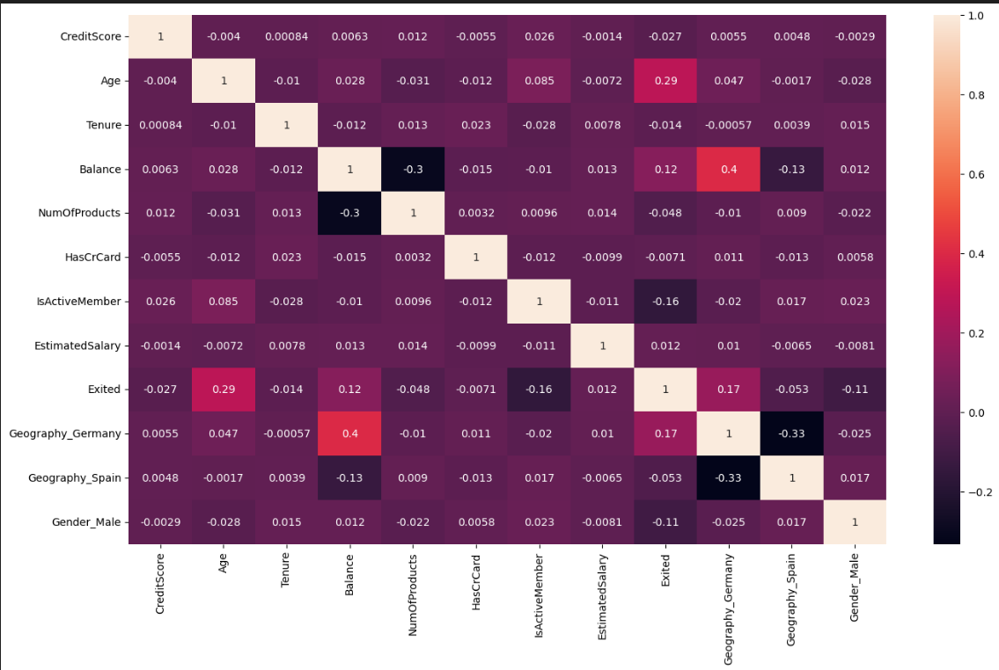



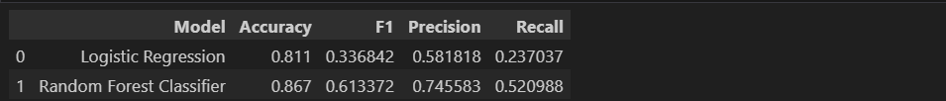





FUTURE SCOPE
Evolution of Churn Prediction Systems: A Look at the Future
Customer churn, that is, losing customers to competitors, causes significant financial problems in the industry. To overcome this challenge, customer churn prediction has become a powerful tool for businesses to identify customers who are at risk of leaving. However, the future of these machines promises to be much more successful than their current capabilities. First, let's take a deeper look at what constitutes happiness:
1. Improving Predictive Power: A Symphony of Advanced Algorithms and Richer Data
Sources
The future of loss prediction depends on pushing the boundaries of accurate and general models. This will be driven by two main points:
The rise of advanced machine learning methods: Traditional machine learning algorithms have established a solid foundation. But the future belongs to more powerful methods such as deep learning, especially Recurrent Neural Networks (RNN). RNNs specialize in capturing complex patterns and hidden patterns in customers, allowing for more accurate prediction of customer churn behavior.
Using the power of different data: Beyond traditional customer data (demographics, purchase history, etc.), future trends will include multiple sources of information. This may include:
Sentiment analysis on social media: By understanding consumer preferences displayed on social media, businesses can measure customer satisfaction and identify relevant factors.
Web browsing behavior: Analyzing customer browsing patterns can indicate browsing patterns and provide early warning results when the customer is losing interest or switching to competing products.
Sensor data from connected devices: The Internet of Things (IoT) opens the door to real-time data from wearable devices, smart homes or connected vehicles. This information can provide insight into customer behavior and usage patterns that may indicate dissatisfaction or reduce demand for products or services.
By combining advanced algorithms with rich data, loss prediction technology will achieve a certain level of accuracy and precision. Versatility beyond current possibilities.
2. From Threats to Prevention: Emergency Prevention Strategies
The future of churn prediction goes beyond customer risk analysis. It's about taking preventative steps to prevent disruption before it happens. Specific methods are as follows:
Stream analytics for real-time insights: Customer churn prediction machine relies on historical data history But the future lies in streaming analytics and real-time processing of user data. This allows for close predictions, allowing businesses to react quickly and implement relevant strategies before customers decide to leave.
Self-governance strategies: Bidding combined with consumer technology provides excellent self-governance. Businesses can tailor interventions based on customer behavior and specific situations identified by the model. This may include offering lower prices, fairer services or improved customer support to resolve specific customer issues.
Consider a situation where a customer's behavior viewing a retailer's website signals a switch to a potential competitor. The churn prediction engine analyzes this information in real time, providing personalized discounts or chat windows with support representatives who can resolve customer issues directly. The effect now has the potential to reduce loss.
3. Seamless integration with CRM systems: insights into actionable steps. This is where seamless integration with customer relationship management (CRM) systems comes in:
Frictionless data flow: the future, churn forecasting The first systems will work seamlessly within the existing CRM ecosystem. This will help transfer risk scores and customer-related information directly into the CRM system.
Trigger-based actions: CRM systems can be configured to take action based on the risk score generated by the forecasting process. This may include assigning high-risk customers to customer support representatives or automatically triggering retention plans.
By combining different aspects of betting and customer relationship management, businesses can make the most of predictions and provide a quick and effective response to potential customer churn.
4. Introducing the Ethical Model: Balancing Innovation with Transparency and Privacy
As predictive systems become more powerful, ethical decisions become Important:
Transparency and Fairness: Businesses must engage with user data on how they can be transparent. Used throughout system development and deployment. This includes explaining the rationale behind loss estimates and avoiding the use of models that are biased based on race, gender, or other sensitive characteristics. Artificial intelligence (XAI) technology can play a key role in clarifying this by helping understand the thinking pattern behind customer churn predictions.
Privacy Laws: With the rise of data privacy laws such as GDPR and CCPA, businesses must comply with consumer privacy laws. data for prediction. Technologies such as anonymity and privacy protection can provide solutions that preserve user privacy while extracting valuable insights from information.

CONCLUSION

In summary, customer churn prediction systems have become essential tools for businesses to manage customer relationships and respond to customers. Going forward, these systems need to continue to evolve. By leveraging the power of advanced algorithms, richer data sources, real-time analytics, and seamless CRM integration, customer churn forecasting will transform from a mere guess to the foundation of proactive customer service. However, the journey to the beautiful region is very important. Businesses must monitor transparency, integrity and data privacy to ensure responsible and reliable use of these powerful tools. The future of gambling is the soundtrack of innovation and ethics, ultimately resulting in a win-win for businesses and consumers; businesses retain customer value and customers get more personal experiences and satisfaction.

REFERENCES

Kaggle-DataSets : https://www.kaggle.com/datasets/louishgy/churn-modelling?select=Churn_Modelling.csv
(1)Wanikar, P., Maurya, S., Vishvakarma, M., Sujatha, K., Rakesh, N., Vimal, V., & Shelke, N. (2024). Telco Customer Churn Prediction Using ML Models. International Journal of Intelligent Systems and Applications in Engineering, 12(2), 644-653.
(2)Jajam, N., Challa, N. P., Prasanna, K. S., & Ch, V. S. D. (2023). Arithmetic Optimization with Ensemble Deep Learning SBLSTM-RNN-IGSA model for Customer Churn Prediction. IEEE Access.
(3)Amin, A., Adnan, A., & Anwar, S. (2023). An adaptive learning approach for customer churn prediction in the telecommunication industry using evolutionary computation and Naïve Bayes. Applied Soft Computing, 137, 110103.
(4)Manghnani, P., Kumari, U., Petakr, I., & Akadkar, A. (2023). Customer churn prediction. Vidhyayana-An International Multidisciplinary Peer-Reviewed E-Journal-ISSN 2454-8596, 8(si7), 259-292.
(5)Prabadevi, B., Shalini, R., & Kavitha, B. R. (2023). Customer churning analysis using machine learning algorithms. International Journal of Intelligent Networks, 4, 145-154.
(6)Imani, M. (2024). Customer Churn Prediction in Telecommunication Industry: A Literature Review.

(7(Jajam, N., & Challa, N. P. (2023). Customer churn detection for insurance data using blended logistic regression decision tree algorithm (BLRDT). International Journal of Intelligent Systems and Applications in Engineering, 11(1s), 72-83.
(8)Gupta, V., & Jatain, A. (2023). Artificial intelligence based predictive analysis of customer churn. Formosa Journal of Computer and Information Science, 2(1), 95-110.
(9)Oliveira, G. X. C. (2023). Addressing data imbalance in customer churn prediction: A novel approach for telecommunications companies (Master's thesis).
(10)Pulkundwar, P., Rudani, K., Rane, O., Shah, C., & Virnodkar, S. (2023, December). A Comparison of Machine Learning Algorithms for Customer Churn Prediction. In 2023 6th International Conference on Advances in Science and Technology (ICAST) (pp. 437-442). IEEE.
(11)Hooda, P., & Mittal, P. (2023). Implementation and performance enhancements of optimised kernel MSVM model for early churn prediction in telecom sector. Semiconductor Optoelectronics, 42(1), 280-298.
(12)Singh, S., Wankhede, A., & Patil, P. S. TELECOM CHURN PREDICTION USING MACHINE LEARNING ALGORITHM.
(13)Wagh, S. K., Andhale, A. A., Wagh, K. S., Pansare, J. R., Ambadekar, S. P., & Gawande, S. H. (2024). Customer churn prediction in telecom sector using machine learning techniques. Results in Control and Optimization, 14, 100342.
(14)Dhanawade, A., Mahapatra, B., & Bhatt, A. (2023, November). A smote-based churn prediction system using machine learning techniques. In 2023 1st DMIHER International Conference on Artificial Intelligence in Education and Industry 4.0 (IDICAIEI) (Vol. 1, pp. 1-7). IEEE.

