Embedding with CNN-Approach
This research performs a protein embedding using Kidera Factors, to train a Convolutional Neural Network (CNN) model, with the goal of identifying protein function similarities by assessing their relationship to reference proteins.
The materials include 10 Kidera Factors from the Rlang Peptide Package, reference proteins and a filtered mapman.tsv table which classified proteins into “bins”. Filtering the largest bin per root bin and merging it with reference amino acid sequences resulted in 40,302 protein sequences.

Embedding
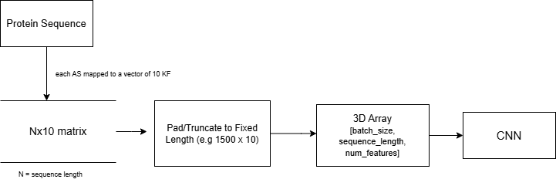
CNN- Architecture  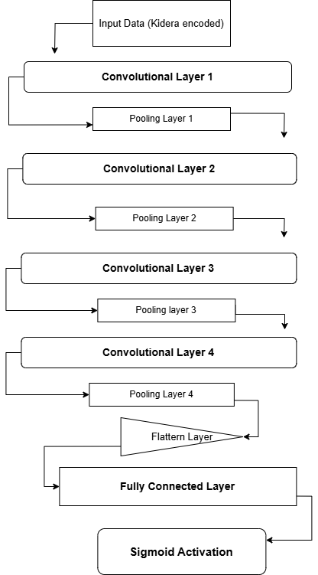 |  | Key features of the model  Number of layers 4 + output layer  Activation function Sigmoid  Loss function Binary Cross Entropy  Optimizer Adaptive Moment Estimation  Learning rate 0.0001  Batch size 64  Convolutional layers’ parameters  Layer Input feature maps Output feature maps Kernel size Stride  1st 10 32 7 2  2nd 32 64 5 2  3rd 64 128 3 2  4th 128 256 3 2
Max pooling layers after each convolutional layer (kernel size of 2, stride of 2) were applied to reduce overfitting. The model was trained during 40 epoches. Sequences of the length of 1500 aminoacids were used for this experiment. The training data was randomly split, so that 80% was used for training and 20% for validation.
Results
Precision | Recall |  | F1-score | MCC
0.9806 | 0.9623 |  | 0.9712 | 0.9704

