**NEXALINK SUPPORT**

**ITNET02 Networking 2, Advanced**

**A.Y. 2024-2025 2nd Semester**

**March 28, 2025**

**Submitted By:**

Raphael A. Aguirre

**Submitted To:**

Edgen Dy M. Gavino

**Instructor**

# **Introduction**

[Brief overview of the project, purpose and objectives]

* This project is for call center set up with 2 HeadQuarters Connected to each other. Each HeadQuarters has customer service, technical support and sales department where each department can accommodate up to 20 devices each.

# **Company Overview**

[Name and description of the organization, Number and locations of branches, Business operations related to networking needs]

* Business name: NexaLink Support
* Branches: 2
* Location: HQ1 HQ2

# **Network Design**

[Chosen network topology and rationale, IP addressing scheme (including subnetting), Network protocols used (e.g., TCP/IP, OSPF, BGP)]

* The network uses a hub-and-spoke topology with a star LAN at HQ for centralized control and scalability, employs VLSM subnetting within 192.168.1.0/24, and 172.16.1.0/24 and using VLSM to partition the subnet to /27 and distribute it to 3 different departments under the same subnetmask.

# **Hardware and Software Specification**

## **Network Devices**

* Routers (brand, model, capabilities)
  + **Brand:** Cisco 4300 series
  + **Model:** ISR4331
  + **Capabilities:** The Cisco ISR4331 Integrated Services Router delivers 100–300 Mbps throughput, supports 3 Gigabit Ethernet ports, 2 NIM slots, 1 SM slot, 4 GB flash, and 4 GB DRAM, enabling advanced routing, VPN, SD-WAN, security, unified communications, and PoE (up to 530W with boost) for scalable enterprise branch networking.
* Switches (layer 2 or layer 3, managed/unmanaged)
  + The network uses Cisco Catalyst 2950 layer 2 manage switches =, with one core switch and four departmental switches for HQ for VLANs and one switch per branch for local LANs, supporting VLAN segmentation, trunking and STP.
* Firewalls (hardware/software type, security features)
  + The network employs Cisco ASA 5505-X hardware firewalls with ASA software at HQ and branches providing stateful inspection, ACLs, NAT, IPS, VPNs, VLAN security, and logging to protect the network

## **Server and Workstation Specification**

[Server types (database, file, web, etc.) and specifications, Computers (hardware and OS specifications)]

* Server PT
  + CPU: Dual-core processor (2.5 GHz).
  + RAM: 4 GB.
  + Storage: 1 TB HDD.
* Computer
  + CPU: Dual-core processor (2.5 GHz).
  + RAM: 8 GB.
  + Storage: 1 TB HDD.

# **Network Security**

[Firewalls and access control policies, Encryption methods and VPN implementation, Authentication mechanisms (e.g., 802.1X, MFA), Backup and disaster recovery plan]

* Firewall Type: Cisco ASA 5506-X.
  + Placement:
  + HQ: Between Router1 and core Catalyst 2950 switch, protecting VLANs tech support, customer service, Sales, and Server.

# **Network Map**

[Explanation of the network map, Screenshots of the Packet Tracer design, Description of each network component in the simulation]

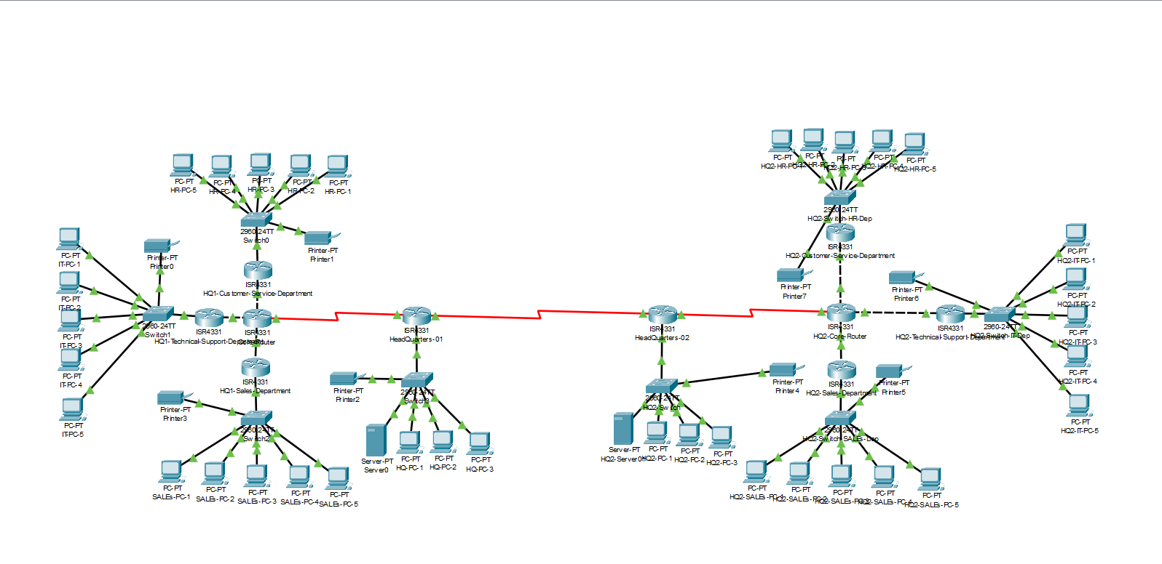

* This simulation has 2 branches HQ1 and HQ2. Each has a 3 sub branches under them Tech support, Customer service, Sales.

# **Conclusion and Recommendations**

[Summary of the network design, Potential future expansions and upgrades]

* **Summary:** The network connects HQ and four branches using a hub-and-spoke and star LAN setup with routers, firewalls, switches, and servers for database, file, and web. VLANs split HQ departments, OSPF routes traffic, and security uses ACLs, VPNs, and supporting 140 PCs with backups.
* **Future Upgrades:** Add branches, add Wi-Fi connection, add backup links, enhance security, and use better switches.

# **References**

[List of resources used]

* YouTube
* Google
* ChatGPT