Test Document

This is a test document, containing a range of features including:

* Lists
* Headers and Footers
* Formatting
* Page Breaks
* Images
* Links
* Tables

This sentence contains **bold**, *italic* and red text!

| ID | Name | Colour |
| --- | --- | --- |
| 001 | Alice | Red |
| 002 | Bob | Green |
| 003 | Charlie | Blue |

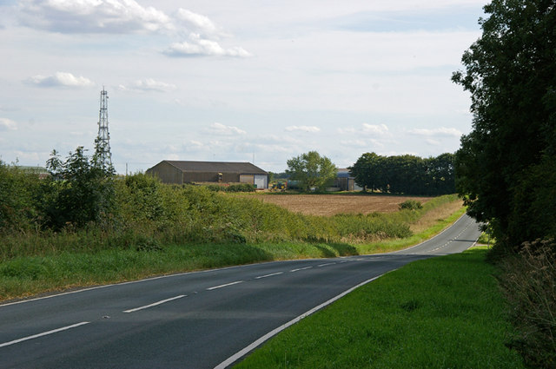

Figure 1: B1206 near Southwold Farm

David Wright / *B1206 near Southwold Farm* / [CC BY-SA 2.0](https://creativecommons.org/licenses/by-sa/2.0/)