Test Document

This is a test document, containing a range of features including:
- Lists
- Headers and Footers
- Formatting
- Page Breaks
- Images
- Links

This sentence contains bold, italic and red text!

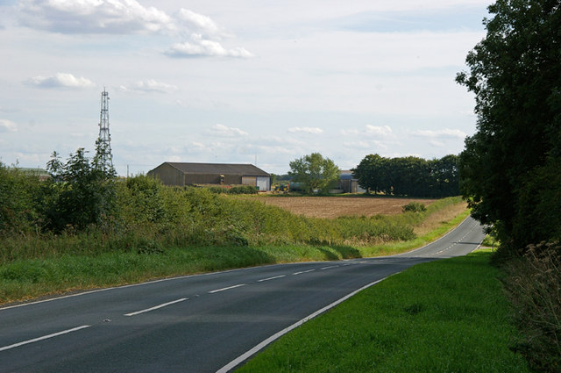
Figure 1: B1206 near Southwold Farm

David Wright / B1206 near Southwold Farm / CC BY-SA 2.0

