Task 1: Running Backend & Frontend Containers

What I Did

- Ran backend and frontend as Docker containers
- Used Docker Compose to manage both services
- Exposed ports to access services from the browser

Problems Faced

- Containers exited unexpectedly
- Frontend could not connect to backend
- Confusion between container ports and host ports
- Services were running but browser showed no response

How I Explored & Resolved

- Checked container status using docker ps and docker ps -a
- Viewed logs using docker logs
- Identified incorrect port mappings
- Learned that containers must communicate using service names, not localhost
- Restarted containers after correcting configuration

Task 2: PostgreSQL Container with Persistent Volume

What I Did

- Pulled PostgreSQL image
- Created PostgreSQL container
- Attached a persistent volume for database storage
- Configured PostgreSQL to run on a non-default port

Problems Faced

- PostgreSQL container not visible in Portainer initially
- PostgreSQL volume not visible in volume list
- Uncertainty about whether port configuration was done correctly

How I Explored & Resolved

- Verified container existence using docker ps -a
- Checked volume list using docker volume ls
- Understood that volumes appear only when actively attached to containers
- Confirmed port mapping using docker ps
- Restarted PostgreSQL container and verified persistence

Task 3: Portainer Setup, Docker Swarm & Service Management

What I Did

- Deployed Portainer using Docker
- Accessed Portainer UI via browser
- Initialized Docker Swarm
- Converted containers into Swarm services
- Managed services through both CLI and Portainer

Problems Faced

- Portainer UI not opening initially
- HTTP request sent to HTTPS server error
- Portainer showed “No environment available”
- docker swarm init failed due to multiple IP addresses
- Services showed as running but were not accessible from browser
- Portainer stopped responding after Swarm initialization

How I Explored & Resolved

- Identified Portainer requires HTTPS, accessed using:- https://localhost:9000
- Accepted browser security warning
- Manually connected Portainer to local Docker environment
- Used hostname -I to identify correct WSL IP
- Initialized Swarm using:- docker swarm init --advertise-addr <WSL-IP>
- Verified Swarm state using docker node ls
- Created backend and frontend as Swarm services

Used:

- docker service ls
- docker service ps
- docker service logs
- Learned difference between containers vs services
- Restarted Portainer as a Swarm service for stability

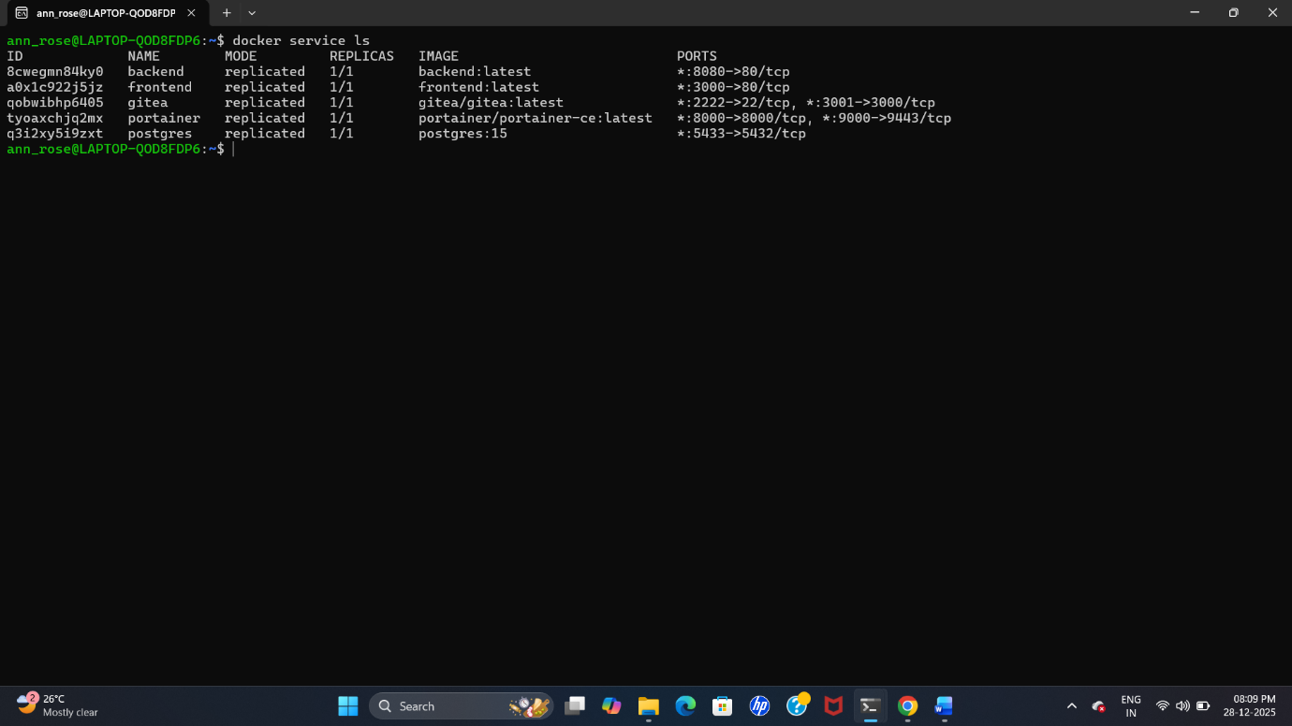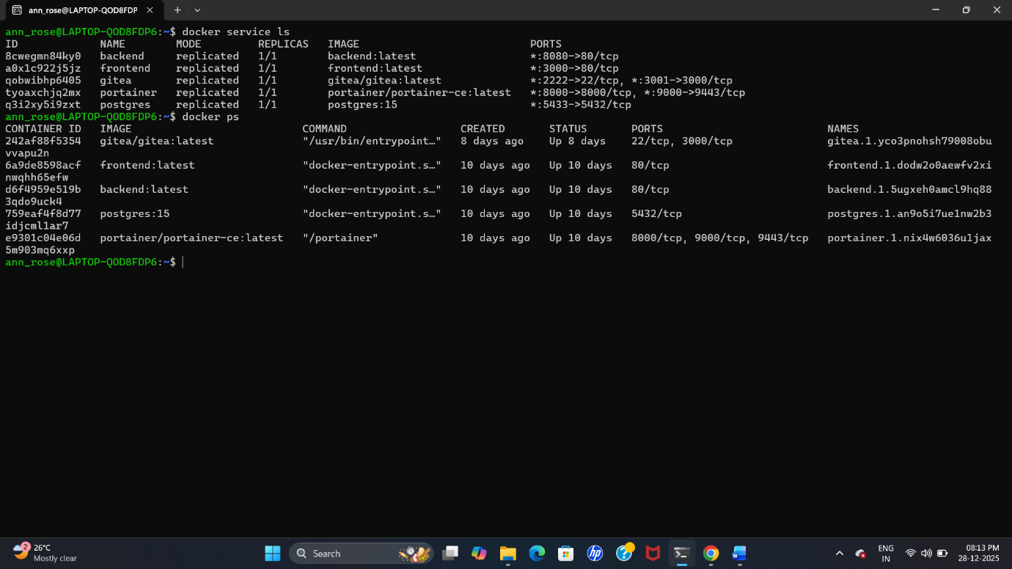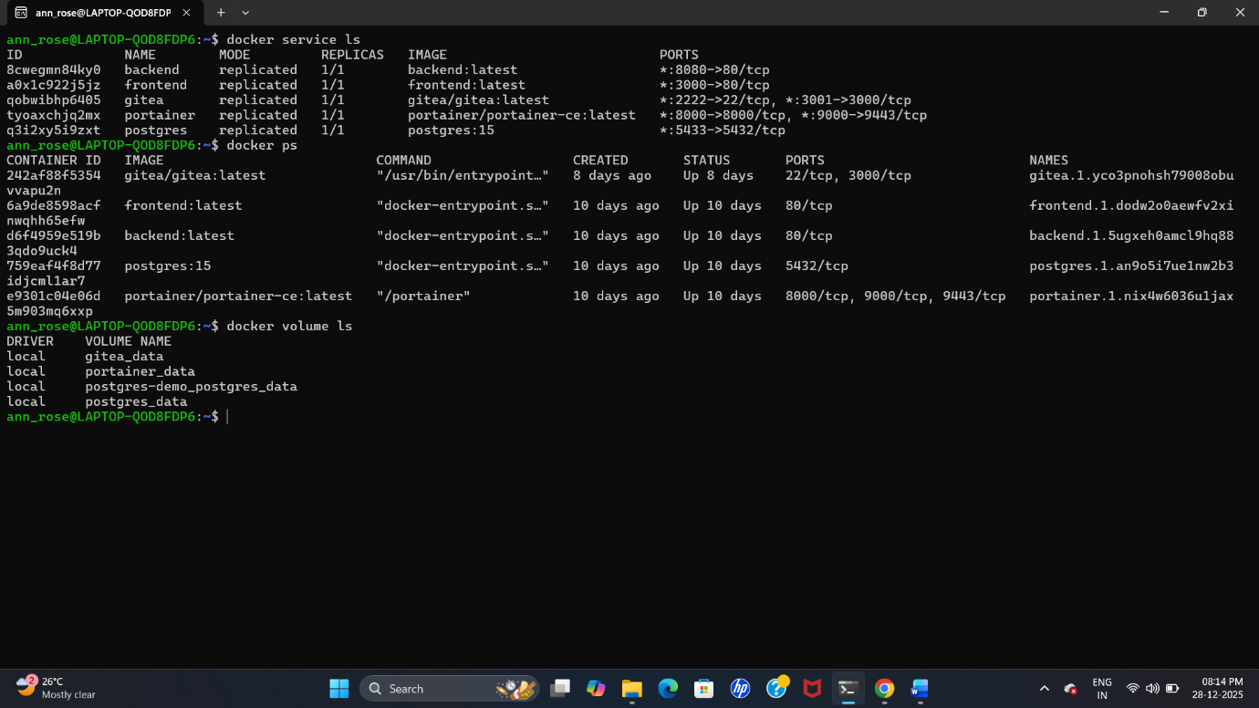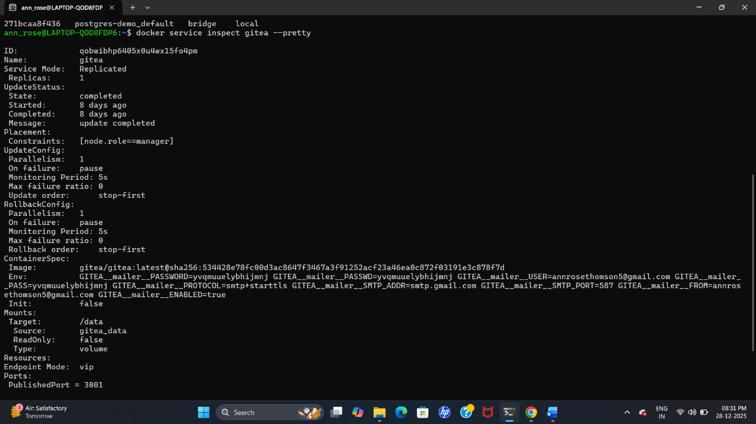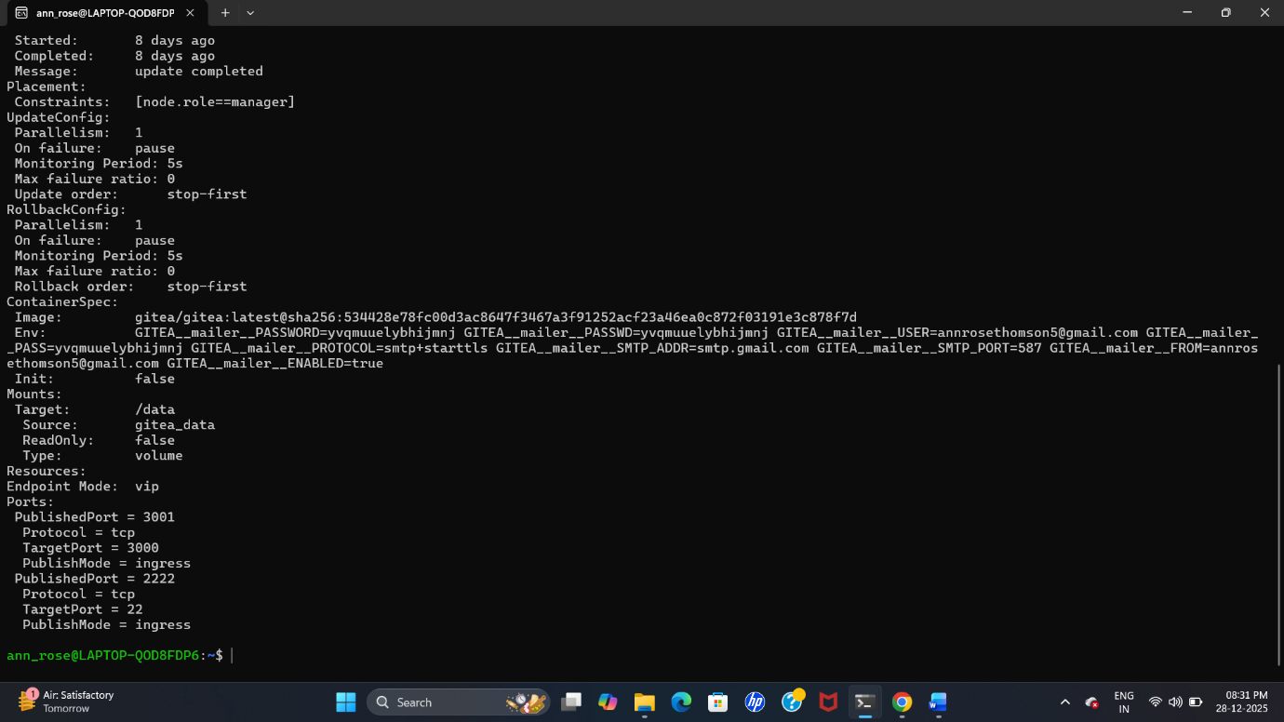

Task 4: Gitea Deployment Using Docker Swarm

What I Did

- Pulled the official gitea/gitea Docker image
- Created a Docker Compose file for Gitea deployment
- Deployed Gitea as a Docker Swarm service using docker stack deploy
- Attached a persistent Docker volume to /data for repositories and configuration
- Published the Gitea service using custom ports to avoid conflicts
- Configured SMTP mail settings via environment variables in the compose file

Problems Faced

- localhost:<port> kept loading without response
- Gitea UI did not open initially
- Confusion between Windows localhost and WSL networking
- Multiple port conflicts:
Port 3000 already in use
Port 3001 already in use
SSH port 2222 already in use
- Docker Swarm warnings related to --detach=false
- Initial SMTP authentication failures due to incorrect configuration
- Difficulty locating SMTP password field in Gitea UI (because it was set via environment variables)

How I Explored & Resolved

- Identified Docker was running inside WSL
- Retrieved WSL IP using:- hostname -I
- Accessed Gitea using:- http://<WSL-IP>:3002
- Successfully reached Gitea setup page
- Configured SMTP mail settings via environment variables in the Docker Compose file
- Verified SMTP configuration using Docker service inspection
- Successfully sent a test email from Gitea, confirming mailer configuration was working

