***Program name***

Arduino-alarm program called “Arduino Alarm”.

***Annotation***

Application reads your schedule from .xls file,that you can download from RUZ. Calculates time that you need to get to the university via Google Maps and awakes you. You can choose the means of transport you would like to use, set time that you need to get ready and it has an opportunity to establish priority to subjects. The applications works with Arduino platform.

***Central repository address***

<https://github.com/anntitaeva/Alarm>

***Members of the team***

* Anna Titaeva  
  *group* - BBI145

*role* - Arduino, application logic

* Shutchenko Daria   
  *group* - BBI146  
  role - GUI
* Chernov Alexander   
  *group* - BBI145  
  *role* - testing, net interaction

***Class Diagram***

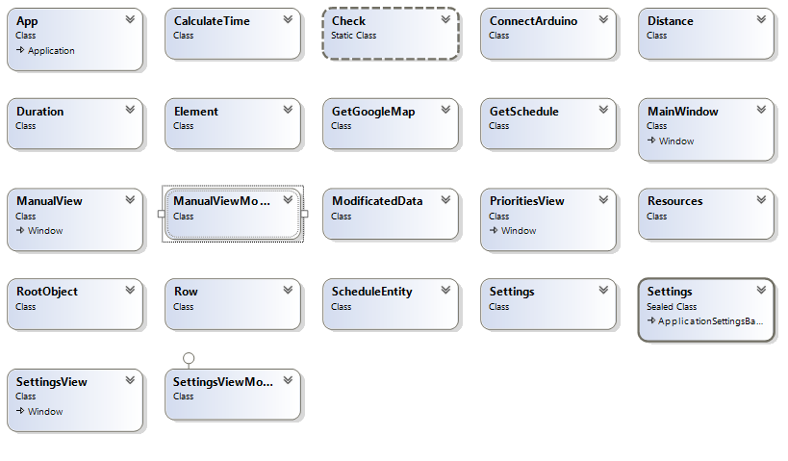

***Interface+Models+Code-behind:***

* MainView includes buttons. Code behind includes code for buttons.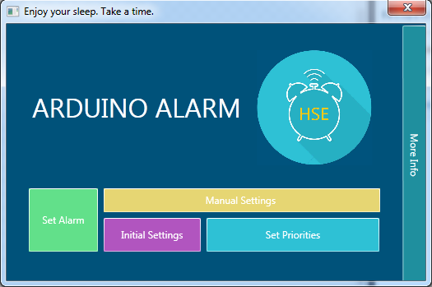
* SettingsView includes logic for entering settings. When you click “OK” SettingsViewModel checks the data you entered and then save it to file Settings.txt and update FinalSchedule according to new settings. When you open SettingsView SettingsViewModel initialize data(also from Settings.txt)

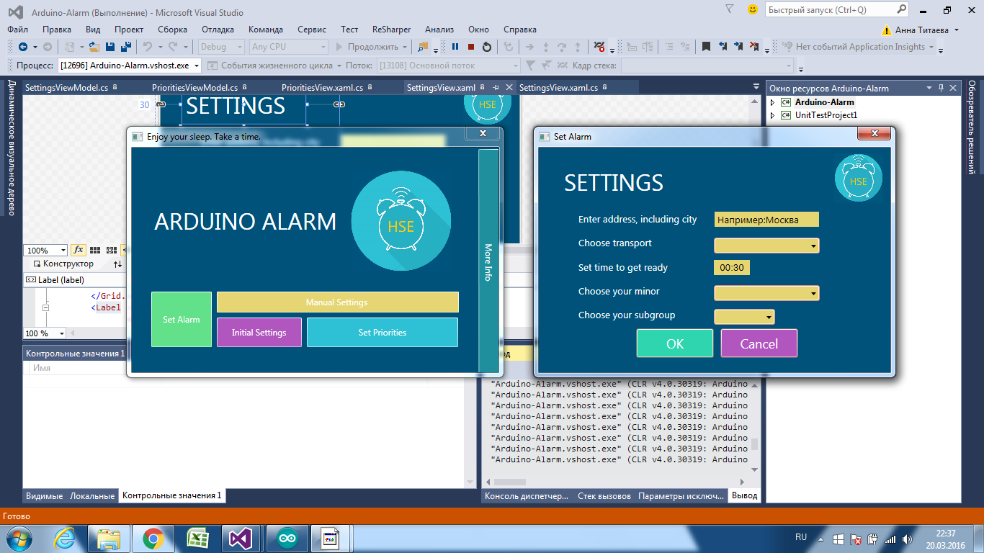

* PrioritiesView includes listbox with your subjects that program gets from .xls file. You need to choose some and press OK to save changes. For these subjects alarm will work twice. Code behind includes logic for SelectionChanged and Model includes initialization of list and saving 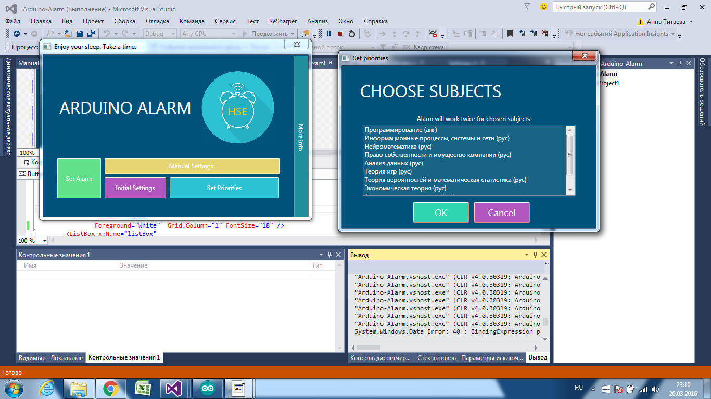changes.
* ManualView has a masked textbox to set alarm time. ManualViewModel saves it to Factory. It also calculates date(when-today or tomorrow-alarm will work)

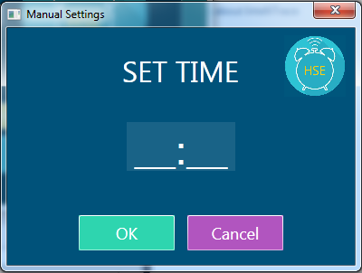

***Other classes:***

* folder Entities includes classes for data: ModificatedData is used for calculations for Arduino, ScheduleEntity is used for reading data from .xls
* folder GetSchedule includes classes that work with .xls

1. Check.cs checks if the row of table includes necessary group and subgroup(these takes from Setting.txt)
2. FinalSchedule.cs creates a dictionary from table
3. GetSchedule.cs creates a table from .xls file
4. Settings.cs includes methods that read and write user setting to file

* folder SetAlarm has a nested folder and two classes:

1. GetGoogleMap has a method to calculate time between origin address and destination via Google Matrix. Origin Address is taken from Settings, destination is taken from Schedule. User can also choose means of transport.
2. CalculateTime.cs calculates time for alarm according to your schedule, google time and time that you need to get ready. It also starts counter(when calculated time==time.now it starts connection with arduino)
3. ConnectArduino.cs has methods to detect arduino and send data to it(how many times alarm should work according to the priority of a subject)

* factory has methods that return or create the most used instances