RESQAI

Project Work and Model Results Handover
A beginner-friendly account from initial data collection through the current independent-test audit
WAYANAD DISTRICT | KERALA | 30 OCTOBER 2026
Main conclusion
The verified RF baseline, five-fold spatial results, ranking map and GSI comparison are complete. Stage 2 acquisition readiness and intake design is documented. No independent real-event data has been acquired; the request remains NOT SENT. The model ranks where conditions resemble mapped landslide locations; it does not forecast whether or when an event will occur.

Purpose: help the project owner understand and explain the work, evidence and limitations, and give another coding model a reliable handover.

1. How to use this handover
Read Sections 2–4 for the project question and data story. Sections 5–8 explain sampling, model training, metrics and maps. Sections 9–11 cover validation limits, presentation, glossary and next steps. The final appendices list exact features and authoritative project files.
Authority
AGENTS.md contains standing technical rules. Progress reports record what was measured and completed. Reports do not authorize sending the prepared agency request or changing the model. Current status is documented in RUN-2026-10-30-01.

One-minute project summary
RESQAI currently builds a Random Forest landslide susceptibility model for Wayanad. It combines 35 terrain and environmental predictors

Status at a glance
Work area | Status | Meaning
Data acquisition and quality | Complete; documented | Sources, files, checks, access limits and caveats recorded.
Inventory and event grouping | Complete; documented | 468 source records from 8 sources; provenance and duplicate links preserved.
Predictor preparation | Complete; verified | 24 geospatial layers / 35 feature bands on the common analysis grid.
Sampling and spatial folds | Complete; verified | 2,460 points assigned to five geographic folds; 1,000 m buffer rule.
RF baseline | Complete; verified | One fixed configuration, per-fold ranking metrics, map and importance.
GSI LSZ comparison | Descriptive only | Two model-derived susceptibility maps compared; not ground truth.
Independent event test | Not done | All usable dated candidate records locally were used in training; request unsent.
Acquisition readiness | Stage 2 design complete; no dataset acquired | Request package and intake gates are documented; the user must complete and send an approved request before data can arrive.

2. The project question and scope

What question does the model answer?
The current question is: using mapped landslide locations and environmental layers for Wayanad, can a Random Forest learn patterns that rank some locations as more susceptible than others? Inputs include slope, elevation, aspect, curvature, land cover, soil, rainfall summaries and broad geology.

Susceptibility is not a forecast
Term | Plain meaning | Project status
Susceptibility | Relative indication of where environmental conditions are associated with mapped landslides. | Yes; this is the scope.
Calibrated probability | A calibrated chance of failure over a defined period. | No; map values are not calibrated.
Forecast / warning | Whether or when a future landslide will occur. | No; there is no event-time model or warning system.

Analogy
The map is like a terrain suitability ranking. It can highlight locations that resemble known landslide sites. It is not like a weather forecast that predicts an event tomorrow.

Study area and coordinate grid
- Study area: Wayanad district, Kerala; working boundary GADM 4.1 measured at 2,121.0 km², cross-checked against OSM at 2,128.6 km².
- Analysis grid: 30 m cells in EPSG:32643 (UTM Zone 43N), a metric CRS for distance and area. EPSG:4326 is retained for geographic storage where applicable.
- Wayanad straddles 76°E. Two DEM tiles E075 and E076 are required; one alone covers only 71.5% of the district.

3. What data was collected and checked

Acquisition and source data
The repository began empty on 25 October 2026. The first acquisition phase assembled primary terrain, land cover, rainfall, soil, geology and boundary layers, plus event inventories and supporting layers. Raw originals are kept separate from interim extracts and processed working copies.
Data | Source/product | Use | Main limitation
Elevation / terrain | Copernicus GLO-30 primary; SRTM 1″ cross-check | Terrain predictors | Two tiles needed. DEMs agree at r=0.9997, MAD=3.41 m.
Land cover | ESA WorldCover 2021 v200 | Categorical predictor | Plantations may be mapped as tree cover; 89.6% of district is one class.
Rainfall | CHIRPS v2 monthly, 2000–2025 | Annual, JJAS and monthly climatologies | ~5.5 km resolution; not an event trigger layer.
Soil | ISRIC SoilGrids 250 m | Seven properties at two depths | Coarse compared with 30 m grid; source scaling was applied.
Geology | GLiM / LiMW 2015 | Categorical geology predictor | 1:3.75 million; detailed GSI 1:50,000 geology is missing.
Boundary | GADM 4.1, OSM cross-check | Study area mask | Working boundary; official Survey of India boundary unavailable.
Inventories | GSI PDFs, 2018 Kerala inventory, GSI PDLS, literature, NASA GLC review | Positive event records / provenance | Uneven years, duplicates, coordinate precision and coverage.

What dataset verification means
VERIFIED means file integrity, format, CRS, resolution, district coverage and value plausibility were checked on the actual file. DOWNLOADED_NOT_FULLY_VALIDATED means readable and consistent with source claims, but record-level correctness is unconfirmed. IDENTIFIED_NOT_DOWNLOADED, ACCESS_RESTRICTED and UNAVAILABLE distinguish potential sources from acquired datasets.

Why the inventory has several counts
There are 468 source records from 8 sources; 385 are dated, 83 are undated site records, and 372 in-window records form 371 event groups. Source records are retained with provenance even when duplicates are cross-referenced. Eligibility and sampling rules later selected 363 positive points for modelling. Thus 468 records, 371 event groups and 363 model positives are different counts, not a contradiction.
Inventory caution
A record is not automatically a distinct landslide. The project measured overlap across sources and preserved a crosswalk. Some coordinates are approximate and some records have no date. Source-record counts must not be presented as independent event counts.

4. How predictor layers were prepared
Source layers were processed into a common Wayanad analysis grid so that each sampled location has aligned predictor values. The 30 m grid makes layers spatially consistent; it does not create finer information in coarse sources such as SoilGrids or CHIRPS. Categorical rasters are not bilinearly interpolated.
Family | Bands | Examples | Interpretation
Terrain | 5 | Elevation, slope, aspect, profile curvature, plan curvature | Topographic setting and surface shape.
Land cover | 1 | WorldCover class | Categorical land-cover code.
Soil | 14 | Clay, sand, silt, bulk density, SOC, CEC, coarse fragments at two depths | Soil characteristics; scaled into physical units.
Rainfall | 14 | Annual mean, JJAS mean, months 1–12 | Broad rainfall regime, not short-term trigger.
Geology | 1 | GLiM class | Broad lithology; local detail is limited.
Total | 35 | 24 source rasters/layers, some multiband | 35 configured model columns.

Values are taken from the source cell containing each point. All 2,460 points were in bounds; the 35 × 2,460 sampled values were finite; nodata, rainfall sentinel, categorical and provenance checks passed. Soil scaling was already applied in Phase 3; Phase 5 must not reapply it.

Processing safeguards established
- Use EPSG:32643 for metric distance and area calculations.
- Never bilinearly/bicubically interpolate categorical land-cover, lithology or soil classes.
- SRTM HGT is point-registered; GeoTIFF DEMs are area-registered. Naively mixing them shifts values about half a pixel (~15 m).
- CHIRPS uses −9999 nodata without a tag; mask explicitly.
- SoilGrids values are scaled integers; upstream conversion to physical units is already complete.

5. Training points and the five folds

Positive versus background
Positive = an audited mapped-event point. Background = a sampled location with no mapped event in the available inventory. Background does not mean field-confirmed stable terrain. Phase 4 contains 363 positives and 2,097 backgrounds, a 5.78:1 sampling ratio; this is a design choice, not the real frequency of landslides.

Why spatial folds are used
Nearby landslides can share terrain and mapping conditions. A random split may put near-neighbours in training and test, making evaluation too favourable. Phase 4 clusters nearby positives, keeps spatial blocks together, and removes designated training points close to each held-out fold.
- Cluster positives at 1,000 m single linkage: 363 points form 76 clusters.
- Tile study area into 3,000 m blocks; keep whole clusters atomic within spatial units.
- Assign whole units to five folds: 471, 541, 503, 473 and 472 points.
- For each round, hold one entire fold out; use other folds for training after the specified 1,000 m drops.
- Record 418 drops (392 background, 26 positive rows); independently recomputed minimum retained train-to-test distance = 1,001.3 m.
What five folds mean
The model is fitted five times. In each round one geographic group is held out for evaluation; the other four train the model, after buffer drops. Each point appears in a held-out fold once. This is spatial cross-validation on the existing dataset, not a test on a new event dataset.

6. The Random Forest baseline

Fixed configuration
One scikit-learn RandomForestClassifier was used: 500 trees, Gini criterion, minimum leaf size 5, max_features=sqrt, bootstrap=True, class_weight=balanced_subsample, random_state=20261026, n_jobs=-1. There was no hyperparameter search, competing model or synthetic training data.

Random Forest in plain language
A decision tree asks questions about predictor values, such as whether slope exceeds a value or which land-cover class a cell belongs to. A forest builds many trees on resampled data and feature subsets, then combines their votes. Here, positive-class vote share ranks places. Because the labels and sampling design are not calibrated, vote share is not a probability of landslide failure.

What the pipeline does
- Sample the 35 predictor values at each of the 2,460 committed Phase 4 points.
- For each fold, train on other folds minus committed buffer drops; predict only that held-out fold.
- Calculate per-fold ROC-AUC and average precision; calculate held-out permutation importance.
- After gates pass, refit the same RF configuration on all 2,460 points to create the district map; this final refit is for mapping, not cross-validation.

7. Results and how to interpret them
ROC-AUC asks how often a randomly chosen mapped-event point receives a higher model score than a randomly chosen background point. Average precision summarizes precision-recall ranking across thresholds in this sampled case-control setup. Neither is ordinary classification accuracy; AP is not precision at one chosen threshold.
Fold | Test + / − | Clusters | ROC-AUC | Average precision | Caution
0 | 52 / 419 | 12 | 0.8674 | 0.3517 | Held-out presence–background ranking.
1 | 121 / 420 | 14 | 0.8712 | 0.5458 | Largest event support.
2 | 84 / 419 | 5 | 0.9263 | 0.6168 | Marginal: only five clusters.
3 | 54 / 419 | 23 | 0.7882 | 0.3200 | Lower ranking scores.
4 | 52 / 420 | 22 | 0.7720 | 0.3348 | Lowest ROC-AUC.
Mean ± SD | — | — | 0.8450 ± 0.0640 | 0.4338 ± 0.1374 | Unweighted; folds correlated.

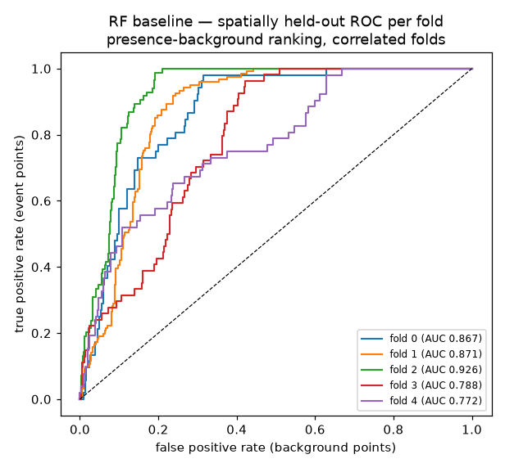
Figure 1. Per-fold ROC curves. Background points are sampled, not confirmed stable ground.

What the numbers do and do not say
- Correct: “ROC-AUC ranged from 0.772 to 0.926 across five spatial folds, for ranking mapped-event points above sampled background points.”
- Incorrect: “The model is 84.5% accurate.” The 0.845 mean is ROC-AUC, not accuracy.
- Fold 2’s 84 positive points come from only five distinct clusters, so its high score is marginal and should be discounted.
- Spatial folds remain correlated; they are not five fully independent replications.
- 335 of 363 positive points are from 2018. Temporal transfer to other years has not been established.

Feature importance
Held-out permutation importance measures the decrease in ROC-AUC after shuffling each feature. Slope had the largest mean decrease (0.0273 ± 0.0139), followed by elevation (0.0134 ± 0.0156); every other feature was ≤0.0028 with overlapping uncertainty. Importance describes model reliance in this setup; it does not prove causation.
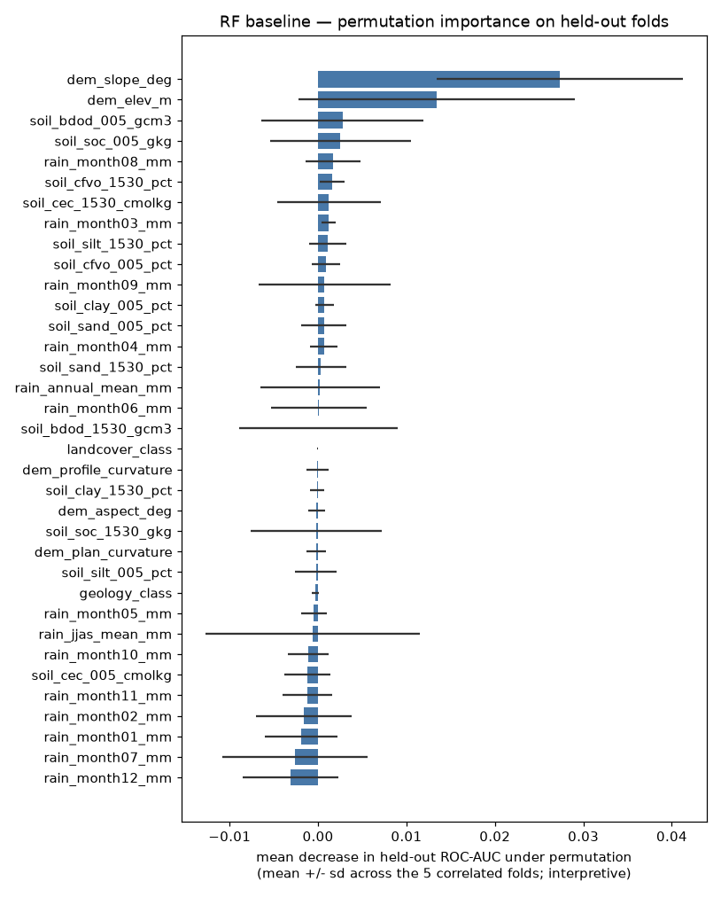
Figure 2. Held-out permutation importance. Interpretation aid, not causal proof.

8. Map and descriptive comparison

Random Forest ranking map
The map model is the same RF refit on all 2,460 points and applied to valid 30 m cells. It has 2,343,343 valid cells out of 2,356,538 district cells; 13,195 cells lack at least one valid predictor. Values: minimum 0.0000, median 0.0316, mean 0.1474, 95th percentile 0.6594, maximum 0.9687. These are relative vote-share ranking values, not probabilities.
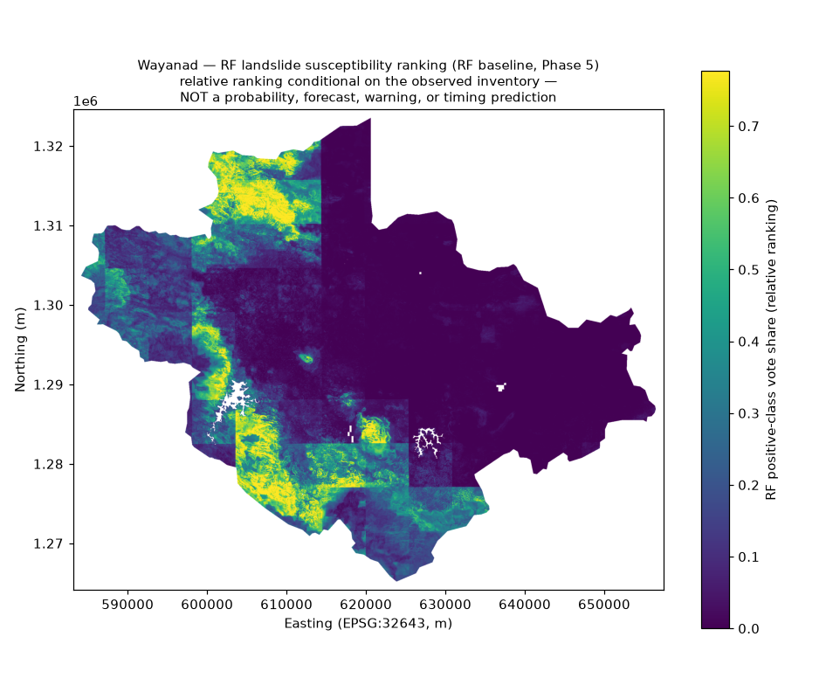
Figure 3. Relative susceptibility ranking across valid Wayanad cells; not a probability or forecast.
GIS file: data/processed/models/susceptibility_rf_baseline_30m.tif (float32, EPSG:32643, 2013 × 2480, nodata −9999).

GSI 2022 LSZ comparison
A descriptive comparison was made with GSI’s 2022 landslide susceptibility zone layer (LSZ-01). It is another model-derived map, not ground truth, a training predictor, or validation labels. LSZ-01 remains DOWNLOADED_NOT_FULLY_VALIDATED.
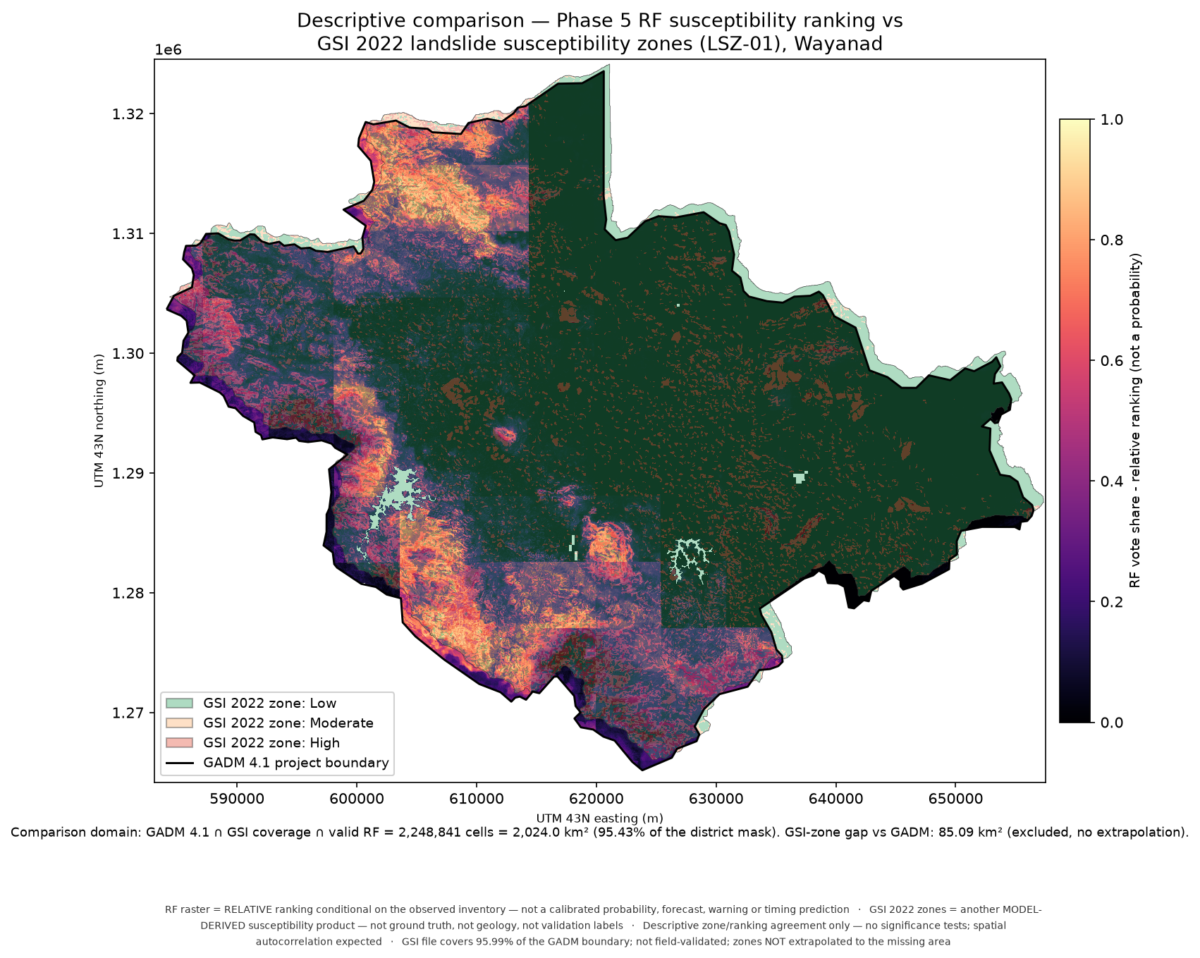
Figure 4. Descriptive RF / GSI overlay. Spatial agreement does not establish accuracy.
On the shared 2,248,841-cell domain (2,023.96 km²), mean RF score rose from GSI Low 0.1002 to Moderate 0.2725 to High 0.3818. 89.59% of GSI High area fell in the upper two RF quintiles. Ordering stayed monotone under two sensitivity variants. Because products are model-derived, share factor families and are spatially autocorrelated, this is not validation.

9. Verification and reproducibility
The saved Phase 5 verifier reports 6/6 gates passed and byte-identical regeneration of all 14 outputs. Phase 4 verification was 8/8. Checks cover source-grid and feature integrity, exact Phase 4 fold/drop counts, configuration matching, independent recomputation of each saved fold model’s AUC/AP, raster profile/domain/statistics/checksum, and reproducibility.
Evidence file | What it contains
data/interim/p5/verify_p5.json | Phase 5 verification summary (6/6 gates).
data/processed/models/extraction_checks.json | Feature extraction checks and raster hashes.
data/processed/models/fold_metrics.json | Per-fold counts, metrics, caveats and provenance.
data/processed/models/map_metadata.json | Map grid, domain, statistics and checksum.
configs/p5_baseline.json | Single source of truth for RF parameters, features, fold use and map.
scripts/p5_extract_features.py, p5_train_baseline.py, p5_map.py, p5_verify.py | Re-runnable pipeline scripts.

What this proves
The same documented inputs and settings regenerate the same outputs. It does not prove inventory completeness, remove sampling bias or show performance on new event data.

10. What is not yet proved
Claim not established | Why
Independent result on a new landslide event | Every usable dated 2000–2026 event record currently on disk is already a training label.
External test of July 2024 records | Both 2024 groups are in fold 3 and were used in training for other folds.
Accuracy against confirmed stable ground | Background means no event mapped in this inventory; it is not confirmed absence.
Calibrated failure probability | Map vote share is relative ranking, not calibrated probability.
When a landslide will occur | No event-time, rainfall-trigger or forecast model exists.
Transfer across years and all Wayanad settings | 335 of 363 positive model points are from 2018; broader temporal transfer untested.
Causal effects | Permutation importance measures model reliance, not cause.

What the 30 October independent-test audit found
The audit compared local candidates with exact Phase 5 IDs and metric-CRS distances. Mundakkai and Meenakshi Bridge (2024) and Puthumala (2019) are training points at 0.00 m from their own positives, all in fold 3. The Sreekumar 2025 corroboration is 495.29 m from the GSI point and is merged as a duplicate. All 2,097 background points are training data.
The 78 undated records cannot support an event-level test; 58 are within 1 km of a training positive. All 35 GSI14337 records crosswalk to GSI14115 records, and 26 partners are training positives. Of six pre-2000 records, five are within 1 km. None provides a sufficient independent test.
Current external-test status
No independent external validation has been performed. The official request package for additional July 2024 records is prepared but NOT SENT. No reply or new independent dataset is present locally.

The audit recommends roughly 15–20 distinct dated event clusters for a meaningful new test, a fresh background sample disjoint from training, and a protocol locked before any scores are viewed. The project’s five-cluster minimum is only a bare fold gate; fold 2 at that minimum is already marginal.

11. What can be shown live

Existing outputs
- ROC curves: data/processed/models/roc_curves.png
- Susceptibility map: data/processed/models/susceptibility_rf_baseline.png
- Permutation importance: data/processed/models/permutation_importance.png
- GIS raster: data/processed/models/susceptibility_rf_baseline_30m.tif
- Optional descriptive comparison: outputs/lsz_rf_comparison/overlay_map.png
- Verification evidence: data/interim/p5/verify_p5.json

Command Prompt run commands
Open Windows Command Prompt at C:\Major and run the real scripts in this order to show live progress:
cd /d C:\Major
python -u scripts/p5_extract_features.py
python -u scripts/p5_train_baseline.py
python -u scripts/p5_map.py
Open figures from CMD:
start "" "C:\Major\data\processed\models\roc_curves.png"
start "" "C:\Major\data\processed\models\susceptibility_rf_baseline.png"
start "" "C:\Major\data\processed\models\permutation_importance.png"
The full verifier is python -u scripts/p5_verify.py. The live-demo guide estimates 10–20 minutes for that complete run; the exact duration of each separate script was not recorded. Saved figures and metrics can be shown without rerunning.

Suggested order for a faculty demonstration
- State the scope: susceptibility ranking for Wayanad, not timing prediction.
- Show actual feature extraction/training output or verification evidence.
- Show fold ROC curves and explain each fold is geographically held out.
- Show map and state its value is ranking, not probability.
- Show feature importance if asked what the model used.
- State clearly that independent real-event testing is pending a new dataset.

12. Glossary and common questions
Term | Beginner definition
Raster | A grid covering a map; each cell stores a value such as elevation or model score.
Predictor / feature | A measured input such as slope, soil clay or rainfall summary.
Label | The example class for training: mapped event (1) or sampled background (0).
Background point | A location with no mapped event in this inventory; not confirmed stable.
Training | Fitting the model so it learns associations between predictors and labels.
Held-out fold | A geographic group excluded from a fold’s fitting and used to evaluate that fold’s model.
Spatial leakage | Overly favourable evaluation when related nearby places appear in both train and test.
Cluster | Nearby mapped event points treated as one related spatial group.
Buffer drop | A point removed from training because it is too near the held-out fold.
ROC-AUC | Ranking measure: how often a positive scores above a background point across thresholds.
Average precision | Summary of precision-recall ranking across thresholds; not one-threshold precision.
Permutation importance | Change in score after shuffling a feature; model reliance, not cause.
External validation | Testing a separate dataset not used in fitting or model choices.
Reproducibility | Ability to rerun the documented process and reproduce the outputs.

Was the model trained? Yes. It was fitted in five spatial-fold rounds and refit on all points to create the map.
Was it tested? Yes, with spatial cross-validation on the committed inventory. Not on a new independent event dataset.
Is 0.845 accuracy? No. It is mean ROC-AUC across five correlated spatial folds.
What does a high map value mean? The model ranks that cell higher relative to other valid cells; it is not an event probability.
Why caution on fold 2? Its 84 positive points came from only five event clusters.
Can it predict a future landslide? No. It estimates susceptibility, not event timing or warnings.
Why do we need more data? The local 2024/2019 events were already used in training; new independent events are required for external testing.

13. Next work in safe stages
Stage | Work | Gate before the next stage
2. Acquisition and validation | Obtain a new real event inventory from an authorized source. Preserve original files, IDs, dates, coordinate precision, uncertainty and provenance. | Record-level verification; count distinct dated groups absent from 363 training positives; validate source, CRS, coverage, duplicate status and predictor coverage.
3. Lock test protocol | Before scoring, freeze candidate IDs, exclusion radius, fresh background rule/seed, reporting unit, metrics and wording. | Protocol saved and hashed; no training ID overlap; all candidates outside the 1,000 m buffer; enough event clusters.
4. Evaluate and demonstrate | Keep fixed RF config; run only after acquisition and protocol gates pass. Save table, figure and reproducible command. | Leakage checks inside evaluator; recomputation matches outputs; limitations beside results.
If data remain insufficient | Report “independent test not yet possible”; present verified spatial cross-validation honestly. | Do not lower support minimums or substitute synthetic data as validation.

Do not
Do not rescore 2024/2019 training events and call them validation; do not use training background as test controls; do not promote undated duplicate compilations into independent events; do not tune RF to improve scores; do not describe a forecast.

Notes for the next coding model
Stage 1 feasibility audit found no suitable local independent dataset, and Stage 2 acquisition-readiness/intake design is now complete. The next work depends on the user reviewing and sending an approved request or choosing another route. The request remains NOT SENT; do not contact agencies or transmit the draft. After real data arrives, validate it against the documented intake and acceptance gates before preparing a locked test protocol. Do not write an evaluator or score records before that protocol is frozen. Inspect current files and git status first; preserve unrelated work. Follow AGENTS.md and create a detailed run report after each work session.

Appendix A. Exact 35 feature columns
The model uses these columns in the configured order:
dem_elev_m • dem_slope_deg • dem_aspect_deg • dem_profile_curvature • dem_plan_curvature
landcover_class • soil_clay_005_pct • soil_clay_1530_pct • soil_sand_005_pct • soil_sand_1530_pct
soil_silt_005_pct • soil_silt_1530_pct • soil_bdod_005_gcm3 • soil_bdod_1530_gcm3 • soil_soc_005_gkg
soil_soc_1530_gkg • soil_cec_005_cmolkg • soil_cec_1530_cmolkg • soil_cfvo_005_pct • soil_cfvo_1530_pct
rain_annual_mean_mm • rain_jjas_mean_mm • rain_month01_mm • rain_month02_mm • rain_month03_mm
rain_month04_mm • rain_month05_mm • rain_month06_mm • rain_month07_mm • rain_month08_mm
rain_month09_mm • rain_month10_mm • rain_month11_mm • rain_month12_mm • geology_class

Appendix B. Key source documents and evidence
Path in project | Use
AGENTS.md | Standing project rules and scientific safeguards.
docs/ACQUISITION_REPORT.md | Initial data acquisition, validation, coverage and gaps.
docs/INVENTORY_VERIFICATION_REPORT.md | Source records, event groups, coordinate precision, duplicates and provenance.
docs/PHASE2_PROGRESS.md | Inventory/source-discovery completion record.
docs/PHASE3_PROGRESS.md | Predictor preparation and geospatial checks.
docs/PHASE4_PROGRESS.md | Sampling, clusters, folds, buffer and verification.
docs/PHASE5_PROGRESS.md | Model setup, metrics, map, limitations and LSZ comparison.
docs/INDEPENDENT_TEST_FEASIBILITY_AUDIT_2026-10-30.md | Newest local-data independence audit.
docs/PHASE5_LIVE_DEMO.md | Baseline rerun and figure display guide.
docs/SOURCE_DISCOVERY_2024_WAYANAD_INVENTORY.md | Public-source search for July 2024 records.
reports/RUN-2026-10-28-03_phase5-rf-baseline.md | Original RF baseline run report.
reports/RUN-2026-10-28-06_lsz-rf-map-comparison.md; RUN-2026-10-29-07_lsz-rf-comparison-sensitivity.md | Descriptive comparison and sensitivity.
reports/RUN-2026-10-29-09_phase5-demo-reproduction.md | Reproduction evidence.
reports/RUN-2026-10-29-10, -11, -12 | Source review and unsent official request drafting/attachments.
reports/RUN-2026-10-30-01_independent-test-feasibility-audit.md | Exact training-overlap results and current readiness verdict.
reports/README.md | Required run-report format and rules.

Appendix C. Stage 2 acquisition readiness and intake design
RUN-2026-10-30-02 extends the Stage 1 audit. It verifies acquisition routes and contacts, improves the request field list, and defines intake and test-acceptance gates. It acquired no data, sent no request, contacted no agency, and computed no external-test score.

Current acquisition routes
Route | Status now | Blocker / next step
GSI request (primary) | Draft complete; NOT SENT | User identity fields; GSI addressee/contact unverifiable from automated fetch; user decides enclosure and send.
KSDMA variant | Draft complete; NOT SENT | User identity fields; official contact was confirmed 30 Oct 2026.
Wayanad DDMA variant | Draft complete; NOT SENT | User identity fields; Collector email and landline confirmed; mobile/fax unconfirmed, user decides whether to remove.
GSI RTI | Not drafted | Fallback if letter receives no substantive reply; confirm official CPIO address, current fee and portal route before filing.
Passive GSI index monitoring | No newer volume found | Recheck after a new PDLS publication; no current data.
Peer-reviewed supplementary tables | Closed unless new evidence appears | Available LIT2025 records are already in training.

Contact and request-package updates
- KSDMA official contact page returned HTTP 200 on 30 October 2026: +91-471-2778855 and keralasdma@gmail.com; the printed office address was unchanged.
- Wayanad official Who’s Who page returned HTTP 200: Collector email dcwayanad[at]gmail[dot]com and landline 04936202230. Page footer is 14.07.2022. The older directory URL now returns 404. Mobile 9447204666 and fax 04936-203450 are not confirmed on that page.
- GSI contact is still not verified: the site presents a JavaScript session-verification shell and the attempted contact page returns 404. Do not invent an email, phone, street address or officer name.
- The covering letter and fields annex now request 13 fields. Three additions cover geometry type and what a point represents, event grouping/duplicate links, and administrative location. These distinguish landslide source-area points from runout or deposition points.
- All four request files retain NOT SENT banners and user placeholders. No reply or data has arrived. The user must complete their identity block, decide enclosures and recipient route, then personally decide whether to send.

Data intake checklist
Intake item | What must be recorded
Source and permission | Supplier, date, reference, licence/access conditions; preserve verbatim restrictions.
Files | Original names, sizes, received time and SHA-256 hashes; include sidecars and notes.
Format and CRS | Read-only open; layer/sheet/page names; declared CRS versus detected CRS; never assume missing CRS.
Coordinates and dates | Verbatim coordinate text, converted coordinates, printed precision/uncertainty, date as stated and its certainty; do not round, snap or infer.
IDs and geometry | Agency ID; point/line/polygon; what each point marks (source area, centroid, runout, deposition).
Duplicates and groups | Crosswalk against existing records by stable ID and metric distance; state radius and grouping; no silent merge.
Coverage and verification | District inclusion/boundary uncertainty, predictor coverage, per-file and per-record verification status.
Manifest | Add a new manifest source only after validation; keep original in data/raw untouched, intake outputs in interim.

Acceptance gates before independent testing
Gate | Pass condition
G1–G3 provenance, format, location | Source/permission and hashes recorded; each record has CRS status; coordinates sanity-checked without silent moves.
G4 stable-ID independence | Zero intersection with the 363 Phase 5 training event groups and relevant source record IDs.
G5 spatial independence | Every candidate point is more than 1,000 m from all training positives in EPSG:32643; report the minimum.
G6 support | At least 5 distinct 1 km clusters and 45 positives (configured minima); target 15–20 clusters for a more defensible evaluation.
G7 predictor coverage | All 35 predictor values valid at each candidate location; zero nodata candidates or explicitly stop.
G8 comparison class | Fresh pre-registered background, disjoint from all 2,097 training background points; 100 m exclusion around training and candidate positives.
G9 leakage exclusions | No 2024, 2019, undated or 2006–2009 training records appear in the candidate test set.
G10 reproducibility | Intake checks rerun with matching hashes and recorded outputs.

Passing these gates could support a presence–background ranking test. It would still not establish accuracy, false-positive performance, calibration or performance against confirmed stable terrain. Lock the protocol and hash it before viewing scores. Only then build and run the evaluator with the fixed Phase 5 configuration.

User decision and next-step handoff
- Complete name, designation, institution, city, postal address, email, phone, date and reference fields in all four files.
- Choose the enclosure (full held-record annex or only its comparison table), decide whether to include the June 2024 Meenakshi Bridge record, and decide whether to remove unconfirmed DDMA mobile/fax details.
- Get GSI addressee details from a normal browser session or choose the RTI route; never invent contact details. Recheck KSDMA/Wayanad contacts on the day of sending.
- If a request is sent, retain the sent copy and dated tracker entry; record a follow-up date. Do not claim it was sent before that evidence exists.
- When data arrive, do Stage 2 intake and gates first; if support or independence fails, report insufficient data and stop. Do not lower thresholds or use synthetic data.
- After data pass, write and hash a locked protocol. Implement the independent evaluation only in the following stage.
Stage 2 authority: docs/INDEPENDENT_TEST_STAGE2_ACQUISITION_READINESS_2026-10-30.md and reports/RUN-2026-10-30-02_acquisition-readiness-and-intake-design.md.

