School of Computer Science Engineering and Technology

Lab No. - 10

Course-B. Tech. | Type- Core
Course Code- CSET301 | Course Name- Artificial Intelligence and Machine Learning
Year- 2025 | Semester- Odd
Date- | Batch- 2023-2027

CO-Mapping
 | CO1 | CO2 | CO3 | CO4 | CO5 | CO6
Q1 |  | ü |  | ü

Lab – Random Forest classifier Total Marks: 1

Objective:
To Implement Random Forest classifier in Python Programming Language on Wine Quality Dataset.

Problem Statement:

About Dataset:
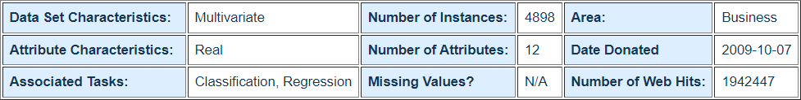

The list of attributes with description is given below:
Input variables (based on physicochemical tests):
- - fixed acidity
- - volatile acidity
- - citric acid
- - residual sugar
- - chlorides
- - free sulfur dioxide
- - total sulfur dioxide
- - density
- - pH
- - sulphates
- - alcohol

Output variable (based on sensory data):
- - quality (score between 0 and 10)

Questions

Dataset: Download the dataset from the link.
https://archive.ics.uci.edu/ml/datasets/wine+quality
  - Read the dataset.
  - Extract the Independent and Dependent Variable.
  - Convert the Output column quality (score between 0 and 10) into the three categories i.e., best, average, and poor.
  - Split the dataset into training and testing using 75-25 division.
  - Perform normalization on numerical features.
  - Build a Random Forest classification model using Sklearn with default parameters. Predict the target values in the testing set.
  - Check the performance of model using confusion matrix.
  - Calculate the accuracy, Precision, Recall and F1-score.
  - Compare the performance of the Random Forest model with Decision Tree Model.

