

SVKM’s NMIMS
Mukesh Patel School of Technology Management and Engineering, Shirpur Campus
Department of Artificial Intelligence and Machine Learning

By:
Anushka Sharma (C201)
Pranav Mundhra (C207)
Devesh Poojary (C217)

1. Case Study Introduction
We have worked on a healthcare-based dataset focusing on Medicaid and Medicare patient services across the United States. The primary objective of this project is to design, develop, and analyze an interactive Power BI dashboard that provides a comprehensive view of healthcare service distribution, patient coverage, and provider accessibility under various Managed Care Organizations (MCOs). This case study aims to deliver meaningful insights for healthcare policymakers, administrators, and analysts to identify gaps, measure performance, and optimize resource allocation within the healthcare system.
The dataset used in this project was provided as a consolidated CSV file titled “Final Dashboard Data March 2025.csv”. It contains information from 2020 to 2024, covering multiple U.S. states, healthcare service categories, and MCOs. Each record represents key indicators such as the number of eligible patients, active patients, providers, and service utilization rates. This dataset serves as a foundation for analytical modeling and visualization using Power BI, enabling decision-makers to monitor trends and disparities in healthcare access across regions.
The goal of this case study is to transform the raw healthcare dataset into a structured, visually interactive dashboard that simplifies complex data into actionable insights, highlighting critical factors affecting patient coverage and service performance.

2. Data Loading and Preparation
The dataset was imported into Power BI through the “Get Data – CSV” option. The data contained healthcare statistics for the years 2020 to 2024, encompassing variables like states, MCOs, service categories, number of active patients, number of eligible patients, and number of providers.
During the preparation phase, several preprocessing and data cleaning operations were performed to ensure accuracy and consistency:
- Replaced suppressed values (“*”) with NULL or 0 to allow numeric calculations.
- Removed commas and unwanted characters from numerical columns such as “Number of Active Patients” and “Number of Eligible Patients”.
- Standardized column names and ensured proper data types (Whole Number, Fixed Decimal, or Text).
- Trimmed unnecessary spaces from text fields like “MCO Name” and “Service Category”.
- Verified data integrity and removed duplicate entries.
Following this, logical data tables were created to build a star schema model in Power BI. The data was segregated into the following tables: Dim_MCO, Dim_Service, Dim_Location, Dim_Date, and Fact_Performance. Each table was carefully designed to maintain data consistency and enable flexible filtering and aggregation during visualization.
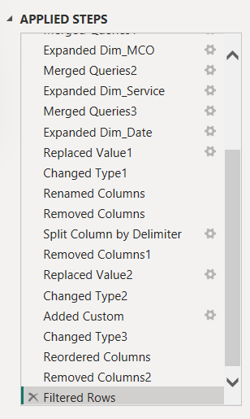
3. Data Transformation
Data transformation was executed using Power Query Editor and DAX expressions within Power BI. The main goal was to refine, normalize, and prepare the dataset for efficient analysis.
Key transformation steps included:
- Handling null and duplicate records to maintain dataset integrity.
- Renaming columns for better readability and standardization.
- Creating calculated columns to derive new metrics such as “Unserved Eligible Patients” and “Average Patients per Provider”.
- Reformatting date columns to create a consistent temporal hierarchy.
- Grouping and summarizing records by service category, MCO, and location to simplify analysis.
These transformations ensured the dataset was structured, clean, and optimized for building an analytical Power BI model that supports both high-level summaries and detailed drill-through analysis.
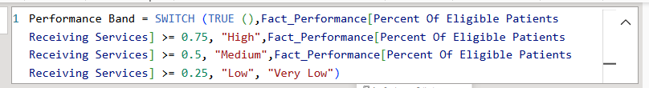
4. Creating Relationships and Data Modeling
The data model was constructed following the star schema design for improved analytical performance and logical organization. The central fact table, Fact_Performance, captures measurable statistics such as the number of active patients, eligible patients, and providers. Surrounding this fact table are dimension tables—Dim_MCO, Dim_Service, Dim_Location, and Dim_Date—each providing contextual information related to their respective attributes.
The established relationships are as follows:
- Dim_MCO[MCO_Key] → Fact_Performance[MCO_Key]
- Dim_Service[Service_Key] → Fact_Performance[Service_Key]
- Dim_Location[Location_Key] → Fact_Performance[Location_Key]
- Dim_Date[Date_Key] → Fact_Performance[Date_Key]
This modeling approach allows efficient filtering, smooth navigation, and cohesive visualization across different perspectives such as by state, MCO, or service category.
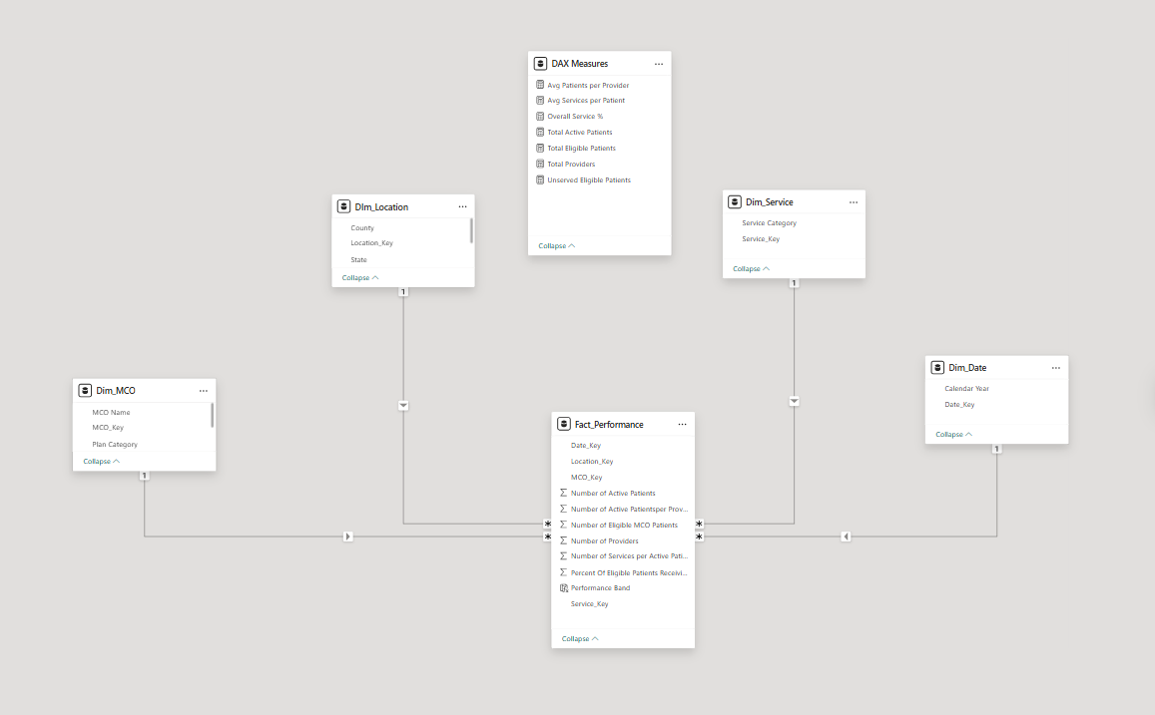

5. DAX Calculations
A set of key DAX measures were implemented to derive essential performance indicators from the dataset. These calculations form the analytical foundation of the Power BI dashboard, enabling comparative and cumulative analyses.
The primary measures include:
1. Total Active Patients = SUM(Fact_Performance[Number of Active Patients])
➤ Calculates the total count of patients who have availed services.
2. Total Eligible Patients = SUM(Fact_Performance[Number of Eligible MCO Patients])
➤ Computes the total number of patients eligible under MCO plans.
3. Unserved Eligible Patients = [Total Eligible Patients] - [Total Active Patients]
➤ Identifies the number of eligible patients who have not yet received any service.
4. Overall Service % = DIVIDE([Total Active Patients], [Total Eligible Patients], 0)
➤ Determines the percentage of eligible patients who have been served.
5. Total Providers = SUM(Fact_Performance[Number of Providers])
➤ Calculates the total number of healthcare providers across all MCOs.
6. Avg Patients per Provider = DIVIDE([Total Active Patients], [Total Providers], 0)
➤ Measures average patient load per provider, indicating network efficiency.
7. Avg Services per Patient = AVERAGE(Fact_Performance[Number of Services per Active Patient])
➤ Determines the mean number of services availed per active patient.
These DAX expressions enhanced the analytical depth of the dashboard, allowing for quick comparisons, ratio analysis, and key performance monitoring.
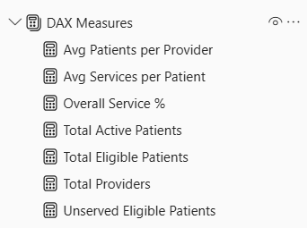

6. Data Visualization
The Power BI dashboard, titled “Medicaid Patient Dashboard,” was designed with a multi-page structure to offer comprehensive insights across different analytical dimensions. Each page emphasizes specific healthcare aspects and facilitates interactive exploration.

Page 1: Overview
Displays key KPIs such as Total Active Patients, Total Eligible Patients, Total Providers, and Overall Service %. Visuals include bar charts for Active Patients by Service Category, a donut chart for MCO contribution, and a geographical map showing patient distribution across states.
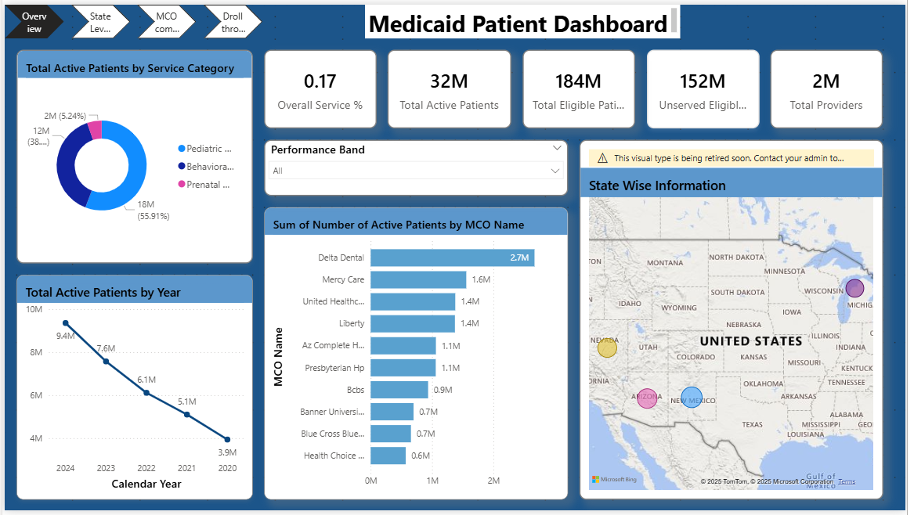

Page 2: State-Level Analysis
Highlights healthcare coverage variations across U.S. states. This page includes visualizations comparing Active vs. Unserved Eligible Patients and allows users to filter data by Year, State, and MCO.

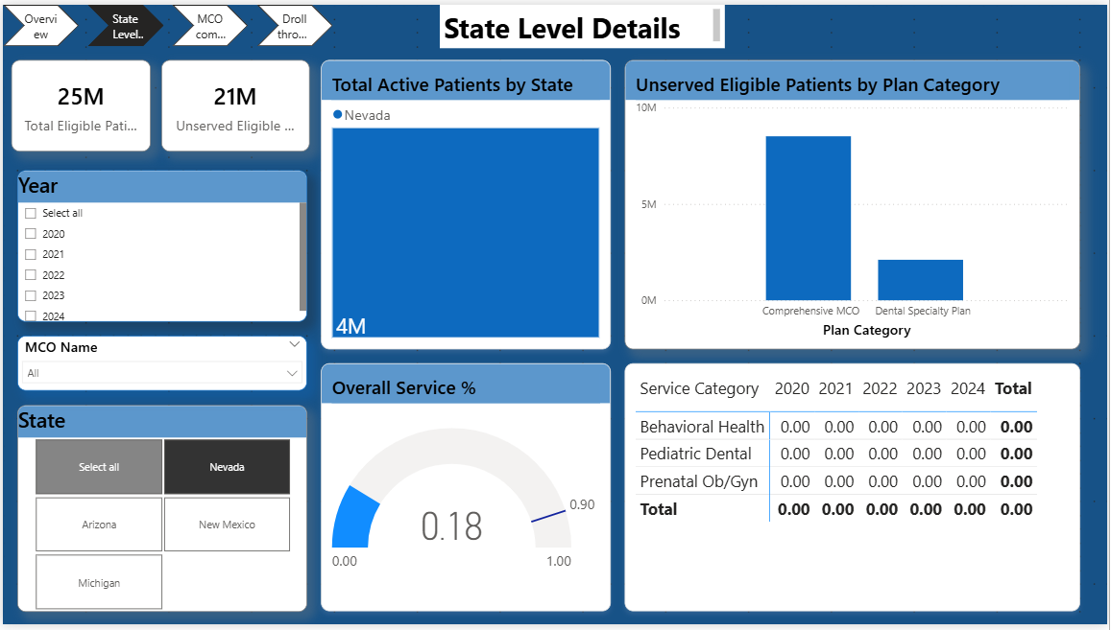
Page 3: MCO Comparison
Provides a comparative analysis of Managed Care Organizations, showing differences in Total Active vs. Eligible Patients, Average Patients per Provider, and network size. Helps identify underperforming or overburdened MCOs.
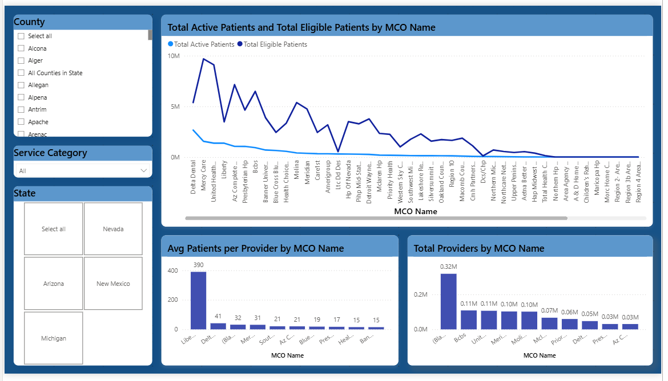
Page 4: Drill-Through Analysis
Focuses on detailed insights for a specific MCO such as Delta Dental or BCBS. It shows year-wise performance, service distribution, and patient-provider ratios, helping to pinpoint gaps and improvement areas.
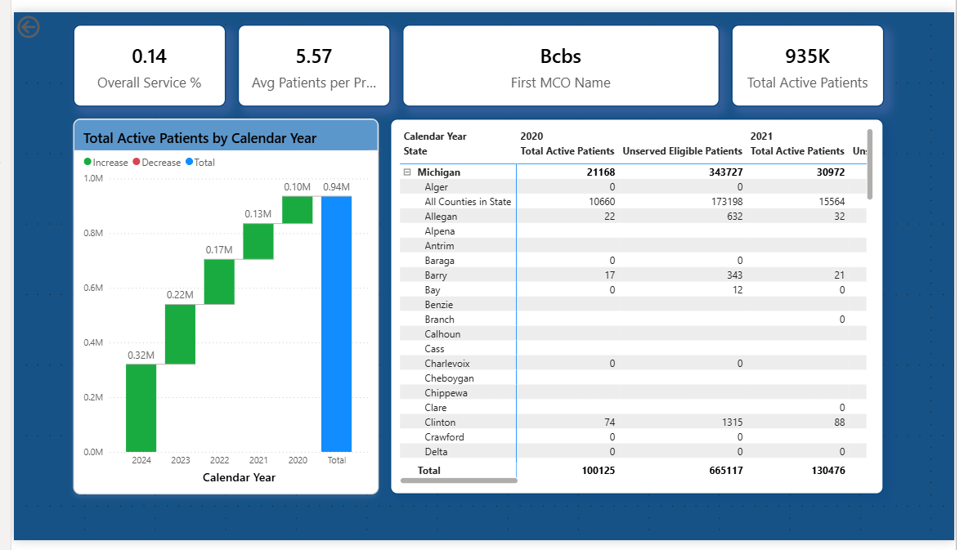

7. Project Insights and Deliverables
The final Power BI report uncovers key healthcare insights and patterns based on the Medicaid and Medicare dataset. Major findings include:
- Pediatric Dental and Behavioral Health services have among the lowest coverage percentages, indicating underserved service areas.
- Certain states, such as Nevada and Michigan, show higher numbers of unserved eligible patients, signaling regional disparities in service delivery.
- High patient-to-provider ratios in MCOs like Delta Dental suggest potential provider shortages or network strain.
- The average Overall Service % remains low (around 17–18%), highlighting that a significant number of eligible patients are yet to receive services.
Deliverables:
The final deliverable includes an interactive Power BI (.pbix) dashboard containing all dimension and fact tables, DAX measures, filters, and visualizations. The report enables dynamic analysis of healthcare coverage, allowing stakeholders to monitor trends, identify inefficiencies, and support data-driven decision-making for better healthcare outcomes.

