1- Write a program to print the sum of two numbers without using + operator. Other operators
can be used.

Addition= (x-(-y)) i.e.: x+y

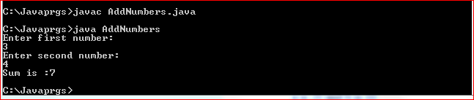

2. Write a program to print the result of the following expressions provided the integer variable
a is 20 and b is 10.
int b = a-- - --a;
int c = a--;
int d = a>>2;
int e = a&b;



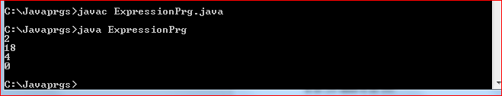

In this prog I am bit confused how to write this actually I am not getting that 4 condition we are supposed to write in one condition and separate one by one we have to write

Because separately when I wrote the condition and executed the prog I was getting different output.

