2. Create a class Student which has some private data like name, phone number, roll number,
class, use getter and setters to access this private data.

In this code we have to take some private date member as mentioned below , and as the datameber are declared as private so this can be accessible in side the class (Student). So outside the class its not accessible . So this is the whole logic as per my understanding.

private String name;
private int phonenumber;
private int rollnumber

Execution screen shot
- As per the code I am getting some issue in the output , for phone number when I am entering a valid number like 9674970734 its giving some error as below , but when I am entering 3 to 4 number its taking fine , I know in declaration I am doing some wrong but where I want to know
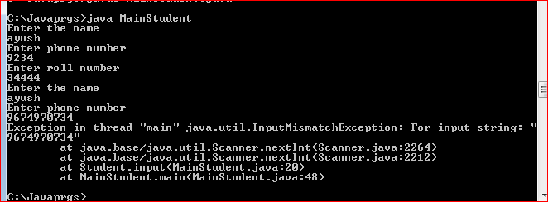

Output as per the code
