1- Declare an integer array of size 10. Initialize using for loop with 1 to 10, and print
all even numbers from an array.

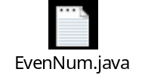
Here in this prog I have declared an arry of size 10 so I have to entered 10 number from 1- 10
And at the end its giving the even number as output

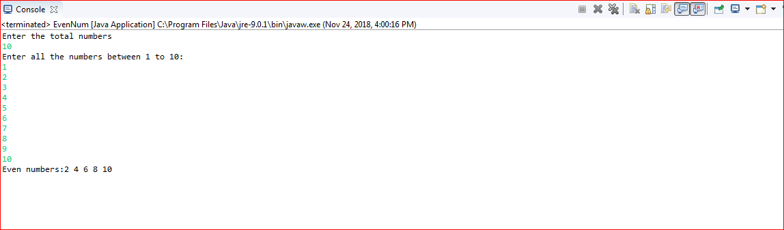

3. Write a program to generate a user-defined exception called
NegativeAgeException if the user inputs negative value for age.

This prog was solved during the training session I have referred that and I have wrote this. I need some more practice I believe. Please provide me your comment on this.
