- Write a simple Timer that can periodically print a timeout message.
As per the training I guess Timer related no topic has been covered. I will take some online help and try to do this but that may take some time
- Write a program to build any collection containing duplicates. Create its copy with all duplicates
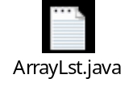
This prog was also discussed during the training and what I understood from this is by using List interface this is allowing duplicate value
Iterator it=al.iterator(); this part iterates all the element from the list
while(it.hasNext())
