- Write a program to find the highest among the given 3 numbers.



In the code I have written like
Take 2 numbers e.g.: x, y , z
So there are 3 condition its checking basically
(x>y && x>z) then x is the highest number
if(y>x && y>z) y is the highest number

if(z>x && z>y) z is the highest number

below is the screen shot that I have got when I ran this prog. Let me know if there is anything that I need to add on to this.

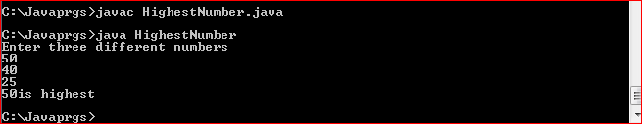




Code logic: here I have used one if condition
Which says that’s when i=j it will print x or there is one more case where its going to print x i.e.: j==(5-1)
To write this logic I had taken some help from google also

Result
