3. Problem Statement
Assignment – 2.1
Launch Internet Explorer using System.setproperty by configuring all the driver under the project.

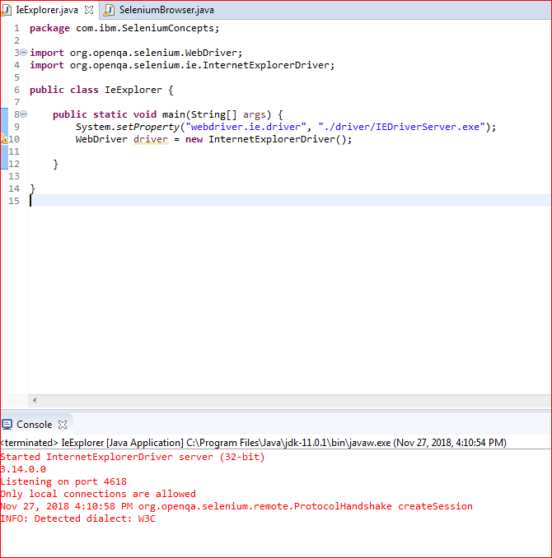
New browser is launched
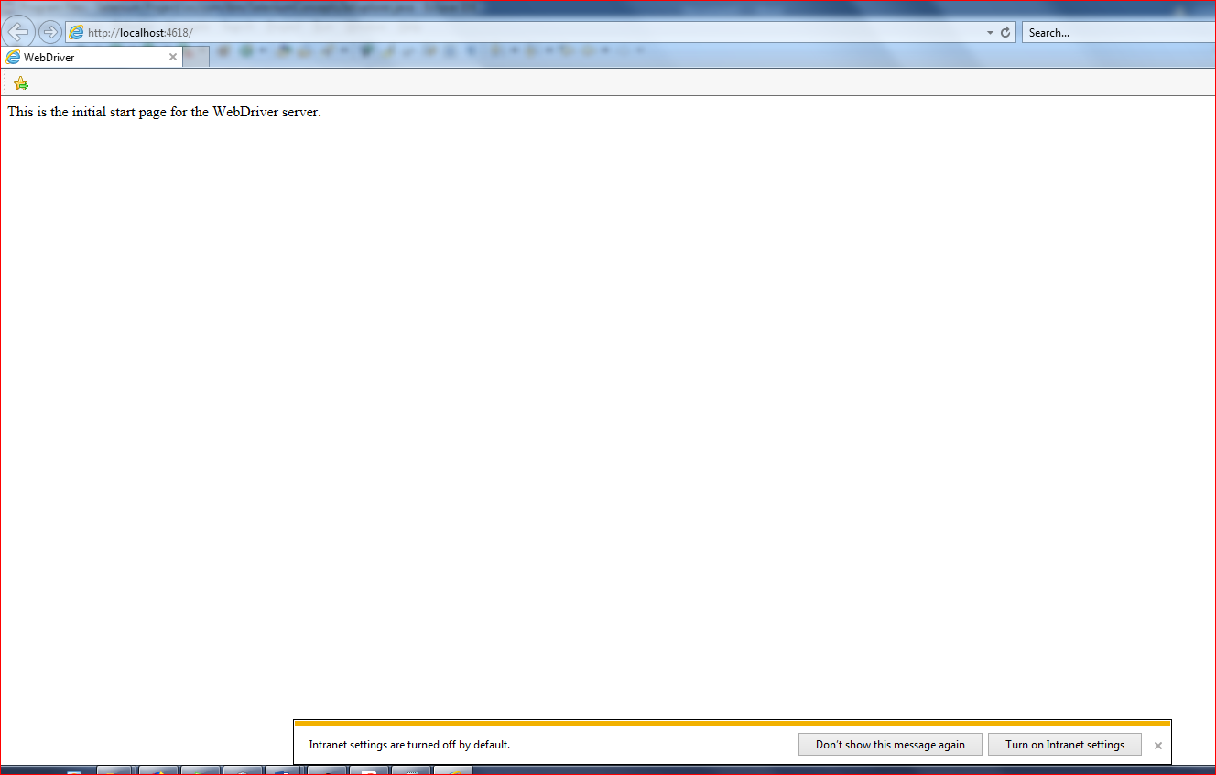
Assignment – 2.2
Task
Please try to configure Chrome Browser and navigate to http://magento.com. Automate all the features
in the registration page using the XPATH locators except captcha.
package com.ibm.SeleniumConcepts;

import java.util.concurrent.TimeUnit;

import org.openqa.selenium.By;
import org.openqa.selenium.WebDriver;
import org.openqa.selenium.WebElement;
import org.openqa.selenium.chrome.ChromeDriver;
import org.openqa.selenium.support.ui.WebDriverWait;

public class IeExplorer {

public static void main(String[] args) {
System.setProperty("webdriver.chrome.driver", "./driver/chromedriver.exe");
WebDriver driver = new ChromeDriver();
WebDriverWait wait = new WebDriverWait(driver,60);
driver.manage().window().maximize();
driver.get("http://magento.com");
driver.manage().timeouts().implicitlyWait(30,TimeUnit.SECONDS);

WebElement AccountEle= driver.findElement(By.xpath("//span[text()='Account']/ancestor::a"));
AccountEle.click();
WebElement RegisterEle = driver.findElement(By.xpath("//button[@type='button']"));
RegisterEle.click();

WebElement FirstNameEle = driver.findElement(By.xpath("//input[@name='firstname']"));
FirstNameEle.sendKeys("Test");

WebElement LastNameEle = driver.findElement(By.xpath("//input[@ name='lastname']"));
LastNameEle.sendKeys("Test");

WebElement EmailAddressEle = driver.findElement(By.xpath("//input[@title='Email Address']"));
EmailAddressEle.sendKeys("anupama.mishra@in.ibm.com");

WebElement PasswordEle = driver.findElement(By.xpath("//input[@title='Password']"));
PasswordEle.sendKeys("summer@123");

WebElement ConfPasswordEle = driver.findElement(By.xpath("//input[@ title='Confirm Password']"));
ConfPasswordEle.sendKeys("summer@123");

driver.findElement(By.id("agree_terms")).click();

After running the above code below is the fields where data are getting filled in

