***UML Diagrams: Main Project***

***Verukal***

***Submitted to Submitted by***

***Ms.Ginumol Joseph Annu Mariya Shaji***

***Assistant Professor S4 LE MCA***

***Amal Jyothi College of Engineering***

**A.Class Diagram**

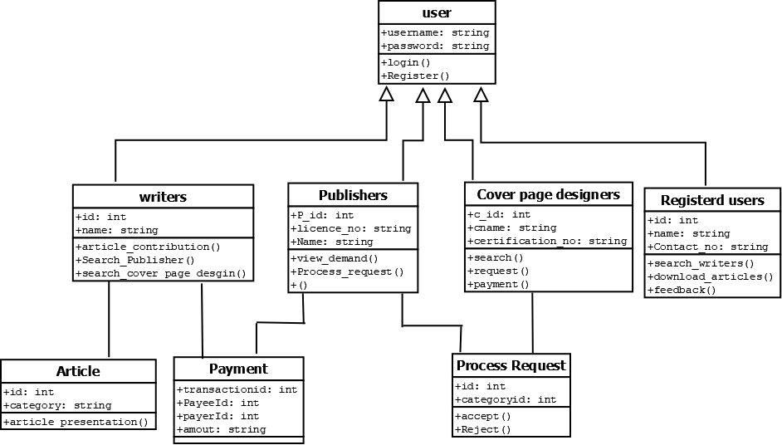

**B. Object diagram**

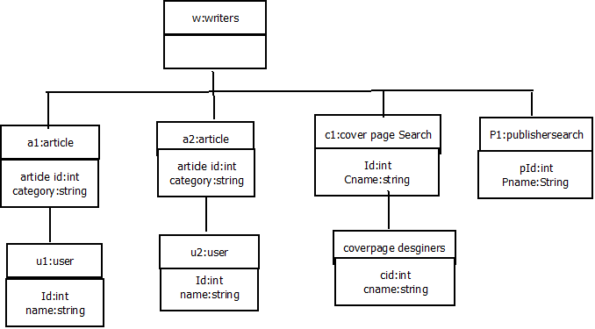

**D:Deployment diagram**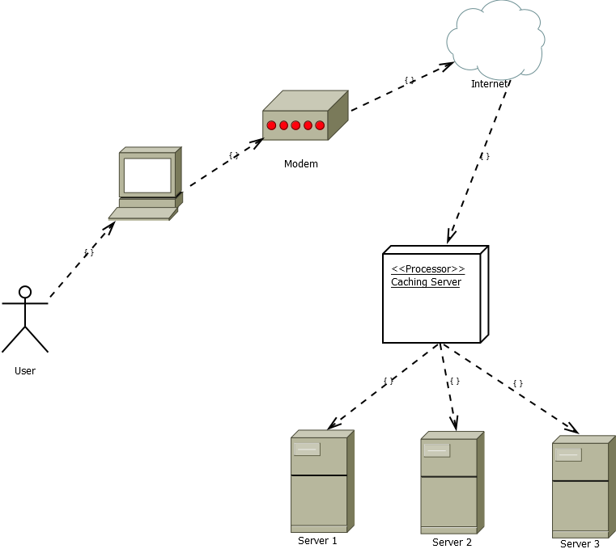

**2.BEHAVIORAL DIAGRAMS**

**Use Case Diagrams**

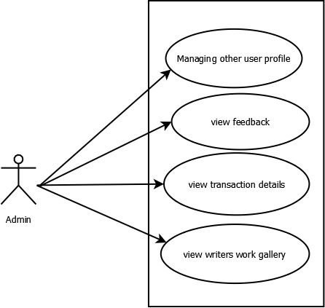

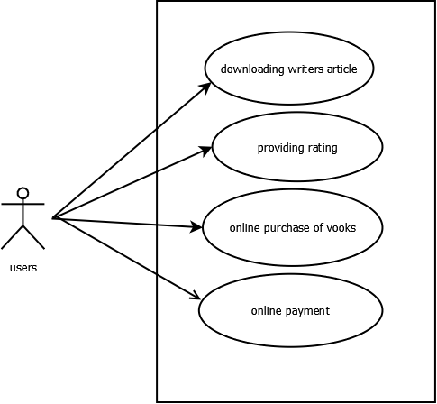

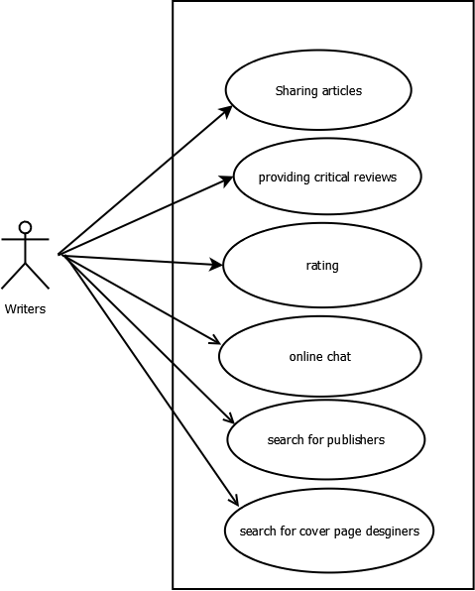

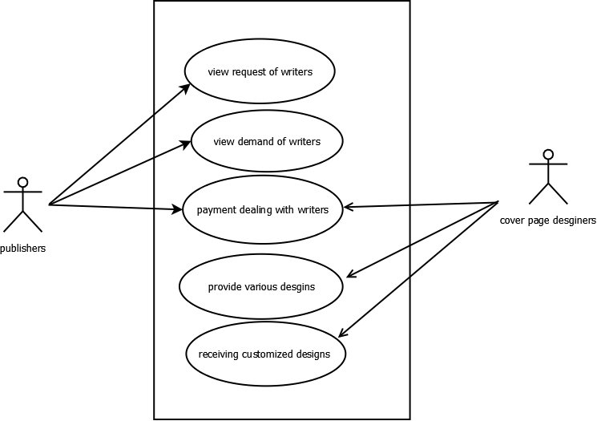

**Sequence Diagram**

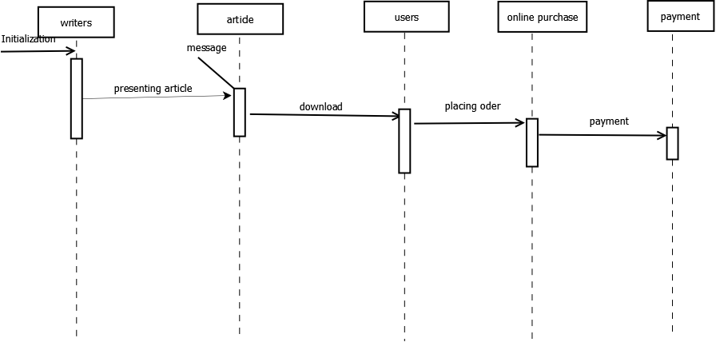

**Collaboration Diagram**

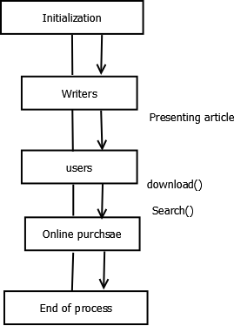

**State Chart Diagram**

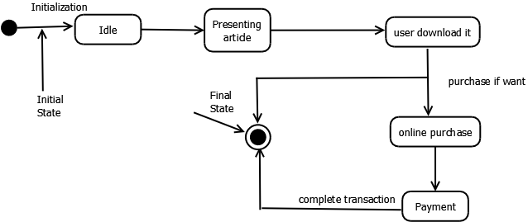

**Activity Diagram**

