GLA UNIVERSITY
17km Stone, NH-19, Mathura-Delhi Road P.O Chaumuhan,
Mathura-281406(Uttar Pradesh) INDIA
Institute of Engineering & Technology

DEPARTMENT OF COMPUTER ENGINEERING AND APPLICATIONS
PROJECT TITLE - Document Intelligence System
COURSE CODE - BCSJ0951
SEMESTER-V
Members of the project
SAMPADA SAXENA- 2315001952
SHUBHAM AGRAWAL – 2315002317
ANNU RAJ – 2315000329
CHARU SHARMA – 2315000647
PRIYANSHU RAJ - 2315001712
SECTION-N
Under the Guidance of
Mr. Ayush Tiwari, Technical trainer, GLA University

SUBMISSION DATE-13/02/2026

CERTIFICATE

This is to certify that the project report entitled “DOCUMENT INTELLIGENCE SYSTEM” has been carried out by the candidates Sampada Saxena(2315001952), Shubham Agrawal(2315002317), Annu Raj(2315000329), Charu Sharma(2315000647), Priyanshu Raj(2315001712), as part of their academic requirement to the GLA University, Mathura. The statements made in this report are correct to the best of our knowledge and belief.

Mr. Ayush Tiwari,
Technical Trainer,
Dept. of Computer Engg. & Applications,
GLA University, Mathura

Date: 13th February, 2026. Place: Mathura
TABLE OF CONTENTS

CONTENTS

ABSTRACT 4
INTRODUCTION 5
1.1 Background of the Problem 5
1.2 Motivation and Relevance 5
1.3 Industry Use-Case Alignment 6
PROBLEM STATEMENT 7
2.1 Problem Definition 7
2.2 Limitations of Existing Systems 7
OBJECTIVES 8
3.1 Primary Objectives 8
3.2 Secondary Objectives 8
3.3 Learning Outcomes 8
SYSTEM DESIGN 9
4.1 System Design Overview 9
4.2 System Architecture 9
TECHNOLOGY STACK 10
IMPLEMENTATION PLAN 10
5.1 Module-wise Breakdown 10
5.2 Team Role Distribution 11
5.3 Project Timeline 11
EXPECTED RESULTS & DELIVERABLES 12
6.1 Functional System Modules 12
6.2 Dashboard & UI Outputs 12
6.3 Reports & Analysis 12
6.4 GitHub Repository 13
RISKS AND MITIGATION PLAN 13
CONCLUSION 14
REFERENCES 15

ABSTRACT
A Document Intelligence System is a software system that uses Artificial Intelligence (AI) to automatically read, understand, and extract important information from documents such as PDF files, scanned images, invoices, forms, and reports. Instead of manually typing data from documents, the system uses technologies like Optical Character Recognition (OCR) to convert images into text and Natural Language Processing (NLP) to identify and organize useful information into a structured format.
The proposed system allow user to interacts with the Document Intelligence System through a simple interface. First, the user uploads a document such as a PDF file or scanned image using the upload option in the application. After the document is uploaded, the system processes it automatically.
The frontend of the system will be developed using HTML, CSS, and Javascript to ensure a simple, responsive, and user-friendly interface. Since the data such as user profiles or service applications, etc. associated with our application is structured so we decided to choose MySQL for efficient structured database management.
The expected outcome of the Document Intelligence System is to develop a working application that can automatically process documents and extract meaningful information from them. The system will allow users to upload scanned documents or PDF files, after which it will use OCR to convert the document content into text and NLP techniques to identify and extract important fields.

INTRODUCTION

1.1 Background of the Problem
In the era of digital transformation, organizations increasingly rely on digital documents such as invoices, forms, reports, and scanned records for daily operations. However, a large amount of important information still exists in unstructured document formats like PDFs and images. Extracting useful data from these documents often requires manual data entry, which is time-consuming, error-prone, and inefficient.
This approach leads to several issues:
- Manual Processing Delay: Employees spend significant time reading documents and entering data into systems, slowing down workflows.
- Human Errors: Manual data entry increases the chances of mistakes in important fields such as names, dates, and financial values.
- Lack of Automation: Many organizations still lack intelligent systems that can automatically understand and process document content.

1.2 Motivation and Relevance
The primary motivation behind the Document Intelligence System is to reduce the dependency on manual document processing by enabling automatic extraction of information from digital and scanned documents using Artificial Intelligence. As organizations handle large volumes of documents daily, there is a growing need for intelligent systems that can process document data quickly and accurately.
The relevance of this project lies in its commitment to:
- Automation: Automatically extracting text and structured information from documents reduces manual effort and speeds up workflows.
- Accuracy: AI-based document processing minimizes human errors in data entry and improves reliability.
- Efficiency: Faster document handling improves productivity and reduces operational delays.

1.3 Industry Use-Case Alignment
This project aligns with modern Enterprise Automation and AI-driven document processing systems used across industries such as banking, insurance, healthcare, and government administration. It reflects real-world implementations of intelligent document processing (IDP) solutions that automate data extraction from invoices, forms, contracts, and reports to streamline organizational workflows.
By utilizing a modern technology stack—specifically HTML, CSS, and JavaScript for the user interface, C.net for backend processing, MySQL for structured data storage—the system follows industry best practices for building scalable and automated document-processing applications.
PROBLEM STATEMENT

2.1 Problem Definition
The current handling of organizational documents is largely dependent on manual data extraction and document review processes. Employees are often required to read scanned files, PDFs, and forms and then manually enter relevant information into digital systems. This lack of automation creates a time-consuming and inefficient workflow, especially when dealing with large volumes of documents.

Without an intelligent document processing system, document management remains slow, repetitive, and resource-intensive, limiting productivity and preventing organizations from fully leveraging digital transformation technologies.

2.2 Limitations of Existing Systems
The existing document handling and data-entry processes in many organizations suffer from several critical bottlenecks:
- Manual Data Extraction: Most systems still depend on humans to read documents and enter information into databases, leading to slow processing and increased workload.
- Low Accuracy and Error-Prone Processes: Manual typing of document data often introduces mistakes in fields such as names, dates, identification numbers, and financial values.
- Lack of Automation: Traditional document management systems store files but do not intelligently extract or understand document content, limiting their usefulness.
- Processing Delays: Handling large volumes of documents manually creates bottlenecks in workflows and delays decision-making.
- Difficulty in Handling Unstructured Data: Many existing systems struggle to process scanned images, handwritten text, and non-standard document formats.

Summary: The absence of an intelligent and automated document processing system results in reduced productivity, higher operational costs, and inefficient document management, highlighting the need for a Document Intelligence System.

OBJECTIVES

3.1 Primary Objectives
The core purpose of the Document Intelligence System is to automate document processing by extracting meaningful information from scanned documents and PDFs using Artificial Intelligence technologies such as OCR and NLP.
- Automated Document Processing: To develop a system that can automatically read digital and scanned documents and convert them into machine-readable text using OCR technology.
- Structured Data Extraction: To implement NLP-based techniques that identify and extract important fields from documents and organize them into structured formats for easy storage and retrieval.
- Efficient Data Management: To design a backend system that securely stores extracted document data and allows users to view, manage, and verify the processed information through a simple user interface.

3.2 Secondary Objectives
These goals support the primary mission by ensuring the system is efficient, reliable, and easy to use in real-world document processing scenarios.
- Data Storage & Security: To design a database system using MongoDB or MySQL that securely stores extracted document data while maintaining consistency and easy retrieval.
- User-Friendly Interface: To build a simple and responsive interface using HTML, CSS, and JavaScript that allows users to upload documents and view extracted information across different devices.

3.3 Learning Outcomes
As the developers of this system, the project aims to achieve the following technical and professional growth:
- Full-Stack Development: Gaining hands-on experience in integrating a frontend interface with backend processing and database storage to build a complete document-processing application.
- • Database Design: Learning how to design and manage databases to store extracted document data efficiently and securely.
- • Problem-Solving & Automation Logic: Developing the logic required to automate document processing workflows, including file handling, text extraction, and structured data generation.

SYSTEM DESIGN

4.1 System Design Overview
The Document Intelligence System is built using a 3-Tier Client–Server Architecture, designed to ensure modularity, scalability, and efficient document processing. The architecture is divided into the following layers:
- Presentation Tier (Frontend): Developed using HTML5, CSS3, and JavaScript, this layer provides the user interface for uploading documents and viewing extracted information.
- Application Tier (Logic): This layer contains the core processing logic of the system. It handles document uploads, integrates OCR processing to extract text from documents.
- Data Tier (Backend): A MongoDB or MySQL database is used for data persistence. It securely stores extracted document data, document metadata, and processing results, ensuring data consistency and reliability.
The system features two primary modules:
- User Module: Allows users to upload documents, initiate document processing, and view extracted structured data.
- Processing Module: Manages OCR and NLP operations, handles document processing workflows, and stores extracted results in the database.

4.2 System Architecture

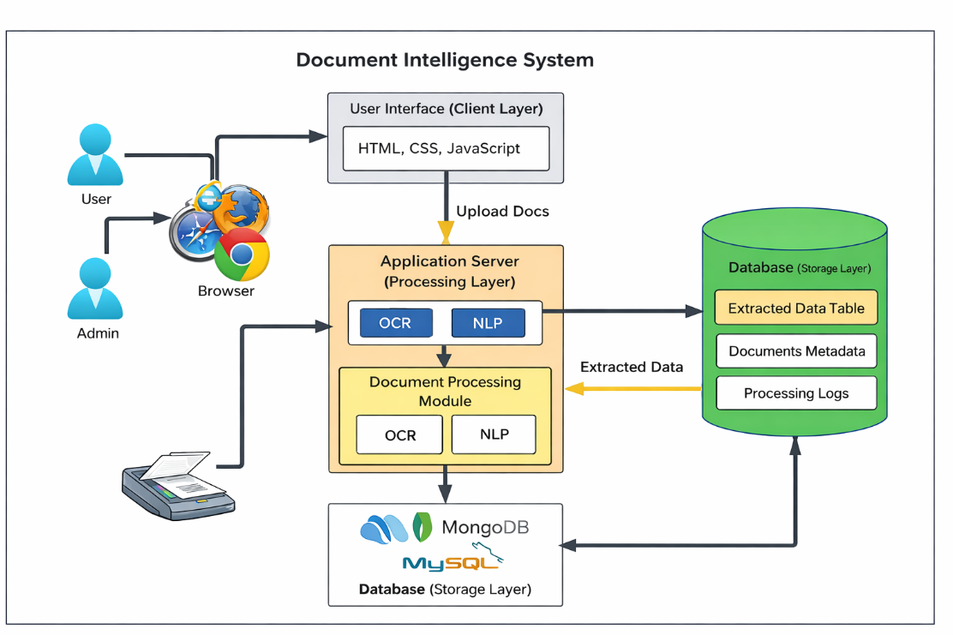
Figure 1: Document Intelligence System Architecture

TECHNOLOGY STACK
Component | Technology Used
Frontend | HTML5, CSS3, JavaScript (ES6+)
Backend | .NET Core / C#
Database | MySQL
Deployment | Local Server
Version Control | GitHub
Table 1: Technology Stack

IMPLEMENTATION PLAN

5.1 Module-wise Breakdown
The project is divided into five core functional modules to ensure a systematic document-processing workflow:
- Document Upload Module: Handles secure document upload functionality, allowing users to submit PDF files and scanned images for processing.
- OCR Processing Module: Responsible for extracting text from uploaded documents using Optical Character Recognition (OCR) technology.
- NLP Extraction Module: Processes the extracted text using Natural Language Processing (NLP) to identify important fields and convert unstructured content into structured data.
- Data Storage Module: Stores extracted document data, document metadata, and processing results in the database (MySQL) for future retrieval.
- Result Visualization Module: Displays the extracted structured data through the user interface, allowing users to review and verify the processed information.

5.2 Team Role Distribution
Team Member | Primary Responsibilities | Security Focus
Sampada Saxena | Frontend Development (UI/UX), Deployment (Hosting), and Technical Documentation. | Client-Side Security: Input validation, XSS prevention, and secure UI routing.
Shubham Agrawal | Deployment setup (hosting configuration), server environment preparation, application build management, and version control integration. | Secure server configuration, environment variable protection, access control management, and safe deployment pipelines.
Annu Raj | Implementing authentication mechanisms, input validation, secure API communication, preparing technical documentation, API documentation, user manuals, and project reports. | Data encryption, prevention of common vulnerabilities (XSS, SQL Injection), secure session handling, protection of sensitive credentials in documentation, and controlled access to system information.
Charu Sharma | Writing and executing test cases for frontend components, backend APIs, and document processing modules. | Testing input validation, authentication flows, error handling, and preventing unexpected system behaviour.
Priyanshu Raj | Application Logic (Server-side), Database Architecture (MySQL), and API Integration. | Server-Side Security: SQL Injection prevention, Data Encryption, and Password Hashing.
Table 2: Team Role Distribution

5.3 Project Timeline
Table 3: Project Timeline
Phase | Activities | Duration | Assigned To
Phase 1: Planning | Requirements gathering and Database Schema design. | Week 1-2 | Shubham Agrawal & Priyanshu Raj
Phase 2: Frontend | Building responsive HTML/CSS/JS wireframes and UI. | Week 3-5 | Sampada Saxena
Phase 3: Backend | Database creation (MySQL) and Application Logic. | Week 4-7 | Priyanshu Raj
Phase 4: Security | Implementing shared security protocols and validation. | Week 8-9 | Shubham Agrawal
Phase 5: Deployment | Hosting the system and final debugging. | Week 10-11 | Charu Sharma
Phase 6: Documentation | Finalizing the project report and user manual. | Week 12 | Annu Raj

EXPECTED RESULTS & DELIVERABLES

6.1 Functional System Modules
Upon completion, the system will deliver the following integrated modules:
- Document Upload Interface: A simple interface where users can upload scanned documents or PDF files for automated processing.
- OCR Processing Engine: A module responsible for converting document images and PDFs into machine-readable text using Optical Character Recognition.
- NLP Extraction System: A processing engine that analyses extracted text and identifies important information, converting unstructured document content into structured data.
- Result Visualization Module: A display interface that presents extracted information in a clear and organized format for user review.
- Database Synchronization Module: A backend storage system that maintains document metadata, extracted data, and processing logs, ensuring data consistency across system operations.

6.2 Dashboard & UI Outputs
The user experience will be defined by the following visual deliverables:
- Document Upload Dashboard: A responsive interface built that allows users to upload documents, view processing status, and access previously processed files.
- Processing Status Indicator: Visual indicators (e.g., Uploaded → Processing → Extracted) that update dynamically based on backend document-processing operations.
- Extracted Data View: A tabular or card-based layout that displays structured data extracted from documents in a clear and organized format.

6.3 Reports & Analysis
The system will generate data-driven insights to help improve document-processing efficiency and accuracy:
- Document Processing Report: A statistical summary showing the number of documents processed within a specific timeframe and their processing status.
- Extraction Accuracy Metrics: Analysis of successfully extracted fields and detection performance across different document types.
- Processing Efficiency Data: A summary for administrators showing the average time taken for a document to move from Upload to Data Extraction Completion.

6.4 GitHub Repository
The complete source code and technical documentation will be hosted on GitHub to ensure version control and transparency.
Public Repository Link: https://github.com/annuraj1/Document-Intelligence-System

RISKS AND MITIGATION PLAN
Identifying potential bottlenecks early ensures a smoother development lifecycle. The following table outlines our strategy for handling project risks:
Risk Category | Potential Risk | Mitigation Strategy
Technical Risks | Security Vulnerabilities: Risks like SQL Injection or XSS.  Cross-Browser Inconsistency: UI elements breaking on older browsers or specific mobile devices. | Implementation of prepared statements in MySQL and strict client-side input validation.  Use of CSS Flexbox/Grid and standardized JS libraries to ensure cross-platform compatibility.
Team Coordination Risks | Integration Conflicts: Overlapping code changes in the frontend and backend.  Task Dependency Bottlenecks: Backend delays stalling frontend progress (or vice versa) | Strict use of GitHub for version control and bi-weekly "sync-up" meetings for module testing.  Adopting a Modular Development approach where UI wireframes are built independently of the live database.
Data Availability Risks | Database Downtime: Potential data loss during the testing phase or server crashes.  Data Scalability Issues: System slowdown as the number of users records increases. | Implementation of daily manual/automated backups and local staging environments for testing.  Optimizing MySQL Indexing and query structures to maintain high performance under increased data loads.
Table 4: Risks and Mitigation Plan

CONCLUSION
The Document Intelligence System serves as an important step toward automating document processing and data extraction in modern digital environments. From an academic perspective, this project demonstrates the practical implementation of OCR, NLP, and a 3-tier architecture to process unstructured documents and convert them into structured, usable data. It highlights how Artificial Intelligence can be integrated with web technologies and database systems to solve real-world document management challenges.

REFERENCES

[1] W3Schools, "Web Development Tutorials," 2024. [Online]. Available: https://www.w3schools.com. [Accessed: 12-Feb-2026].
[2] MDN Web Docs, "Web technology for developers," Mozilla, 2024. [Online]. Available: https://developer.mozilla.org. [Accessed: 12-Feb-2026].
[3] Microsoft, "Introduction to C# and .NET," Microsoft Learn, 2024. [Online]. Available: https://learn.microsoft.com/en-us/dotnet/csharp/. [Accessed: 12-Feb-2026].
[4] Oracle, "MySQL 8.0 Reference Manual," MySQL Documentation. [Online]. Available: https://dev.mysql.com/doc/refman/8.0/en/. [Accessed: 12-Feb-2026].
[5] Microsoft Azure, "Azure App Service Documentation," Microsoft, 2024. [Online]. Available: https://learn.microsoft.com/en-us/azure/app-service/. [Accessed: 12-Feb-2026].
[6] R. Elmasri and S. B. Navathe, Fundamentals of Database Systems, 7th ed. Boston, MA, USA: Pearson, 2016. (Standard academic reference for your DBMS notes).

