# PROJECT REPORT

# 1. INTRODUCTION

## 1.1 Project Overview

TrafficTelligence is a machine learning-based system that predicts traffic volume using structured historical and environmental data (e.g., holidays, climate, weather). The system avoids the use of CCTV footage or sensors, focusing purely on predictive modeling.

## 1.2 Purpose

To enable city planners and traffic authorities to make data-driven decisions by forecasting traffic volume based on historical patterns, weather, and holiday schedules.

# 2. IDEATION PHASE

## 2.1 Problem Statement

Managing urban traffic is increasingly difficult due to population growth and vehicle volume. Manual counting methods are error-prone and inefficient. There is a need for a predictive system that estimates traffic without reliance on expensive hardware or live feeds.

## 2.2 Empathy Map Canvas

Developed based on understanding the needs of traffic managers, city planners, and drivers.

## 2.3 Brainstorming

Brainstormed different solutions including computer vision models, but opted for structured data ML models due to resource constraints and practicality.

# 3. REQUIREMENT ANALYSIS

## 3.1 Customer Journey map

User starts with traffic analysis need → feeds relevant data → system predicts traffic volume → user utilizes output for planning.

## 3.2 Solution Requirement

- Predict traffic volume based on features like holidays, climate, etc.  
- Provide output in readable and graphical format.  
- Ensure system is lightweight and easy to run locally.

## 3.3 Data Flow Diagram

CSV Data → Preprocessing → ML Model → Prediction

## 3.4 Technology Stack

- Python (numpy, pandas, scikit-learn, Flask, Html, CSS, xgboost, pickle, warnings, OS)  
- Local file system (CSV data)  
- No database

- Flask frontend frameworks used

# 4. PROJECT DESIGN

## 4.1 Problem Solution Fit

The proposed solution fits areas where real-time data is unavailable but historical data exists.

## 4.2 Proposed Solution

Use structured data and ML models to forecast traffic volume with minimal infrastructure.

## 4.3 Solution Architecture

Structured Dataset → Model Training → Prediction Interface → Output

# 5. PROJECT PLANNING & SCHEDULING

## 5.1 Project Planning

- Sprint 1: Data preprocessing and feature selection  
- Sprint 2: Model training and evaluation  
- Sprint 3: Visualization and output formatting  
- Sprint 4: Testing and refinement  
- Sprint 5: Documentation and review

# 6. FUNCTIONAL AND PERFORMANCE TESTING

## 6.1 Performance Testing

Tested accuracy using RMSE, MAE, and R². Output prediction accuracy is within acceptable bounds for a static dataset.

**7. RESULTS**

## 7.1 Output Screenshots

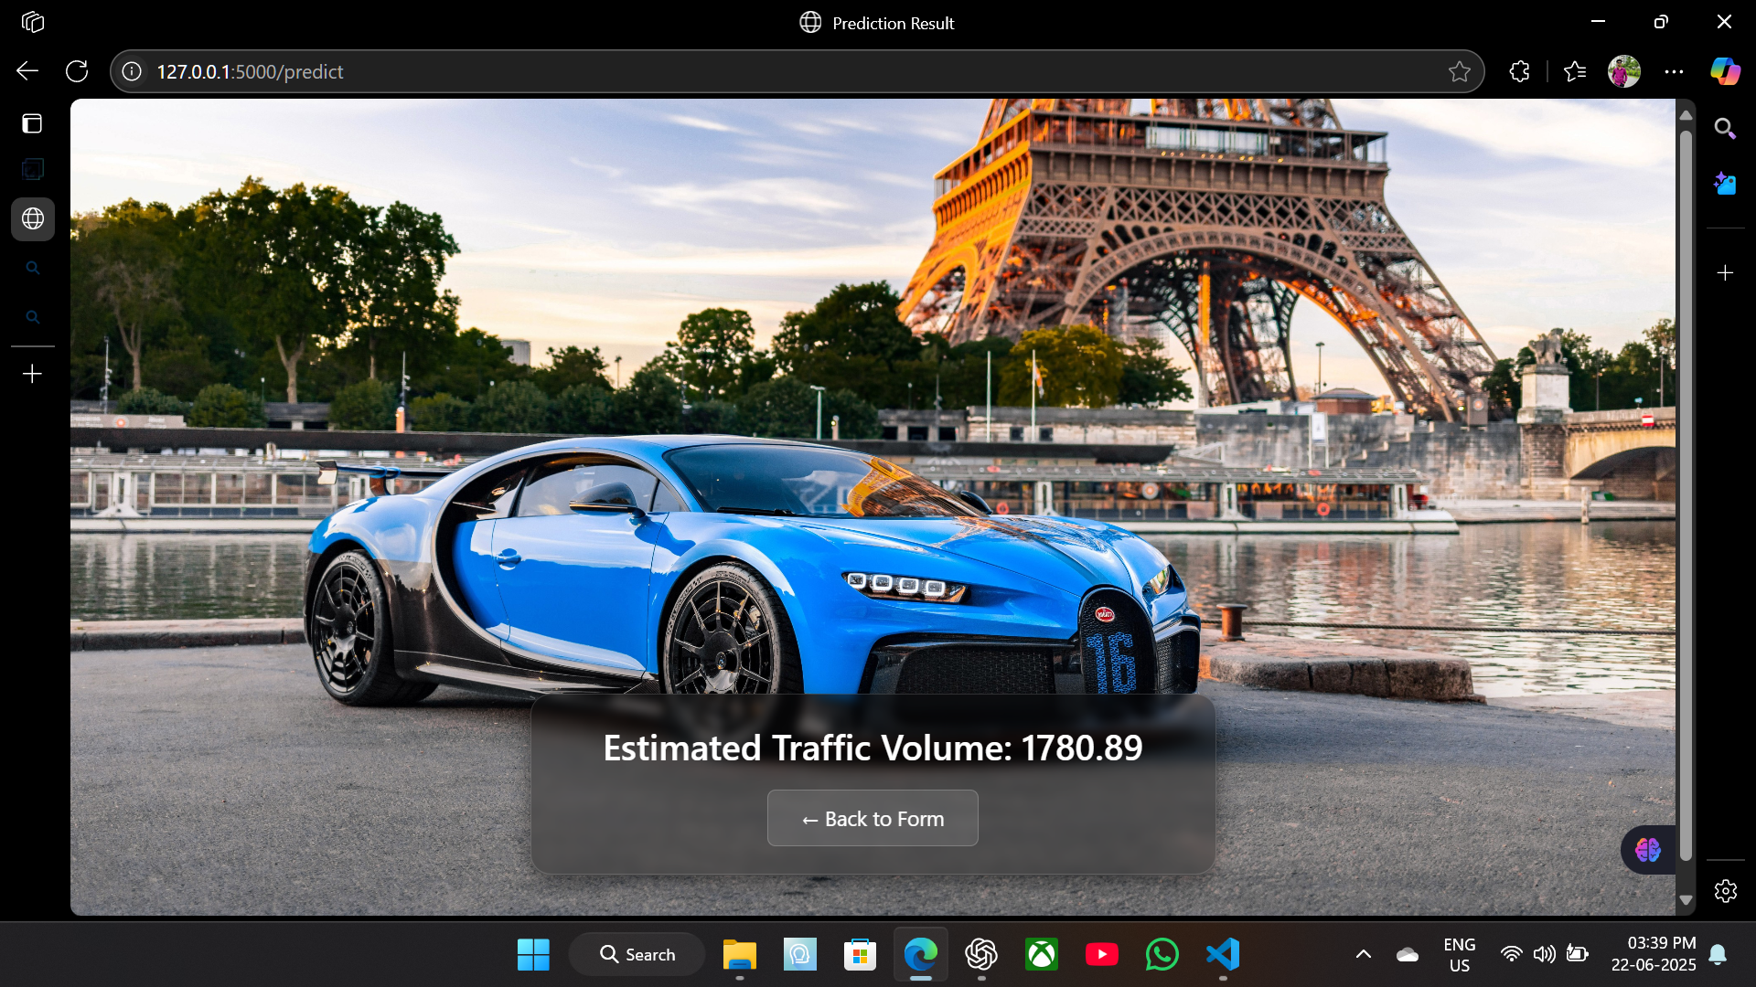

# 8. ADVANTAGES & DISADVANTAGES

Advantages:  
- No need for CCTV/sensor hardware  
- Easy to deploy  
- Interpretable predictions

Disadvantages:  
- No real-time capability yet  
- Limited to structured data

# 9. CONCLUSION

TrafficTelligence successfully demonstrates traffic volume forecasting using machine learning on structured datasets, laying a foundation for future real-time intelligent traffic systems.

# 10. FUTURE SCOPE

- Integrate live traffic data sources  
- Build real-time dashboards  
- Enable cloud-based access and city-wide deployment

# 11. APPENDIX

• Source Code: <https://github.com/annuu005/TrafficTelligence-Advanced-Traffic-Volume-Estimation-with-Machine-Learning.git>  
• Dataset Link: <https://drive.google.com/file/d/1iV5PfYAmI6YP0_0S4KYy1ZahHOqMgDbM/view>  
• Project Demo:

