Lab Assignment 7

Multiobjective Optimization: 37 Algorithms, Trade-offs and Applications
Optimization Techniques Lab · based on Chapter 5 (Parts 1-4 and Bonus Module 5E)
Item | Value
Roll number R | 77
Deep-dive algorithms (Task C) | Algorithm 1 = ((77-1) mod 37)+1 = 3 Benson's Method  Algorithm 2 = ((77+11) mod 37)+1 = 15 NSGA-III  Algorithm 3 = ((77+23) mod 37)+1 = 27 MODE
Language / libraries | Python 3.13, NumPy + Matplotlib + standard library only for every algorithm, baseline and metric. scikit-learn is used ONLY to load the Wisconsin breast-cancer data (P9); reportlab only builds this PDF.
Seeds | Task A: seed 0. Tasks C and D: seeds 0-9 (10 independent runs, mean ± std). Reference-front builds: seeds 0-4.
Budget | 10,000 function evaluations for every population / swarm algorithm (classical sweeps: 11-21 settings, evaluations reported).
Unit tests | 67 passed, 0 failed, 67 tests (results/test_report.txt)
Code | moo_utils.py, problems.py, solvers.py, ops.py, mtl_net.py, algorithms/alg01..alg37, tests/, experiments/, handtrace/, README.md

Honesty note. Everything reported here was produced by the code in the accompanying zip; the raw numbers behind every table and plot are in results/*.json. Where an algorithm only partly works, or where our implementation deliberately differs from a lecture formula, this is stated next to the result (see the implementation log in Section 3 and the list of deviations in Appendix B).

1 Conventions, shared toolkit and verification
Minimisation everywhere. A maximised objective f is stored as -f (Max f = Min -f); Problem.natural() converts back for plots and tables. Normalisation. Before computing hypervolume (HV), IGD or Spacing every front is mapped with (f - ideal)/(nadir - ideal), using for each problem the ideal and nadir of its true / best-known front (so the same scale is used for all algorithms). The HV reference point is 1.1 on every normalised axis. Metrics. HV: exact sweep for 2 objectives, a fixed-seed Monte-Carlo estimate (200,000 samples) for 3 or more; IGD: mean distance from points of the true / reference front to the nearest obtained point; Spacing: Schott's standard deviation of nearest-neighbour distances. IGD on P4, P5, P6 uses a dense-sampling front, on P8 and P9 the pooled best-known front of long runs (marked * in tables; P8 has only 10 non-dominated tours, P9 only 7).
Shared toolkit (moo_utils.py, Task A1). dominance test, Deb's constrained dominance, vectorised dominance matrix, fast non-dominated sorting (np/Sp), crowding distance, normalisation, 2-D hypervolume (+ Monte-Carlo, + 2-D/MC hypervolume contributions), IGD, GD, Spacing, Das-Dennis reference points. They are tested on the lecture examples: the car Pareto-front table (A, B, C, D non-dominated; E, F dominated), Deb's constrained-dominance table (A, D feasible; B beats C by smaller violation), the crowding-distance table of Part 4 (1.00, 0.70, 1.00), and the 5E metric example (HV = 0.7283 / 0.7234, IGD ≈ 0.077). Our own simplex LP, Nelder-Mead and integer solvers (solvers.py) serve the classical methods, so no scipy call is made by any algorithm.
Verification summary. tests/test_moo_utils.py (9 tests), test_problems.py (13: every 'sanity check' number of Section 4), test_solvers.py (5), test_algorithms.py (37 tests, one per algorithm, each reproduces a number printed on a lecture slide: e.g. Weighted-Sum x* = 5 and 3.8, eps-constraint x* = 2 and 3, TOPSIS Ci = 0.466/0.459/0.541/0.629, VIKOR Q = 0.607/1.0/0.571/0, IBEA fitness -4.05 ... -4.87, SMS-EMOA total HV 9.10, MGDA x1 = (4.6, 4.6), GradNorm w = (1.063, 0.937), ...), and test_handtraces.py (3 tests: the deep-dive hand traces of Task C). All 67 tests pass (results/test_report.txt).
Slide discrepancies found while testing (kept, not hidden): (i) 5E slide 15 quotes an SMS-EMOA contribution of 0.70 for L2 but the exclusive rectangle is 0.3 x 3 = 0.90 (the other five contributions and the total 9.10 are right); (ii) Part 2 slide 40: x = 2 is dominated by x = 0 and by x = 1, so its MOGA rank is 3, not 2; (iii) the 5E IBEA fitness formula F(i) = Σj -exp(-I(i,j)/κ) (delete the largest) reproduces the slide numbers exactly but is the 'dual' of the original paper's F(x) = Σy -exp(-I(y,x)/κ) (delete the smallest); the lecture convention collapses to a single point on ZDT2 in our runs (Table B-IBEA), so the default is the paper's.

2 Problem bank: one-page formulations
For every problem used in this report the table states the standard form, the encoding of a solution, how constraints are handled, how objectives are normalised, the hypervolume reference point and the termination rule. All objectives are converted to minimisation before dominance is used.

P1 Factory production speed
Item | Specification
Standard form | min F(x) = [ (x-3)², (x-7)² ] s.t. 1 ≤ x ≤ 10
Encoding | real scalar x
Constraints | bounds only (clip)
Normalisation | ideal [0.0, 0.0], nadir [16.0, 16.0] (natural units)
HV reference point | (1.1, ..., 1.1) in normalised space (the same for every algorithm)
Termination | 10,000 evaluations for EAs / swarms; end of the sweep for classical methods
Sanity check / remark | Pareto set 3≤x≤7; convex front f2 = (4-√f1)². Checked: x=5 -> (4,4); x=3 -> (0,16).

P2 Delivery fleet sizing
Item | Specification
Standard form | min F(x) = [ 100/x, x² ] s.t. 1 ≤ x ≤ 10 (real, and integer)
Encoding | real scalar, or integer (rounded after variation)
Constraints | bounds only
Normalisation | ideal [10.0, 1.0], nadir [100.0, 100.0] (natural units)
HV reference point | (1.1, ..., 1.1) in normalised space (the same for every algorithm)
Termination | 10,000 evaluations for EAs / swarms; end of the sweep for classical methods
Sanity check / remark | every x is Pareto optimal; front f2 = 10000/f1². Checked: x=2 -> (50,4); x=10 -> (10,100). Integer: 10 distinct points.

P3 ZDT2 benchmark
Item | Specification
Standard form | ZDT2: f1 = x1, g = 1 + Σi=2..10 xi, f2 = g (1 - (f1/g)²); x ∈ [0,1]¹⁰
Encoding | real vector, n = 10
Constraints | bounds only
Normalisation | ideal [0.0, 0.0], nadir [1.0, 1.0] (natural units)
HV reference point | (1.1, ..., 1.1) in normalised space (the same for every algorithm)
Termination | 10,000 evaluations for EAs / swarms; end of the sweep for classical methods
Sanity check / remark | non-convex front f2 = 1 - f1² (x2..10 = 0).

P4 Investment portfolio
Item | Specification
Standard form | min [ w'Σw , -μ'w ] s.t. Σwi = 1, w ≥ 0 (4 assets, data of Section 4)
Encoding | x ∈ [0,1]⁴; w = x / Σx (repair)
Constraints | equality by repair (w = x/Σx): satisfied exactly, no evaluation is wasted and the search space keeps its dimension. The penalty variant (CV = |Σx - 1|, tolerance 1e-3) is compared in Section 4 evidence.
Normalisation | ideal [0.007, 0.15], nadir [0.09, 0.0926] (natural units)
HV reference point | (1.1, ..., 1.1) in normalised space (the same for every algorithm)
Termination | 10,000 evaluations for EAs / swarms; end of the sweep for classical methods
Sanity check / remark | Checked: w=(0,0,1,0) -> risk 0.09, return 0.15. Min-risk end = mixture (risk 0.00704, return 0.0926).

P5 Cantilever beam
Item | Specification
Standard form | min [ 7850 L b h , 4 P L³/(E b h³) ] s.t. b h² ≥ 2.4e-5; b ∈ [0.01,0.10], h ∈ [0.02,0.20]
Encoding | real vector (b, h)
Constraints | relative violation CV = max(0, (2.4e-5 - b h²)/2.4e-5); Deb's rules (alg 21) or penalty rho·CV·(nadir-ideal) (default for the others)
Normalisation | ideal [3.8457, 0.0], nadir [157.0, 0.017] (natural units)
HV reference point | (1.1, ..., 1.1) in normalised space (the same for every algorithm)
Termination | 10,000 evaluations for EAs / swarms; end of the sweep for classical methods
Sanity check / remark | Checked: (0.01, 0.05) -> mass 3.925 kg, deflection 0.016 m, stress 240 MPa, feasible.

P6 Binh-Korn
Item | Specification
Standard form | Binh-Korn: min [ 4x1²+4x2², (x1-5)²+(x2-5)² ] s.t. (x1-5)²+x2² ≤ 25, (x1-8)²+(x2+3)² ≥ 7.7; x1∈[0,5], x2∈[0,3]
Encoding | real vector
Constraints | CV = max(0,g1) + max(0,g2); Deb's rules / penalty / none (experiment)
Normalisation | ideal [0.0, 4.0], nadir [136.0, 50.0] (natural units)
HV reference point | (1.1, ..., 1.1) in normalised space (the same for every algorithm)
Termination | 10,000 evaluations for EAs / swarms; end of the sweep for classical methods
Sanity check / remark | Checked: (0,0) -> (0,50), (5,3) -> (136,4), both feasible.

P7 Water allocation
Item | Specification
Standard form | max [0.8x1, 1.2x2] s.t. x1+x2 ≤ 90, x1 ≥ 10, x2 ≥ 20 (stored as min of the negatives)
Encoding | real vector
Constraints | bounds + CV = max(0, x1+x2-90)
Normalisation | ideal [56.0, 96.0], nadir [8.0, 24.0] (natural units)
HV reference point | (1.1, ..., 1.1) in normalised space (the same for every algorithm)
Termination | 10,000 evaluations for EAs / swarms; end of the sweep for classical methods
Sanity check / remark | front = the line x1+x2=90: (10,80) -> (8,96); (70,20) -> (56,24).

P8 Bi-objective TSP
Item | Specification
Standard form | bi-objective TSP, 15 cities (numpy seed 7), min total distance and total time tij = dij uij, uij ~ U(0.5,2)
Encoding | permutation of 0..14 (closed tour)
Constraints | every city once -- guaranteed by construction (OX crossover, swap / inversion mutation; ants build permutations)
Normalisation | ideal [351.8412, 366.3284], nadir [411.434, 463.6668] (natural units)
HV reference point | (1.1, ..., 1.1) in normalised space (the same for every algorithm)
Termination | 10,000 evaluations for EAs / swarms; end of the sweep for classical methods
Sanity check / remark | coordinates printed in Section 4; nearest-neighbour tours used as baselines.

P9 Feature selection
Item | Specification
Standard form | min [ 1 - accuracy(5-NN, 5-fold CV), #features ] over 0/1 masks of the 30 standardised features
Encoding | binary mask, repair keeps ≥ 1 bit
Constraints | at least one feature (CV = 1 if empty, repaired by the operators)
Normalisation | ideal [0.0193, 1.0], nadir [0.0931, 7.0] (natural units)
HV reference point | (1.1, ..., 1.1) in normalised space (the same for every algorithm)
Termination | 10,000 evaluations for EAs / swarms; end of the sweep for classical methods
Sanity check / remark | own 5-NN and own 5-fold CV (fixed fold assignment); all-ones baseline error 0.0369 (96.3 % accuracy).

P10 DTLZ2 many-objective
Item | Specification
Standard form | DTLZ2, M = 3 and 5, n = M+9: g = Σi≥M(xi-0.5)², fm = (1+g) Π cos(xiπ/2) sin(xM-m+1π/2)
Encoding | real vector
Constraints | bounds only
Normalisation | ideal 0, nadir 1 on every axis (M = 3 and M = 5)
HV reference point | (1.1, ..., 1.1) in normalised space (the same for every algorithm)
Termination | 10,000 evaluations for EAs / swarms; end of the sweep for classical methods
Sanity check / remark | g = 0 ⇒ Σ fm² = 1 (checked for M = 3, 5); true front = Das-Dennis points projected on the unit sphere.

P11 Production planning
Item | Specification
Standard form | max [4A+6B, A+B] s.t. 2A+3B ≤ 1200, 4A+2B ≤ 1600, A,B ≥ 0 (goals: profit ≥ 2400, units ≥ 600; priority: profit then units)
Encoding | real vector
Constraints | relative violations summed; LP data used by goal programming / lexicographic
Normalisation | ideal [2400.0, 500.0], nadir [1600.0, 400.0] (natural units)
HV reference point | (1.1, ..., 1.1) in normalised space (the same for every algorithm)
Termination | LP optimum (exact)
Sanity check / remark | corners (0,0),(400,0),(300,200),(0,400); profit 2400 on the whole edge (300,200)-(0,400); units max 500 at (300,200).

P12 Supplier selection
Item | Specification
Standard form | 5 suppliers x 4 criteria (cost min, quality max, delivery min, reliability max), weights (0.3,0.3,0.2,0.2)
Encoding | decision matrix
Constraints | -
Normalisation | -
HV reference point | -
Termination | n/a (ranking)
Sanity check / remark | ranking problem for TOPSIS / VIKOR (algorithms 8, 9).

P13 Multi-task learning
Item | Specification
Standard form | (a) f1=|x-a|², f2=|x-b|², a=(3,3), b=(-3,-3), start (0,5); (b) two-head network (classification BCE + regression MSE) on a shared 2-layer tanh body, hand-coded back-propagation
Encoding | x ∈ R²; network weights
Constraints | none
Normalisation | ideal [0.0, 0.0], nadir [72.0, 72.0] (natural units)
HV reference point | (1.1, ..., 1.1) in normalised space (the same for every algorithm)
Termination | 300 gradient steps (a), 500 epochs (b)
Sanity check / remark | Pareto set of (a) = segment [a,b]; gradient check of (b) agrees with finite differences to 4e-7.

P14 Laptop design
Item | Specification
Standard form | min weight 0.4+0.05x1+0.012x2, max runtime 0.2x2/(0.5+0.03x1); x1∈[13,17], x2∈[40,90]
Encoding | real vector
Constraints | bounds only
Normalisation | ideal [1.53, 20.2247], nadir [2.13, 8.9888] (natural units)
HV reference point | (1.1, ..., 1.1) in normalised space (the same for every algorithm)
Termination | 10,000 evaluations for EAs / swarms; end of the sweep for classical methods
Sanity check / remark | Checked: (13,40) -> 1.53 kg, 8.99 h; (13,90) -> 2.13 kg, 20.2 h; all Pareto points have x1=13.

P8 coordinates used (numpy.random.seed(7), 15 x 2, scaled to [0,100]): 0:(7.6,78.0); 1:(43.8,72.3); 2:(97.8,53.8); 3:(50.1,7.2); 4:(26.8,50.0); 5:(67.9,80.4); 6:(38.1,6.6); 7:(28.8,91.0); 8:(21.3,45.2); 9:(93.1,2.5); 10:(60.1,95.0); 11:(23.0,54.8); 12:(90.9,13.3); 13:(52.3,75.0); 14:(66.9,46.8). Symmetric uij ~ U(0.5,2.0) drawn from the same stream (upper triangle).

3 Task A — the 37 algorithms: implementation log and results
Every algorithm is its own module (algorithms/algNN_name.py) with DEFAULTS, initialize, evaluate, step (one iteration) and run, and a docstring that lists the lecture steps and the default parameters. Each one has a unit test (tests/test_algorithms.py), each has been run with the fixed seed 0 on at least two problems of its 'Test problems' column, and the front is plotted against the true / reference front (grey). The three deep-dive algorithms (3, 15, 27) additionally reproduce the hand traces of Task C. A3 implementation log (HV higher is better, Spacing and IGD lower is better; * = pooled best-known front; classical sweeps use 11 settings, evaluation counts are the real number of function calls):
# | algorithm | problems used (seed 0) | eval. budget | HV / Spacing / IGD | runtime | status
1 | Weighted Sum  classical | P1, P3, P4 | 22,480, 60,878, 231,227 | P1: 1.0065 / 0.0185 / 0.0406  P3: 0.2102 / 0.0001 / 0.3540  P4: 0.9041 / 0.1161 / 0.0459 | 0.7 s / 9.3 s / 2.5 s | works  end points only on the non-convex P3 (by design, see evidence)
2 | epsilon-Constraint  classical | P2, P3, P5 | 31,583, 51,170, 270,883 | P2: 1.0472 / 0.2040 / 0.0636  P3: 0.4726 / 0.0608 / 0.0514  P5: 1.1048 / 0.2544 / 0.1601 | 0.9 s / 11.0 s / 2.0 s | works
3 | Benson's Method  classical | P1 (lambda sweep), P7 (lambda sweep) | 22,654, 53,695 | P1: 1.0082 / 0.0165 / 0.0378  P7: 0.2519 / 0.7450 / 0.3238 | 0.8 s / 2.1 s | works  linear form: lambda-sweep = weighted sum; moving z* reaches the dent (Task C)
4 | Weight Metric  classical | P1 (p=2), P3 (p=inf) | 26,530, 269,699 | P1: 0.9898 / 0.0551 / 0.0969  P3: 0.4835 / 0.0190 / 0.0398 | 0.9 s / 11.0 s | works
5 | Value Function  classical | P14, P4 | 2,776, 17,670 | P14: 0.2392 / n/a / 0.4153  P4: 0.6908 / 0.2578 / 0.1699 | 0.1 s / 0.7 s | works  returns one solution per preference input
6 | Goal Programming  classical | P11 (unit w), P7 (unit w) | 1 | P11: 1.2100 / n/a / n/a  P7: 0.3600 / n/a / 0.3537 | 0.0 s / 0.0 s | works  one compromise solution
7 | Lexicographic  classical | P11, P7 (eps sweep) | 1, 6 | P11: 1.2100 / n/a / n/a  P7: 0.3131 / 0.0000 / 0.4463 | 0.0 s / 0.0 s | works  one solution per priority list / tolerance
8 | TOPSIS  ranking | P12; NSGA-II front of P4 | - | ranking only (Ci / Q listed in Task D) | <0.01 s | works  ranking only
9 | VIKOR  ranking | P12; NSGA-II front of P4 | - | ranking only (Ci / Q listed in Task D) | <0.01 s | works  ranking only
10 | VEGA  non-elitist | P2, P3 | 10,000 | P2: 1.0982 / 0.0131 / 0.0806  P3: 0.0000 / n/a / 1.2223 | 0.1 s / 0.1 s | works  implements the lecture algorithm; it collapses to extremes on P3 -- the expected failure mode
11 | MOGA  non-elitist | P3, P5 | 10,000 | P3: 0.5122 / 0.0169 / 0.0203  P5: 1.1933 / 0.0152 / 0.0167 | 0.2 s / 0.2 s | works
12 | NSGA  non-elitist | P5, P7 | 10,000 | P5: 1.1934 / 0.0120 / 0.0170  P7: 0.6501 / 0.0225 / 0.0312 | 0.3 s / 0.3 s | works
13 | NPGA  non-elitist | P3, P5 | 10,000 | P3: 0.0000 / n/a / 1.2823  P5: 1.1894 / 0.0302 / 0.0291 | 0.7 s / 0.7 s | partly works  does not reach the ZDT2 front within 10,000 evaluations (non-elitist, 2 non-dominated points); fine on P5
14 | NSGA-II  elitist | P3, P5, P6 | 10,000 | P3: 0.5333 / 0.0042 / 0.0082  P5: 1.1950 / 0.0070 / 0.0064  P6: 1.0196 / 0.0071 / 0.0057 | 0.6 s / 0.6 s / 0.6 s | works
15 | NSGA-III  many-objective | P10_M3, P10_M5 | 10,000 | P10_M3: 0.5665 / 0.0647 / 0.1127  P10_M5: 0.4758 / 0.1693 / 0.4312 | 1.0 s / 0.9 s | works
16 | SPEA2  elitist | P4, P5 | 10,000 | P4: 0.9692 / 0.0022 / 0.0043  P5: 1.1952 / 0.0028 / 0.0051 | 8.5 s / 7.7 s | works
17 | PESA-II  elitist | P3, P5 | 10,000 | P3: 0.5329 / 0.0070 / 0.0088  P5: 1.1948 / 0.0081 / 0.0074 | 1.7 s / 2.3 s | works
18 | MOEA/D  decomposition | P10_M3, P3 | 10,000 | P10_M3: 0.6912 / 0.0384 / 0.0741  P3: 0.4886 / 0.0032 / 0.0262 | 2.8 s / 2.2 s | works
19 | MOEA/D-DE  decomposition | P3, P5 | 10,000 | P3: 0.5360 / 0.0028 / 0.0046  P5: 1.1955 / 0.0047 / 0.0057 | 1.8 s / 2.3 s | works
20 | MOEA/D-ACO  decomposition | P8 | 10,000 | P8: 0.7263 / 0.1123 / 0.0264* | 6.3 s | works
21 | Constrained NSGA-II  constrained | P5, P6, P7 | 10,000 | P5: 1.1950 / 0.0070 / 0.0064  P6: 1.0194 / 0.0051 / 0.0054  P7: 0.6997 / 0.0054 / 0.0062 | 0.6 s / 0.6 s / 0.6 s | works
22 | MOPSO  swarm | P4, P5 | 10,000 | P4: 0.9690 / 0.0030 / 0.0045  P5: 1.1954 / 0.0034 / 0.0049 | 0.6 s / 0.6 s | works
23 | MOGWO  swarm | P5, P9 | 10,000 | P5: 1.1953 / 0.0035 / 0.0050  P9: 0.8687 / 0.2550 / 0.1192* | 0.6 s / 12.5 s | works
24 | MOABC  swarm | P3, P6 | 10,000 | P3: 0.5314 / 0.0069 / 0.0090  P6: 1.0212 / 0.0025 / 0.0043 | 0.5 s / 0.9 s | works
25 | MOACO  swarm | P8 | 10,000 | P8: 0.6944 / 0.5091 / 0.0882* | 3.6 s | works
26 | MOSA  physics | P3, P5 | 10,000 | P3: 0.2912 / 0.0226 / 0.1993  P5: 1.1955 / 0.0047 / 0.0049 | 0.5 s / 2.5 s | partly works  slow: reaches only HV 0.29 on P3 (vs 0.53) within the budget; fine on P5
27 | MODE  evolutionary | P3 (lecture rule), P5 (lecture rule) | 10,000 | P3: 0.1090 / n/a / 0.6099  P5: 1.1952 / 0.0151 / 0.0069 | 0.5 s / 1.1 s | partly works  lecture rule 'replace only if dominating' collapses to f1 = 0 on P3 (HV 0.11); works on P5; survival variant fixes it
28 | MO-TLBO  human-inspired | P3, P5 | 10,000 | P3: 0.5375 / 0.0025 / 0.0040  P5: 1.1955 / 0.0045 / 0.0051 | 0.8 s / 0.6 s | partly works  premature collapse in some seeds on P3 (see Task D variance)
29 | MOBA  swarm | P3, P4 | 10,000 | P3: 0.5385 / 0.0021 / 0.0039  P4: 0.9690 / 0.0032 / 0.0043 | 0.7 s / 1.1 s | works
30 | MOMA  hybrid | P5, P9 | 10,000 | P5: 1.1951 / 0.0079 / 0.0069  P9: 0.9100 / 0.2251 / 0.0377* | 0.7 s / 23.5 s | works
31 | RVEA  many-objective | P10_M3, P10_M5 | 10,000 | P10_M3: 0.4061 / 0.0324 / 0.2003  P10_M5: 0.9044 / 0.0907 / 0.3365 | 0.1 s / 0.1 s | partly works  runs, but with the lecture APD only 37-50 reference sectors stay occupied and IGD is worse than NSGA-III / MOEA/D at this budget
32 | IBEA  indicator | P14, P3 | 10,000 | P14: 0.7041 / 0.0033 / 0.0041  P3: 0.5363 / 0.0125 / 0.0078 | 0.6 s / 0.6 s | works
33 | SMS-EMOA  indicator | P14, P3 | 10,000 | P14: 0.7049 / 0.0012 / 0.0036  P3: 0.5377 / 0.0050 / 0.0046 | 17.6 s / 15.9 s | works
34 | HypE  indicator | P10_M3, P10_M5 | 10,000 | P10_M3: 0.6953 / 0.0326 / 0.1588  P10_M5: 1.0138 / 0.0743 / 0.3664 | 4.3 s / 6.4 s | works
35 | R-NSGA-II  preference | P14, P5 | 10,000 | P14: 0.6913 / 0.0025 / 0.0095  P5: 1.1950 / 0.0070 / 0.0324 | 2.2 s / 2.1 s | works  focused subset near the reference point (not the whole front)
36 | MGDA  gradient | P13(a) toy, P13(b) network | 300 steps / 500 epochs | see Task D5 (losses, distance to Pareto set) | <1 s / 2 s | works  converges to the Pareto set from every start
37 | GradNorm  gradient | P13(a) toy, P13(b) network | 300 steps / 500 epochs | see Task D5 (losses, distance to Pareto set) | <1 s / 2 s | works  weights adapt; see saturation for large gradients

3.2 Plots: obtained front (orange) against the true / reference front (grey)
#1 Weighted Sum — scalarise with fixed weights, solve, repeat for other weights
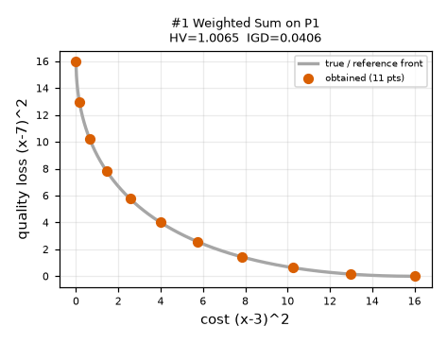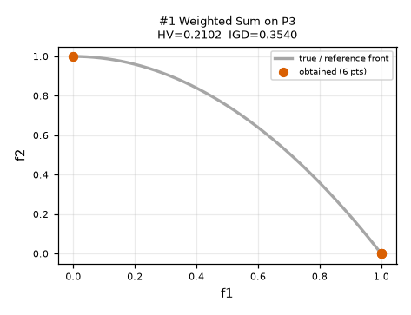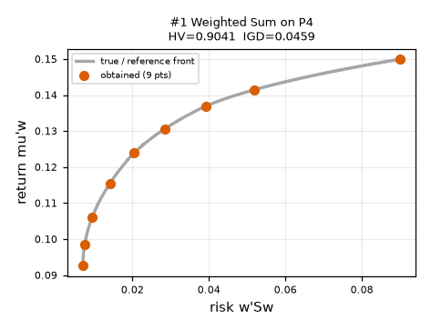
#2 epsilon-Constraint — optimise f1, bound the other objectives by eps_i, sweep eps
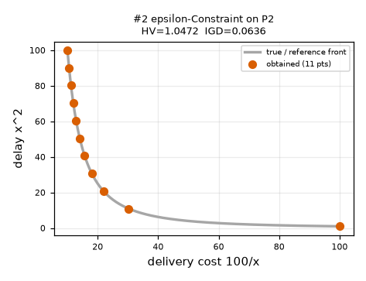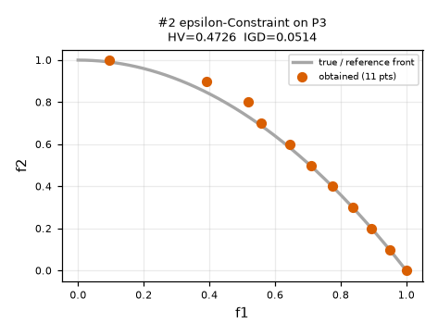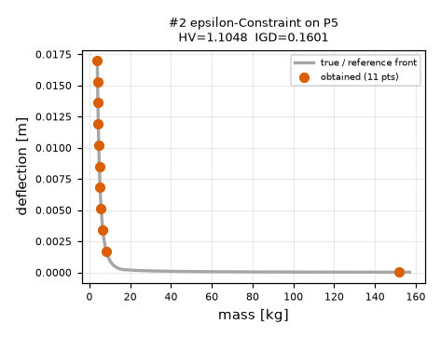
#3 Benson's Method — maximise weighted achievement past a reference point z*, s_i >= 0
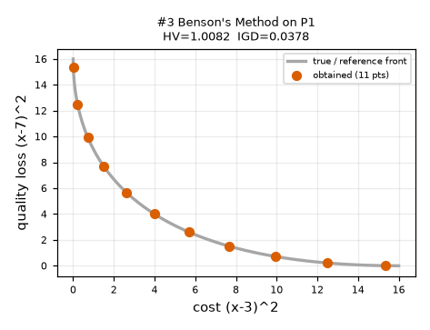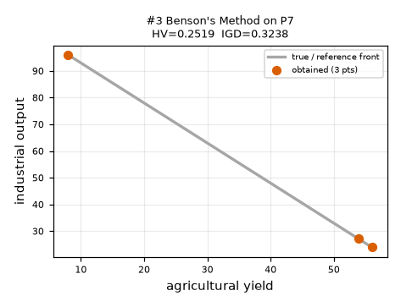
#4 Weight Metric — minimise a weighted p-norm distance to the ideal point
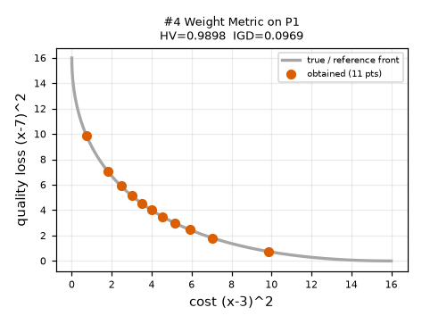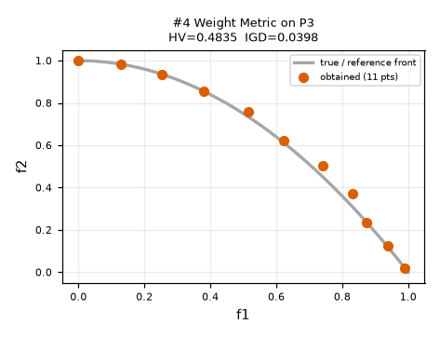
#5 Value Function — maximise the decision maker's utility function
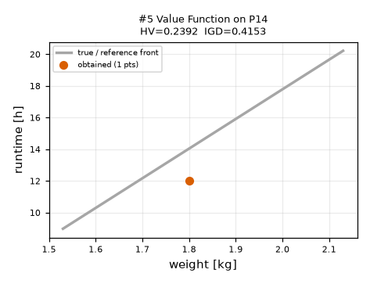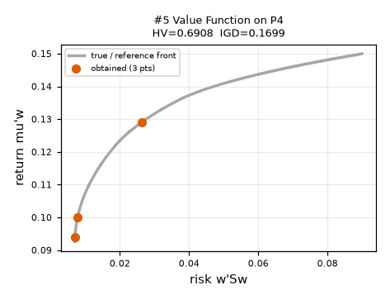
#6 Goal Programming — minimise weighted deviations d-, d+ from numeric targets (LP)
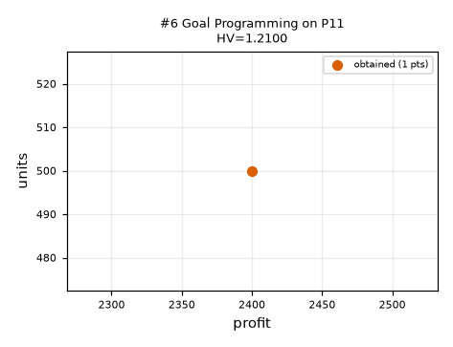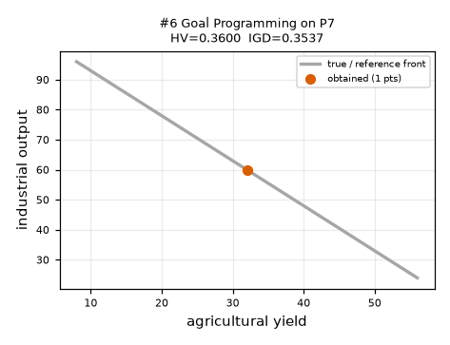
#7 Lexicographic — optimise objectives in strict priority order, holding earlier optima
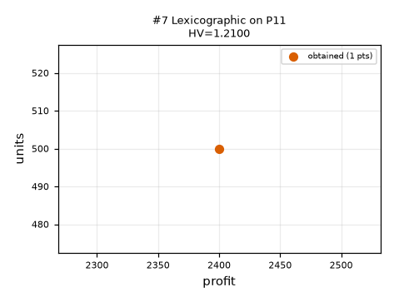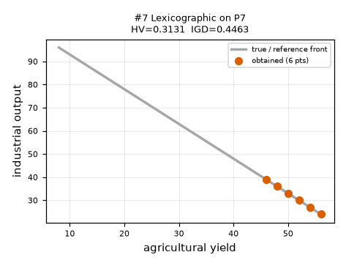
#10 VEGA — k sub-populations, each selected by one objective
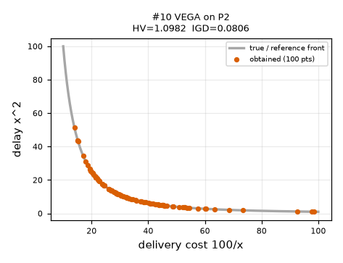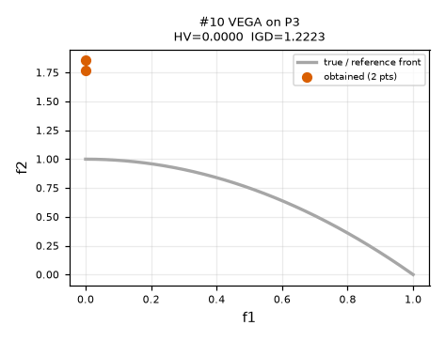
#11 MOGA — rank = 1 + #dominators, fitness sharing, roulette
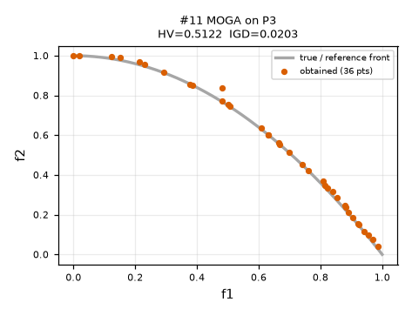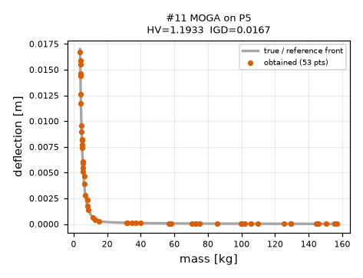
#12 NSGA — non-dominated fronts with dummy fitness, sharing inside each front
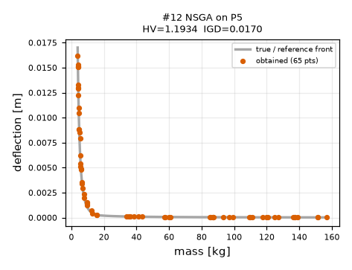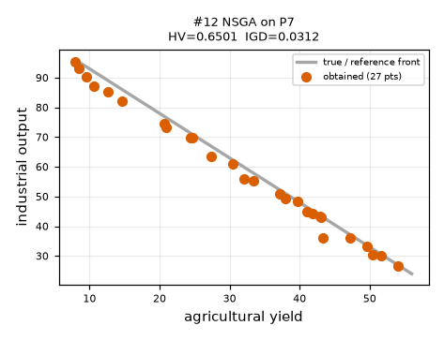
#13 NPGA — Pareto tournaments, niche count of a comparison set breaks ties
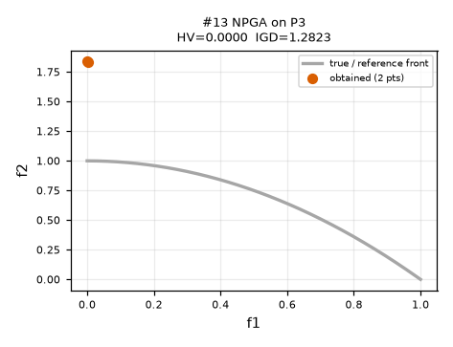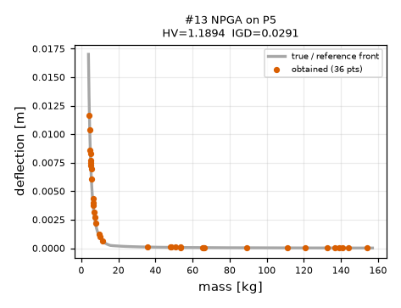
#14 NSGA-II — fast non-dominated sort + crowding distance + parent/offspring elitism
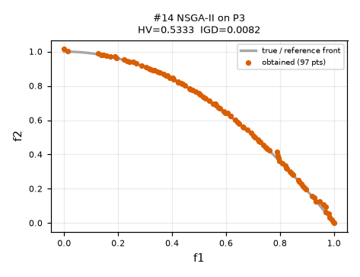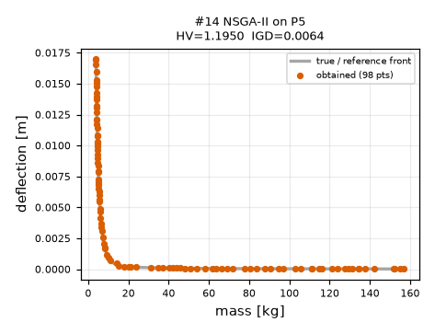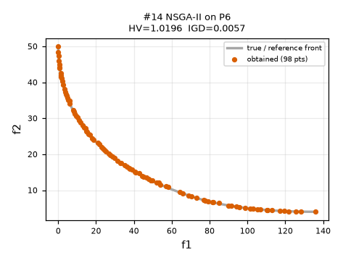
#15 NSGA-III — NSGA-II sorting, reference points / lines replace crowding
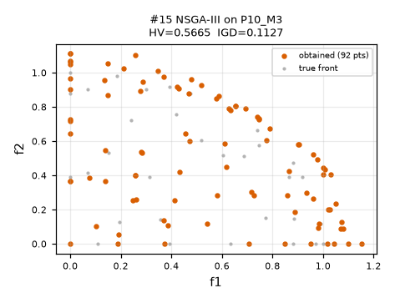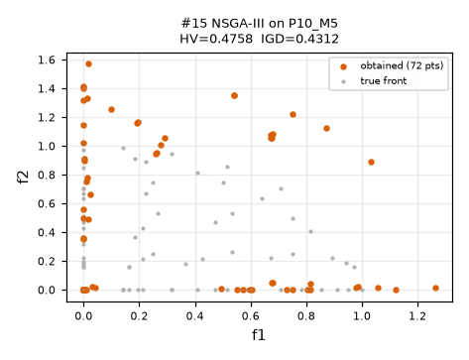
#16 SPEA2 — strength + raw fitness + k-th neighbour density, fixed-size archive
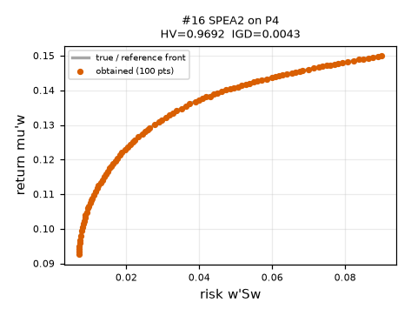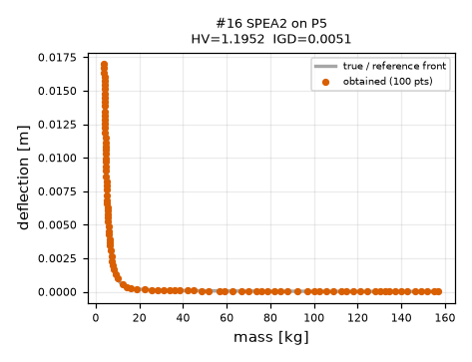
#17 PESA-II — archive + hyper-grid, region-based selection
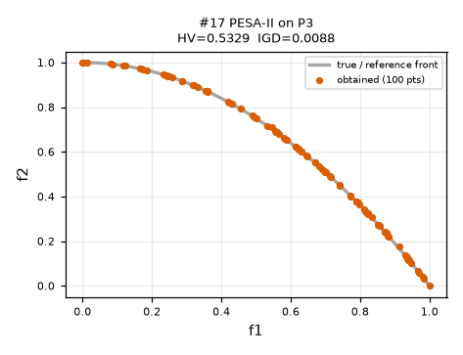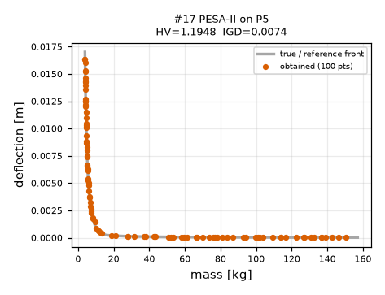
#18 MOEA/D — N Tchebycheff sub-problems solved cooperatively through neighbours
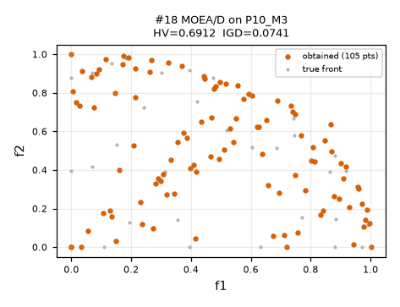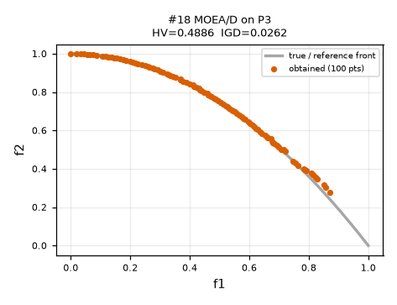
#19 MOEA/D-DE — MOEA/D with differential-evolution variation
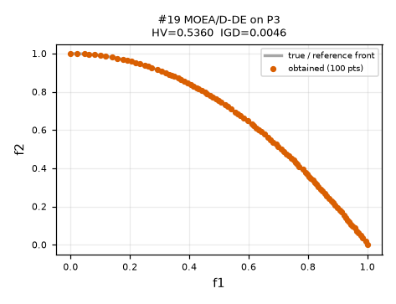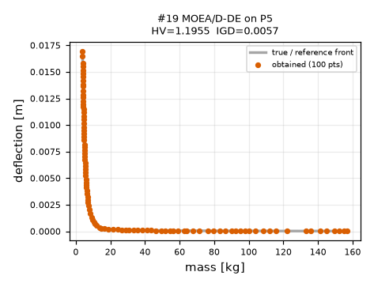
#20 MOEA/D-ACO — MOEA/D where ants build tours with sub-problem pheromone
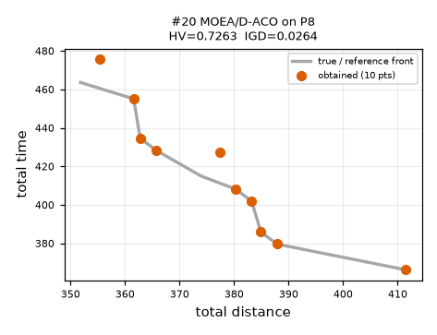
#21 Constrained NSGA-II — NSGA-II with Deb's feasibility rules inside the comparison
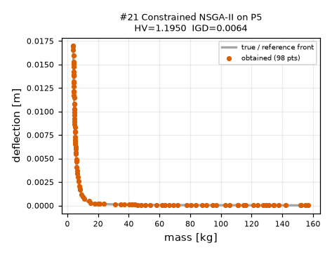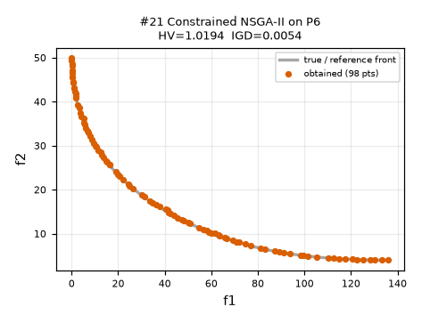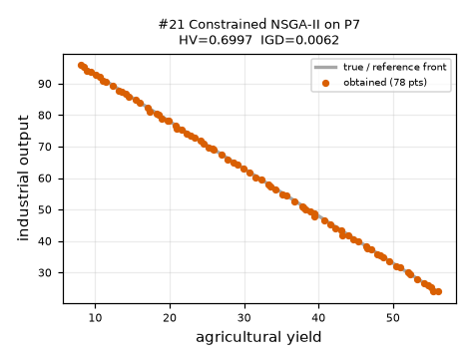
#22 MOPSO — particles guided by personal best and an archive leader
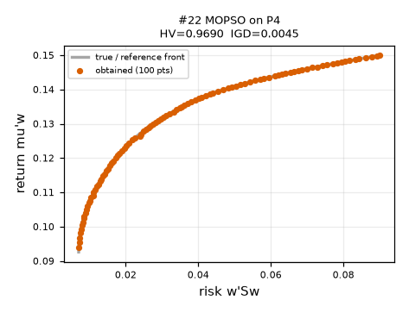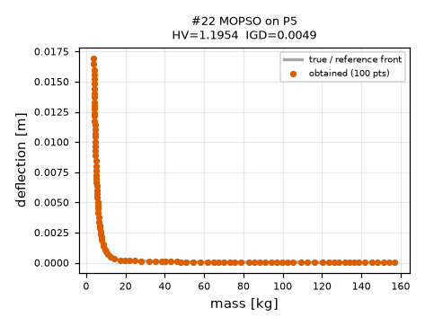
#23 MOGWO — alpha, beta, delta leaders from the archive, encircling
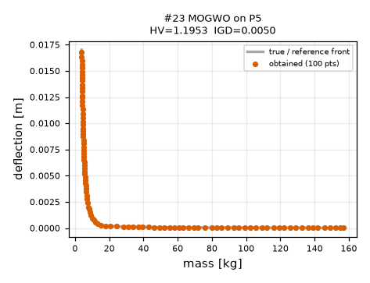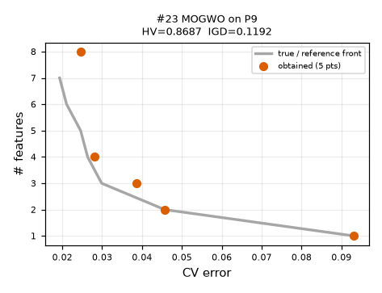
#24 MOABC — employed / onlooker / scout bees with dominance greedy choice
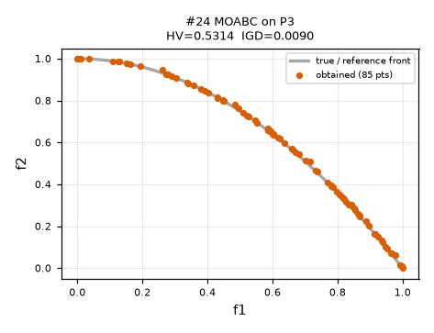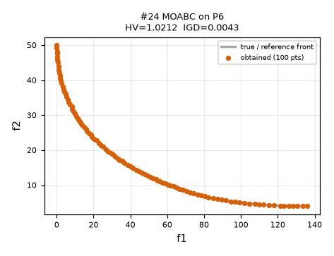
#25 MOACO — two pheromone matrices, only non-dominated ants deposit
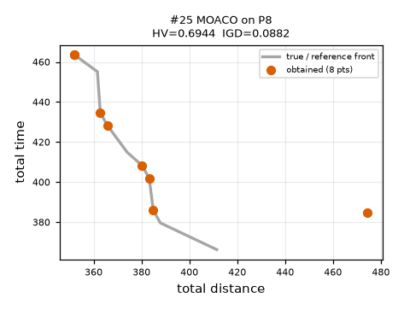
#26 MOSA — random neighbour, Boltzmann acceptance, cooling
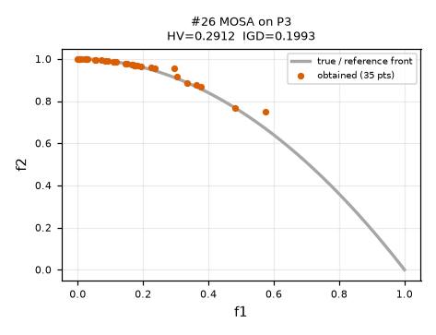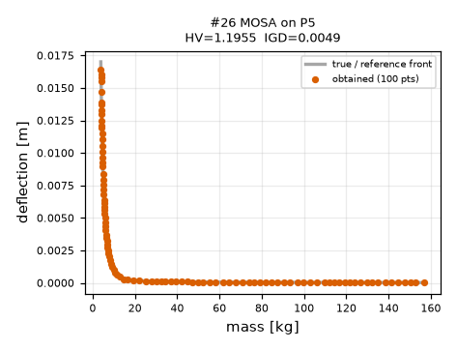
#27 MODE — DE trial replaces its target only if it dominates it
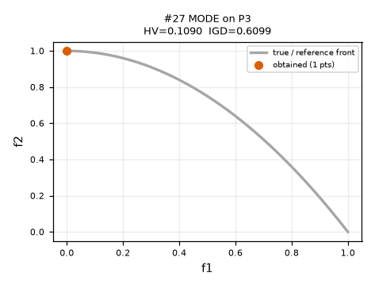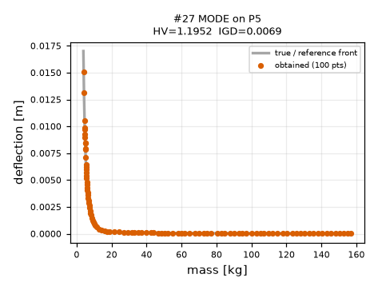
#28 MO-TLBO — teacher phase and learner phase
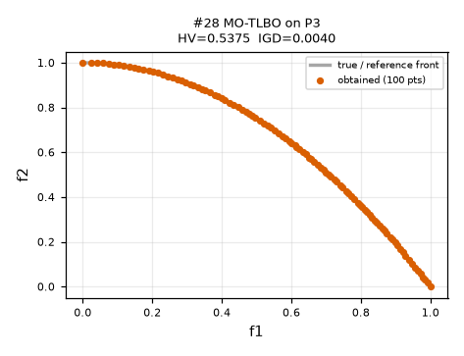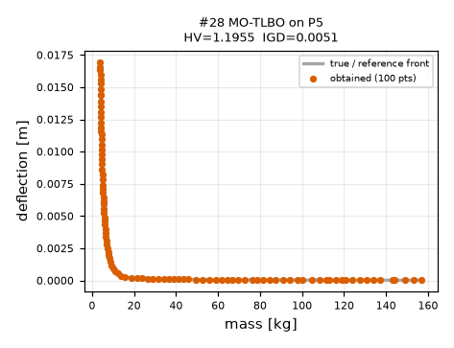
#29 MOBA — frequency-driven velocity, loudness / pulse schedules
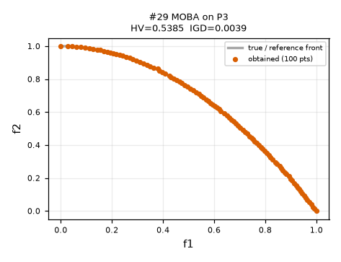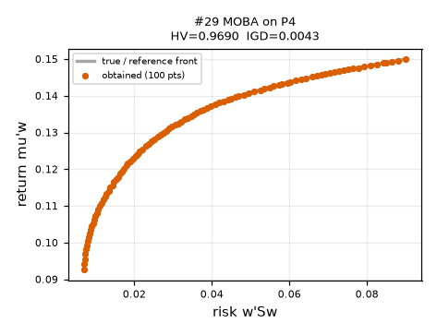
#30 MOMA — NSGA-II + hill-climbing on the least crowded
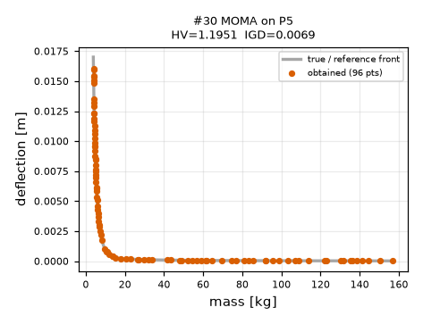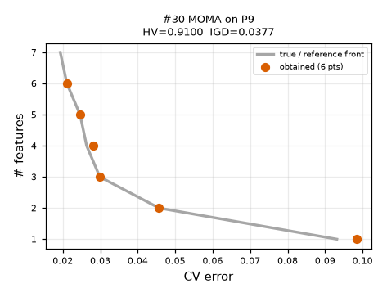
#31 RVEA — reference vectors, angle-penalised distance
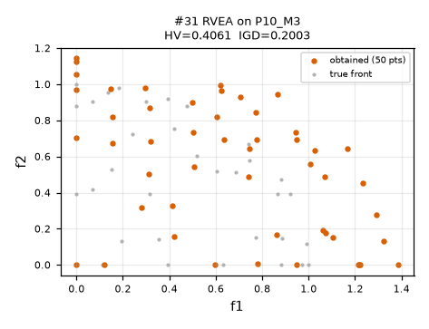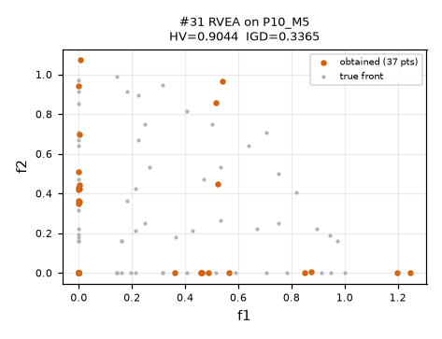
#32 IBEA — epsilon-indicator fitness, no diversity step
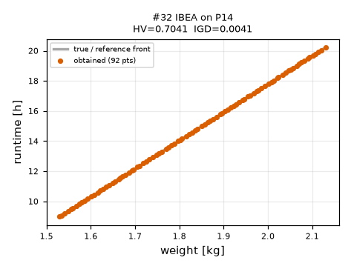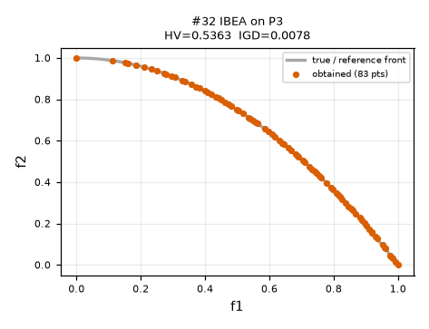
#33 SMS-EMOA — steady state, delete the least hypervolume contribution
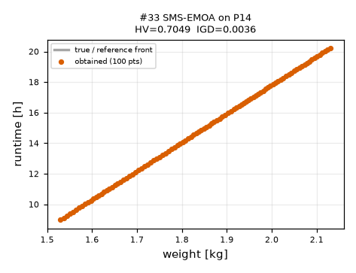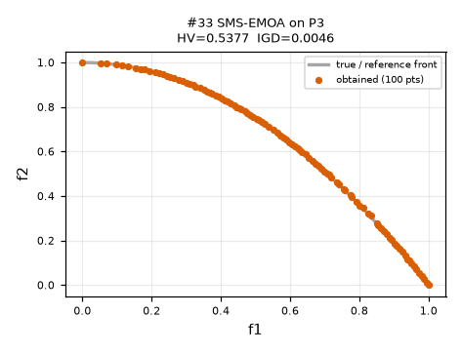
#34 HypE — Monte-Carlo estimate of hypervolume contributions
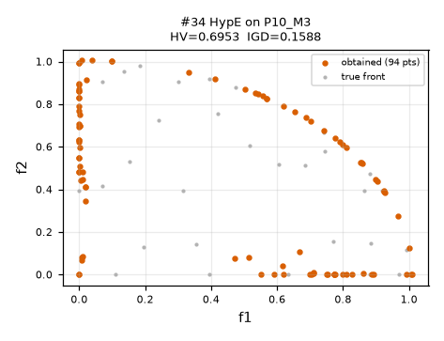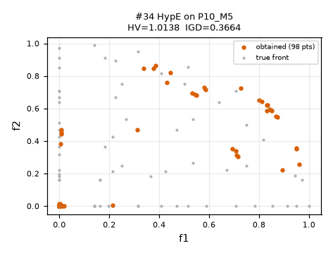
#35 R-NSGA-II — NSGA-II ranking + distance to a reference point with eps-clearing
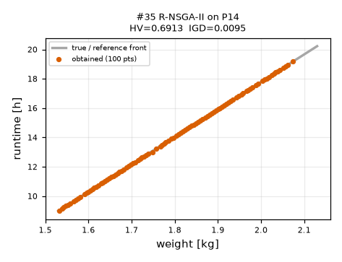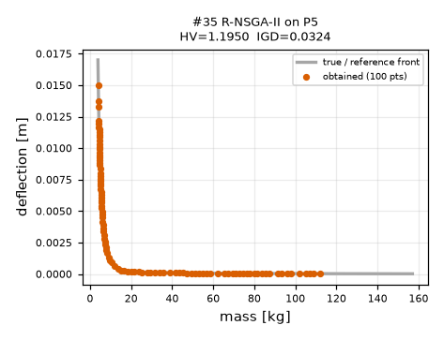
#8 TOPSIS, #9 VIKOR (ranking methods) — they do not generate solutions; they rank the supplier table P12 and the NSGA-II front of P4.
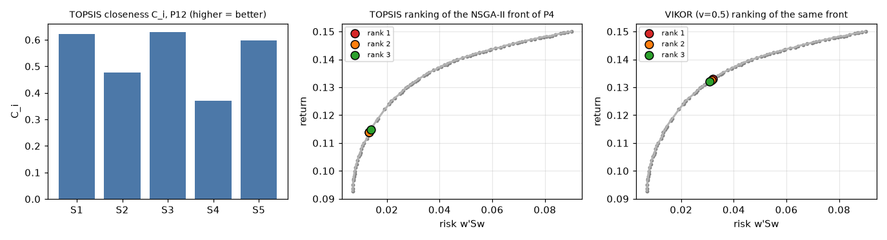
#36 MGDA, #37 GradNorm — toy P13(a): trajectories, end points on the Pareto set, objective space; P13(b): loss curves of the two-head network.
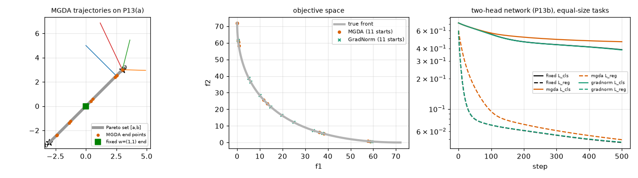

4 Task B — master comparison table (all 37 algorithms)
Advantages / disadvantages: at least four of each, at least two of each backed by a number or figure from our own runs; the rest by short arguments from the algorithm's steps. Runtimes quote Task A (seed 0); runtimes inside the 10-seed Task D runs were inflated by laptop power throttling and are not used.
# | algorithm | what it does (own words) | advantages (evidence: Fig./number from our runs, or argument) | disadvantages | best choice | avoid
Classical
1 | Weighted Sum  classical | Collapse the objectives into one number F(x) = Σ wi fi (wi ≥ 0, Σwi = 1), minimise it with a single-objective solver, then change the weights and solve again; every solve gives one point of the front. | • One cheap single-objective solve per point: 11 weights on P1 cost 22,480 evaluations and 0.2 s [log, Fig. A-1].  • On the convex front of P1 every weight gives a Pareto-optimal point (HV 1.006, 11 distinct points for 11 weights).  • Any off-the-shelf optimiser can be used inside (we used Nelder-Mead; an LP solver would do for linear problems) — argument: the sub-problem is a plain scalar function.  • Weights are easy to explain to a decision maker and the extreme weights give the single-objective optima (anchor points) — argument from the formula.  • Memory O(1), nothing stored but the points found. | • Cannot reach a dent: on ZDT2 (21 weights) every returned point is (within 0.006) one of the two end points (f1 = 0 or 1), 0 lie in 0.3<f1<0.7, HV 0.210 (true 0.538) [Fig. E-1].  • Equal steps in w do not give exactly equal spacing: on P1 the gaps between consecutive points (normalised) range from 0.142 to 0.190, i.e. up to 34 % apart, and the end gaps differ most [Fig. E-2].  • Very sensitive to objective scaling: on P5 in raw units (mass ~ 100 kg, deflection ~ 0.01 m) 11 weights give 2 distinct design(s), with normalised objectives 10.  • Needs meaningful weights before the run, and each solve is independent (no information is shared between settings) — argument.  • Linear fronts (P7) are an extreme case: every weight lands on one of the two end points (argument; see Benson, Fig. A-3). | Convex front, roughly known preferences, an expensive-to-code but cheap-to-run single-objective solver (e.g. portfolio P4: HV 0.904). | Non-convex or disconnected fronts, objectives of very different scale unless normalised, linear trade-offs.
2 | epsilon-Constraint  classical | Pick one objective as the goal and turn the others into constraints fi(x) ≤ εi; solve the constrained single-objective problem for a grid of ε values. | • Reaches non-convex parts: on ZDT2 21 ε values give 19 distinct points, 6 in the dent, HV 0.499 vs weighted sum 0.210 [Fig. E-1].  • Control per objective: the bound εi is in the units of the objective; on the integer fleet problem P2 40 ε values give 10 distinct points (one per integer vehicle count).  • Handles real and integer decision variables unchanged (enumeration for one integer variable) — run on P2 and P2int.  • Spacing follows the ε grid, so an even grid gives an even front (Spacing 0.061 on ZDT2, Fig. A-2).  • Deterministic and interpretable: each point comes with the guarantee fi ≤ εi — argument from the formulation. | • Needs an ε range: a grid wider than the front's range wastes solves, 3 of 14 ε values were infeasible when it was extended 0.3 beyond ideal and nadir.  • Expensive: 270,883 evaluations for 11 points on ZDT2 (population methods use 10,000 for 100 points) [Fig. A-2].  • The number of solves grows as (grid size)^{k-1}: 21 values per bound need 441 solves for 3 objectives (argument).  • Constraints on fi may be weakly active: the returned point can be only weakly Pareto-optimal (needs a second pass) — argument.  • Each solve needs a solver able to handle the extra constraints (our penalty Nelder-Mead gets slow on 10 variables) — runtime 11 s for P3. | Non-convex front with one objective that has priority, few objectives (2-3), integer decision variables. | Many objectives (grid explodes), or when ε ranges are unknown and solves are expensive.
3 | Benson's Method  classical | Choose a reference point z* in objective units and weights λ. si = z*i - fi measures how far x is past the target; maximise Σλi si subject to si ≥ 0. Vary λ or z* for more points. | • Anchored search: the answer is never worse than the target in any objective (checked: si ≥ 0 for every returned point, unit test 3).  • Moving the reference point reaches the dent of ZDT2: z*-sweep gives 15 distinct points, 5 in 0.3<f1<0.7, HV 0.505 vs 0.210 for a λ-sweep [Fig. E-1, Task C3].  • On convex P1 it matches weighted sum (HV 1.008, 11 points) and uses the same cheap solves (22,654 evaluations for 11 settings).  • Intuitive for decision makers who think in targets; the si values tell how much slack remains in each objective — argument.  • Handles any constraints the sub-solver accepts. | • A λ-sweep alone is a weighted sum in disguise: on ZDT2 it gives 6 distinct points, 0 in the dent; on the linear front P7 only 3 distinct points.  • Needs a sensible z*: on ZDT2 only 20 of 21 z* settings on the anti-diagonal had a non-empty admissible region [Task C3].  • Needs weights AND a reference point, i.e. preferences must be partly known — argument.  • 467,199 evaluations for 21 settings on ZDT2 (sub-solver NM, 10 variables).  • Many objectives: a good sweep needs k-1 degrees of freedom in z* and in λ (argument). | A target is available (e.g. hospital cost 100 / 50 patients) and a handful of preference points are needed; convex or linear problems. | No reasonable reference point, or a front that must be mapped completely with λ only.
4 | Weight Metric  classical | Find the ideal point z* (k single-objective solves), then minimise the weighted p-norm distance (Σ wi |fi - z*i|^{p})^{1/p} for p = 1, 2 or ∞ and several weight vectors. | • p = ∞ (Tchebycheff) reaches the whole non-convex front: on ZDT2 21 distinct points, 7 in the dent, HV 0.509; p = 2 only 2 in the dent (HV 0.492) [Fig. E-1].  • Flexible: the norm reshapes the search; on convex P1 p = 1, 2, ∞ give HV 1.027, 1.000, 1.022.  • The ideal point gives a natural normalisation of the objectives (the deviation is measured in 'distance to the best possible') — argument.  • p = 1 is linear (weighted sum with the ideal point removed), so it can use LP solvers.  • Weights keep their meaning when objectives are rescaled by the ideal-nadir range. | • Needs the ideal point: 269,699 evaluations on ZDT2 include 2 extra solves; with expensive objectives these are not free.  • Solution depends on p: HV on ZDT2 0.212 (p=1), 0.492 (p=2), 0.509 (p=∞).  • p = ∞ is non-smooth (max of terms): gradient solvers fail; weak Pareto optimality possible — argument.  • Slow with a derivative-free sub-solver: 11 s for 11 points on ZDT2.  • Spacing is not controlled: equal weight steps give unequal gaps (same as weighted sum). | Fine control over trade-off shape with a known ideal point; non-convex fronts (use p = ∞). | Ideal point unknown or very expensive; many objectives (more weights to sweep).
5 | Value Function  classical | Write the decision maker's utility v(f1..fk), substitute F(x) and maximise it as one single-objective problem; the optimum is the most preferred point. | • One solve and no front to rank: P14 with v = closeness to (1.8 kg, 12 h) returns exactly (1.80 kg, 12.00 h) in 2,776 evaluations.  • Gives investor-specific answers: P4 with risk aversion 60 / 10 / 1.5 returns risk 0.0071 / 0.0078 / 0.0264 and return 0.0939 / 0.1001 / 0.1291 (Fig. E-4).  • Theoretically the 'correct' answer: it optimises what the decision maker really values — argument.  • Works with any single-objective optimiser and any shape of front (non-convex too) provided v is quasi-concave — argument.  • Cheap: < 3,000 evaluations on P14. | • The utility is a guess: halving / doubling the risk aversion on P4 moves the answer from return 0.1074 to 0.0964 (γ = 5 / 10 / 20 gives risks 0.0100 / 0.0078 / 0.0072).  • Returns ONE point: no knowledge of the trade-offs that were given up — run on P14 returns a single solution (HV is meaningless).  • Eliciting v from a human is hard and error-prone (lecture slide 38) — argument.  • A badly chosen v (non-concave) gives local optima and needs multi-start (our solver used 6 starts) — argument.  • Cannot be used to explore: wrong preferences are invisible until the answer is inspected. | A believable utility exists (portfolio theory, cost models) and a single recommendation is wanted. | Preferences unknown or unstable; exploratory design where the front itself is the product.
6 | Goal Programming  classical | Set a target Ti for each objective, add deviation variables di⁻, di⁺ with fi + di⁻ - di⁺ = Ti, and minimise the weighted undesired deviations (an LP for linear problems). | • Exact LP solution in one call: P11 gives x = (300, 200) with shortfall d2⁻ = 100 (the unit goal 600 can never be met, max 500) and 1 evaluation.  • Reports WHICH goal fails and by how much (di⁻ = [0.0, 100.0]) — unit and normalised weights agree on P11 ([0.0, 100.0]).  • Reachable targets are met exactly: P11 with T = (2400, 500) has all deviations [0.0, 0.0] (objective 0).  • Many goals with different units fit in one model — argument (deviation variables add 2k columns).  • Fast: LP, 0.00 s runtime. | • Weights decide infeasible trade-offs: P7 with targets (50,70) gives [25.333333333333332, 70.0] with unit weights, [25.333333333333332, 70.0] with normalised weights and [50.0, 33.0] with w=(3,1).  • Needs targets in advance; unreachable targets just report a shortfall instead of a trade-off curve (P11: shortfall 100) — one compromise point only.  • Satisficing, not optimising: with all goals met the solution is not necessarily Pareto-optimal — argument (profit 1200 > goal 1000 in the 5E slide leaves 200 unused).  • Only linear goals stay an LP; non-linear fall back to a general solver — argument.  • No picture of the front is produced. | Clear numeric targets for several goals of different units (production planning P11). | Targets unknown, or a full trade-off curve is wanted.
7 | Lexicographic  classical | Rank the objectives; optimise the first alone, add the constraint f1 ≥ f1* - ε1, optimise the second subject to it, and so on (k sequential solves). | • No weights at all; breaks ties correctly: P11 profit 2400 is attained on a whole edge — max xA gives [300.0, 200.0] (units 500), min xA gives [0.0, 400.0] (units 400); the second priority picks the better one, [2400.0, 500.0].  • Exact (LP) and takes k solves, not a sweep: 6 evaluations for 6 settings of ε on P7.  • The tolerance ε opens a controlled trade-off: P7 with ε = 0, 2, 5, 10, 20 gives yield [56, 54, 51, 46, 36] and output [24, 27, 32, 39, 54].  • Natural for safety-first problems (never trade away a higher priority) — argument.  • Trivial to implement on top of an LP solver. | • Priorities swap the answer entirely: P11 with units first gives [2400.0, 500.0], profit first [2400.0, 500.0].  • With ε = 0 the lower priorities only act among exact ties: P7 yields the end point (56, 24) — no trade-off (Fig. E-5).  • Needs a strict total order; roughly equal objectives cannot be expressed — argument.  • Output is one point per priority list and ε: no front.  • Sequential solves cannot be parallelised across stages — argument. | Strict, non-negotiable priorities (safety before cost). | Objectives of comparable importance; when a trade-off picture is needed.
Ranking / MCDM
8 | TOPSIS  ranking | Rank an already generated set of alternatives: vector-normalise the decision matrix, weight it, find the ideal A⁺ and anti-ideal A⁻, compute Ci = di⁻/(di⁺ + di⁻) and sort. | • Single, intuitive ranking in O(mk): P12 gives C = [0.621, 0.476, 0.63, 0.37, 0.597] and the order S[3, 1, 5, 2, 4] (rank list).  • Works on any decision matrix with min/max criteria — reproduces the 5E slide values (0.466, 0.459, 0.541, 0.629) in unit test 8.  • Applied to the NSGA-II front of P4 it ranks 100 portfolios in < 0.01 s; the top three lie at risk 0.0132, 0.0132, 0.0139 (Task D4).  • No extra evaluation of the problem; consumes only the front — argument.  • Fully deterministic. | • Weight-sensitive: moving 0.1 of weight from cost to quality changes the TOPSIS order from [3, 1, 5, 2, 4] to [3, 5, 1, 2, 4] on P12.  • Not protected against one terrible criterion: adding a supplier with cost 80 / quality 9 / delivery 40 d / reliability 96 gives it TOPSIS rank 6 of 6 whereas VIKOR (v = 0.25) puts it at rank 4.  • Sensitive to the normalisation method (vector vs min-max) — argument.  • Is not an optimiser: cannot create better alternatives (needs a generated front) — viva question 8.  • Rank reversal can occur when an alternative is added or removed — known property (argument). | Ranking a short list of already generated Pareto solutions with known weights. | Weights unknown, or when one very bad criterion must disqualify an alternative.
9 | VIKOR  ranking | For every alternative compute group utility Si (weighted sum of normalised gaps to the best) and individual regret Ri (largest weighted gap), combine them into Qi = v(S - S*)/(S⁻ - S*) + (1 - v)(R - R*)/(R⁻ - R*) and rank by Q (small = good). | • Explicitly balances average performance and worst-case regret: with the bad-criterion supplier added, VIKOR (v = 0.25) ranks it 4 while TOPSIS ranks it 6.  • Shows when a single winner is not justified: on P12 the 'acceptable advantage' test Q(2nd) - Q(1st) ≥ 1/(m-1) is False for v = 0.5 (Q = [0.09, 0.31, 0.5, 1.0, 0.43]).  • Parameter v exposes the compromise: rankings for v = 0.25 / 0.5 / 0.75 are [1, 2, 5, 3, 4] / [1, 2, 5, 3, 4] / [1, 3, 2, 5, 4].  • Reproduces the 5E numbers (S = .533/.6/.4/.367, Q = .607/1/.571/0) — unit test 9.  • O(mk) and no problem evaluations. | • Weight-sensitive as well: after the 0.1 shift the VIKOR (v = 0.5) order becomes [1, 3, 5, 2, 4].  • Needs v (utility/regret trade-off) — the ranking changes with v (see above).  • More computation and more parameters than TOPSIS — lecture slide 44.  • Not an optimiser (ranks only).  • The compromise 'set' may contain several alternatives, so no unique answer is guaranteed. | A compromise is wanted that never sacrifices one criterion badly. | When pure closeness-to-ideal is the goal and no regret protection is needed.
Non-elitist MOEAs
10 | VEGA  non-elitist | Split the mating pool into k parts; part m is filled by proportional selection on objective fm alone; shuffle the parts together, apply crossover and mutation, repeat. No archive, no dominance. | • Fastest per generation: 0.1 s for 10,000 evaluations (O(kN)), the cheapest of all population methods [Task A log].  • Finds the single-objective optima quickly: on P2 it returns 99 points with HV 1.096 (NSGA-II 1.116).  • Trivial to implement on top of any GA: only the selection step changes — argument.  • Needs no parameters besides the GA ones (N, pc, pm) — no niche radius.  • Works for any encoding that a GA supports. | • Collapses to the extremes: on ZDT2 only 2.0 non-dominated points survive, HV 0.000 (true 0.538), IGD 1.073 [Fig. A-10].  • Rank 28/28 on P3 and 27/29 on P5 in the 10-seed comparison (HV 0.000 ± 0.000 / 1.160 ± 0.016).  • No elitism: the best point found can vanish in the next generation (argument, lecture slide 8).  • Cannot represent balanced compromises: a compromise is mediocre in every single objective and is never selected — argument verified by the collapse above.  • No constraint handling of its own (penalty used). | Teaching, or quickly locating the single-objective optima. | Whenever a spread of balanced trade-offs is required.
11 | MOGA  non-elitist | Rank each individual by 1 + the number of individuals dominating it, set fitness 1/rank, divide by the niche count of a sharing function in normalised objective space, select by roulette wheel, vary. | • Dominance-based fitness gives real spread: on ZDT2 it returns 41 points with HV 0.501 ± 0.009 versus VEGA's 2.0 points, HV 0.000.  • Sharing keeps crowded ranks alive: Spacing 0.0271 on P3, only mild degradation on the constrained P5 (HV 1.193 ± 0.001).  • Cheap: 0.2 s for 10,000 evaluations (O(kN²)).  • Simple to code and works for real, integer, binary and permutation encodings — argument (uses only dominance and distances).  • A first-generation Pareto method that needs no archive. | • Depends strongly on σshare: HV on P3 = 0.497 / 0.503 / 0.495 / 0.480 for σ = 0.02 / 0.1 / 0.3 / 0.6 [Fig. E-6].  • Not elitist and converges slowly: rank 17/28 on P3 (IGD 0.0255 ± 0.0048) against NSGA-II's 0.0182 ± 0.0348.  • All rank-1 individuals get the same raw fitness, so selection pressure toward the front vanishes once the population is mostly non-dominated — argument.  • O(N²) niche counts every generation: grows quickly with N.  • Many objectives: almost everybody is rank 1 (Fig. E-7). | Moderate diversity needed and the dominance-rank idea is to be taught. | Elitism mandatory, no time to tune σshare, or more than 3 objectives.
12 | NSGA  non-elitist | Peel the population into non-dominated fronts, give each front a dummy fitness lower than the previous one, share fitness inside each front, select by roulette and vary. | • Explicit front structure plus sharing gives good spread: P5 gives 66 points, HV 1.193 ± 0.000, P3 49 points, HV 0.516 ± 0.003.  • Better spread than MOGA on P3 (HV 0.516 ± 0.003 vs 0.501 ± 0.009).  • Conceptually clean: the front index orders fronts strictly, sharing only reorders inside a front — argument (adaptive dummy fitness).  • Directly inspired NSGA-II, so it is a good stepping stone — lecture.  • Handles the water allocation P7 (linear front on a constraint boundary) with HV 0.650, IGD 0.0312. | • Not elitist and sensitive to σ: P3 HV = 0.509 / 0.516 / 0.512 / 0.482 for σ = 0.02 / 0.1 / 0.3 / 0.6.  • Behind modern methods: rank 12/28 on P3 (IGD 0.0179 ± 0.0016), rank 19/29 on P5.  • Repeated full sorting plus per-front sharing is O(kN³) in the original analysis — slowest of the non-elitist group (lecture slide 33).  • Fewer points than NSGA-II (49 vs 95 on P3).  • No archive: good solutions can be lost. | Small populations and teaching the origin of non-dominated sorting. | Large populations, tight time budgets, or elitism needed.
13 | NPGA  non-elitist | Binary tournament: draw two candidates and a comparison set; if one dominates the other it wins, otherwise the candidate with the smaller niche count (measured against the comparison set) wins. | • No fitness computation at all: a tournament is 2 dominance tests + at most 2 niche counts; 0.7 s per 10,000 evaluations.  • Reasonable on the constrained beam: P5 HV 1.191 ± 0.001 (40 points).  • Plugs into any GA as a selection operator — argument.  • Direct use of dominance, no scalarisation.  • Works with any encoding. | • Fails to converge on ZDT2 in 10,000 evaluations: only 6 non-dominated points, HV 0.061 ± 0.058, IGD 0.6296 ± 0.2443 [Fig. A-13].  • Needs σshare and the comparison-set size: P3 HV for tdom = 2 / 10 / 40 is 0.100 / 0.082 / 0.040.  • Non-elitist: tournaments can discard front members (argument).  • IGD rank 19/29 on P5 (IGD 0.0251 ± 0.0042).  • Result quality depends on random comparison sets — high variance between seeds. | Fast selection with moderate diversity, as an add-on selection operator. | Maximum diversity or guaranteed elitism.
Elitist MOEAs
14 | NSGA-II  elitist | Parents + offspring are sorted into fronts; the next population takes whole fronts and fills the last one by crowding distance; parents come from binary tournaments (lower rank, then larger crowding). | • Strong, fast, parameter-light: P3 HV 0.518 ± 0.046 (IGD 0.0182 ± 0.0348), P5 IGD 0.0063 ± 0.0003, 0.6 s per run.  • Good spread on the true-front problems: Spacing 0.0069 on P3.  • Behaves well with population size: IGD on P3 = 0.0331 (N = 20), 0.0182 (N = 100) at a fixed 10,000 evaluations [Fig. E-6].  • Keeps improving with budget: IGD 2.1775 at 1,000, 0.0182 at 10,000, 0.0051 at 40,000 evaluations.  • Elitism guarantees the best front can never get worse — argument (parents compete with offspring). | • Degrades with objectives: DTLZ2 M = 5 IGD 0.675 ± 0.070 versus 0.415 ± 0.033 for NSGA-III; 100 % of its population is in front 1 after 20 generations [Fig. D-2].  • A few bad seeds on ZDT2: HV 0.518 ± 0.046, so the mean is below the best methods (rank 10/28).  • Crowding distance is a crude spacing estimate and only uses neighbours along sorted objectives — argument.  • No built-in preference or constraint rule (penalty); the constrained version is algorithm 21.  • Convergence stalls on deceptive landscapes — lecture slide 6. | 2-3 objectives, a simple reliable general-purpose elitist method. | 4+ objectives, or when a precise archive is required.
15 | NSGA-III  many-objective | NSGA-II sorting is kept, but the last front is filled using reference points on a normalised simplex: each solution is associated with its nearest reference line and the least-crowded reference points are served first. | • Better than NSGA-II with many objectives: DTLZ2 M = 5 IGD 0.415 ± 0.033 vs 0.675 ± 0.070; M = 3 0.107 ± 0.010 vs 0.127 ± 0.008 [Fig. D-2].  • Guaranteed spread by construction: one niche per reference point, 72 solutions for H = 70 (M = 5) [Task C].  • Fast: 0.9 s per 10,000 evaluations (O(kN²)).  • No convexity assumption (reference lines are directions) — argument.  • Converges with enough budget: IGD 0.052 at 100,000 evaluations on DTLZ2 M = 3 versus NSGA-II 0.099 (one extra seed-0 run, not part of the tables). | • Needs H decided in advance and N ≈ H: p = 6 gives N = 212 and only 47 generations at 10,000 evaluations (Task C3).  • Weak on 2 objectives: ZDT2 rank 21/28 (HV 0.415 ± 0.105, IGD 0.0922 ± 0.0883) — one reference point per front slot is a poor fit.  • Constrained problems with a penalty: P5 IGD 0.1209 ± 0.0102, rank 21/29.  • More moving parts than NSGA-II (normalisation, association, niching) — code is 3x longer.  • Regular reference sets bias the result when the front is irregular — lecture slide 14. | 3-10 objectives with a regular front. | 2 objectives or tiny budgets relative to H.
16 | SPEA2  elitist | Keep an external archive; fitness = strength of the dominated set plus raw fitness of the dominators plus a k-th nearest-neighbour density; truncate the archive by removing the closest pair; select parents from the archive by tournament. | • Best-in-class spread: Spacing 0.0022 on P4 and IGD 0.0043 (rank among the best), 0.0051 on P5.  • Elitist with a fixed archive size: P5 IGD 0.0051 ± 0.0001, 100 points.  • Density is fine-grained (k-th neighbour) — sharper than a grid — argument.  • Archive truncation preserves boundary points (lexicographic nearest-neighbour rule).  • Few parameters (N, archive, k = √N). | • Slow: 7.7 s vs 0.6 s for NSGA-II on P5 (distance matrix every generation) [Fig. A-16].  • Variance on ZDT2: HV 0.517 ± 0.035 (rank 11/28).  • Memory O(N²) for distances.  • More code (archive truncation) — lecture slide 22.  • Not designed for many objectives (k-th neighbour distances concentrate) — argument. | 2-3 objectives where a precise, well-spread archive matters. | Quick prototypes, large populations, many objectives.
17 | PESA-II  elitist | Archive plus a hyper-grid over the archive's objective range; parents are chosen by picking a grid box (sparser box wins) and a random member in it; a new point enters only if non-dominated and a member of the fullest box is dropped on overflow. | • Cheap bookkeeping: 1.7 s per run, grid counting is O(N).  • Solid result at low cost: P3 HV 0.532 ± 0.002 (rank 7/28), P5 HV 1.195 ± 0.000.  • Insensitive to resolution in a wide range: P3 HV = 0.522 / 0.527 / 0.532 / 0.534 for 4 / 8 / 16 / 32 divisions.  • Elitist; scales to more objectives since a grid needs no pairwise distances — argument.  • Simple to explain. | • Less precise spread than SPEA2/NSGA-II: Spacing 0.0084 vs 0.0069.  • Grid resolution matters at the extremes: IGD 0.0145 (4 divisions) vs 0.0082 (16).  • Grid cells exist only where the archive is: a fixed grid cannot represent irregular fronts well — lecture slide 30.  • Number of cells grows as div^{k}: memory explodes for many objectives (dictionary here) — argument.  • Only 20 offspring per iteration: many small steps, sequential loop in Python. | Limited budget and many objectives where speed matters. | High-precision diversity control.
18 | MOEA/D  decomposition | N weight vectors define N Tchebycheff sub-problems; each sub-problem mates within its T nearest neighbours, and a child replaces up to nr neighbours that it improves. | • Best on DTLZ2 with 3 objectives at this budget: IGD 0.082 ± 0.006, HV 0.677 (NSGA-III 0.107) and strong at M = 5 (HV 0.939).  • Cheap: scalar comparisons only; 2.2 s for 10,000 evaluations on P3.  • Tchebycheff reaches non-convex fronts (ZDT2 IGD 0.0280 ± 0.0630) — the dent is covered.  • Neighbourhood mating focuses search; each child improves up to nr sub-problems.  • Scales with objectives (only weight vectors grow): H = 70 (M = 5). | • Variance on ZDT2: HV 0.507 ± 0.072 (rank 15/28).  • Neighbourhood size matters: P3 HV = 0.491 / 0.529 / 0.478 / 0.402 for T = 5 / 10 / 20 / 50.  • Quality depends on the weight-vector layout matching the front shape — irregular fronts leave sub-problems with duplicates (lecture slide 38).  • Needs normalised objectives and an ideal-point estimate — we use the problem's scale.  • GA operators converge slower than DE (algorithm 19). | Many objectives / large scale with a regular front. | Disconnected or very irregular fronts, trivial 2-objective cases.
19 | MOEA/D-DE  decomposition | MOEA/D with a differential-evolution child: V = Xr1 + F(Xr2 - Xr3) from neighbours, binomial crossover, polynomial mutation, then the usual neighbour update. | • Best decomposition method on continuous 2-objective problems: ZDT2 HV 0.536 ± 0.001 (rank 4/28), IGD 0.0045 ± 0.0003 vs MOEA/D 0.0280 ± 0.0630.  • Stable across seeds (std 0.0010).  • On DTLZ2 M = 3 it improves on MOEA/D (one extra seed-1 run: IGD 0.049 vs 0.067, not part of the tables).  • DE steps adapt to the spread of the neighbourhood — argument.  • Good on constrained P5: HV 1.195 ± 0.000, IGD 0.0061 ± 0.0007. | • Needs F and CR (0.5 / 1.0 here) — DE is sensitive to them (see MODE sensitivity, Task C).  • Real-valued only: DE arithmetic has no meaning for permutations (argument).  • Same T / weight-vector dependency as MOEA/D.  • Slower per evaluation than NSGA-II: 1.8 s vs 0.6 s.  • Population of 100 sub-problems requires 100 evaluations per sweep — slow feedback at small budgets. | Continuous problems with complicated Pareto sets. | Discrete or combinatorial variables.
20 | MOEA/D-ACO  decomposition | MOEA/D where each sub-problem keeps its own pheromone matrix and heuristic; an ant builds a tour with probabilities τ^{α}η^{β}, and the tour updates neighbouring sub-problems. | • Among the best on the bi-objective TSP (lowest IGD*, lowest variance): HV 0.742 ± 0.012 (best-known front has 10 tours; it finds 10.6 on average), IGD* 0.013.  • Low variance across seeds (std 0.0117) compared with NSGA-II's 0.059.  • Constructive: every tour is valid by construction (no repair) — argument.  • Pheromone memory transfers structure between neighbouring sub-problems.  • Inherits MOEA/D decomposition. | • Slow: 6.3 s vs 0.6 s for NSGA-II (python loops over cities and sub-problems).  • Four parameters (α, β, ρ, Q) — slower convergence than operators-based GA (lecture slide 52).  • Cannot be used for continuous variables (argument).  • N matrices of size n² — memory O(N n²).  • Our simplified version has a slightly lower mean HV than MOMA (0.748 ± 0.014): difference is within noise. | Discrete / routing problems. | Continuous variables.
Constrained
21 | Constrained NSGA-II  constrained | NSGA-II in which dominance is replaced by Deb's constrained dominance: feasible beats infeasible, feasible pairs by Pareto dominance, infeasible pairs by smaller violation; infeasible points sit behind all feasible fronts. | • Returns only feasible points: on Binh-Korn all 98 returned points are feasible, HV 1.019, IGD 0.0054.  • Without any rule NSGA-II returns 1 % infeasible points (max CV 0.00), with the rule 0 % [Fig. E-8].  • No penalty factor to tune — argument.  • Cantilever beam: HV 1.195 ± 0.000, IGD 0.0063 ± 0.0003, same quality as the penalty version at no extra cost.  • Handles the boundary-optimal water problem P7 (78 feasible points, IGD 0.0062). | • No gain over a good penalty on easy constraints: P5 IGD 0.0063 ± 0.0003 equals NSGA-II's 0.0063 ± 0.0003.  • Infeasible individuals are ranked only by CV, so the objectives of infeasible points are ignored — it can stall when the feasible region is tiny (argument).  • Needs a CV scale: sums of unlike constraints are compared directly (we normalise P5).  • Inherits NSGA-II's weakness for 4+ objectives.  • Equality constraints need a tolerance. | Constrained problems with moderately large feasible regions. | Many objectives or tiny feasible regions without repair.
Swarm / heuristics
22 | MOPSO  swarm | Particles move with v = wv + c1r1(pbest - x) + c2r2(gbest - x); the guide is an archive leader chosen by crowding distance; pbest updates by dominance; a shrinking turbulence mutation is added. | • Fast and accurate on continuous problems: P5 IGD 0.0049 ± 0.0001 (rank 1/29), P4 IGD 0.0045, 0.6 s per run.  • Good spread from the archive: Spacing 0.0033 on P5.  • Two-line update rule, easy to implement — argument.  • Reasonable on ZDT2: HV 0.528 ± 0.001 (rank 9/28).  • Archive keeps the elite solutions (elitist). | • Sensitive to the inertia weight: P3 HV = 0.533 / 0.529 / 0.413 / 0.152 for w = 0.2 / 0.4 / 0.7 / 0.9 [Fig. E-6].  • Prone to premature convergence on multimodal landscapes — lecture slide 13 (not stressed by our unimodal problems).  • Continuous variables only (argument).  • Three real parameters (w, c1, c2) plus archive size.  • Lower HV than the best on ZDT2 (0.528 ± 0.001 vs 0.538 ± 0.000 for MOBA). | Continuous, smooth problems with a limited budget. | Discrete / combinatorial problems.
23 | MOGWO  swarm | Three leaders (alpha, beta, delta) are drawn from the archive by crowding distance each iteration; every wolf moves to the mean of three encircling positions Xk = Xleader - A|CXleader - X|. | • Almost parameter-free yet strong: ZDT2 HV 0.536 ± 0.001 (rank 5/28), P5 IGD 0.0050 ± 0.0001.  • Even spread: Spacing 0.0030 on P3.  • Works for feature selection with a sigmoid mask: P9 HV 0.869 with 5 subsets.  • Only the archive size is a parameter — lecture slide 20.  • Fast: 0.6 s. | • On P9 behind MOMA (HV 0.869 vs 0.910, IGD* 0.119 vs 0.038) — the binary mapping is crude.  • Can converge prematurely on multimodal fronts (lecture) — the average-of-three-leaders update shrinks the swarm.  • Position update has no memory of a personal best — argument.  • Continuous design: binary / permutation need a transfer function.  • Quality depends on the archive truncation rule. | Continuous MOO with smooth landscapes, few parameters wanted. | Highly multimodal problems.
24 | MOABC  swarm | Employed bees perturb one coordinate of their source with a greedy dominance choice; onlookers pick less-crowded sources; scouts replace sources that fail more than `limit` times. | • Robust on the constrained Binh-Korn: HV 1.021, IGD 0.0043 (best-class).  • Scouts add exploration: limit = 5 / 30 / 300 gives HV 0.497 / 0.529 / 0.529 on P3.  • Few parameters (SN, limit) — lecture slide 27.  • Good on P5: IGD 0.0051 ± 0.0002.  • Good for multimodal landscapes (argument — not stressed here). | • Slower to converge on ZDT2: HV 0.528 ± 0.003 (rank 8/28), 77 points.  • Changes only one coordinate per move — slow for high-dimensional problems (argument).  • Sensitive to the limit parameter (HV range 0.497-0.529).  • Continuous variables.  • Spacing 0.0118 worse than MOBA / MOGWO. | Multimodal MOO and diversity-critical problems. | Tight budgets.
25 | MOACO  swarm | Two pheromone matrices (distance, time); each ant draws a weight, builds a tour with the blended pheromone/heuristic, and only the non-dominated ants deposit on both matrices. | • Builds valid tours directly: P8 HV 0.584 ± 0.160, no repair needed.  • Occasionally finds the full front: best seed HV near 0.743.  • Two trails keep both objectives alive — lecture slide 34.  • Handles combinatorial structure natively.  • Cheap per iteration: 3.6 s. | • High variance: HV std 0.160 and only 6.8 tours on average (best-known 10), IGD* 0.165.  • Slow convergence and sensitive to α, β, ρ — lecture slide 34.  • Strong evaporation (ρ = 0.5) forgets structure quickly.  • Continuous problems impossible.  • Rank last of the four on P8 (HV 0.584). | TSP-like routing with several costs. | Continuous decision spaces.
26 | MOSA  physics | Walkers propose random neighbours; non-dominated moves are always accepted, dominated moves with probability exp(-ΔE/T); T is cooled geometrically; accepted points feed an archive. | • Excellent on easy fronts: P5 HV 1.195 ± 0.000 and IGD 0.0054 ± 0.0002 despite the simple moves.  • Escapes local optima by design: acceptance of worse moves; archive spread Spacing 0.0053.  • Works with any neighbourhood (swap, bit flip, Gaussian) — argument (ops.neighbour).  • Tiny memory: one point per walker.  • Few lines of code. | • Slow convergence on ZDT2: HV 0.398 ± 0.048 vs 0.538, IGD 0.0871 ± 0.0446 (rank 22/28).  • One walker is far too weak: chains = 1 / 10 / 50 gives HV 0.419 / 0.394 / 0.285.  • Cooling schedule needs tuning (T0, α) — lecture.  • No population information is shared (except through the archive).  • Boltzmann acceptance depends on objective scaling — we had to normalise. | Highly multimodal problems with cheap moves. | Small budgets where fast convergence is required.
27 | MODE  evolutionary | Each target gets a DE trial V = Xr1 + F(Xr2 - Xr3) (binomial crossover); the trial replaces the target only if it dominates it; non-dominated trials go to the archive. | • Very fast and precise on smooth continuous fronts: P5 HV 1.195 ± 0.000 IGD 0.0052 ± 0.0006, 1.1 s.  • With NSGA-II survival (variant) ZDT2 HV 0.536 ± 0.001, rank 6/28 — DE variation is excellent.  • Self-scaling step size (difference of members) — argument.  • Only F, CR and NP — simple.  • Archive keeps 100 points on P5. | • Collapse with the lecture rule on ZDT2: HV 0.110 ± 0.000, 1 point, IGD 0.6096 ± 0.0001 [Fig. E-3, Task C].  • The cause is selection: all 1 archive point(s) have f1 in [0.0, 0.0].  • Needs F, CR tuned (Task C3).  • Real variables only.  • Many objectives: trials are rarely dominating, so replacements stall — argument. | Continuous, smooth, low-dimensional objective problems (with survival selection). | Non-convex fronts with the lecture rule; discrete variables.
28 | MO-TLBO  human-inspired | Learners are taught by archive leaders (x + r(T - TF mean)), then learn from random classmates (move toward the better one); acceptance by dominance; no algorithm-specific parameters. | • No tuning parameters beyond N — strong on P5 (HV 1.195 ± 0.000, IGD 0.0053 ± 0.0004).  • Excellent spacing when it works: 0.0023 on P3.  • Two simple phases — easy to code.  • Archive-based, elitist.  • Cheap: 0.6 s. | • Unreliable on ZDT2: HV 0.381 ± 0.196 over 10 seeds (std 0.196), IGD 0.2118 ± 0.2712 — some seeds collapse to f1 = 0.  • Population collapses against the bound when TF M exceeds the teacher (clipping) — verified on seed 1.  • Slower convergence per lecture slide 55.  • Needs an external archive (the MO version).  • Continuous only. | When no parameter tuning is possible. | Fast results or ZDT2-type fronts.
29 | MOBA  swarm | Bats fly toward an archive leader with frequency-scaled velocity, do local random walks around it with probability 1 - r, and accept moves by dominance or loudness A; A decays, r rises. | • Best result on ZDT2 in the 10-seed comparison: HV 0.538 ± 0.000, IGD 0.0040 ± 0.0001 (rank 1/28).  • Excellent spread: Spacing 0.0022.  • Also strong on the portfolio P4: IGD 0.0043.  • Exploration-to-exploitation shift via loudness — lecture slide 62.  • Fast: 0.7 s. | • Sensitive to frequency range and loudness decay — lecture slide 62 (we did not scan them; defaults chosen as slides).  • Continuous variables (binary through thresholding).  • Local walk scale (10 % of range) is a hidden parameter — our design choice.  • Accepts worse moves with probability A — can lose good points (archive protects them).  • Little theory. | Continuous MOO, balanced exploration/exploitation. | Discrete problems.
30 | MOMA  hybrid | One NSGA-II generation, then hill climbing (few neighbour moves) on the least-crowded front members; improved points replace the originals. | • Best of the four on the TSP: HV 0.748 ± 0.014, IGD* 0.014 (NSGA-II 0.732 ± 0.059).  • On feature selection it finds the 7-subset front: P9 HV 0.910, IGD* 0.038.  • Works with permutation, binary and real encodings through ops.neighbour.  • Combines global and local search.  • Local search ablation on P5: HV 1.195 vs 1.195 without it. | • Local search costs evaluations: with 10,000 evaluations MOMA is not better than NSGA-II on ZDT2 (HV 0.512 ± 0.067 vs 0.518 ± 0.046, high variance 0.067).  • On P5 IGD 0.0097 ± 0.0038 vs 0.0063 ± 0.0003 for NSGA-II: no gain on easy continuous problems.  • More parameters (nls, steps) and code.  • Improved points reduce diversity if nls too large (nls = 30 gives HV 1.194).  • Cost-benefit depends on the budget — lecture slide 69. | Combinatorial problems where local moves are cheap and effective. | Tight budgets.
Many-objective, indicator, preference
31 | RVEA  many-objective | Unit reference vectors; each individual is assigned to the vector with the smallest angle; within a sector the individual with the smallest angle-penalised distance (1 + α(t/tmax)θ/γ) survives; vectors adapt to the objective range. | • Very cheap per generation: 0.1 s for 10,000 evaluations.  • On DTLZ2 M = 5 it has the lowest IGD of the five methods in the comparison (0.331 ± 0.013, NSGA-II 0.675).  • Angle penalty trades exploration for convergence over the run — argument.  • Reference vectors adapt to the front's scale.  • Only α and the adaptation frequency. | • Sectors stay empty: only 44 survivors of 70 vectors (M = 5), 53 of 91 (M = 3).  • Weak with few objectives and at this budget: M = 3 IGD 0.183 ± 0.022 vs MOEA/D 0.082; ZDT2 HV 0.200 ± 0.116.  • α = 0 / 2 / 8 gives IGD 0.086 / 0.186 / 0.236 (M = 3).  • Can keep dominated points (exclusive sectors) — 5E slide 10.  • More complexity (adaptation, γ). | 5+ objectives, strong convergence needed late. | 2 objectives or small budgets.
32 | IBEA  indicator | Fitness from the additive epsilon indicator I(a,b) = maxi(ai - bi) summed with exp(-I/κ); the worst individual is deleted repeatedly with fitness recomputed; no diversity step. | • No explicit diversity mechanism and no niche radius — strong on ZDT2: HV 0.537 ± 0.000 (rank 3/28), 3rd best.  • Excellent on the laptop problem P14: IGD 0.0041.  • Not sensitive to κ in a wide range: HV 0.466 / 0.537 / 0.472 / 0.210 for κ = 0.005 ... 5.  • Works for any number of objectives (indicator is O(k)) — argument.  • Fast: 0.6 s. | • Fitness convention matters: the lecture's formula gives HV 0.110 (collapse) vs 0.537 for the paper's.  • Objectives must be normalised or the indicator is dominated by the largest-range objective (5E slide 13).  • Constrained problems with a penalty cause huge indicator values: P5 IGD 0.1397 ± 0.0204 (rank 22/29).  • O(N²) indicator matrix and recomputation after each deletion.  • κ scale must match the objective scale. | When a quality indicator drives the result and objectives are normalised. | Unnormalised objectives, constrained problems without a repair.
33 | SMS-EMOA  indicator | Steady state: one offspring per iteration; the worst non-dominated front loses the member with the smallest hypervolume contribution. | • Top performer on ZDT2 (rank 2/28, HV 0.538 ± 0.001) and on the constrained beam (rank 1/29).  • Directly optimises the hypervolume: the hypervolume of the final set is highest: P14 HV 0.7049.  • Excellent spread in 2 objectives: Spacing 0.0012 on P14.  • Total hypervolume never decreases — monotone (5E slide 16).  • One offspring per step, so no generation lag. | • By far the slowest: 15.9 s (ZDT2) and 17.6 s (P14) for 10,000 evaluations vs 0.6 s for NSGA-II.  • Exact hypervolume is exponential in k; we use Monte-Carlo beyond 2 objectives — argument.  • Needs a reference point (1.1 normalised) — results depend on it.  • Steady-state loop in Python: one iteration per evaluation.  • IGD 0.0080 ± 0.0003 on P5 is mid-ranked despite top HV (rank 13/29). | 2-3 objectives with a small budget where quality per evaluation is key. | 4+ objectives or when runtime matters.
34 | HypE  indicator | Hypervolume contributions are estimated by Monte-Carlo sampling in a bounding box (each sample shared among its dominators); the lowest estimate is removed repeatedly with re-estimation. | • Scales to many objectives: DTLZ2 M = 5 HV 1.079 ± 0.051, the highest of the five methods; M = 3 HV 0.694.  • Accuracy / cost trade-off is explicit: S = 50 / 500 / 2000 gives IGD 0.685 / 0.383 / 0.367 on M = 5.  • No reference vectors or niche radius.  • Works for any k.  • Fast enough: 6.4 s. | • Sampling noise: on ZDT2 it gives HV 0.456 ± 0.073 with std 0.073, rank 20/28.  • IGD on M = 5 0.380 ± 0.047 is not better than MOEA/D 0.364.  • A dominated solution can survive a generation (5E slide 19).  • Needs enough samples S (cost grows with S N k).  • Constrained P5: IGD 0.2472 ± 0.0216, rank 28/29. | Many objectives where exact hypervolume is too costly. | Small budgets and constrained problems.
35 | R-NSGA-II  preference | The decision maker gives a reference point; after non-dominated sorting the last front is ordered by normalised distance to the reference with eps-clearing so the survivors stay spread near it. | • Focuses the search: for the reference (1.8 kg, 12 h) the population concentrates at centroid (1.80 kg, 14.0 h), weight range 0.54 kg of the 0.60 kg front [Fig. E-9].  • Different references move the focus: B centroid (1.81, 14.2), D (1.82, 14.4).  • Saves evaluations in the region of interest — argument.  • On the water problem the closest point to (40, 50) is found: population centroid [33.82696386416479, 56.92533242391102].  • Keeps NSGA-II machinery. | • Needs a reference point: an unattainable one (C: 1.2 kg, 25 h) pulls the population to the extreme at centroid (1.79, 13.9).  • Returns a subset: its IGD on P5 is 0.0345 ± 0.0041 (rank 20/29) against the full front [Fig. D-1].  • ε must be tuned; shrinks as k grows (5E slide 20).  • Trades Pareto-optimality for preference relevance: dominated solutions can remain (5E slide 22).  • Needs a decision maker's input. | The decision maker already knows the region of interest. | Unknown preferences, or when the whole front is the product.
Gradient-based
36 | MGDA  gradient | At x compute the gradients of all objectives; the min-norm point of their convex hull is a common descent direction; step x ← x - ηd until it vanishes (Pareto-stationary). | • Converges from every start to the Pareto set of the toy: max |x1 - x2| = 7.0e-07; from (0,5) ends at [2.5, 2.5] (equal weights ends at [0.0, 0.0]).  • Both objectives never increase in a step (guaranteed descent) — unit test 36 reproduces the 5E numbers.  • Cost O(nk) + O(k²), independent of n — scales to networks.  • No weights needed.  • Network with large-gradient task: classification loss 0.37, lowest of the three methods. | • Favours the task with small gradients: regression loss 9.32 vs 0.39 for equal weights (scale 10, 10 seeds) [Fig. D-5].  • Needs gradients (differentiable objectives only).  • Reaches only Pareto-STATIONARY points, which may not be globally optimal — lecture.  • One point per start: a front needs many starts.  • k > 2 needs a small QP (Frank-Wolfe here). | Differentiable multi-task learning with moderate imbalance. | Non-differentiable or discrete problems.
37 | GradNorm  gradient | Task weights wi are trained so that the weighted gradient norms Gi = wi||gi|| match Gbar ri^{α}, where ri is the relative inverse training rate; weights are renormalised to sum k. | • On the imbalanced network, with a small lrw, it lowers the classification loss at an unchanged regression loss relative to equal weights: classification 0.43 vs fixed 0.46, regression 0.39 vs 0.39.  • Balances training automatically: weights end at [1.49, 0.51] on scale-10 data.  • Reproduces the 5E numbers (w = 1.063, 0.937).  • Extra cost: one gradient-norm per task per step; k scalars trained.  • Works for any number of tasks. | • Saturates with the lecture's lrw = 0.025 when gradients are large: weights run to [1.999, 0.001] [Fig. D-5].  • Needs α, lrw tuned and a second optimisation loop.  • Needs gradients.  • Does not give a front, just one trade-off per run.  • On the toy it moves away from the equal-weight midpoint to [5.9, 36.6] (f1,f2) — the balance is defined by gradient norms, not by losses. | Multi-task networks with differing gradient scales. | Non-differentiable problems, or when lrw cannot be tuned.

Half-page synthesis: how the families differ
Diversity. Classical methods have none of their own: spread equals the quality of the sweep (equal weight steps gave gaps up to 34 % apart on P1). Non-elitist EAs use fitness sharing or niche tournaments, which work only with a tuned niche radius (MOGA's P3 HV ranges from 0.50 to 0.48); VEGA has none and collapses. Elitist EAs build it into selection: crowding distance (NSGA-II), k-th neighbour density (SPEA2), grid (PESA-II), reference points / vectors (NSGA-III, RVEA), weight vectors (MOEA/D). Swarm / heuristic methods reuse an archive with crowding-distance truncation, so their spread is almost uniform (Spacing 0.002-0.005 on P3). Indicator methods get it from the indicator itself (SMS-EMOA best Spacing on P14, IBEA none at all).
Convergence. Classical methods converge exactly per solve but need many solves (11-21 points cost 230,000-270,000 evaluations on ZDT2 with a derivative-free sub-solver). Elitist and swarm methods converge steadily and reach IGD < 0.01 on P3/P5 in 10,000 evaluations; DE-based methods (MOEA/D-DE, MODE with survival) and MOBA converge fastest. Non-elitist methods converge slowly or not at all (NPGA, VEGA). Hybrid and indicator methods buy accuracy with runtime (SMS-EMOA 15 s vs 0.6 s).
Constraints. Only one algorithm has its own rule (21); all others in our runs use a penalty, which worked well on the two-variable P5 but made indicator-based methods (IBEA, HypE) and reference-point methods (NSGA-III) much worse on P5 (IGD 0.12-0.25 versus 0.005). Without any rule NSGA-II returns infeasible points on Binh-Korn; classical methods hand constraints to the sub-solver.
Non-convex fronts. Weighted sum and the lambda-form of Benson cannot reach a dent; epsilon-constraint, Tchebycheff weight metric, Benson with a moving reference point, and all dominance / decomposition-Tchebycheff based EAs can. Nonetheless, selection rules can still fail: MODE (lecture rule) and MO-TLBO collapsed on ZDT2. Many objectives. Dominance-and-crowding (NSGA-II) fails beyond 3 objectives; decomposition (MOEA/D), reference points / vectors, and hypervolume estimation (HypE) are the remedies, with different costs (H grows combinatorially; HypE needs sampling).

Evidence figures referred to in Task B
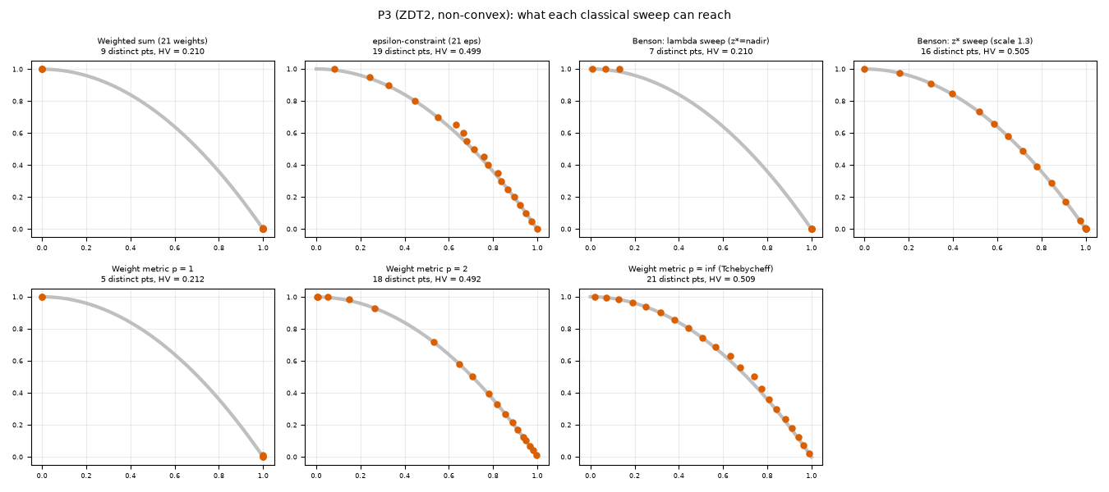
Fig. E-1: what each classical sweep can reach on the non-convex ZDT2.
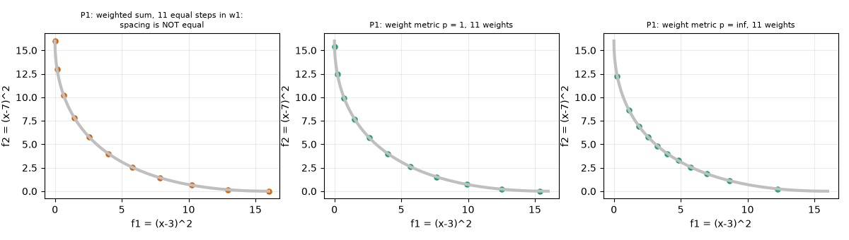
Fig. E-2: P1 (convex): equal weight steps do not give equal spacing; effect of p.
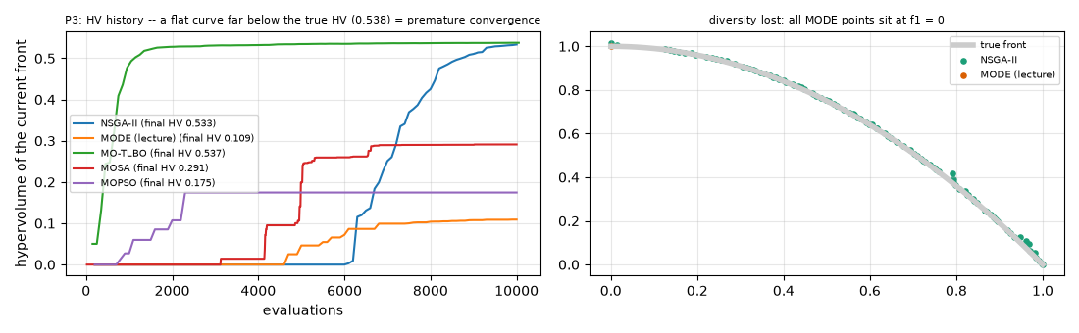
Fig. E-3: premature convergence: HV histories and the collapsed MODE front.
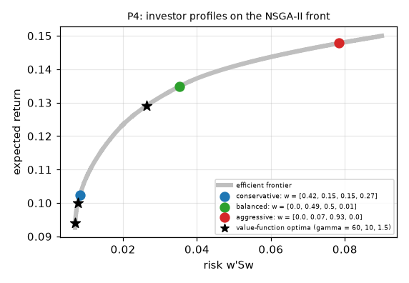
Fig. E-4: P4 investor profiles on the NSGA-II front and value-function optima.
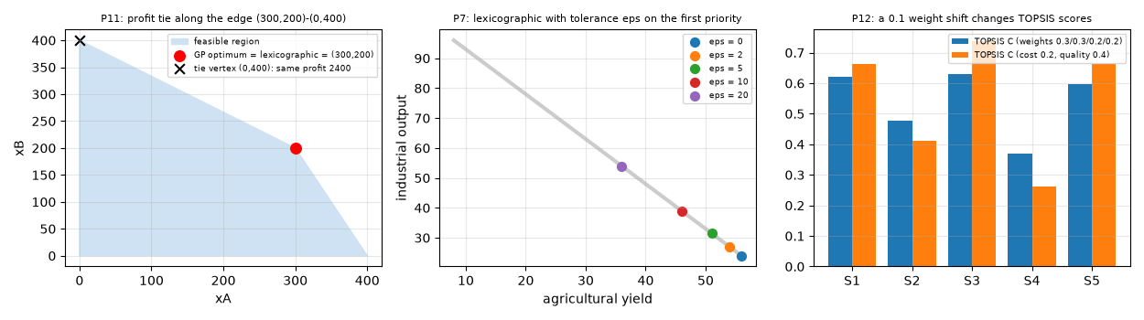
Fig. E-5: P11 tie, P7 lexicographic tolerance sweep, P12 TOPSIS weight shift.
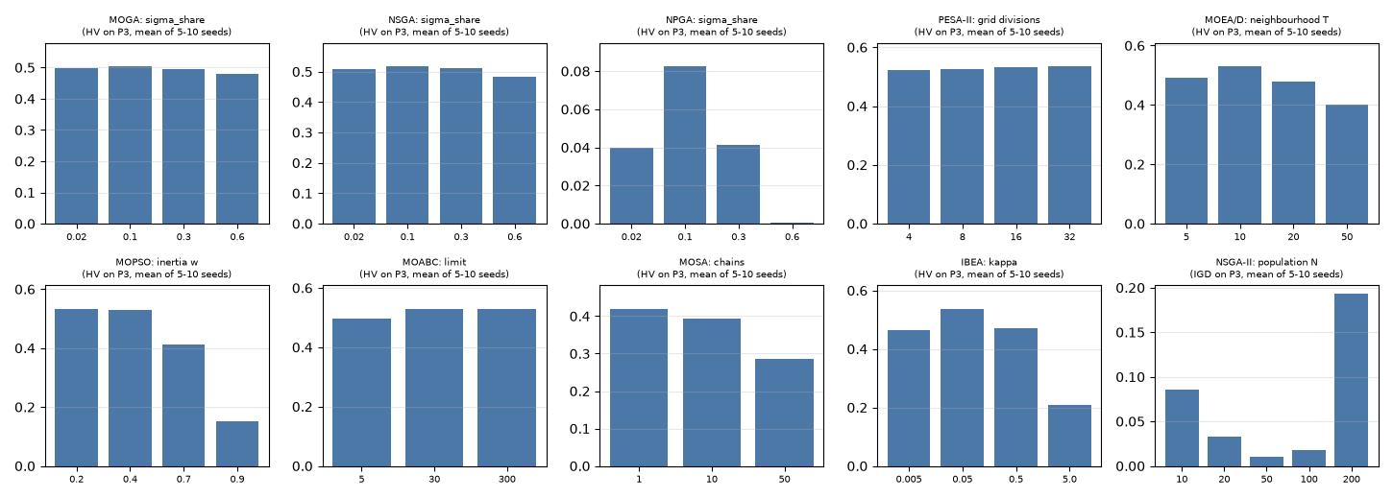
Fig. E-6: sensitivity of the main parameter of ten algorithms (P3).
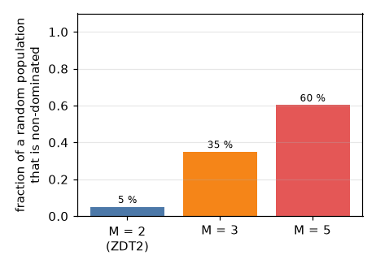
Fig. E-7: fraction of a random population that is non-dominated.
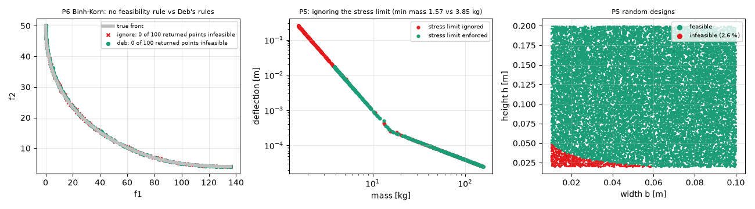
Fig. E-8: constraint handling: no rule vs Deb's rules (P6), ignoring the stress limit (P5), infeasible designs.
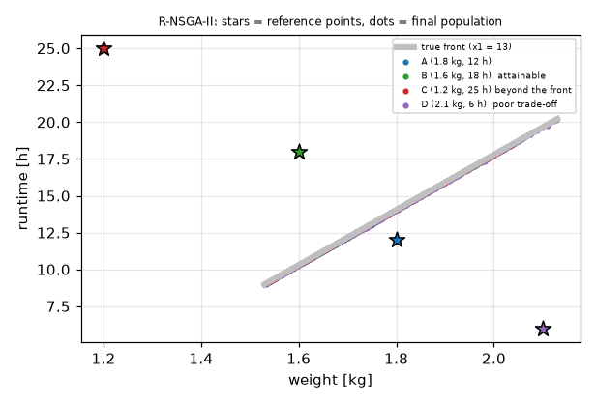
Fig. E-9: R-NSGA-II with four different reference points on P14.
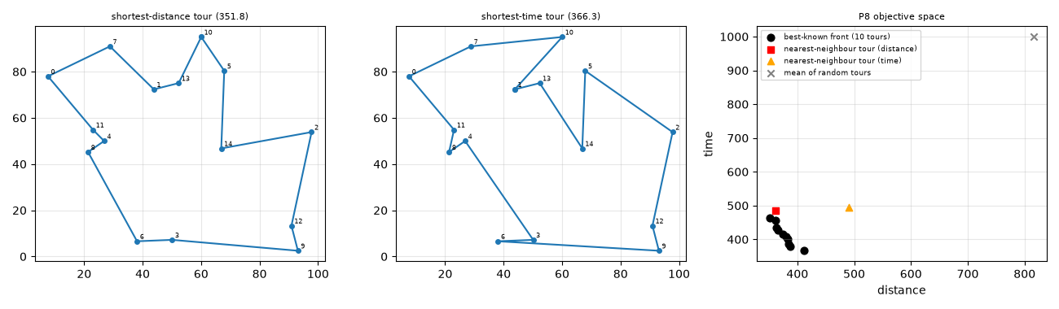
Fig. E-10: P8 tours and objective space.
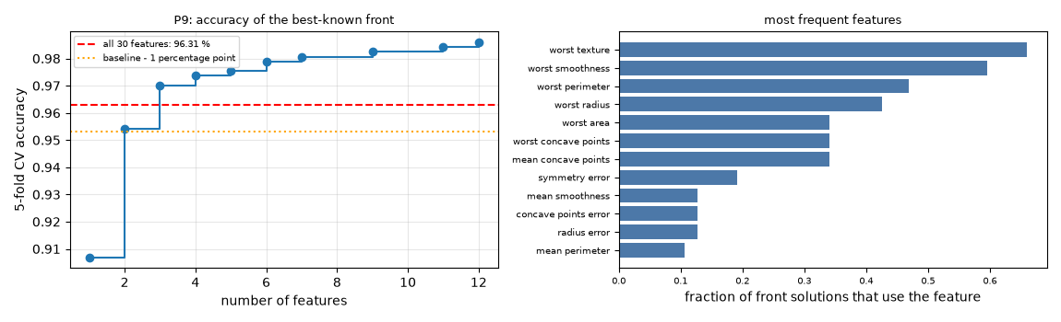
Fig. E-11: P9 accuracy vs number of features and most frequent features.

5 Section 4 investigations: answers to the problem questions
P1. 11 weights give 11 distinct points; equal steps in w give gaps from 0.142 to 0.190 (not equal). Weight metric on P1: HV p=1 1.027, p=2 1.000, p=∞ 1.022 (Fig. E-2).
P2. Real x: NSGA-II returns 98 points, Spacing 0.0058; VEGA 99 points, Spacing 0.0171. Integer x: NSGA-II 10 points (there are only 10 integers), ε-constraint 10 distinct vs 40 for real x.
P4 (repair vs penalty). NSGA-II, 10 seeds: repair HV 0.9673, IGD 0.0058; penalty HV 0.7356, IGD 0.1144, and the penalty front still violates Σw = 1 by up to 0.0010. We therefore use repair. Profiles on the front: conservative: risk 0.0084, return 0.1023, w = [0.42, 0.15, 0.15, 0.27]; balanced: risk 0.0354, return 0.1349, w = [0.0, 0.49, 0.5, 0.01]; aggressive: risk 0.0784, return 0.1478, w = [0.0, 0.07, 0.93, 0.0]. The minimum-risk end is a mixture w = [0.61, 0.12, 0.05, 0.22] (Fig. E-4).
P5. 2.6 % of random designs violate the stress limit. Constraint handling: Deb's rules (alg 21) / penalty. Ignoring the limit lowers the minimum mass from 3.85 to 1.57 kg and while the hypervolume of the whole front hardly changes (1.195 vs 1.196): the unsafe designs appear only in the light, flexible end of the front (Fig. E-8). Sanity: [3.9250000000000003, 0.015999999999999997] kg/m, stress 240 MPa.
P6. Deb's rules by hand on six candidates (f, CV): A (0,0): f = (0.0, 50.0), CV 0.00; B (5,3): f = (136.0, 4.0), CV 0.00; C (0,3): f = (36.0, 29.0), CV 9.00; D (0.5,2.5): f = (26.0, 26.5), CV 1.50; E (4,3): f = (100.0, 5.0), CV 0.00; F (1,3): f = (40.0, 20.0), CV 0.00. Rule 1: A, B, E, F (feasible) beat C and D (infeasible) whatever their objectives; rule 2: A, B, E, F are mutually non-dominated (a genuine trade-off, ordinary dominance); rule 3: D (CV 1.5) beats C (CV 9). NSGA-II over 10 seeds returns 1 % infeasible points with no rule, 0 % with a penalty and 0 % with Deb's rules (Fig. E-8).
P7. Constrained NSGA-II front: 78 points, maximum deviation from x1+x2 = 90 is 1.05e+00. For the reference (40, 50) the closest front point is [39.3, 49.0] (x = [49.2, 40.8]); R-NSGA-II centres at [33.8, 56.9].
P8. NSGA-II with different permutation operators (10 seeds, HV): OX + mixed(swap/inv): 0.732; OX + swap: 0.588; OX + inversion: 0.743; mutation only (inversion): 0.533; OX only: 0.443. Best distance 351.8 (time of that tour 463.7); best time 366.3 (distance of that tour 411.4); the two tours share 8 of 15 edges. Nearest-neighbour tours: distance 362.0, time 495.7; mean random tour 816 / 999 (Fig. E-10).
P9. All-ones baseline accuracy 96.31 %. Smallest subset within 1 percentage point of the baseline: 2 features (error 0.0457: ['worst perimeter', 'worst smoothness']). Best error 0.0141 with 12 features. Most frequent features: worst texture (66 %), worst smoothness (60 %), worst perimeter (47 %), worst radius (43 %), worst area (34 %), worst concave points (34 %) (Fig. E-11).
P10. Non-dominated fraction of a random population of 100: 5 % (2 objectives), 35 % (M = 3), 60 % (M = 5): selection pressure from Pareto rank disappears (Fig. E-7).
P11. The Pareto set is the single point (300, 200) (profit and units are both maximal there). Goal programming with unit and with normalised weights both give x = [300, 200], shortfall 100 on the units goal. Lexicographic: stage 1 returns profit 2400 on an edge (max xA: [300.0, 200.0], units 500; min xA: [0.0, 400.0], units 400); only the second priority separates them.
P12. Pareto-optimal suppliers: ['S1', 'S2', 'S3', 'S4', 'S5'] (all five). TOPSIS order S[3, 1, 5, 2, 4] (C = [0.621, 0.476, 0.63, 0.37, 0.597]); after moving 0.1 weight from cost to quality: [3, 5, 1, 2, 4]. VIKOR order for v = 0.25 / 0.5 / 0.75: [1, 2, 5, 3, 4] / [1, 2, 5, 3, 4] / [1, 3, 2, 5, 4]; after the shift (v = 0.5): [1, 3, 5, 2, 4]. VIKOR protects against one very bad criterion through the regret term R (Task B rows 8-9).
P14. NSGA-II front: x1 in [13.000, 13.057], 94 % of points at x1 = 13 (the algorithm discovers it). The reference (1.8 kg, 12 h) lies 0.13 (normalised) away from the front: the front offers 14.0 h at 1.8 kg, so the reference is dominated; R-NSGA-II focuses near weight 1.80 kg (Fig. E-9).

6 Task C — deep dive: algorithms 3, 15 and 27 (roll no. 77)
R = 77: Algorithm 1 = ((77-1) mod 37)+1 = 3, Algorithm 2 = ((77+11) mod 37)+1 = 15, Algorithm 3 = ((77+23) mod 37)+1 = 27.

C1 Study cards

Algorithm 3 — Benson's method
Item | Content
Full form, year, authors | Benson's method (H. P. Benson, 1978, J. Optim. Theory Appl. 26 — an efficiency-testing / efficient-point-generating scalarisation). The lecture (Part 1, slides 36-37) presents the reference-point form used here.
Problem it was invented to fix | Weighted sums only reach the convex-hull part of a front and give no control over WHERE on the front the answer lies; a decision maker usually has a target (reference) in mind. Benson's construction asks: how far can we go past the target in every objective at once?
Core idea (5 lines) | 1. Pick a reference point z* in objective units (a target for each objective).  2. The achievement si = z*i - fi(x) is the distance by which x beats the target on objective i (all objectives minimised).  3. Only x with every si ≥ 0 are admissible.  4. Among those, maximise the weighted total Σ λi si — one single-objective solve.  5. Change (z*, λ) and repeat to obtain more efficient points.
Flow diagram | 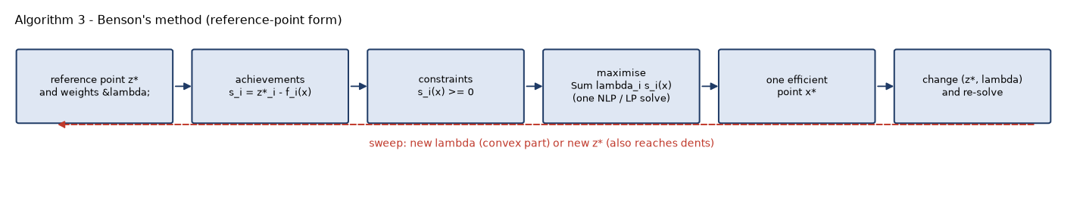
Numbered steps and formulas | 1. Choose z* ∈ R^{k} and λ ∈ R^{k}+.  2. si(x) = z*i - fi(x) (minimised fi); si(x) = fi(x) - z*i (maximised fi).  3. Solve maxx Σi λi si(x) s.t. si(x) ≥ 0 (i = 1..k), g(x) ≤ 0, bounds.  4. Report x*, f(x*), s(x*). If no x satisfies all si ≥ 0 the setting is infeasible (z* is better than anything attainable).  5. New (z*, λ) → step 2. Equivalent form: min Σλi fi s.t. fi ≤ z*i.
Parameters | z* (reference point): too loose (e.g. the nadir) ⇒ the si ≥ 0 constraints never bind and the method collapses to a weighted sum; too tight (better than the ideal) ⇒ empty feasible region, no answer; exactly on the front ⇒ the only admissible point is z* itself. λ: tilts the optimum inside the admissible box; too extreme (λi → 0) ⇒ objective i is only kept at its target si = 0. sub-solver tolerance and restarts (our Nelder-Mead with exact L1 penalty).
Convergence / diversity / constraints | Each solve is exact if the sub-problem is convex; the quality of the FRONT is only as good as the sweep of (z*, λ): diversity is under the user's control, not automatic. Constraints g(x) ≤ 0 enter the sub-problem directly.
Non-convex fronts | λ-sweeps alone behave like a weighted sum (only the convex hull / end points). Moving z* makes the box constraint bind on the front itself and reaches the dent (see the sensitivity table in C3: the z* sweep places points in the dent).
More than three objectives | Nothing in the formulation limits k, but a good sweep needs k-1 free dimensions of z* and of λ: the number of solves grows exponentially; also no way to visualise.
Complexity | One constrained single-objective solve per (z*, λ) pair; for linear data a simplex LP (polynomial in practice); in our code O(maxfev) function evaluations per setting (≈ 2,000-27,000 evaluations on P1/P3).

Algorithm 15 — NSGA-III
Item | Content
Full form, year, authors | Non-dominated Sorting Genetic Algorithm III — K. Deb and H. Jain, 2014, IEEE Trans. Evolutionary Computation 18(4):577-601 (the lecture: Part 3 slides 12-19 and 5E slides 5-7).
Problem it was invented to fix | NSGA-II breaks down for k ≥ 4 objectives: almost every individual of a random population is non-dominated, so Pareto rank no longer discriminates, and crowding distance (designed for 2-3 objectives) neither spreads the solutions nor pushes them to the front.
Core idea (5 lines) | Keep NSGA-II's elitist non-dominated sorting, but replace crowding distance by niching around a set of structured reference points spread on the normalised unit simplex. Objectives are normalised every generation. Each candidate is associated with the closest reference LINE; the last front is filled from the least-crowded reference points. Diversity is therefore built into the geometry and does not degrade with k.
Flow diagram | 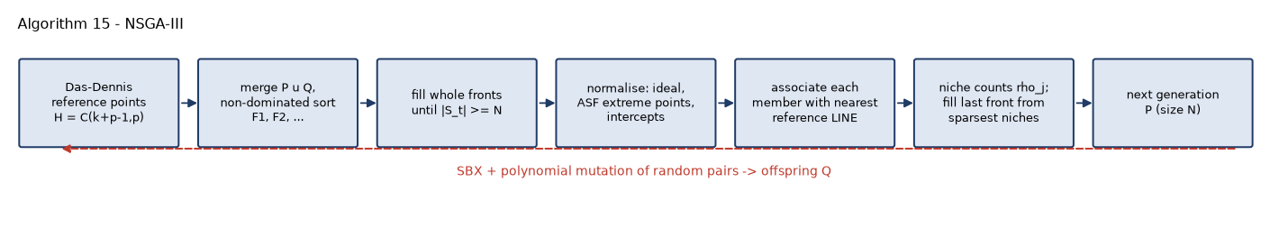
Numbered steps and formulas | 1. H = C(k+p-1, p) Das-Dennis points w with Σwi = 1, step 1/p. 2. N = H rounded up to a multiple of 4; random initial population.  3. Offspring Q (SBX + polynomial mutation of random pairs); R = P ∪ Q; non-dominated sort F1, F2, ...; St = F1 ∪ ... ∪ Fl with |St| ≥ N.  4. Normalise: zmin,i = min fi; f' = f - zmin; extreme point j = argmin ASFj, ASFj(x) = maxi f'i/wji (wjj = 1, others 10⁻⁶); intercepts a = 1 / (E⁻¹ 1) from the hyperplane through the extreme points (fallback: max f'); f^{n} = f'/a.  5. d⊥(s, w) = || f^{n} - (w'f^{n} / ||w||²) w ||; associate s with the w of smallest d⊥.  6. ρj = #members of F1..l-1 associated with wj. Repeat K = N - |F1..l-1| times: take j with minimum ρj (random ties); candidates = members of Fl associated with j; none ⇒ discard j; ρj = 0 ⇒ take the closest to the line, else a random one; ρj += 1.
Parameters | p (divisions) sets H and N: too small ⇒ few reference points, coarse front (p = 2, H = 15: 16 solutions); too large ⇒ N huge (p = 6, H = 210, N = 212) so at a fixed budget there are only 47 generations and convergence suffers (Task C3 numbers). pc = 1.0, ηc = 30 (small ηc ⇒ large jumps / disruption, large ηc ⇒ offspring stick to parents), pm = 1/n, ηm = 20. Two-layer reference sets are advised from k = 8.
Convergence / diversity / constraints | Convergence from elitist non-dominated sorting; diversity from niching; constraints by Deb's constrained domination in the sort (we use the penalty S = F + ρCV·scale).
Non-convex fronts | No convexity assumption: reference lines are directions, not weights, so a dented or concave front is covered. Irregular (degenerate, disconnected) fronts waste reference points whose niches stay empty.
More than three objectives | Designed for it: H and the normalisation scale with k, not with n. The price is N ≈ H (210 reference points for k = 5, p = 6).
Complexity | Sorting O(N² k) + association O(N H k) + niching O(N H) per generation; memory O(N H).

Algorithm 27 — MODE
Item | Content
Full form, year, authors | Multi-Objective Differential Evolution — Xue, Sanderson & Graves, 2003 (lecture Part 4, slide 48), built on Differential Evolution (R. Storn & K. Price, 1997).
Problem it was invented to fix | Differential evolution is a very fast optimiser for continuous single-objective problems, but its greedy 'trial replaces target if better' rule needs a definition of 'better' when there are several objectives. MODE substitutes Pareto dominance and keeps the non-dominated trials in an archive.
Core idea (5 lines) | Each member Xi is a target. A mutant V = Xr1 + F (Xr2 - Xr3) uses the scaled difference of two random members as a self-adapting step; binomial crossover mixes V with Xi into a trial U. The trial replaces Xi only if it Pareto-dominates it; otherwise Xi survives. Every non-dominated trial is offered to an external archive that holds the answer.
Flow diagram | 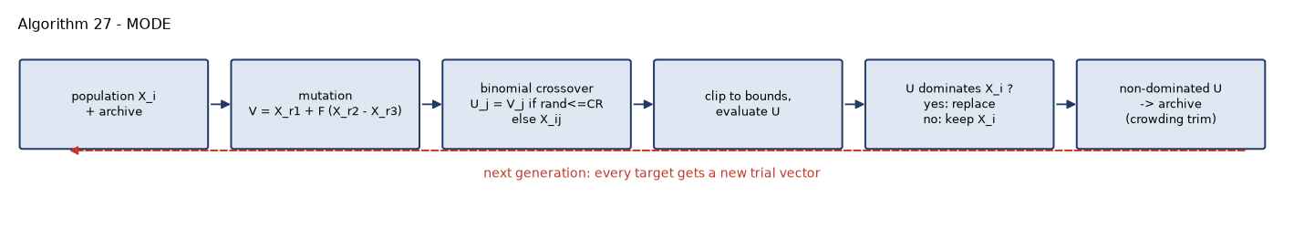
Numbered steps and formulas | 1. Random population X1..NP, archive A = non-dominated(X).  2. For each i draw distinct r1, r2, r3 ≠ i: V = Xr1 + F (Xr2 - Xr3).  3. Draw jrand; Uj = Vj if randj ≤ CR or j = jrand, else Xi,j; clip U to [lb, ub].  4. Evaluate U. If U ≺ Xi (constrained dominance when constrained) then Xi ← U, else keep Xi.  5. A ← non-dominated(A ∪ {U}) with crowding-distance truncation to 100.  6. Repeat; output A.
Parameters | F (scale factor): too small (0.2) ⇒ tiny steps, slow but the population stays spread; too large (0.9) ⇒ mutants overshoot, steps destroy good structure (see sensitivity). CR: small ⇒ trials differ from the target in few coordinates (good for separable problems), 1.0 ⇒ trial = mutant (rotation invariant). NP: too small ⇒ few distinct differences, premature convergence; too large ⇒ slow. Archive size: truncation by crowding distance.
Convergence / diversity / constraints | Very fast convergence on smooth continuous problems. Diversity comes ONLY from the archive and the initial population, because the dominance-only replacement rule has no spreading mechanism. Constraints: Deb's rules or penalty in the dominance test.
Non-convex fronts | Dominance handles any shape in principle, but on ZDT2 the lecture rule collapsed to f1 = 0 (all trials with lower f1 and lower g dominate; trials that trade f1 for f2 are rejected).
More than three objectives | A trial is dominating less and less often as k grows (mostly mutually non-dominated), so replacements stop and the archive grows without pressure: not suited without an indicator or reference-point selection.
Complexity | O(NP n) per generation for variation + O(NP k) for the dominance tests + O((NP + |A|)² k) for the archive update; memory O(NP + |A|).

C2 Hand traces (reproduced by the code: tests/test_handtraces.py)

Algorithm 3 — Benson on P1, three (z*, λ) settings
Setting (z*, λ) | objective and derivative | admissible interval from si ≥ 0 and the box | optimum | result
z* = (16,16), λ = (0.5,0.5) | Φ = 0.5(16-(x-3)²) + 0.5(16-(x-7)²) = 16 - (x² - 10x + 29)  Φ' = -2x + 10 | (x-3)² ≤ 16 ⇒ -1 ≤ x ≤ 7; (x-7)² ≤ 16 ⇒ 3 ≤ x ≤ 11; box [1,10] ⇒ [3,7] | Φ' = 0 at x = 5 (inside) | f = (4.00, 4.00)  s = (12.00, 12.00)  Φ = 12.00
z* = (16,16), λ = (0.8,0.2) | Φ = 16 - (0.8(x-3)² + 0.2(x-7)²) = 16 - (x² - 7.6x + 17)  Φ' = -2x + 7.6 | same interval [3,7] | Φ' = 0 at x = 3.8 (inside) | f = (0.64, 10.24)  s = (15.36, 5.76)  Φ = 13.44
z* = (4,10), λ = (0.5,0.5) | Φ = 0.5(4-(x-3)²) + 0.5(10-(x-7)²) = 7 - (x² - 10x + 29)  Φ' = -2x + 10 | (x-3)² ≤ 4 ⇒ 1 ≤ x ≤ 5; (x-7)² ≤ 10 ⇒ x ≥ 7-√10 = 3.838 ⇒ [3.838, 5] | Φ' ≥ 0 on the whole interval ⇒ optimum at the right end x = 5 where s1 = 0 (constraint binds) | f = (4.00, 4.00)  s = (0.00, 6.00)  Φ = 3.00

Settings 1-2 are interior optima (the same x as the weighted sum of lecture slide 32: 5 and 3.8); setting 3 shows the reference point binding: s1 = 0.

Algorithm 15 — NSGA-III, drone problem (3 objectives, N = 4, p = 1 so H = 3 reference points = the unit axes, 'max' normalisation)
f1 = 0.5 + 0.6x1 + 0.004x2, f2 = 20 + 40x1 + 0.3x2, f3 = -(15 + 0.05x2 - 8x1). Niche ties are broken by lowest index (the paper draws at random). Perpendicular distance to axis j = norm of the other two normalised coordinates.
Iteration 1
point | x = (wingspan, power) | f1 weight | f2 cost | f3 -flight time | front
D1 (parent) | (0.60, 120.00) | 1.340 | 80.0 | -16.20 | F1
D2 (parent) | (0.80, 150.00) | 1.580 | 97.0 | -16.10 | F2
D5 (parent) | (0.70, 250.00) | 1.920 | 123.0 | -21.90 | F1
D6 (parent) | (1.40, 300.00) | 2.540 | 166.0 | -18.80 | F3
a (offspring) | (0.65, 110.00) | 1.330 | 79.0 | -15.30 | F1
b (offspring) | (0.75, 240.00) | 1.910 | 122.0 | -21.00 | F1
c (offspring) | (0.95, 195.00) | 1.850 | 116.5 | -17.15 | F1
d (offspring) | (1.10, 260.00) | 2.200 | 142.0 | -19.20 | F2

Fronts: F1 = {D1, D5, a, b, c}, F2 = {D2, d}, F3 = {D6}. St = {D1, D5, a, b, c}, 0 members accepted whole (F1..l-1), K = 4 to be chosen from Fl. ideal = (1.330, 79.000, -21.900), intercepts (max f') = (0.590, 44.000, 6.600).
member of St | translated f' = f - ideal | normalised f^{n} = f' / intercepts | d⊥ to w1, w2, w3 | nearest
D1 | (0.010, 1.000, 5.700) | (0.017, 0.023, 0.864) | (0.864, 0.864, 0.028) | w3
D5 | (0.590, 44.000, 0.000) | (1.000, 1.000, 0.000) | (1.000, 1.000, 1.414) | w1
a | (0.000, 0.000, 6.600) | (0.000, 0.000, 1.000) | (1.000, 1.000, 0.000) | w3
b | (0.580, 43.000, 0.900) | (0.983, 0.977, 0.136) | (0.987, 0.993, 1.386) | w1
c | (0.520, 37.500, 4.750) | (0.881, 0.852, 0.720) | (1.115, 1.138, 1.226) | w1

Niching: ref 0 (rho=0): candidates ['D5', 'b', 'c'] -> b; ref 1: no candidate -> excluded; ref 2 (rho=0): candidates ['D1', 'a'] -> a; ref 0 (rho=1): candidates ['D5', 'c'] -> D5; ref 2 (rho=1): candidates ['D1'] -> D1. Survivors: b, a, D5, D1.
Iteration 2 (parents = survivors of iteration 1)
point | x = (wingspan, power) | f1 weight | f2 cost | f3 -flight time | front
b (parent) | (0.75, 240.00) | 1.910 | 122.0 | -21.00 | F2
a (parent) | (0.65, 110.00) | 1.330 | 79.0 | -15.30 | F1
D5 (parent) | (0.70, 250.00) | 1.920 | 123.0 | -21.90 | F2
D1 (parent) | (0.60, 120.00) | 1.340 | 80.0 | -16.20 | F1
e (offspring) | (1.37, 145.00) | 1.902 | 118.3 | -11.29 | F2
f (offspring) | (1.34, 200.00) | 2.104 | 133.6 | -14.28 | F3
g (offspring) | (1.32, 255.00) | 2.312 | 149.3 | -17.19 | F3
h (offspring) | (0.62, 245.00) | 1.852 | 118.3 | -22.29 | F1

Fronts: F1 = {a, D1, h}, F2 = {b, D5, e}, F3 = {f, g}. St = {a, D1, h, b, D5, e}, 3 members accepted whole (F1..l-1), K = 1 to be chosen from Fl. ideal = (1.330, 79.000, -22.290), intercepts (max f') = (0.590, 44.000, 11.000).
member of St | translated f' = f - ideal | normalised f^{n} = f' / intercepts | d⊥ to w1, w2, w3 | nearest
a | (0.000, 0.000, 6.990) | (0.000, 0.000, 0.635) | (0.635, 0.635, 0.000) | w3
D1 | (0.010, 1.000, 6.090) | (0.017, 0.023, 0.554) | (0.554, 0.554, 0.028) | w3
h | (0.522, 39.300, 0.000) | (0.885, 0.893, 0.000) | (0.893, 0.885, 1.257) | w2
b | (0.580, 43.000, 1.290) | (0.983, 0.977, 0.117) | (0.984, 0.990, 1.386) | w1
D5 | (0.590, 44.000, 0.390) | (1.000, 1.000, 0.035) | (1.001, 1.001, 1.414) | w1
e | (0.572, 39.300, 11.000) | (0.970, 0.893, 1.000) | (1.341, 1.393, 1.318) | w3

Niching: ref 0 (rho=0): candidates ['b', 'D5'] -> b. Survivors: a, D1, h, b.

Algorithm 27 — MODE, two iterations
Problem P1 (f1 = (x-3)², f2 = (x-7)², 1 ≤ x ≤ 10), NP = 4, initial population x = [1.0, 4.0, 8.0, 10.0] with f = [(4.0, 36.0), (1.0, 9.0), (25.0, 1.0), (49.0, 9.0)]. Initial archive (non-dominated) = [4.0, 8.0] (x = 1 is dominated by x = 4, x = 10 by x = 4). Donor indices r1, r2, r3 are fixed (they are random in the algorithm) so the trace is reproducible; one variable ⇒ U = V.
Iteration 1 (F = 0.5)
i | target xi (f) | r1,r2,r3 | F | V = xr1 + F(xr2 - xr3) | U (clipped) | f(U) | outcome
1 | 1 (4, 36) | 2,3,4 | 0.5 | 3 | 3 | (0, 16) | replace
2 | 4 (1, 9) | 3,4,1 | 0.5 | 12.5 | 10 | (49, 9) | keep (target dominates trial)
3 | 8 (25, 1) | 2,1,4 | 0.5 | -0.5 | 1 | (4, 36) | keep (non-dominated, trial -> archive)
4 | 10 (49, 9) | 3,2,1 | 0.5 | 9.5 | 9.5 | (42.25, 6.25) | replace

Population after iteration 1: x = [3.0, 4.0, 8.0, 9.5]; archive = [3.0, 4.0, 8.0].
Iteration 2 (F = 0.6)
i | target xi (f) | r1,r2,r3 | F | V = xr1 + F(xr2 - xr3) | U (clipped) | f(U) | outcome
1 | 3 (0, 16) | 2,3,4 | 0.6 | 3.1 | 3.1 | (0.01, 15.21) | keep (non-dominated, trial -> archive)
2 | 4 (1, 9) | 1,3,4 | 0.6 | 2.1 | 2.1 | (0.81, 24.01) | keep (non-dominated, trial -> archive)
3 | 8 (25, 1) | 2,4,1 | 0.6 | 7.9 | 7.9 | (24.01, 0.81) | replace
4 | 9.5 (42.25, 6.25) | 3,1,2 | 0.6 | 7.4 | 7.4 | (19.36, 0.16) | replace

Population after iteration 2: x = [3.0, 4.0, 7.9, 7.4]; archive = [3.0, 3.1, 4.0, 7.4].

C3 Sensitivity of the most important parameter (3 values x 10 seeds)

Benson: reference-point scale z_scale (P3, 21 settings)
z_scale | HV mean ± std | IGD mean ± std | #points | in dent 0.3<f1<0.7
z_scale=1.0 | 0.0000 ± 0.0000 | n/a ± n/a | 0.0 | 0.0
z_scale=1.3 | 0.5051 ± 0.0002 | 0.0337 ± 0.0004 | 16.1 | 5.0
z_scale=1.8 | 0.3599 ± 0.0361 | 0.2015 ± 0.0318 | 10.2 | 0.0

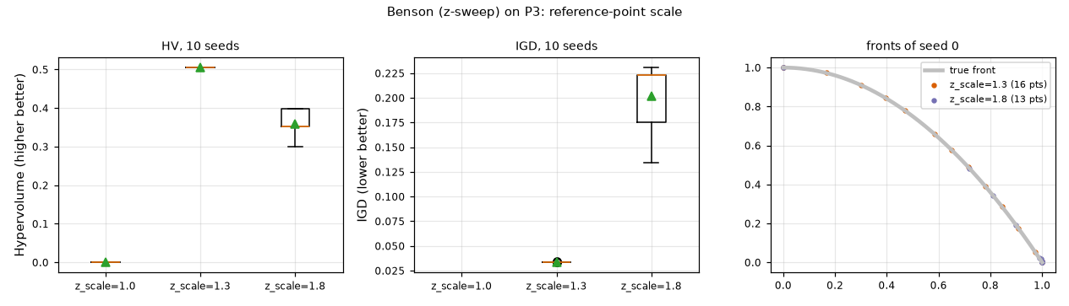
Effect. z_scale=1.0: 0.0 points, 0.0 in the dent, HV 0.000; z_scale=1.3: 16.1 points, 5.0 in the dent, HV 0.505; z_scale=1.8: 10.2 points, 0.0 in the dent, HV 0.360. The scale decides whether the box constraints si ≥ 0 bind: when the reference box is tight enough to cut the front, the optimum is pushed onto the front itself, including the dent; when it is loose the constraints are inactive and the method degenerates to a weighted sum (end points); when too tight many settings are empty (fewer points).

NSGA-III: divisions p (DTLZ2, M = 5, 10,000 evaluations)
p | HV mean ± std | IGD mean ± std | #points | runtime [s]
p=2 | 0.6859 ± 0.0799 | 0.5393 ± 0.0408 | 16.0 | 1.1
p=4 | 0.5299 ± 0.0951 | 0.4145 ± 0.0330 | 72.0 | 1.9
p=6 | 0.3520 ± 0.0627 | 0.4630 ± 0.0248 | 212.0 | 4.6

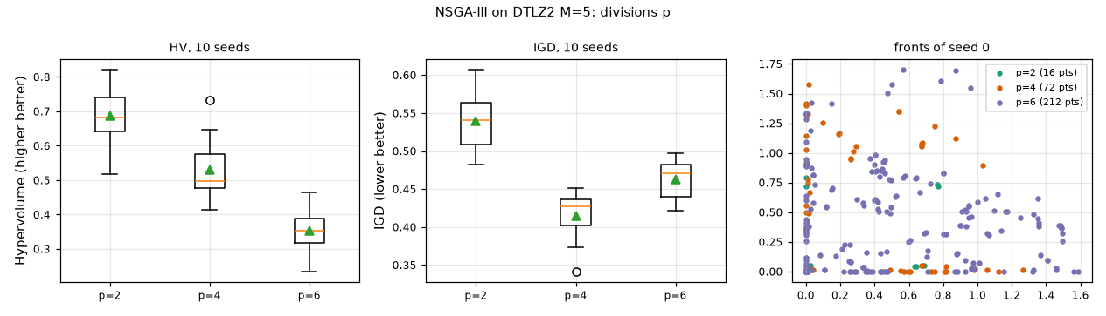
Effect. p=2: IGD 0.539, HV 0.686, 16 solutions; p=4: IGD 0.415, HV 0.530, 72 solutions; p=6: IGD 0.463, HV 0.352, 212 solutions. Few reference points give a coarse front; many give a fine front but, at a fixed budget, too few generations to converge (N = 212 means 47 generations).

MODE (lecture rule): scale factor F (P3)
F | HV mean ± std | IGD mean ± std | #points | in dent 0.3<f1<0.7
F=0.2 | 0.1087 ± 0.0036 | 0.6101 ± 0.0015 | 1.0 | 0.0
F=0.5 | 0.1097 ± 0.0003 | 0.6096 ± 0.0001 | 1.0 | 0.0
F=0.9 | 0.1111 ± 0.0033 | 0.5896 ± 0.0599 | 1.1 | 0.0

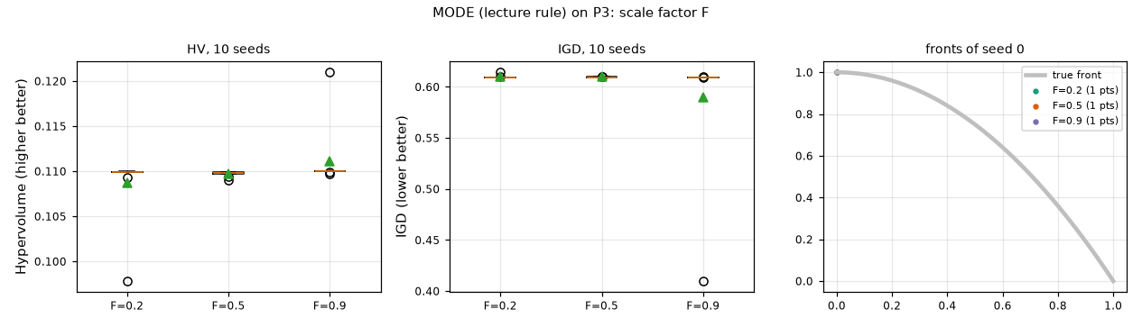
Effect. F=0.2: HV 0.109, IGD 0.610, 1.0 archive points; F=0.5: HV 0.110, IGD 0.610, 1.0 archive points; F=0.9: HV 0.111, IGD 0.590, 1.1 archive points. With the lecture's dominance-only replacement the population collapses towards f1 = 0 for all F; F only changes how fast and how many intermediate archive points are collected before the collapse.

7 Task D — head-to-head comparison (10 seeds, equal budgets)

D1 Continuous bi-objective: P3 (ZDT2, unconstrained) and P5 (beam, constrained)
Every algorithm of our set that applies to a continuous problem was run with 10,000 evaluations and 10 seeds (classical methods: 21 weights / eps values / reference points, evaluations reported). HV and IGD are in the normalised space (HV reference 1.1); rank 1 is best. R-NSGA-II is a preference method (its front is a focused subset around a reference point), so its rank is shown for completeness only. MODE appears twice: the lecture rule and the NSGA-II-survival variant.

P3 (ZDT2, n = 10) -- unconstrained, non-convex
rank (HV) | algorithm | HV mean ± std | IGD mean ± std | Spacing mean ± std | #pts | evals | time [s] | rank IGD
1 | #29 MOBA | 0.5384 ± 0.0001 | 0.0040 ± 0.0001 | 0.0022 ± 0.0003 | 100 | 10,000 | 1.2 | 1
2 | #33 SMS-EMOA | 0.5380 ± 0.0010 | 0.0050 ± 0.0011 | 0.0058 ± 0.0024 | 100 | 10,000 | 135.8 | 5
3 | #32 IBEA | 0.5369 ± 0.0004 | 0.0082 ± 0.0009 | 0.0132 ± 0.0016 | 84 | 10,000 | 1.3 | 7
4 | #19 MOEA/D-DE | 0.5359 ± 0.0010 | 0.0045 ± 0.0003 | 0.0025 ± 0.0003 | 100 | 10,000 | 2.6 | 2
5 | #23 MOGWO | 0.5358 ± 0.0015 | 0.0046 ± 0.0004 | 0.0030 ± 0.0004 | 100 | 10,000 | 1.9 | 3
6 | #27 MODE [survival variant] | 0.5358 ± 0.0009 | 0.0048 ± 0.0004 | 0.0038 ± 0.0008 | 100 | 10,000 | 1.9 | 4
7 | #17 PESA-II | 0.5322 ± 0.0019 | 0.0079 ± 0.0008 | 0.0084 ± 0.0033 | 100 | 10,000 | 3.5 | 6
8 | #24 MOABC | 0.5284 ± 0.0032 | 0.0103 ± 0.0015 | 0.0118 ± 0.0024 | 77 | 10,050 | 1.0 | 9
9 | #22 MOPSO | 0.5278 ± 0.0012 | 0.0087 ± 0.0007 | 0.0051 ± 0.0011 | 100 | 10,000 | 1.1 | 8
10 | #14 NSGA-II | 0.5175 ± 0.0459 | 0.0182 ± 0.0348 | 0.0069 ± 0.0051 | 95 | 10,000 | 1.0 | 12
11 | #16 SPEA2 | 0.5172 ± 0.0347 | 0.0162 ± 0.0183 | 0.0071 ± 0.0076 | 100 | 10,000 | 2.4 | 10
12 | #12 NSGA | 0.5164 ± 0.0028 | 0.0179 ± 0.0016 | 0.0171 ± 0.0019 | 49 | 10,000 | 0.4 | 11
13 | #30 MOMA | 0.5120 ± 0.0666 | 0.0251 ± 0.0568 | 0.0064 ± 0.0014 | 91 | 10,046 | 1.5 | 14
14 | #4 Weight Metric [WM p=inf 21w] | 0.5105 ± 0.0027 | 0.0200 ± 0.0007 | 0.0112 ± 0.0006 | 21 | 488,457 | 43.8 | 13
15 | #18 MOEA/D | 0.5071 ± 0.0720 | 0.0280 ± 0.0630 | 0.0031 ± 0.0010 | 100 | 10,000 | 3.9 | 16
16 | #3 Benson's Method [Benson z-sweep 21] | 0.5051 ± 0.0002 | 0.0337 ± 0.0004 | 0.0550 ± 0.0025 | 16 | 467,218 | 42.3 | 18
17 | #11 MOGA | 0.5008 ± 0.0090 | 0.0255 ± 0.0048 | 0.0271 ± 0.0155 | 41 | 10,000 | 0.4 | 15
18 | #35 R-NSGA-II | 0.4965 ± 0.0157 | 0.0293 ± 0.0113 | 0.0195 ± 0.0150 | 92 | 10,000 | 1.4 | 17
19 | #2 epsilon-Constraint [eps 21] | 0.4958 ± 0.0075 | 0.0371 ± 0.0061 | 0.0316 ± 0.0189 | 19 | 489,645 | 592.9 | 19
20 | #34 HypE | 0.4556 ± 0.0731 | 0.0625 ± 0.0553 | 0.0107 ± 0.0043 | 79 | 10,000 | 2.0 | 20
21 | #15 NSGA-III | 0.4154 ± 0.1053 | 0.0922 ± 0.0883 | 0.0152 ± 0.0119 | 75 | 10,000 | 1.6 | 22
22 | #26 MOSA | 0.3979 ± 0.0483 | 0.0871 ± 0.0446 | 0.0302 ± 0.0073 | 39 | 10,000 | 1.2 | 21
23 | #28 MO-TLBO | 0.3810 ± 0.1958 | 0.2118 ± 0.2712 | 0.0023 ± 0.0017 | 90 | 10,050 | 1.4 | 23
24 | #1 Weighted Sum [WS 21w] | 0.2105 ± 0.0006 | 0.3527 ± 0.0010 | 0.3083 ± 0.5083 | 8 | 453,496 | 662.3 | 25
25 | #31 RVEA | 0.1995 ± 0.1161 | 0.3363 ± 0.2011 | 0.0384 ± 0.0202 | 18 | 10,000 | 0.4 | 24
26 | #27 MODE | 0.1097 ± 0.0003 | 0.6096 ± 0.0001 | n/a ± n/a | 1 | 10,000 | 1.1 | 26
27 | #13 NPGA | 0.0615 ± 0.0575 | 0.6296 ± 0.2443 | 0.0317 ± 0.0226 | 6 | 10,000 | 1.2 | 27
28 | #10 VEGA | 0.0000 ± 0.0000 | 1.0734 ± 0.2101 | 0.0173 ± 0.0085 | 2 | 10,000 | 0.2 | 28

P5 (cantilever beam) -- constrained
rank (HV) | algorithm | HV mean ± std | IGD mean ± std | Spacing mean ± std | #pts | evals | time [s] | rank IGD
1 | #33 SMS-EMOA | 1.1957 ± 0.0000 | 0.0080 ± 0.0003 | 0.0152 ± 0.0006 | 100 | 10,000 | 1021.0 | 13
2 | #19 MOEA/D-DE | 1.1955 ± 0.0000 | 0.0061 ± 0.0007 | 0.0052 ± 0.0013 | 100 | 10,000 | 5.1 | 10
3 | #18 MOEA/D | 1.1955 ± 0.0000 | 0.0090 ± 0.0022 | 0.0075 ± 0.0022 | 100 | 10,000 | 5.8 | 15
4 | #28 MO-TLBO | 1.1954 ± 0.0000 | 0.0053 ± 0.0004 | 0.0042 ± 0.0010 | 100 | 10,050 | 1.2 | 8
5 | #22 MOPSO | 1.1954 ± 0.0000 | 0.0049 ± 0.0001 | 0.0033 ± 0.0003 | 100 | 10,000 | 1.2 | 1
6 | #27 MODE [survival variant] | 1.1954 ± 0.0000 | 0.0050 ± 0.0000 | 0.0032 ± 0.0003 | 100 | 10,000 | 3.2 | 3
7 | #24 MOABC | 1.1954 ± 0.0000 | 0.0051 ± 0.0002 | 0.0042 ± 0.0011 | 100 | 10,050 | 1.7 | 6
8 | #27 MODE | 1.1954 ± 0.0001 | 0.0052 ± 0.0006 | 0.0057 ± 0.0034 | 100 | 10,000 | 2.3 | 7
9 | #26 MOSA | 1.1954 ± 0.0000 | 0.0054 ± 0.0002 | 0.0053 ± 0.0008 | 100 | 10,000 | 4.9 | 9
10 | #23 MOGWO | 1.1954 ± 0.0001 | 0.0050 ± 0.0001 | 0.0033 ± 0.0003 | 100 | 10,000 | 1.2 | 4
11 | #29 MOBA | 1.1953 ± 0.0001 | 0.0050 ± 0.0000 | 0.0031 ± 0.0004 | 100 | 10,000 | 1.7 | 2
12 | #16 SPEA2 | 1.1953 ± 0.0000 | 0.0051 ± 0.0001 | 0.0030 ± 0.0003 | 100 | 10,000 | 12.7 | 5
13 | #14 NSGA-II | 1.1951 ± 0.0001 | 0.0063 ± 0.0003 | 0.0074 ± 0.0009 | 96 | 10,000 | 385.1 | 11
14 | #21 Constrained NSGA-II | 1.1951 ± 0.0001 | 0.0063 ± 0.0003 | 0.0074 ± 0.0009 | 96 | 10,000 | 1.2 | 12
15 | #30 MOMA | 1.1949 ± 0.0002 | 0.0097 ± 0.0038 | 0.0100 ± 0.0022 | 97 | 10,080 | 1.3 | 16
16 | #35 R-NSGA-II | 1.1948 ± 0.0002 | 0.0345 ± 0.0041 | 0.0066 ± 0.0050 | 100 | 10,000 | 6.2 | 20
17 | #17 PESA-II | 1.1946 ± 0.0002 | 0.0085 ± 0.0009 | 0.0084 ± 0.0007 | 100 | 10,000 | 4.8 | 14
18 | #32 IBEA | 1.1940 ± 0.0004 | 0.1397 ± 0.0204 | 0.0214 ± 0.0031 | 92 | 10,000 | 283.0 | 22
19 | #12 NSGA | 1.1932 ± 0.0003 | 0.0146 ± 0.0018 | 0.0150 ± 0.0039 | 66 | 10,000 | 0.4 | 17
20 | #11 MOGA | 1.1930 ± 0.0005 | 0.0148 ± 0.0017 | 0.0187 ± 0.0042 | 62 | 10,000 | 0.4 | 18
21 | #31 RVEA | 1.1913 ± 0.0008 | 0.2066 ± 0.0372 | 0.0279 ± 0.0121 | 80 | 10,000 | 0.4 | 25
22 | #13 NPGA | 1.1907 ± 0.0006 | 0.0251 ± 0.0042 | 0.0358 ± 0.0140 | 40 | 10,000 | 1.3 | 19
23 | #15 NSGA-III | 1.1891 ± 0.0011 | 0.1209 ± 0.0102 | 0.0658 ± 0.0328 | 95 | 10,000 | 386.3 | 21
24 | #4 Weight Metric [WM p=inf 21w] | 1.1878 ± 0.0000 | 0.2375 ± 0.0000 | 0.0449 ± 0.0000 | 21 | 50,621 | 3.7 | 27
25 | #34 HypE | 1.1866 ± 0.0015 | 0.2472 ± 0.0216 | 0.0177 ± 0.0099 | 74 | 10,000 | 227.1 | 28
26 | #1 Weighted Sum [WS 21w] | 1.1832 ± 0.0000 | 0.1614 ± 0.0000 | 0.2549 ± 0.0000 | 18 | 36,404 | 2.5 | 24
27 | #10 VEGA | 1.1600 ± 0.0163 | 0.2769 ± 0.0425 | 0.0139 ± 0.0126 | 39 | 10,000 | 0.2 | 29
28 | #2 epsilon-Constraint [eps 21] | 1.1515 ± 0.0006 | 0.1477 ± 0.0038 | 0.1926 ± 0.0028 | 21 | 94,669 | 6.8 | 23
29 | #3 Benson's Method [Benson z-sweep 21] | 1.1274 ± 0.0000 | 0.2351 ± 0.0000 | 0.2885 ± 0.0000 | 21 | 41,943 | 3.0 | 26

Combined ranking (algorithms that ran on both problems)
overall rank | algorithm | mean of the 4 ranks (HV, IGD on P3 and P5) | HV rank P3 / P5 | IGD rank P3 / P5
1 | #29 MOBA | 3.8 | 1 / 11 | 1 / 2
2 | #19 MOEA/D-DE | 4.5 | 4 / 2 | 2 / 10
3 | #27 MODE [survival variant] | 4.8 | 6 / 6 | 4 / 3
4 | #33 SMS-EMOA | 5.2 | 2 / 1 | 5 / 13
5 | #23 MOGWO | 5.5 | 5 / 10 | 3 / 4
6 | #22 MOPSO | 5.8 | 9 / 5 | 8 / 1
7 | #24 MOABC | 7.5 | 8 / 7 | 9 / 6
8 | #16 SPEA2 | 9.5 | 11 / 12 | 10 / 5
9 | #17 PESA-II | 11.0 | 7 / 17 | 6 / 14
10 | #14 NSGA-II | 11.5 | 10 / 13 | 12 / 11
11 | #18 MOEA/D | 12.2 | 15 / 3 | 16 / 15
12 | #32 IBEA | 12.5 | 3 / 18 | 7 / 22
13 | #28 MO-TLBO | 14.5 | 23 / 4 | 23 / 8
14 | #30 MOMA | 14.5 | 13 / 15 | 14 / 16
15 | #12 NSGA | 14.8 | 12 / 19 | 11 / 17
16 | #26 MOSA | 15.2 | 22 / 9 | 21 / 9
17 | #27 MODE | 16.8 | 26 / 8 | 26 / 7
18 | #11 MOGA | 17.5 | 17 / 20 | 15 / 18
19 | #35 R-NSGA-II | 17.8 | 18 / 16 | 17 / 20
20 | #4 Weight Metric [WM p=inf 21w] | 19.5 | 14 / 24 | 13 / 27
21 | #15 NSGA-III | 21.8 | 21 / 23 | 22 / 21
22 | #2 epsilon-Constraint [eps 21] | 22.2 | 19 / 28 | 19 / 23
23 | #3 Benson's Method [Benson z-sweep 21] | 22.2 | 16 / 29 | 18 / 26
24 | #34 HypE | 23.2 | 20 / 25 | 20 / 28
25 | #13 NPGA | 23.8 | 27 / 22 | 27 / 19
26 | #31 RVEA | 23.8 | 25 / 21 | 24 / 25
27 | #1 Weighted Sum [WS 21w] | 24.8 | 24 / 26 | 25 / 24
28 | #10 VEGA | 28.0 | 28 / 27 | 28 / 29

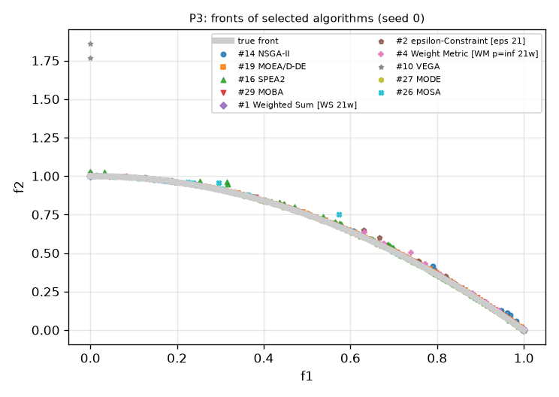
Fig. D-0: fronts of selected algorithms on P3 (seed 0).
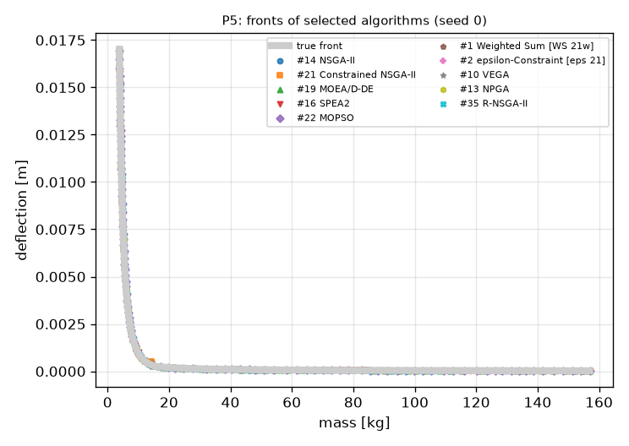
Fig. D-0b: P5.
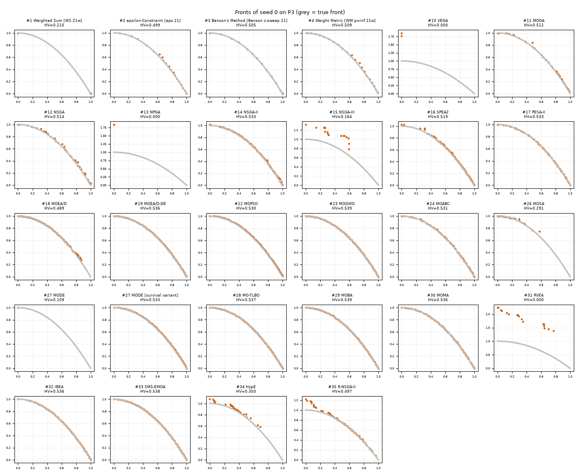
Fig. D-1a: seed-0 front of every algorithm on P3.
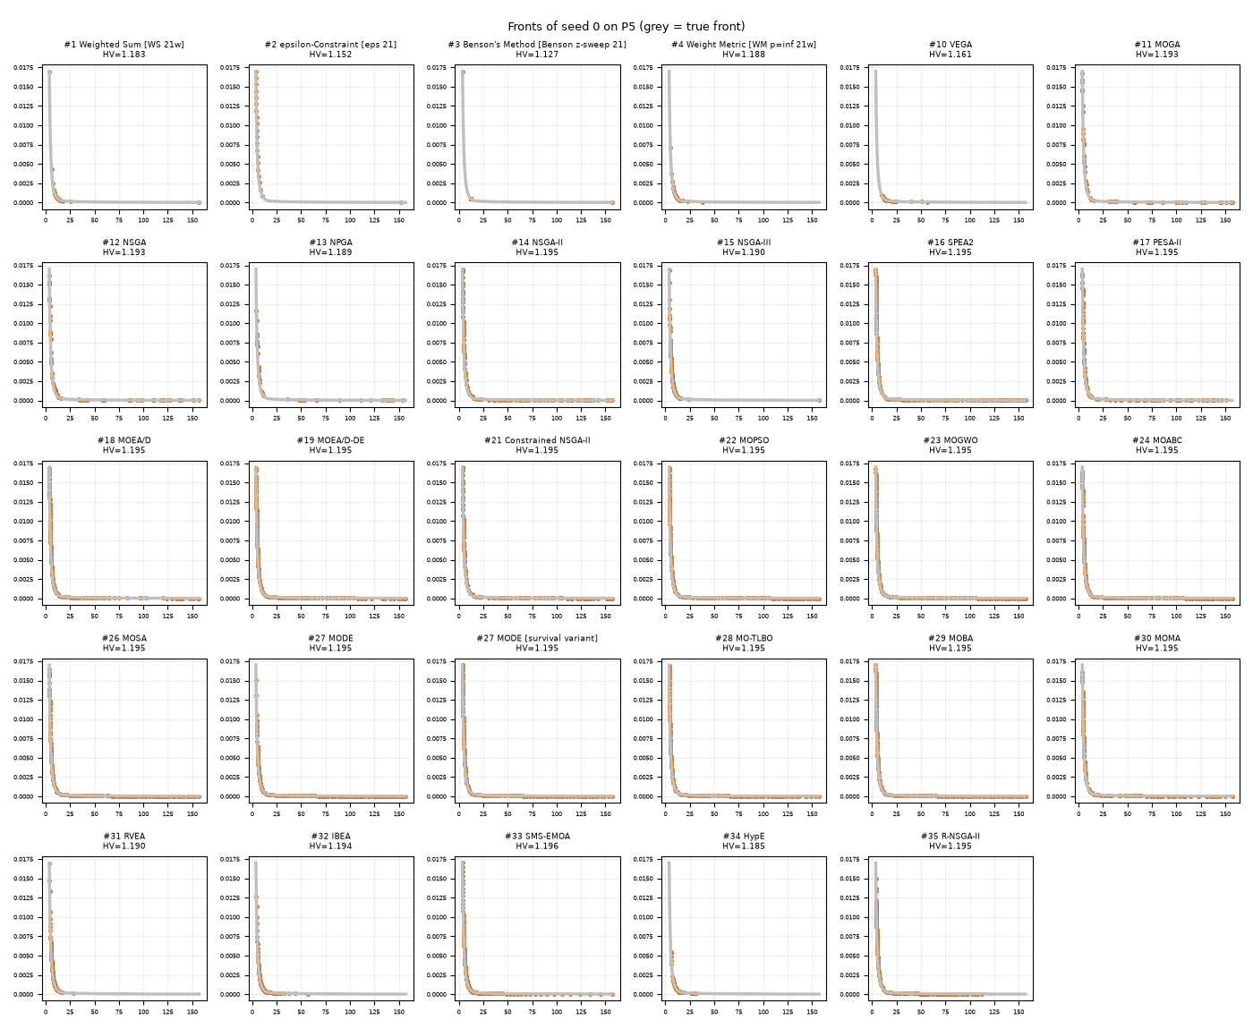
Fig. D-1b: P5.
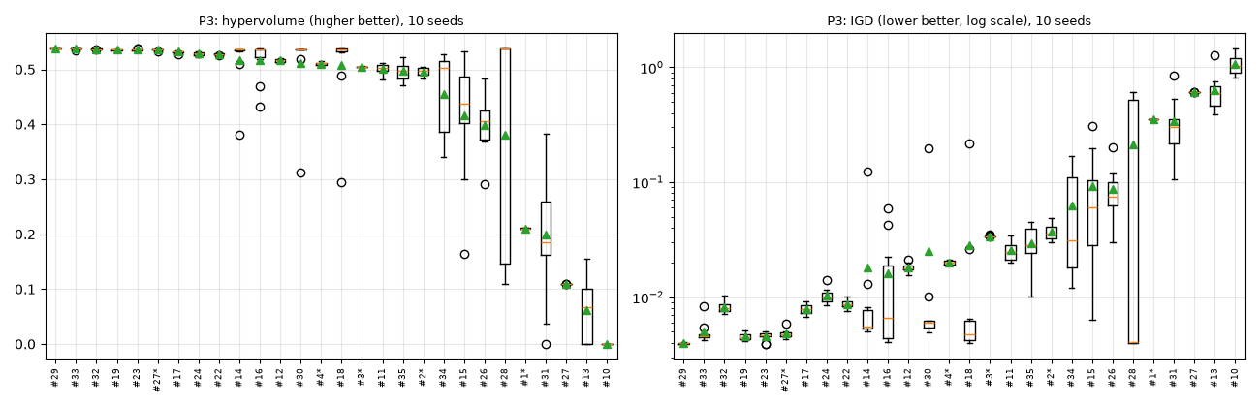
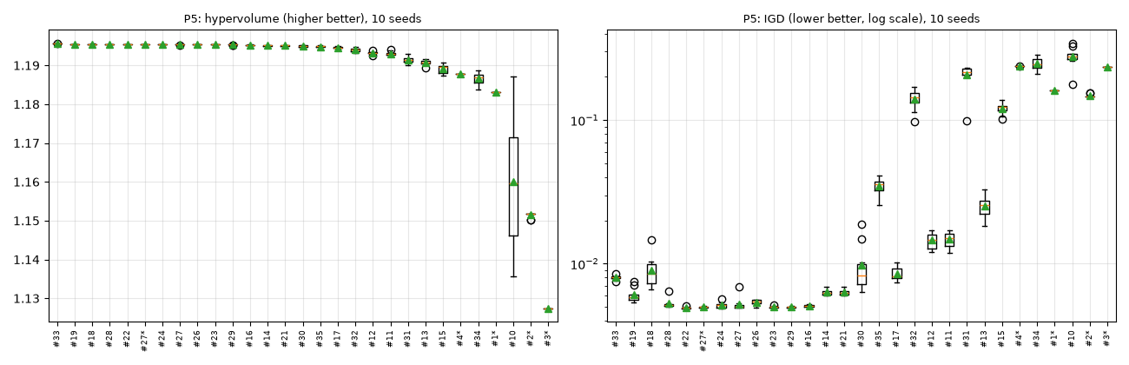
Box plots of HV and IGD over 10 seeds (* = variant).
Reading the ranking. Best combined ranks: #29 MOBA, #19 MOEA/D-DE, #27 MODE, #33 SMS-EMOA, #23 MOGWO. Worst: #34 HypE, #13 NPGA, #31 RVEA, #1 Weighted Sum, #10 VEGA. The top of the table is occupied by methods that combine a good diversity mechanism with strong variation (MOBA, SMS-EMOA, IBEA, MOEA/D-DE, MOGWO, MODE with survival); on ZDT2 differences between these are in the third decimal of HV, so ranks 1-8 are statistically close (std 0.000-0.003). The bottom is explained by mechanism: Weighted Sum reaches only the end points of a non-convex front; VEGA and NPGA never converge; RVEA keeps few sectors; the lecture-rule MODE collapses; MO-TLBO collapses in some seeds (large std). On the constrained P5 almost all methods reach HV 1.195, so IGD separates them: methods that rely on the penalty with an indicator or reference structure (IBEA, NSGA-III, HypE, RVEA) are the worst of the EAs. NSGA-II / Constrained NSGA-II give identical results on P5, as the penalty already separates feasible from infeasible points. Classical sweeps use 2-27x more evaluations (21-270k) for 11-21 points and are not better. Runtimes in this table were inflated by laptop power throttling; the clean runtimes are those of Task A.

D2 Many-objective: DTLZ2 with M = 5 (and M = 3)

M = 5 -- N = 72 (NSGA-II, NSGA-III, HypE), 70 reference vectors / weight vectors (MOEA/D, RVEA); sorted by IGD (best first)
algorithm | HV (MC) mean ± std | IGD mean ± std | Spacing mean ± std | #pts | time [s]
#31 RVEA | 0.8957 ± 0.0324 | 0.3305 ± 0.0127 | 0.1013 ± 0.0097 | 44 | 0.3
#18 MOEA/D | 0.9392 ± 0.0527 | 0.3635 ± 0.0261 | 0.1046 ± 0.0294 | 70 | 199.4
#34 HypE | 1.0791 ± 0.0510 | 0.3798 ± 0.0470 | 0.0620 ± 0.0275 | 70 | 206.2
#15 NSGA-III | 0.5299 ± 0.0951 | 0.4145 ± 0.0330 | 0.1319 ± 0.0465 | 72 | 50.1
#14 NSGA-II | 0.0796 ± 0.0434 | 0.6753 ± 0.0697 | 0.1457 ± 0.0229 | 72 | 1.1

M = 3 -- N = 92 / 91 / H = 91; sorted by IGD (best first)
algorithm | HV (MC) mean ± std | IGD mean ± std | Spacing mean ± std | #pts | time [s]
#18 MOEA/D | 0.6773 ± 0.0071 | 0.0823 ± 0.0057 | 0.0453 ± 0.0092 | 91 | 6.1
#15 NSGA-III | 0.6023 ± 0.0274 | 0.1066 ± 0.0096 | 0.0631 ± 0.0059 | 92 | 2.1
#14 NSGA-II | 0.5585 ± 0.0284 | 0.1268 ± 0.0084 | 0.0469 ± 0.0070 | 92 | 1.0
#34 HypE | 0.6940 ± 0.0063 | 0.1543 ± 0.0127 | 0.0367 ± 0.0153 | 88 | 8.0
#31 RVEA | 0.4245 ± 0.0499 | 0.1833 ± 0.0219 | 0.0412 ± 0.0093 | 53 | 0.3

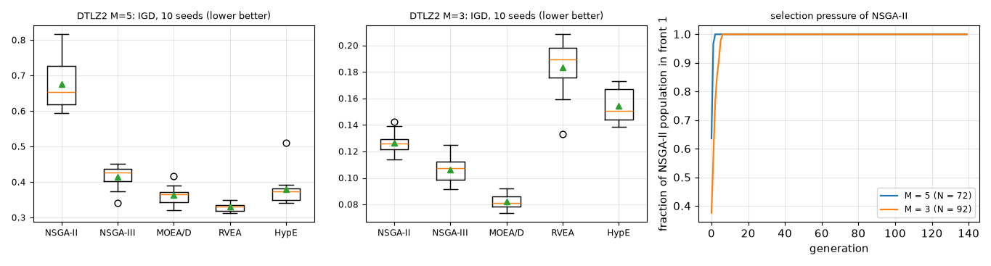
Fig. D-2: IGD of the five many-objective methods and the share of NSGA-II's population in front 1.
What degrades in NSGA-II. At M = 5 64 % of the initial population is already in front 1 and it is 100 % after 20 generations (M = 3: 38 % and 100 %). Pareto rank no longer discriminates, crowding distance rewards boundary points, and the result is the worst IGD (0.675 ± 0.070) and a hypervolume of 0.080 against 0.939 for MOEA/D. RVEA has the lowest IGD but a small, partly empty set (about 44 of 70 vectors), HypE the highest hypervolume.

D3 Discrete: bi-objective TSP (P8), permutation operators
algorithm | HV mean ± std | Spacing mean ± std | IGD* mean ± std | #pts (non-dominated tours) | time [s]
#30 MOMA | 0.7479 ± 0.0139 | 0.1083 ± 0.0219 | 0.0141 ± 0.0156 | 10.1 | 2.1
#20 MOEA/D-ACO | 0.7420 ± 0.0117 | 0.1140 ± 0.0031 | 0.0130 ± 0.0102 | 10.6 | 13.5
#14 NSGA-II | 0.7321 ± 0.0589 | 0.1010 ± 0.0347 | 0.0327 ± 0.0409 | 9.7 | 2.0
#25 MOACO | 0.5841 ± 0.1602 | 0.1555 ± 0.1263 | 0.1645 ± 0.1046 | 6.8 | 7.6

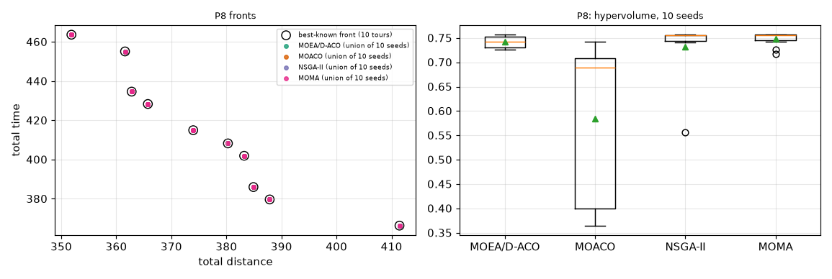
Fig. D-3: P8 fronts (union of 10 seeds) and HV box plot.
MOMA (0.748 ± 0.014) and MOEA/D-ACO (0.742 ± 0.012) find nearly the whole 10-tour front with low variance; NSGA-II is close on average but with larger variance (0.732 ± 0.059); MOACO is clearly worse and unstable (0.584 ± 0.160). Permutation operators used: order crossover + swap/inversion mutation (Section 4 evidence: P8).

D4 TOPSIS and VIKOR on the NSGA-II front of P4 (100 portfolios) and on P12
method / weights | top-3 (risk, return)
topsis w=(0.5,0.5) | (0.0132, 0.1139); (0.0132, 0.1139); (0.0139, 0.1147)
vikor w=(0.5,0.5) v=0.25 | (0.0320, 0.1329); (0.0315, 0.1326); (0.0307, 0.1320)
vikor w=(0.5,0.5) v=0.5 | (0.0320, 0.1329); (0.0315, 0.1326); (0.0307, 0.1320)
vikor w=(0.5,0.5) v=0.75 | (0.0320, 0.1329); (0.0315, 0.1326); (0.0298, 0.1315)
topsis w=(0.6,0.4) | (0.0108, 0.1091); (0.0103, 0.1079); (0.0113, 0.1100)
vikor w=(0.6,0.4) v=0.25 | (0.0271, 0.1297); (0.0263, 0.1289); (0.0256, 0.1283)
vikor w=(0.6,0.4) v=0.5 | (0.0271, 0.1297); (0.0263, 0.1289); (0.0256, 0.1283)
vikor w=(0.6,0.4) v=0.75 | (0.0230, 0.1262); (0.0217, 0.1251); (0.0263, 0.1289)
topsis w=(0.4,0.6) | (0.0160, 0.1180); (0.0145, 0.1159); (0.0166, 0.1186)
vikor w=(0.4,0.6) v=0.25 | (0.0378, 0.1361); (0.0360, 0.1353); (0.0391, 0.1366)
vikor w=(0.4,0.6) v=0.5 | (0.0378, 0.1361); (0.0393, 0.1370); (0.0360, 0.1353)
vikor w=(0.4,0.6) v=0.75 | (0.0378, 0.1361); (0.0393, 0.1370); (0.0360, 0.1353)

Moving the weight vector by 0.1 changes the top-3 of both methods (compare w = (0.5,0.5) with (0.6,0.4) and (0.4,0.6)): the ranking flips for TOPSIS and for VIKOR. On P12: TOPSIS [3, 1, 5, 2, 4] -> [3, 5, 1, 2, 4] after the shift.

D5 MGDA and GradNorm against fixed equal weights on P13
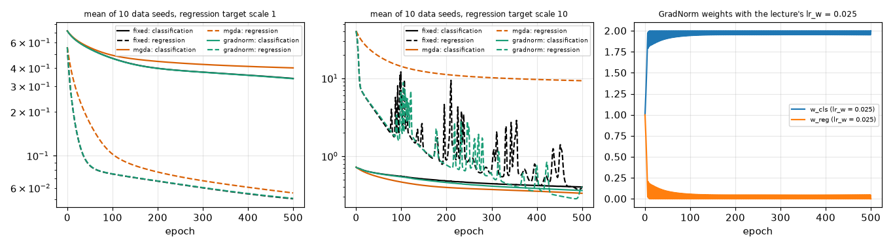
Fig. D-5: network losses (mean of 10 data seeds) and GradNorm weights with the lecture's lrw.
Toy P13(a) from (0,5): fixed equal weights end at f = [18.0, 18.0] (the middle of the segment, whatever the gradient sizes), MGDA at [0.5, 60.5] (the foot of the perpendicular on [a,b], a Pareto-stationary point), GradNorm at [5.9, 36.6]. Network, equal-size tasks (scale 1): final (classification, regression) = fixed (0.340, 0.051), MGDA (0.402, 0.055), GradNorm (0.339, 0.051). One task with ~50x larger gradients (regression target scale 10; gradient norms 0.18 vs 9.1): fixed (0.403, 0.394), MGDA (0.334, 9.320), GradNorm (0.362, 0.394). With equal weights the large-gradient task dominates; MGDA follows the small-gradient task and lets the regression loss lag; GradNorm with a small lrw keeps the regression loss equal to the equal-weight run while lowering the classification loss, whereas the lecture's lrw = 0.025 saturates the weights (Fig. D-5, right).

8 Task E — algorithm selection reasoning
Six problems (one many-objective: P10; one constrained: P5). Choices backed by our own results: P3, P5, P10, P8 and P13 (Tasks D1-D5).
problem | two suitable algorithms | one poor choice | justification (convexity, #objectives, variables, constraints, preferences, budget) and evidence
P3 ZDT2: non-convex, 2 objectives, 10 real variables, no constraints, budget 10,000 | 29 MOBA, 19 MOEA/D-DE (also 33 SMS-EMOA, 32 IBEA) | 1 Weighted Sum | The front is concave, so any weighted sum reaches only the end points (Weighted Sum: HV 0.210 ± 0.001 vs 0.538 ± 0.000 for MOBA; 8 points, 0 in the middle). Two objectives and a smooth continuous space favour population methods with a good spread mechanism; the budget is enough (D1: MOBA rank 1, MOEA/D-DE rank 4 of 28). Evidence: Task D1, Fig. E-1.
P5 beam: 2 objectives, 2 real variables, one nonlinear inequality constraint | 21 Constrained NSGA-II, 16 SPEA2 (or 27 MODE with survival) | 10 VEGA (or any method with constraints ignored) | One constraint that excludes 3 % of random designs: Deb's rules return only feasible designs (IGD 0.0063 ± 0.0003). Ignoring the stress limit lowers the 'optimal' mass from 3.85 to 1.57 kg — an unsafe beam (Fig. E-8). VEGA has neither a rule nor spread (IGD 0.2769 ± 0.0425). Evidence: Task D1 (P5) and Section 4 investigation.
P10 DTLZ2 with M = 5: many objectives, 14 real variables, budget 10,000 | 18 MOEA/D, 31 RVEA / 15 NSGA-III (with a larger budget) | 14 NSGA-II | With 5 objectives 60 % of a random population is non-dominated, so Pareto rank cannot select and crowding distance does not spread. At 10,000 evaluations the IGD ranking is RVEA 0.331 < MOEA/D 0.364 < HypE 0.380 < NSGA-III 0.415 < NSGA-II 0.675 (NSGA-III overtakes MOEA/D at 100,000 evaluations on M = 3: 0.052 vs 0.072). Evidence: Task D2, Fig. D-2.
P8 TSP: permutation encoding, 2 objectives, no constraint | 20 MOEA/D-ACO, 30 MOMA | 27 MODE (or 22 MOPSO) | Permutations need order crossover / swaps or constructive ants; continuous arithmetic (DE, PSO velocity) has no meaning. MOEA/D-ACO HV 0.742 ± 0.012, MOMA 0.748 ± 0.014, NSGA-II 0.732 ± 0.059, MOACO 0.584 ± 0.160. Evidence: Task D3.
P14 laptop: 2 objectives, DM prefers about (1.8 kg, 12 h) | 35 R-NSGA-II, 5 Value Function | 18 MOEA/D (no preference mechanism) - or a full-front method when only that region matters | A preference exists, so spend evaluations there: R-NSGA-II concentrates around the reference (centroid 1.80 kg / 14.0 h); a utility optimum needs one solve (2,776 evaluations) but gives one point only. Careful: an unattainable reference (1.2 kg, 25 h) distorts the result. Evidence: Fig. E-9.
P13 multi-task network: differentiable, shared parameters | 36 MGDA, 37 GradNorm | 14 NSGA-II (population search over network weights) | Gradients exist and the number of parameters is large (a population method would need far more than 10,000 evaluations). With tasks of very different gradient scale equal weights hurt the small-gradient task; GradNorm (small lrw) lowers the classification loss at the same regression loss: classification 0.36, regression 0.39 versus 0.40 / 0.39 (Fig. D-5).

9 Task F — viva preparation: answers to the eight sample questions
Short answers with the evidence from our own runs; the code walkthrough questions (change one line, predict the effect) are prepared through the docstrings and unit tests of each module.

1. Why can Weighted Sum never reach a dented part of a non-convex front?
A weighted sum w1f1 + w2f2 is minimised where a straight line of slope -w1/w2 first touches the feasible set from below-left. On a concave (dented) part every such line touches an end point first, so no weight selects an interior point: ZDT2 with 21 weights gave only end points, 0 points in the middle, HV 0.210 versus 0.538 (Fig. E-1).

2. Why did VEGA collapse towards the extremes in your run?
Each sub-population is selected by one objective only, so a balanced compromise (average in both objectives) is never the best for any single one and is selected by nobody; repeated generations amplify the extremes. ZDT2: 2.0 non-dominated points, HV 0.000 (Fig. A-10). It has no elitism either.

3. What does elitism guarantee, and which of your algorithms have it?
That a non-dominated solution once found is not lost: the next population is chosen from parents plus offspring (or an archive), so the best front is monotone (HV non-decreasing for archive methods). Elitist: 14, 15, 16, 17, 18, 19, 20, 21, 22, 23, 24, 25, 26 (archive), 27, 28, 29, 30, 31 (per sector), 32, 33, 34, 35. Non-elitist: 10 VEGA, 11 MOGA, 12 NSGA, 13 NPGA (we report the final population only). RVEA and HypE can keep a dominated point but never lose the best of a sector / front.

4. Why does crowding distance stop working well with many objectives, and what replaces it?
With k = 5, 60 % of a random population is non-dominated (k = 2: 5 %), so after a few generations the whole population sits in front 1 (NSGA-II: 100 % at generation 20) and the only remaining criterion, crowding, rewards boundary points and does not push to the front. Reference points / vectors (NSGA-III, RVEA, MOEA/D) or indicators (IBEA, SMS-EMOA, HypE) replace it; NSGA-II IGD 0.675 vs 0.415 (NSGA-III).

5. Which of your algorithms needs a preference from the decision maker, and what happens if it is wrong?
5 Value Function (utility), 6 Goal Programming (targets), 7 Lexicographic (priorities), 3 Benson (reference point), 35 R-NSGA-II (reference point), 8/9 TOPSIS/VIKOR (weights, v), and weighted-sum-type methods (weights). Wrong preference: P4 with risk aversion 5 / 10 / 20 moves the portfolio from return 0.107 to 0.096; an unattainable R-NSGA-II reference collapses the population to one end; a 0.1 weight shift flips the TOPSIS winner on P12.

6. Explain Deb's three constraint rules with one numerical example.
Rule 1: feasible beats infeasible; rule 2: two feasible points compare by Pareto dominance; rule 3: two infeasible points compare by smaller total violation CV. Example (lecture): A(3,6), D(4,5) feasible; B(1,2) CV 2, C(0.5,1) CV 5. A and D dominate B and C although B, C have better objectives; A vs D is a trade-off; B dominates C (CV 2 < 5) although C's objectives are better. On Binh-Korn: (0,0) is feasible with CV 0.0, (3.2,0.5) has CV 0.00, (5,0.2) has CV 0.00: the feasible point beats both, and between the infeasible ones the smaller CV wins. Without rules NSGA-II returned 1 % infeasible points.

7. How would you detect that your algorithm has prematurely converged?
Track the hypervolume of the current front against evaluations (Fig. E-3): a plateau far below the reachable value (MODE lecture rule stays at 0.11 while NSGA-II reaches 0.53), and a collapsing spread (f1-range of the archive [0.0, 0.0], Spacing NaN), or population variance going to zero.

8. Why do TOPSIS and VIKOR not count as optimisers?
They never search the decision space: they only rank alternatives that already exist (a matrix). They cannot create a better point, their output depends on the supplied front and on the weights (a 0.1 shift changes the order on P12), and they have no objective function to improve.

Appendix A — How to reproduce
python3 run_all_tests.py (67 tests, 3 hand traces) · python3 build_refs.py · python3 experiments/run_taskA.py [p9] · run_taskA_special.py · run_evidence.py · run_taskC.py · run_taskD.py · make_figures_D.py / make_figures_E.py / make_flow.py · report/build_report.py. Seeds: Task A seed 0, Tasks C/D seeds 0-9, reference fronts seeds 0-4; P8 data numpy seed 7. The raw numbers behind every table and plot are in results/*.json (taskA, taskA_p9, taskA_special, evidence, taskC, taskD, handtrace) and the reference fronts in results/ref/.

Appendix B — Deliberate deviations from the lecture versions and known limitations
alg | what we do | why
1, 4 | objectives scaled by (nadir - ideal) before weighting (normalize = True); raw units available (normalize = False) | the lecture lists scale-sensitivity as a weakness; we measure it (Task B) but use the fair version in comparisons
3 | reference-point form of the lecture (maximise Σλs, s ≥ 0); two sweeps: λ and z* | the lecture's form equals a box-constrained weighted sum, so z* must move to reach non-convex parts
5 | utilities are our stand-ins for an elicited decision maker (mean-variance utility for P4, target-closeness for P14) | no real DM available
6, 7 | own simplex LP (Bland's rule), deviation variables as LP columns | scipy.linprog not used
12 (NSGA) | dummy fitness of front r+1 = 0.9 x smallest shared fitness of front r (Srinivas-Deb) instead of a fixed ΔF | keeps the front order whatever the niche counts
13 (NPGA) | lecture variant: the two candidates are compared with each other; the comparison set (10 % of N) only measures niche counts | as on lecture slide 27; Horn's original compares both against the set
15 | extreme-point normalisation (paper) by default; 'max' normalisation (5E) for the hand trace; Das-Dennis p = 12 / 4 for k = 3 / 5 (single layer) | hand trace must be checkable by pencil
20, 25 | simplified ant models: one ant per sub-problem (20); deposit = Q/(f/fNN)/#depositors, τ clipped (25) | stability within 10,000 evaluations
21 and others | algorithms other than 21 use an exact-style penalty S = F + 1000 · CV · (nadir - ideal); 21 uses Deb's rules; 'ignore' mode exists for the experiment | so that every algorithm can run on constrained problems
22 | leader = archive member picked by a crowding-distance tournament (Coello's adaptive grid not used); w = 0.4 | lecture says crowding distance
26 (MOSA) | 10 independent walkers share one archive; objectives normalised, T0 = 1, geometric cooling to 10⁻³; chains = 1 gives the lecture algorithm | one walker cannot cover a front in 10,000 evaluations
27 (MODE) | default = lecture rule; selection = 'survival' is an extra variant for the comparison | to show the collapse and its cure
31 (RVEA) | penalty form of the 5E slide, 1 + α(t/tmax)θ/γ, α = 2 (the paper uses M (t/tmax)^{α}) | follow the lecture; we checked the paper's form too: IGD 0.145 vs 0.174 (M = 3)
32 (IBEA) | paper's fitness F(x) = Σy -exp(-I(y,x)/κ), delete the smallest; objectives normalised; κ = 0.05 | the lecture's dual form reproduces the slide numbers (unit test) but collapses in practice
33, 34 | hypervolume contributions exact for k = 2, Monte-Carlo (20,000 / 2,000 samples) otherwise; HypE shares each sample equally among its dominators (no αi weights) | as on the 5E slides
35 | NSGA-II fronts first, eps-clearing order replaces crowding in the last front; eps = 0.01 (normalised) | lecture eps = 0.15 is for 6 points
37 | in the network experiment lrw = 0.001 (the lecture's 0.025 saturates the weights because the gradient norms are 50x larger); both are reported | see Task D5
P8, P9, P4-P6 | IGD uses a best-known front (dense sampling for P4-P6, pooled long runs for P8, P9; marked *) | no closed form
P9 | features standardised with full-data mean / std (a mild leakage into the CV estimate that is the same for every algorithm) | simplicity
Hypervolume | Monte-Carlo (200,000 fixed samples) for k ≥ 3 | allowed by the lab sheet; ± 0.003 sampling error

