OPTIMIZATION TECHNIQUES | LAB ASSIGNMENT

Assignment 8: Optimize Anything
14-Day Vibe-Coding Challenge: Technical Report
Main case study (Track E): university exam timetabling
All ten compulsory tracks A–J, completed in a reduced 5-day scope
Name: ______________________________
Roll number: ______________________
Repository: https://github.com/<your-username>/ot_lab8
Date: November 2026

Contents
1. Introduction and scope
Hardware and software
How the brief's problem-solving process (Section 4) was applied
2. Main case study (Track E): university exam timetabling
2.1 Problem statement and evidence
2.2 Mathematical formulation and assumptions
2.3 Baseline and methods
2.4 Results
2.5 Strategy selection
2.6 Correctness
2.7 Limitations
3. Experiment tracks A–J
A. Continuous optimization
B. Discrete optimization
C. Quantum optimization, all simulated
D. Submodular, parallel and distributed
E. Main case study: exam timetabling
F. Compiler optimization
G. xv6 operating system
H. DBMS: index selection
I. Quantum algorithms and QML, all simulated
J. Software engineering: test-suite minimization
4. Answers to the final questions (brief Section 11)
5. Chapter 6 coverage checklist
6. Responsible AI use (brief Section 8)
6.1 AI tools register
6.2 Prompt logs and commit traceability
6.3 External code and libraries
6.4 Failure log: AI-generated code that was wrong, unsafe, inefficient or misleading
6.5 Tool comparison
7. Limitations, trade-offs and next steps
7.1 Self-review
7.2 Main trade-offs found
7.3 Next steps
8. Reproducibility
Setup
Running each track
Appendix: key plots

Right-click the table and choose “Update Field” if the page numbers are missing.

1. Introduction and scope
All ten tracks (A–J) were completed in a reduced 5-day scope instead of 14 days (see plan.md, "Scope"): every track has an objective, a baseline, a fair comparison, a correctness check and results tables, but sizes are small and some optional extensions were skipped (listed per track under Limitations). Every number in this report comes from a file in results/; each track's README has the full tables and how to reproduce them.
- Hardware: Apple M4 (10 cores: 4 performance + 6 efficiency), 16 GB RAM, macOS 26.6.2. Python 3.12.
- Labels: quantum results are simulated (no quantum hardware was used). Parallel timings in Track D are measured on the M4. FedAvg and multi-task runs are simulated on one machine. xv6 results are measured in QEMU.
- Reproduce: python trackX_*/run.py per track; pytest runs the tests for all tracks.

Hardware and software
- Apple M4 (10 cores: 4 performance + 6 efficiency), 16 GB RAM
- macOS 26.6.2
- No GPU or quantum hardware; quantum results are from simulators.
Software: Python 3.12 (Homebrew, arm64), NumPy, SciPy, PyTorch, PuLP 2.9 (CBC), Qiskit 2.6 + Aer, PennyLane, dwave-neal, minorminer, DuckDB, SQLite, QEMU + riscv64-elf-gcc. Exact versions are in requirements.txt.

How the brief's problem-solving process (Section 4) was applied
step | how it was done
1. Discover the process | Each track starts from a measured inefficiency (Section 4, question 1)
2. Establish the baseline | Every track has a named baseline measured on the same hardware and data (first-fit, round-robin, no-index SQLite, O0 IR, full test suite, plain GD, greedy, …)
3. Formulate the problem | Decision variables, objective and constraints are stated per track (Section 2 for the case study, Section 3 for the others)
4. Select the method | Strategy-selection tables in Section 2.5 (case study) and Track D (Chapter 6 methods)
5. Use vibe coding | Claude Code generated the code; every prompt, revision and fix is logged (Section 6)
6. Experiment and compare | Fair comparisons: same data, budget, tuning grid and hardware; repeated runs for stochastic methods
7. Analyze trade-offs | Each track reports its trade-offs and negative results; summary in Section 7

2. Main case study (Track E): university exam timetabling
Code: trackE_case_study/timetabling.py, e_experiments.py · Results: results/trackE_case_study/ · Tests: tests/test_trackE.py

2.1 Problem statement and evidence
Every term, a registry office has to place each course's exam in a time slot and a room. When it is done by hand, courses are typically taken from a list and put into the first slot that still works. That is our baseline: first-fit in course-list order. It produces a valid timetable, but (results below) it needs up to 3 more slots than necessary (each slot is an extra half-day of rooms and invigilators) and leaves hundreds of students with two exams back to back on the same day. The domain (education/transport-style timetabling) is different from Tracks F–J.

2.2 Mathematical formulation and assumptions
Data (timetabling.make_instance, seeded, synthetic; no real enrolment data was available):
- N courses (20 or 40), 15·N students. Each student belongs to a department of 5 courses and takes 3–5 courses, 97% of them from their own department.
- Course popularity is skewed (Zipf-like), so a few courses are large.
- 4 rooms with capacities 100% / 60% / 40% / 25% of the largest course.
- 3 slots per day.
- Resulting conflict density (share of course pairs that share a student): see e_instances.csv.
Decision variables (ILP form, timetabling.ilp):
- x[c,t,r] ∈ {0,1}: course c's exam is in slot t, room r (only rooms large enough for c are created)
- y[t] ∈ {0,1}: slot t is part of the exam period (y[t] ≥ y[t+1], so the period is a prefix of slots)
- b[c,d,t] ≥ 0: conflicting courses c and d are in consecutive same-day slots t and t+1
Objective: minimize 20 · (number of slots in the period) + (number of student back-to-backs)
Hard constraints
- every course is scheduled exactly once
- no student has two exams in the same slot (conflicting courses get different slots)
- the room fits the course's enrolment
- a room holds one exam per slot
- exams only in slots inside the period
Soft constraint (in the objective): back-to-back exams, meaning a student has exams in slots t and t+1 on the same day.
Assumptions (stated rather than invented as facts):
- One slot costs as much as 20 back-to-backs. This is a policy weight, so it is a parameter (SLOT_WEIGHT).
- An exam is not split across rooms.
- Every slot has the same 4 rooms.
- Overnight gaps don't count as back-to-back.
Success metrics: period length (slots), back-to-backs, the combined objective, hard-constraint violations (must be 0, from an independent checker), and runtime.

2.3 Baseline and methods
method | idea | file
first-fit (baseline) | courses in list order, earliest slot with no clash and a free room that fits | first_fit
DSATUR | graph colouring: next course = the one whose conflicting courses already use the most distinct slots; lowest feasible slot | dsatur
DSATUR b2b-aware | same order, but choose the open slot that adds the fewest back-to-backs | dsatur(b2b_aware=True)
DSATUR b2b + local search | then hill-climb: swap two whole slots, or move one course, whenever back-to-backs drop | local_search
ILP (CBC) | the model above, warm-started from local search, time limit 60 s (20 courses) / 120 s (40 courses) | ilp

Lower bound on the period: max(largest clique of conflicting courses, ⌈N / rooms⌉), computed with networkx.

2.4 Results
Instances (e_instances.csv): 20 courses / 300 students / ~1,200 enrolments (conflict density 0.72–0.77), and 40 courses / 600 students / ~2,400 enrolments (density 0.49–0.57). Every timetable below has 0 hard-constraint violations according to the independent checker.
Main table (e_summary.csv, mean ± std over 3 seeded instances; objective = 20·slots + back-to-backs; lower is better)
courses | method | slots | back-to-backs | objective | vs baseline | runtime
20 | first-fit (baseline) | 12.3 ± 0.6 | 175 ± 29 | 421.7 ± 38.6 | — | 0.3 ms
 | DSATUR | 11.7 ± 1.2 | 248 ± 15 | 481.7 ± 23.2 | +14% (worse) | 0.3 ms
 | DSATUR b2b-aware | 11.3 ± 0.6 | 163 ± 43 | 390.0 ± 53.0 | −8% | 0.3 ms
 | DSATUR b2b + local search | 11.3 ± 0.6 | 51 ± 20 | 277.7 ± 18.9 | −34% | 40 ms
 | ILP (CBC, 60 s limit) | 12.0 ± 1.0 | 22 ± 9 | 262.0 ± 15.6 | −38% | 59 s
40 | first-fit (baseline) | 20.7 ± 2.1 | 183 ± 65 | 596.7 ± 52.2 | — | 1 ms
 | DSATUR | 19.7 ± 0.6 | 324 ± 161 | 717.0 ± 152.2 | +20% (worse) | 1 ms
 | DSATUR b2b-aware | 20.3 ± 0.6 | 208 ± 145 | 615.0 ± 136.2 | +3% | 2 ms
 | DSATUR b2b + local search | 20.3 ± 0.6 | 14 ± 6 | 420.7 ± 12.0 | −29% | 0.44 s
 | ILP (CBC, 120 s limit) | 19.3 ± 0.6 (= lower bound on every seed) | 16 ± 7 | 403.0 ± 4.4 | −32% | 115 s

Plot: e_objective.png. Per-instance rows: e_results.csv.
- Evidence that the process needed optimization: the list-order baseline leaves 175–183 student back-to-backs
and uses up to 3 slots more than the lower bound (e_results.csv, 40 courses seed 2: 23 slots vs bound 20).
The optimized timetables cut back-to-backs by 87% (ILP, 20 courses) to 92% (local search, 40 courses) and the combined objective by 32–38%.
- Plain DSATUR is worse than the baseline here. It is the textbook colouring heuristic, but it minimizes slots by
packing courses tightly, which creates more back-to-backs (248 vs 175), and it barely shortens the period. The
lower bound explains why: at 40 courses the binding limit is rooms, not clashes. The room bound (courses that
only fit the 1, 2, … largest rooms) is 19–20 slots, while the largest clique is only 9–11. DSATUR orders courses by
clashes and ignores room sizes. (First-fit happened to reach the bound, 19, on seed 0.)
- Local search is the most cost-effective step: it takes 40–440 ms and gets within 4–6% of the ILP's objective.
- ILP: 1,500–7,200 binary variables and 4,000–21,000 constraints. CBC never proved optimality within the time
limit (status "Solution Found" on all 6). Still, it beat local search on every instance by trading slots against
back-to-backs: at 20 courses, seed 0, it uses 13 slots with 20 back-to-backs (280) instead of 12 slots with 42
(282). At 40 courses it hit the lower bound on the period on all 3 seeds, so its slot count is provably optimal.
- Scaling (e_scaling.csv, seed 0, heuristics only):
courses | first-fit | DSATUR b2b + local search | back-to-backs (FF → LS) | slots (FF / LS / bound)
80 | 3 ms | 1.4 s | 94 → 20 | 26 / 26 / 20
160 | 12 ms | 11.7 s | 152 → 0 | 47 / 48 / 40

The ILP already needs its full 2-minute limit at 40 courses, so at 80+ courses only the heuristics are practical.
Local search grows roughly as N² per round (every course × every slot, each re-checked).
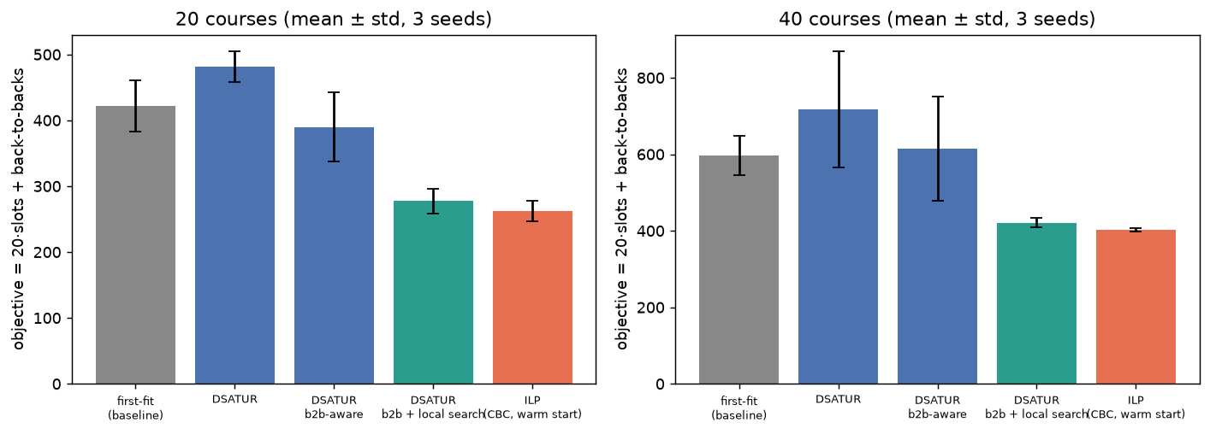
Figure 1: Objective per method, mean ± std over 3 seeds (results/trackE_case_study/e_objective.png)

2.5 Strategy selection
method | variable type | problem size it suits | exact / heuristic | hardware | parallelism
first-fit | discrete assignment | any (O(N·T)) | heuristic, order-dependent | any CPU, < 1 ms | none needed
DSATUR (+ b2b) | discrete (graph colouring) | thousands of courses (O(N²)) | heuristic; exact on some graph classes only | CPU, ms | none needed
local search | discrete, moves on a feasible timetable | large; cost per round O(N·T) checks | heuristic (local optimum) | CPU | restarts run in parallel trivially
ILP (CBC) | binary x, y; continuous b | small: about 20–40 courses within minutes | exact, with a proof of optimality only if it finishes | CPU; one thread here; commercial solvers parallelize branch-and-bound | parallel tree search
(not used) QUBO / annealing | binary | tens of courses (Track C: embedding blows up) | heuristic | annealer / simulator | —
(not used) continuous methods (Track A) | — | — | not applicable: variables are discrete and constraints combinatorial | — | —

Choice for this problem: variables are binary and the constraints are combinatorial, so continuous methods (Track A) don't apply. At registry scale (hundreds of courses), DSATUR or first-fit followed by local search is the practical method: it runs in seconds and gets within ~5% of the ILP. Use the ILP for small instances, or to check heuristics and give a bound. A QUBO/annealer version would need penalty terms for every hard constraint, and Tracks B and C showed that large penalties hurt annealing and that dense QUBOs over ~35 variables don't embed on Chimera.

2.6 Correctness
tests/test_trackE.py (all passing):
- Independent checker: check() recomputes every hard constraint from the raw enrolment lists, without the conflict graph or any solver code. A planted student clash, room overflow, double-booked room and missing course are each detected.
- Every heuristic is feasible on 4 instances (20–80 courses), and the period is never below the lower bound.
- Local search never makes the period or the back-to-back count worse.
- On two tiny instances (5 courses, 2 rooms), the ILP's optimum equals brute force over all 5⁵ slot assignments. The ILP's own objective equals the checker's, which confirms the pair-based back-to-back count in the model.
- Every reported timetable in e_results.csv has 0 violations, according to the checker.

2.7 Limitations
Synthetic data: the structure (departments, Zipf popularity) is plausible, but it is not a real registry. One room per exam; no invigilator or student-preference constraints; slot weight 20 is a policy choice; the ILP is run with a time limit, so it is not always proven optimal; CBC is single-threaded here.

3. Experiment tracks A–J
Each subsection summarizes one compulsory track: its objective, baseline, results and correctness check. It links to the code folder and the result files. The full tables are in each track's README.md.

A. Continuous optimization
Code: trackA_continuous/ · Results: results/trackA_continuous/ · Tests: tests/test_trackA.py
Objective: compare GD, SGD, mini-batch SGD, Momentum, NAG, AdaGrad, RMSProp, Adam, Newton and Gauss–Newton on convex and non-convex objectives. Baseline: plain GD. Every method gets the same start, budget, tolerance and learning-rate grid.
result | evidence
Ill-conditioned quadratic (κ = 100): GD 1859 iterations, NAG 246, AdaGrad 20, Newton 1 | a1_landscapes.csv
Rosenbrock: Momentum 1277, Adam 1230, Newton 6; GD not converged in 5000 | a1_landscapes.csv
Saddle function: Newton converges to the saddle (0, 0); every first-order method reaches a minimum | a1_saddle.png
Noisy gradients (10 epochs, 5 seeds): mini-batch Adam 5.0e-5 ± 9.6e-6; full-batch GD 0.254 | a1_stochastic.csv
Hand-written backprop = PyTorch autograd to 2.8e-17; HVP = H·v to 2e-15 | a2_*.csv
Convex O(1/k) (slope −0.84) vs strongly convex linear rate (ρ = 0.975) | a2_convergence.png

Trade-off: second-order methods converge in a few steps but need the Hessian and are attracted to saddle points. Diagonal preconditioning reduced the condition number from 10,597 to 1,540, but GD still converged faster. Eigen-analysis explained why: the error had no component along the slowest directions. Correctness: finite-difference gradient and Hessian checks, plus a check against SciPy.

B. Discrete optimization
Code: trackB_discrete/ · Results: results/trackB_discrete/ · Tests: tests/test_trackB.py
Objective: compare greedy, DP, Branch-and-Bound and ILP; formulate QUBO/Ising models with penalty terms. Baseline: greedy (and brute force for verification).
result | evidence
Knapsack: DP = B&B = ILP optimum always; greedy gap ≤ 2.74% (n = 10), 0.10% mean at n = 200 | b1_knapsack_summary.csv
B&B explores ~760 nodes at n = 200; ILP ~20 ms, mostly CBC start-up | same
Feature selection: greedy 6–16× cheaper, misses the optimum at k = 3 (0.939 vs 0.950) | b1_feature_selection.csv
Max-Cut QUBO = −cut = Ising energy on all bitstrings; SA ratio 1.00 for n ≤ 12 | b2_maxcut.csv
Penalty too large (P ≥ 5) drops SA success to 0–5% | b2_feature_qubo_penalty.csv

C. Quantum optimization, all simulated
Code: trackC_quantum_opt/ · Results: results/trackC_quantum_opt/ · Tests: tests/test_trackC.py
result | evidence
QAOA Max-Cut ratio 0.778 → 0.851 → 0.918 (p = 1, 2, 3; 6 nodes); simulated annealing gets 1.00 | c1_qaoa.csv
Noise erases the gain from depth: 8 nodes, p = 1/2/3 → 0.787 / 0.810 / 0.811 | c1_noise.csv
Shot noise follows 1/√shots (std 0.164 / 0.047 / 0.011) | c1_shots.csv
VQE H₂: exact (4e-8 Ha) ideal; 28.6 mHa error with noise (chemical accuracy 1.6 mHa) | c1_vqe.csv
Parameter-shift = autodiff to 3.5e-16; SPSA loss 0.239 vs 0.200 at equal circuit budget | c2_classifier.csv
QNG vs GD: tie at 6 steps once both step sizes are tuned | c2_qng.csv
Barren plateau: gradient variance 0.087 → 0.0022 (2 → 10 qubits, deep circuits) | c2_barren_plateau.png
K₃₆ fails to embed on Chimera C8 (512 qubits); Pegasus needs 166 qubits | c2_embedding.csv

D. Submodular, parallel and distributed
Code: trackD_submodular_parallel_distributed/ · Results: results/trackD_submodular_parallel_distributed/ · Tests: tests/test_trackD.py
result | evidence | label
Coverage objective: 0 diminishing-returns violations, greedy ratio 1.00. Pair-bonus objective: 14.3% violations, ratio 0.61 (below 1 − 1/e) | d1_submodular.csv | measured
120 uneven SHA-256 tasks, 10 threads: static 5.51×, LPT 6.80×, central queue 6.81×, work stealing 6.71× | d1_scheduling.csv | measured
Amdahl serial fraction ≈ 0.05 (LPT); Gustafson scaled speedup 6.96 at p = 10 | d1_gustafson.csv | measured
20,000 tiny tasks: 0.37–0.50× (slower than serial) at 4–10 threads | d1_overhead.csv | measured
Lock contention 69.6 vs 13.7 ms; column-wise access 2.6× slower than row-wise | d1_sync_locality.csv | measured
Pipeline bubble 50% → 3% with 32 micro-batches | parallelism_demo.py output | simulated
FedAvg: E = 1/5/20 local epochs → 34/7/2 rounds to 98% of centralized; non-IID slower | d2_fedavg.csv | simulated
Multi-task: normalized MGDA best on both tasks (MSE 69.7, accuracy 0.979); raw MGDA neglects the large-loss task | d2_multitask.csv | measured (CPU)

E. Main case study: exam timetabling
Code: trackE_case_study/ · Results: results/trackE_case_study/ · Tests: tests/test_trackE.py
This is the main case study; the full write-up is Section 2. Summary:
Process: placing each course's exam in a slot and a room so that no student has two exams at once. The baseline mimics a manual registry: first-fit in course-list order. Data: seeded synthetic enrolments, 20 and 40 courses (300 / 600 students), 4 rooms, 3 slots per day. Formulation:
- variables: binary x[c,t,r] (course in slot and room), y[t] (slot is in the period), b[c,d,t] (back-to-back pairs)
- minimize 20·slots + student back-to-backs
- hard constraints: every course once, no student clash, room capacity, one exam per room per slot
Methods: first-fit (baseline), DSATUR, DSATUR b2b-aware, DSATUR + local search, ILP (CBC, warm start, time limit).
40 courses, 3 seeds (e_summary.csv) | slots | back-to-backs | objective | runtime
first-fit (baseline) | 20.7 ± 2.1 | 183 ± 65 | 596.7 ± 52.2 | 1 ms
DSATUR | 19.7 ± 0.6 | 324 ± 161 | 717.0 ± 152.2 (worse) | 1 ms
DSATUR b2b + local search | 20.3 ± 0.6 | 14 ± 6 | 420.7 ± 12.0 (−29%) | 0.44 s
ILP (120 s limit) | 19.3 ± 0.6 = lower bound | 16 ± 7 | 403.0 ± 4.4 (−32%) | 115 s

At 20 courses, the ILP objective is 262.0 vs the baseline's 421.7 (−38%).
Findings:
- Plain DSATUR packs courses tightly and creates more back-to-backs. It doesn't shorten the period either, because rooms are the binding constraint (room bound 19–20 slots vs largest clique 9–11).
- Local search does most of the work in under a second.
- The ILP never proved optimality within the limit, but its period matched the lower bound on all 40-course seeds.
- At 160 courses only the heuristics are practical (local search 11.7 s, 152 → 0 back-to-backs).
Correctness: an independent checker validates all hard constraints from the raw enrolment lists (0 violations everywhere), and the ILP equals brute force on tiny instances. The strategy-selection table is in the track README, §5.

F. Compiler optimization
Code: trackF_compiler/ · Results: results/trackF_compiler/ · Tests: tests/test_trackF.py
Built: lexer, parser, three-address IR, CFG + liveness, interpreter, and 6 passes (constant folding/propagation, CSE, strength reduction, DCE, LICM, copy coalescing). Baseline: unoptimized (O0) IR, run on the same interpreter.
result | evidence
Executed instructions −11% (primes) to −47% (sum_squares) over 8 programs; same output on all | f1_O0_vs_opt.csv
Passes enable each other: folding, CSE and strength reduction give 0 change alone | f1_pass_ablation.csv
Register allocation: greedy colouring = ILP optimum in 30/32 cases (0.02 ms vs 14–53 ms) | f2_regalloc.csv
Pass ordering: exhaustive best 44,097 vs original order 44,109; greedy order construction picks the worst (44,697) | f2_pass_ordering.csv

Correctness: differential fuzzing found 0 mismatches in 2,000 random programs. The fuzzer was checked by planting two bugs, which it caught in 49% and 35% of programs.

G. xv6 operating system
Code: trackG_xv6/ · Results: results/trackG_xv6/ · Tests: tests/test_trackG.py
Implemented: a 3-level MLFQ scheduler (slices 1/2/4 ticks, demotion, preemption by higher levels, a priority boost every 40 ticks) plus a waitstat system call that returns each child's turnaround, response and run ticks. Baseline: stock round-robin (RR). Measured in QEMU.
workload (6 interleaved repeats, 1 CPU) | RR | MLFQ
interactive jobs' turnaround (mixed workload) | 33.0 ticks | 13.0
CPU-bound jobs' turnaround | 109.8 | 110.1
short jobs behind a long one | 22.4 | 26.0 (worse)
4 equal jobs (fairness, Jain index) | 0.9999 | 0.9991

Longer slices (2/4/8) help short jobs (23.0) but double interactive response time (3 → 6 ticks), the classic trade-off. Correctness: usertests -q ALL TESTS PASSED under both schedulers on 3 CPUs; both build with -Werror.

Patch excerpt (trackG_xv6/mlfq_scheduler.patch)
The patch changes 13 files against xv6-riscv commit e93dabe: Makefile, kernel/defs.h, kernel/param.h, kernel/proc.c, kernel/proc.h, kernel/pstat.h, kernel/syscall.c, kernel/syscall.h, kernel/sysproc.c, kernel/trap.c, user/schedbench.c, user/user.h, user/usys.pl. Below is the core of the policy: the timer-interrupt hook that demotes a process that used its whole slice, and preempts it early when a higher-priority process is runnable.
// Called from the timer interrupt for the process running on this CPU.
// Charges it one tick and returns 1 if it should give up the CPU now.
int
sched_tick(void)
{
struct proc *p = myproc();
int give_up = 1; // round-robin: preempt on every tick
acquire(&p->lock);
p->rtime++;
#ifdef SCHED_MLFQ
int mylevel = p->level;
p->slice_used++;
if (p->slice_used >= mlfq_quantum[p->level]) { // used its whole slice: demote
if (p->level < NMLFQ - 1)
p->level++;
p->slice_used = 0;
give_up = 1;
} else {
give_up = 0;
}
release(&p->lock);
// Preempt early if a higher-priority process is waiting (e.g. an I/O-bound process just woke up).
// Unlocked reads: only a hint, the scheduler re-checks under the lock.
if (!give_up) {
for (struct proc *q = proc; q < &proc[NPROC]; q++) {
if (q != p && q->state == RUNNABLE && q->level < mylevel) {
give_up = 1;
break;
}
}
}
return give_up;
#else
release(&p->lock);
return give_up;
#endif
}

H. DBMS: index selection
Code: trackH_dbms/ · Results: results/trackH_dbms/ · Tests: tests/test_trackH.py
Setup: SQLite, TPC-H scale factor 0.1, 8 queries, 13 candidate indexes. Baseline: SQLite's default optimizer with no indexes: 1,006 ms. Formulation: 0/1 knapsack (benefit vs size under a storage budget), solved with greedy, DP and ILP.
budget | knapsack (greedy = DP = ILP unless noted) | measured greedy
10% (5 MB) | 1.08× | 1.36×
25% (13 MB) | 2.20× | 2.18×
50% (25 MB) | greedy 3.11×, DP = ILP 3.04× | 2.97×
all 13 | 4.93×

Finding: benefits don't add up. orders(o_orderdate) alone makes Q10 hit the 5 s cap (normally 0.17 s), but it becomes useful once lineitem(l_orderkey) also exists. Correctness: every query returns an identical result hash in every configuration.

Query plans for Q10 (results/trackH_dbms/h_query_plans.txt)
No indexes (baseline): SQLite builds temporary automatic indexes and Bloom filters.
SCAN nation
BLOOM FILTER ON customer (c_nationkey=?)
SEARCH customer USING AUTOMATIC COVERING INDEX (c_nationkey=?)
BLOOM FILTER ON orders (o_custkey=?)
SEARCH orders USING AUTOMATIC PARTIAL COVERING INDEX (o_custkey=?)
BLOOM FILTER ON lineitem (l_orderkey=? AND l_returnflag=?)
SEARCH lineitem USING AUTOMATIC PARTIAL COVERING INDEX (l_orderkey=? AND l_returnflag=?)
USE TEMP B-TREE FOR GROUP BY
USE TEMP B-TREE FOR ORDER BY
25% budget (greedy = DP = ILP set): the new index on lineitem(l_orderkey) replaces the automatic index.
SCAN customer USING INDEX idx_customer_c_custkey
BLOOM FILTER ON orders (o_custkey=?)
SEARCH orders USING AUTOMATIC PARTIAL COVERING INDEX (o_custkey=?)
SEARCH lineitem USING INDEX idx_lineitem_l_orderkey (l_orderkey=?)
BLOOM FILTER ON nation (n_nationkey=?)
SEARCH nation USING AUTOMATIC COVERING INDEX (n_nationkey=?)
USE TEMP B-TREE FOR GROUP BY
USE TEMP B-TREE FOR ORDER BY
All 13 indexes: the plan starts from orders by date range. o_orderdate on its own produced a plan that exceeded the 5 s cap, but with l_orderkey present it is the fastest plan.
SEARCH orders USING INDEX idx_orders_o_orderdate (o_orderdate>? AND o_orderdate<?)
SEARCH customer USING INDEX idx_customer_c_custkey (c_custkey=?)
SEARCH lineitem USING INDEX idx_lineitem_l_orderkey (l_orderkey=?)
BLOOM FILTER ON nation (n_nationkey=?)
SEARCH nation USING AUTOMATIC COVERING INDEX (n_nationkey=?)
USE TEMP B-TREE FOR GROUP BY
USE TEMP B-TREE FOR ORDER BY

I. Quantum algorithms and QML, all simulated
Code: trackI_quantum_algos_qml/ · Results: results/trackI_quantum_algos_qml/ · Tests: tests/test_trackI.py
result | evidence
DJ and BV: 1 query, 100% ideal; BV 85–90% with noise | i1_algorithms.csv
Grover: 25 vs 528 queries at N = 1,024, but the simulation is 6,000× slower than a classical search; 9% success at 5 qubits with noise | i1_grover_vs_linear.csv
QFT = DFT matrix to 3.8e-15; QPE exact for φ = 1/8 | i1_algorithms.csv
Shor N = 15: factors 3 × 5 from 51.6% of shots; 13,328 CX gates | i1_shor.csv
Annealing: P(optimum) 0.04 → 0.99 as anneal time 0.5 → 50 | i1_annealing.csv
QML (5 splits): VQC 0.958 ± 0.013, quantum kernel 0.934 ± 0.021, RBF SVM 0.962 ± 0.019 | i2_qml_vs_classical.csv

J. Software engineering: test-suite minimization
Code: trackJ_software_eng/ · Results: results/trackJ_software_eng/ · Tests: tests/test_trackJ.py
Target: python-tabulate (2,900-line module, 6,078 lines of tests, 322 passing tests), pinned commit. Baseline: the full suite takes 0.807 s inside tests and 1.060 s of wall time. Profiling showed 10 subprocess CLI tests taking 75% of the time, plus one-time pandas/numpy imports. Formulation: keep test t (x_t ∈ {0,1}) to minimize predicted run time, such that each of the 938 covered lines stays covered. Heavy imports are a fixed charge, z_m ≥ x_t (a fixed-charge weighted set cover).
suite (j_selection.csv, j_mutation.csv) | tests | time in tests | wall (median of 5) | line coverage | mutants killed / 40
full suite | 322 | 0.807 s | 1.060 s | 100% | 33
greedy | 70 | 0.247 s | 0.427 s | 100% | 31
ILP (proven optimal, 0.14 s solve) | 68 | 0.245 s (−70%) | 0.425 s (2.5×) | 100% | 30
random, same size | 68 | 0.122 s | 0.278 s | 76.8% | 27

Findings:
- Greedy is within 0.1% of the ILP.
- The cost model mattered more than the solver. A naive model (raw per-test times, in-process coverage) dropped every CLI test, and predicted 2.5× too little time, because imports are charged to whichever test runs first (failure log #19, #20).
- The cost in correctness: the minimized suite misses 3 of the 33 mutants the full suite catches, even at 100% line coverage. Use it as a fast CI path and keep the full suite nightly.

4. Answers to the final questions (brief Section 11)
1. What process did you choose, and what evidence showed that it needed optimization? Main case study (E): exam timetabling.
- The list-order baseline left 175–183 students with back-to-back exams per instance.
- It used up to 3 more slots than the provable lower bound (23 vs 20 on 40 courses, seed 2).
Each fixed track also started from a measured bottleneck:
- J: CLI subprocess tests were 75% of tabulate's test time.
- H: SQLite took 1,006 ms with no indexes.
- G: interactive jobs waited 33 ticks behind CPU-bound jobs under round-robin.
- F: unoptimized IR executed up to 1.9× more instructions (sum_squares 4,508 vs 2,407).
- D: a static split left 38% load imbalance.
2. How did you formulate the objective function and constraints? Every track's README has the variables, objective and constraints.
- E: binary x[c,t,r], y[t]; minimize 20·slots + back-to-backs; hard constraints for clashes, room capacity and one exam per room per slot.
- J: weighted set cover with fixed import charges.
- H: 0/1 knapsack (benefit vs index size under a storage budget).
- F: register allocation as an ILP (minimize spill cost, interfering variables get different registers); pass ordering as a search over permutations.
- B/C: knapsack, and Max-Cut / feature selection as QUBO with penalty terms.
- A: unconstrained losses with L2 regularization.
- D: makespan; MGDA's min-norm problem.
3. Which Chapter 6 methods did you test, and why were they appropriate? All of them, mapped in docs/chapter6_checklist.md.
- Continuous methods (A) for differentiable losses.
- Exact discrete methods (DP, B&B, ILP) where instances are small enough to prove optimality (B, E, F, H, J), and greedy / DSATUR / local search where they must scale (E at 160 courses, J, H).
- QUBO / QAOA / annealing (B, C, I) on binary problems small enough to simulate.
- Submodular greedy only after testing diminishing returns (D).
- Load-balancing schedulers for uneven parallel tasks (D).
- FedAvg / MGDA / GradNorm for distributed and multi-task training (D).
Methods that don't fit a problem are stated as such. For example, continuous methods are not used for timetabling, and a QUBO version of E would hit the penalty and embedding limits shown in B and C.
4. How did the optimized solution compare with the baseline?
- E: objective −32% (40 courses) and −38% (20 courses); back-to-backs −87% to −92%; 0 violations.
- J: 2.5× faster wall time and −70% test time, keeping 100% line coverage.
- H: 2.20× at a 25% storage budget, 4.93× with all indexes.
- G: interactive turnaround 33 → 13 ticks.
- F: −11% to −47% executed instructions.
- D: 5.51× → 6.80× speedup with load balancing.
- C/I: quantum methods did not beat the classical baselines. SA solves Max-Cut exactly; RBF SVM 0.962 vs VQC 0.958.
5. What trade-offs, failures or limitations did you discover?
- Speed vs proof: the ILP needs 115 s against 0.44 s for local search for 4% better (E); greedy is almost free and near-optimal in B, H and J.
- Models vs reality: knapsack benefits don't add up (H: one index made Q10 slower than the 5 s cap); test costs depend on execution order (J); greedy pass ordering picked the worst order (F).
- Policy trade-offs: MLFQ hurts short jobs that don't fit the top queues (G); line coverage doesn't preserve fault detection (J: 3 of 33 mutants missed).
- Quantum and parallel limits: noise erases QAOA depth gains; barren plateaus; tiny parallel tasks run slower than serial.
- AI errors: 20 AI-generated errors are documented in docs/failure_log.md.
- Scope: sizes are small and run on one laptop; quantum results are simulated only; the scope was cut from 14 to 5 days.
6. What evidence shows that your results are correct and reproducible?
- 96 pytest tests, all passing. They include exact methods equal to brute force (B, E, F, H, J), gradients checked against finite differences and autodiff (A, C), and quantum circuits checked against analytic results (I).
- Independent checkers: the timetable checker (E), register-allocation validity (F), and query result hashes identical in every configuration (H).
- Differential fuzzing of the compiler: 0 mismatches in 2,000 programs, and planted bugs were caught.
- usertests passes under both schedulers (G). Reduced test suites were re-run to measure coverage (J).
- Fixed seeds everywhere; repeated runs with mean ± std for stochastic methods; interleaved A/B runs for timing (G, J).
- Every number in this report comes from a CSV in results/, and one run.py per track regenerates them.
7. How could the approach be adapted if the scale, data, constraints or hardware changed?
- E: at hundreds of courses, drop the ILP and use DSATUR + local search, which handles 160 courses in 12 s; parallel restarts are trivial. Keep the ILP for bounds or sub-problems. New soft constraints only add objective terms. Real enrolment data would replace the generator without code changes.
- J: on a big suite, the ILP stays easy (set cover with merged constraints), but profiling cost grows. Coverage could be profiled incrementally per changed file, and branch or mutation data could replace line coverage when fault detection matters more.
- H: with more candidates, use measured or interaction-aware selection rather than an additive model.
- D: on a GPU or cluster, communication becomes the bottleneck, so prefer FedAvg-style local steps.
- C/I: on real quantum hardware, keep circuits shallow because of noise.
8. Compiler, xv6 and DBMS: what was implemented, what concept was learned, and how was correctness preserved?
- F: 6 passes on a three-address IR (constant folding/propagation, CSE, strength reduction, DCE, LICM, coalescing), plus greedy vs ILP register allocation and pass-order search.
  - Concept: dataflow analysis (liveness), passes that enable each other, phase ordering.
  - Correctness: identical output on all programs, and 0 mismatches in 2,000 fuzzed programs, using a fuzzer shown to catch planted bugs.
- G: a 3-level MLFQ scheduler and a waitstat system call in xv6-riscv.
  - Concept: scheduling policy vs mechanism, lock ordering in proc.c (never two process locks at once), starvation prevention by priority boost.
  - Correctness: usertests -q passes under both schedulers on 3 CPUs; builds with -Werror.
- H: index selection on TPC-H in SQLite.
  - Concept: access paths and join order. A new index changes the planner's choices, sometimes for the worse (h_query_plans.txt).
  - Correctness: identical result hashes for every query in every configuration.
9. What advantages and limits of QML, quantum algorithms and parallel computing did your experiments reveal?
- Quantum (all simulated):
  - Grover needs fewer queries (25 vs 528 at N = 1,024), but simulating it is 6,000× slower than a classical search.
  - DJ and BV need 1 query, and Shor factors 15 (51.6% of shots) but needs 13,328 CX gates.
  - Noise drops Grover to 9% at 5 qubits and puts VQE 28.6 mHa off.
  - Barren plateaus shrink gradient variance 40× from 2 to 10 qubits.
  - QML ties but doesn't beat a tuned RBF SVM, at a far higher circuit cost.
- Parallel (measured): a 6.8× speedup on 10 cores today, limited by Amdahl (serial fraction ≈ 5%), overhead (tiny tasks 0.37×), locks and locality.
Parallelism gives a bounded constant factor that is available now. Quantum algorithms promise better scaling that today's noise and simulation costs don't deliver.
10. Which AI tools did you use, how did their outputs differ, and which AI-generated errors did you find and fix?
- Claude Code (Claude Opus 5.5) was used for all tracks (register in the README; prompts per track in prompts/; commits tagged [AI:claude-code]).
- Second tool: prompt B1 was also given to Claude Sonnet 5.5, as a separate agent with a fresh context and an isolated folder (docs/tool_comparison.md, output in prompts/B/tool2_sonnet_B1/).
  - Sonnet was correct on the first try (20/20 tests in 47 s; its optima match ours on all 12 instances), but it returned only objective values and never checked feasibility.
  - Opus did more verification (an independent check(), harder instances), but needed a fix for an out-of-date PuLP API.
  - Both are Claude models, so a non-Claude tool would make a stronger comparison.
- Errors found and fixed: 20, in docs/failure_log.md. They include:
  - unfair comparisons: coarse or edge-of-grid hyperparameter tuning, untuned quantum-kernel baselines
  - wrong evaluation points: Fisher at w = 0
  - workloads that measured the wrong thing: matmul on the AMX coprocessor, non-interleaved QEMU runs
  - method bugs: MGDA scaling the task heads
  - optimizer and model errors: phase ordering made code worse; additive index benefits hung the DBMS run; test-minimization costs that depended on execution order, plus a coverage blind spot
Most were caught because a result was implausible, and the error was confirmed with a targeted check before fixing.

5. Chapter 6 coverage checklist
Every taught method mapped to its experiment, code location and result; also in docs/chapter6_checklist.md. “Simulated” = run on a simulator or as a single-machine simulation; “measured” = timed or counted on real hardware (Apple M4, or QEMU for xv6).
Area | Method / concept | Track | File | Result (one line) | Simulated / measured
Foundations | ML as optimization (parameters, loss, regularization) | A | trackA_continuous/mlp.py | MLP = BCE + L2; λ shrinks ‖W‖ 10.9 → 1.7, best test acc at λ = 0.001 | measured
Foundations | Continuous vs discrete optimization | A, B | Track A vs Track B | Same "selection" idea: continuous weights (A) vs binary x_i (B) | measured
Foundations | Convex vs non-convex landscapes | A | functions.py | Quadratic (convex) vs Rosenbrock / saddle function | measured
Foundations | Local/global minima, saddle points | A | functions.Saddle | Newton converges to the saddle (0,0); first-order methods reach minima (0, ±1) | measured
Continuous | Gradient descent | A | optimizers.GD | Quadratic 1859 iters; Rosenbrock not converged in 5000 | measured
Continuous | SGD, mini-batch SGD | A | a1_experiments.stochastic | Lin. reg., 10 epochs: SGD 1.9e-4, mini-batch 2.4e-4 vs GD 0.25 (5 seeds) | measured
Continuous | Momentum | A | optimizers.Momentum | Rosenbrock 1277 iters | measured
Continuous | Nesterov (NAG) | A | optimizers.NAG | Quadratic 246 iters (vs GD 1859) | measured
Continuous | AdaGrad | A | optimizers.AdaGrad | Quadratic 20 iters; Rosenbrock stalls (step size decays) | measured
Continuous | RMSProp | A | optimizers.RMSProp | Quadratic 35 iters | measured
Continuous | Adam | A | optimizers.Adam | Rosenbrock 1230 iters; robust to lr 0.01–0.3 | measured
Continuous | Newton | A | optimizers.Newton | 1 iter quadratic, 6 Rosenbrock; attracted to saddle | measured
Continuous | Gauss–Newton | A | optimizers.GaussNewton | Exp-fit in 6 iters (GD 233), matches SciPy | measured
Continuous | Backpropagation (separate from optimizer) | A | mlp.backward | Matches autograd to 2.8e-17 | measured
Continuous | Fisher, diagonal approximations | A | a2_experiments.curvature_experiment | Empirical Fisher 26% from H at w*; diag precond κ 10,597 → 1,540 | measured
Continuous | Hessian-vector products | A | a2_experiments.hvp | Double-backward HVP = H·v to 2e-15 | measured
Continuous | Convergence: convex / strongly convex / non-convex | A | a2_experiments.convergence_experiment, a1_* | Convex: O(1/k) slope −0.84; strongly convex: linear ρ = 0.975; non-convex: saddle/Rosenbrock | measured
Continuous | Step-size / optimizer tuning | A | a1_lr_sweep.csv | GD on Rosenbrock diverges for lr ≥ 0.01; Adam fine 0.01–0.3 | measured
Continuous | Noisy objectives | A | a1_experiments.stochastic | Constant-lr SGD stalls at a noise floor; Adam lowest (5e-5) | measured
Discrete | Greedy | B | knapsack.greedy, feature selection | Knapsack gap ≤ 2.7%; feature selection suboptimal at k = 3 | measured
Discrete | Dynamic programming | B | knapsack.dp | Exact; 1.4 ms at n = 200 (pseudo-polynomial in C) | measured
Discrete | Branch-and-Bound | B | knapsack.branch_and_bound | Exact; ~760 nodes at n = 200 | measured
Discrete | ILP | B | knapsack.ilp (PuLP/CBC) | Exact; ~20 ms (solver start-up dominated) | measured
Discrete | Feature selection (combinatorial) | B | b_experiments.feature_selection_experiment | Greedy 6–16× cheaper, misses optimum at k = 3 | measured
Discrete | QUBO / Ising, binary↔spin, penalty terms | B | qubo.py | Max-Cut QUBO = −cut = Ising verified; penalty too large → SA success 0% | measured
Foundations | Basic quantum computing concepts, role of optimization in QML | C, I | trackI_quantum_algos_qml/, trackC_quantum_opt/pqc.py | Superposition/interference (DJ, BV), variational circuits trained classically | simulated
Quantum | QAOA | C | qaoa_vqe.py | Max-Cut ratio 0.78→0.92 (p = 1→3, n = 6); SA (classical) = 1.00 | simulated
Quantum | VQE | C | qaoa_vqe.vqe_experiment | H₂ exact to 4e-8 Ha ideal; 28.6 mHa error with noise | simulated
Quantum | PQCs / QNNs | C, I | pqc.classifier | 12-angle classifier, test acc 0.975 (C), 0.958 (I) | simulated
Quantum | Parameter-shift rule | C | pqc.parameter_shift_grad | Equals autodiff to 3.5e-16 | simulated
Quantum | SPSA | C | pqc.train_classifier | Same budget: loss 0.239 vs 0.200 (param-shift); 2 runs/step regardless of #params | simulated
Quantum | Quantum natural gradient | C | pqc.qng_experiment | 4× fewer steps at equal step size; ties GD once both tuned (6 steps) | simulated
Quantum | Barren plateaus | C | pqc.barren_plateau_experiment | Deep: Var 0.087 → 0.0022 (2 → 10 qubits); shallow flat ≈ 0.09 | simulated
Quantum | Finite-shot measurement cost | C | qaoa_vqe.shots_experiment | Std ∝ 1/√shots (0.16 / 0.047 / 0.011) | simulated
Quantum | Hardware noise | C, I | common/quantum.py noise model | QAOA p > 1 gains erased; Grover n = 5 → 9% success | simulated (noise model)
Quantum | Limits of embedding QUBOs on annealers | C | pqc.embedding_experiment | K₃₆ does not embed on Chimera C8 (512 qubits); chains up to 13 | simulated (classical embedding)
Quantum | Deutsch–Jozsa | I | algorithms.deutsch_jozsa (hand-written) | 1 query, 100% ideal | simulated
Quantum | Bernstein–Vazirani | I | algorithms.bernstein_vazirani (hand-written) | 1 query, 100% ideal, 85–90% noisy | simulated
Quantum | Grover | I | algorithms.grover (hand-written) | 25 vs 528 queries at N = 1024; simulator 6000× slower than classical | simulated
Quantum | Quantum Fourier Transform | I | algorithms.qft (hand-written) | = DFT matrix to 3.8e-15 | simulated
Quantum | Quantum Phase Estimation | I | algorithms.qpe | T gate φ = 1/8 exact; φ = 1/3 needs more bits | simulated
Quantum | Shor | I | algorithms.shor15 | 15 = 3 × 5, 51.6% of shots; 13,328 CX gates | simulated
Quantum | Quantum annealing | I | algorithms.annealing_experiment | P(opt) 0.04 → 0.99 as anneal time 0.5 → 50 | simulated (exact time evolution)
Quantum | Variational classifier | I | qml_vs_classical.py | 0.958 ± 0.013 vs RBF SVM 0.962 ± 0.019 | simulated
Quantum | Quantum kernels | I | qml_vs_classical.quantum_kernel | 0.934 ± 0.021 after tuning feature scale (0.744 untuned) | simulated
Submodular | Diminishing returns, testing assumptions | D | submodular.test_assumptions | Coverage: 0% violations; pair-bonus objective: 14.3% violations | measured
Submodular | Greedy selection + checking the (1−1/e) guarantee | D | submodular.greedy | Ratio 1.00 when submodular; 0.61 (k = 3) and 0.01 (adversarial) when not | measured
Parallel | Load balancing, makespan | D | parallel.py | Static 5.5× vs LPT/dynamic 6.8× at p = 10 (imbalance 1.38 → 1.06) | measured
Parallel | Work stealing | D | parallel.work_stealing | 6.7× at p = 10, 19 steals | measured
Parallel | Locality | D | parallel.sync_locality_experiment | Row-wise 12.5 ms vs column-wise 32.4 ms | measured
Parallel | Synchronization | D | parallel.sync_locality_experiment | Shared lock 69.6 ms vs private counters 13.7 ms | measured
Parallel | Communication overhead | D | parallel.overhead_experiment, parallelism_demo.py | Tiny tasks: 0.37× at 10 threads; floats communicated per scheme | measured / simulated
Parallel | Data, model, pipeline parallelism | D | parallelism_demo.py | All match the single worker exactly; pipeline bubble 50% → 3% | simulated
Parallel | Speedup, efficiency, Amdahl, Gustafson | D | parallel.py | Amdahl serial fraction ≈ 0.05; Gustafson scaled speedup 6.96 at p = 10 | measured
Strategy selection | Choosing methods by variable type, size, hardware, communication | D, E | Track D README table | Table for all methods in A–D | —
Distributed | FedAvg vs centralized | D | fed.py | E = 1/5/20 → 34/7/2 rounds; non-IID slower | simulated
Multi-task | MGDA | D | multitask.py | Raw MGDA ignores the large-gradient task; normalized MGDA best on both tasks | measured (CPU)
Multi-task | GradNorm | D | multitask.py | Weights → [0.013, 1.987]; task 2 acc 0.970, task 1 MSE 132.5 | measured (CPU)
Discrete (applied) | Greedy vs ILP for register allocation | F | trackF_compiler/regalloc.py | Greedy optimal in 30/32 cases; ILP exact | measured
Discrete (applied) | Exhaustive vs greedy search for pass ordering | F | f_experiments.pass_ordering | Greedy picks the worst of 720 orders | measured
Discrete (applied) | Greedy vs DP vs ILP for index selection (knapsack) | H | trackH_dbms/index_selection.py | DP = ILP always; greedy equal at 10/25% budgets; up to 3.11× speedup at 50% budget | measured
Discrete (applied) | Interaction-aware (measured) greedy | H | index_selection.measured_greedy | 1.36× vs 1.08× for knapsack methods at 10% budget | measured
Scheduling (applied) | MLFQ as an online scheduling heuristic | G | trackG_xv6/mlfq_scheduler.patch | Interactive turnaround 33 → 13 ticks; no CPU-throughput cost | measured (QEMU)
Discrete (applied, main case study) | First-fit vs DSATUR vs local search vs ILP for exam timetabling | E | trackE_case_study/timetabling.py | 40 courses: objective −32% (ILP) / −29% (local search) vs first-fit; ILP period = lower bound on all seeds; plain DSATUR worse than baseline | measured
Discrete (applied) | Lower bounds to certify heuristics (clique + room-capacity bound) | E | timetabling.clique_lower_bound | Room bound 19–20 slots vs clique 9–11 at 40 courses; rooms are the binding constraint | measured
Strategy selection | Method choice for the main case study | E | trackE_case_study/README.md §5 | Heuristic + local search at registry scale; ILP for small instances and bounds | —
Discrete (applied) | Greedy vs ILP weighted set cover (test-suite minimization) | J | trackJ_software_eng/minimize.py | tabulate: 322 → 68 tests, 100% line coverage kept, 2.5× faster wall time; greedy within 0.1% of ILP | measured
Discrete (applied) | Fixed-charge set cover (shared setup costs) | J | minimize.ilp(needs, setup) | Naive per-test costs under-predicted the suite 2.5×; fixed-charge model within 10% of measured | measured

6. Responsible AI use (brief Section 8)

6.1 AI tools register
Tool | Model / version | Tracks | Dates | Kind of work
Claude Code (CLI) | Claude Opus 5.5 (claude-opus-5-5) | Setup, A–J, report | 2026-10-29 – 2026-10-30 | planning, code generation, debugging, testing, documentation
Claude Code agent (fresh context) | Claude Sonnet 5.5 (claude-sonnet-5-5) | B (prompt B1, tool comparison only; not merged into the repo's code) | 2026-10-30 | code generation, testing

6.2 Prompt logs and commit traceability
prompts/ has one sub-folder per track (and setup/). Each log holds the original prompt, an excerpt of the AI response, the revised prompt and corrections, the commit hash and a verification note. Commits are tagged [AI:claude-code] for AI-generated work and [manual] for the student's own edits, so git log shows what was generated and what was corrected. Secrets scan (2026-10-30): no API keys, tokens or passwords in the files or the git history.

6.3 External code and libraries
- python-tabulate (MIT licence, commit 268615a): the Track J target. It is cloned at run time and not included in this repo.
- xv6-riscv (MIT licence, commit e93dabe): Track G. Only my patch is included.
- TPC-H data: generated with DuckDB's tpch extension.
- Python libraries are listed in requirements.txt. Everything else was written for this assignment with AI assistance, as recorded in prompts/.

6.4 Failure log: AI-generated code that was wrong, unsafe, inefficient or misleading
20 cases (at least 3 are required); also in docs/failure_log.md.
# | Track | Tool | What the AI produced | How it was caught | Fix | Lesson
1 | Setup | Claude Code (Opus 5.5) | Shell loop over a $tracks variable in zsh created a single directory named with the entire space-separated list instead of 10 directories | ls output showed one long folder name | Deleted it; re-ran the loop under bash -c (or use a zsh array) | Check generated shell commands against the actual shell (zsh ≠ bash word splitting); always inspect results with ls
2 | Setup | Claude Code (Opus 5.5) | Used a shell variable named path; in zsh path is tied to $PATH, so every following command (awk, cat, head) was "not found" | Commands failed with exit 127 | Renamed the variable and ran the script under bash | zsh has special variable names (path, status…); avoid them in generated scripts
3 | Setup | Claude Code (Opus 5.5) | Created the venv with the existing Miniconda Python, which is an Intel (x86_64) build under Rosetta → pip installed torch 2.2.2 (last Intel-Mac build) compiled against NumPy 1.x, which crashed with NumPy 2 | Import warning "module compiled using NumPy 1.x cannot be run in NumPy 2" + file showed x86_64 | Recreated the venv with Homebrew's native arm64 Python 3.12 → torch 2.15, no warnings | Check the interpreter architecture (platform.machine()) on Apple Silicon before installing compiled packages
4 | B | Claude Code (Opus 5.5) | ILP code used pulp.LpVariable(..., cat=...) and PULP_CBC_CMD, but pip installed PuLP 4.2, which changed the API and no longer bundles a solver | 8 tests failed with TypeError / AttributeError | Pinned pulp==2.9.0 (bundled CBC) in requirements.txt | Pin versions of libraries whose API the code depends on; AI knowledge of library APIs can be out of date
5 | A | Claude Code (Opus 5.5) | Benchmark start point (1, 1): AdaGrad/RMSProp with lr = 1 step by exactly sign(g) and landed on the optimum in 2 iterations — a misleading "win" | Critical review of results: 2 iterations for AdaGrad on an ill-conditioned quadratic was implausible | Moved start to (1.3, 0.7); AdaGrad now 20 iterations | Suspiciously good results usually mean an artifact of the setup
6 | A | Claude Code (Opus 5.5) | Compared empirical Fisher with the Hessian at w = 0, where for logistic regression they are identical — reported "0.01% difference" as if Fisher were an excellent approximation | Derived by hand: at w = 0, (p − y)² = p(1 − p) = 0.25 | Compare at the optimum w* instead → 26% difference | Check where an approximation is evaluated, not just the number
7 | A | Claude Code (Opus 5.5) | Coarse learning-rate grid (×3 steps) made plain GD look better than preconditioned GD, because GD's best lr happened to be on the grid near its stability edge while the preconditioned methods' best lr fell between grid points | Result contradicted the condition-number reduction; swept lrs by hand | Used the same fine log grid (13 points) for every method; then verified the remaining GD advantage by eigen-decomposition (error has no component on the slow eigenvectors) | Unequal tuning resolution is an unfair comparison; explain surprising results with evidence before reporting them
8 | C | Claude Code (Opus 5.5) | QAOA optimizer with only random restarts and a fixed iteration cap: p = 2 came out barely better than p = 1 (0.811 vs 0.811 at n = 8), which would wrongly suggest extra QAOA layers don't help | p = 2 contains p = 1 as a special case, so a worse/equal result means the optimizer failed | INTERP warm start from depth p−1 + maxiter 300·p → 0.811 / 0.865 / 0.902 | Check results against known properties (monotonicity in p) before interpreting them
9 | C | Claude Code (Opus 5.5) | Same mistake as #7: QNG vs GD step-size grid stopped at 0.4, which was GD's best value, so QNG looked 2× faster | GD's best step was at the edge of the grid | Grid widened to 1.6: tuned GD and tuned QNG both need 6 steps, and QNG costs 40% more circuits per step | The AI repeated an earlier error: always check that the chosen hyperparameter is not on the edge of the grid
10 | I | Claude Code (Opus 5.5) | QML comparison with default hyperparameters: quantum kernel scored 0.744 (feature scale too large → kernel oscillates) and the MLP underfit, giving a misleading ranking | Results inconsistent with known behaviour (MLP ≈ logistic regression on make_moons) | Same 5-fold CV tuning for every model, incl. the quantum kernel's feature scale; widened grids until choices were interior → quantum kernel 0.934 | Untuned baselines (or untuned quantum models) make any "advantage" claim meaningless
11 | D | Claude Code (Opus 5.5) | Used NumPy matrix multiplications as the "CPU-bound" parallel workload and limited BLAS threads with threadpoolctl. On Apple Silicon NumPy uses Accelerate (shared AMX coprocessor), which threadpoolctl cannot see, and the tasks were tiny → 1.37× speedup on 10 cores, a misleading "parallelism doesn't help" result | Speedup implausibly low; np.show_config() showed Accelerate and threadpool_info() returned [] | Switched to SHA-256 hashing (per-core, releases the GIL), ~25× more work → 6.8× speedup | Know what the workload actually runs on before measuring parallel speedup
12 | D | Claude Code (Opus 5.5) | FedAvg experiment where a linear model hits its ~70% accuracy ceiling after one round — every setting looked identical, so nothing could be concluded about local steps or non-IID data | All rows ≈ 0.70 from round 1 | More separable data + smaller learning rate so training takes many rounds → E = 1/5/20 need 34/7/2 rounds | An experiment that saturates immediately cannot show differences between methods
13 | D | Claude Code (Opus 5.5) | MGDA implemented as backward on α·L1 + (1−α)·L2, which also scales the task-specific heads; when α → 0, task 1's head received no gradient at all (MSE 330) | Task 1 error far worse than equal weighting; α was exactly 0 every step | Heads get their own loss gradient; only shared trunk uses the min-norm combination; added normalized-gradient MGDA | Read the method's definition carefully: MGDA's combination applies to shared parameters only
14 | F | Claude Code (Opus 5.5) | Pass pipeline in the "natural" order made factorial worse than one pass alone (88 vs 76 executed instructions): copy propagation turned print f into print %t2, keeping the temp alive and blocking coalescing | Ablation table showed "all passes" worse than "coalesce only" | Formulated pass ordering as an optimization problem; exhaustive search over 720 orders; default changed to the best order (44,097 vs 44,109 total) | More optimization passes are not automatically better; passes interact (phase ordering)
15 | G | Claude Code (Opus 5.5) | Benchmark design ran all round-robin boots first and all MLFQ boots second. QEMU's speed on the host drifted ~1.75× between the batches, so MLFQ appeared to make the same CPU work take 2× longer (impossible for a scheduler) | Run ticks per job differed between schedulers; a same-boot A/B test showed identical speed | Alternate the schedulers on every repeat and calibrate at the start of every boot (all 12 boots then calibrated at exactly 36 ticks) | Interleave A/B runs and calibrate; never compare batches measured at different times on a shared host
16 | G | Claude Code (Opus 5.5) | The busy loop in schedbench.c used a set-but-unused variable, which xv6's -Werror rejects; my own build check grepped the output in a way that matched compiler flags and hid the real error, so the build "looked" fine | The Python driver's make call failed with exit status 2 | Write the loop result to a global volatile sink; check make's exit status instead of grepping its output | Check exit codes, not filtered logs; kernel/user code built with -Werror needs warning-free code
17 | H | Claude Code (Opus 5.5) | Experiment assumed indexes can only help and had no per-query time limit; an index on orders(o_orderdate) alone made SQLite pick a catastrophic plan for Q10 (>15 s instead of 0.09 s), so the whole run hung for 10+ minutes | Profiled each candidate with a progress-handler timeout; EXPLAIN QUERY PLAN showed the bad join order | 5 s cap per query (charged as penalty), timeout-aware correctness checks, and a measured (interaction-aware) greedy method | Adding an index can make queries much slower; benefits are not additive, so a knapsack model must be validated by building the chosen set
18 | E | Claude Code (Opus 5.5) | Synthetic enrolment generator gave conflict density ≈ 0.9 (17 of 20 courses pairwise clashing), and the only lower bound was the largest clique (11 slots) while every method needed ~20, which made all methods look far from optimal | Clique bound 17 for 20 courses was implausible; gap to bound didn't shrink with the ILP | Sparser, department-structured data (density 0.49–0.77); added a room-capacity lower bound, which is tight at 40 courses (ILP meets it on all seeds) | Check that synthetic data is realistic, and use a bound that reflects the binding constraint (rooms here, not clashes)
19 | J | Claude Code (Opus 5.5) | Per-test coverage was recorded in-process only. The 7 CLI tests run python tabulate/cli.py in a subprocess, so they showed 0 covered lines, and the optimizer dropped all of them, leaving cli.py's script path untested | j_tests.csv: the slowest tests covered "0 lines" | Profile every test alone under coverage.py with subprocess measurement (patch = subprocess); the CLI tests now cover 364 lines including cli.py | "Covers nothing" usually means "measured wrongly"; coverage tools have blind spots (subprocesses, threads, C code)
20 | J | Claude Code (Opus 5.5) | Cost model = per-test times from one full run. One-time imports (pandas ≈ 0.12 s, numpy ≈ 0.02 s) are charged to whichever test imports them first, so other pandas tests looked free. The "optimal" ILP suite therefore carried a hidden 0.23 s pandas import, and a random suite with 10× the modelled cost ran faster end-to-end | Random subset wall time 0.27 s < ILP 0.33 s; per-test times in the ILP suite showed test_pandas_firstrow at 0.231 s vs 0.0001 s in the full run | Record which modules each test imports; model imports as shared setup costs paid once (fixed-charge set cover, z_m ≥ x_t); validate with real runs | Measured costs can depend on execution order; validate an optimizer's cost model against real runs before trusting "optimal"

6.5 Tool comparison
Task: prompt B1 (0/1 knapsack: greedy, DP, own Branch-and-Bound, PuLP ILP; seeded instances n = 10/50/100/200; tests against brute force), given to two set-ups with the same wording (prompts/B/01_knapsack.md).
 | Tool 1 | Tool 2
Set-up | Claude Code (CLI), Claude Opus 5.5, the main session that built this repo | Claude Sonnet 5.5, run as a separate Claude Code agent with a fresh context, on 2026-10-30
Isolation | — | Worked in an empty scratch folder; told not to read this repository; got only the B1 prompt plus the Python path
Output kept in | trackB_discrete/ (commit 131d1cf) | prompts/B/tool2_sonnet_B1/ (code, summary CSV, plot, as produced)

Caveat: both tools are Claude models from the same vendor, used through the same CLI, so this compares two models more than two products. A comparison with a non-Claude tool (ChatGPT, Copilot or Gemini) on the same prompt would be stronger. Add a third column here if one is run.

Results
criterion | Opus 5.5 (tool 1) | Sonnet 5.5 (tool 2)
Correct on first try? | Algorithms yes, but 8 tests failed at first: the ILP used the PuLP 2.x API while pip had installed PuLP 4.2, which changed the API and dropped the bundled solver (failure log #4) | Yes: 20/20 tests passed on the first run. I re-ran its tests, and its DP, B&B and ILP equal this repo's DP on all 12 benchmark instances
Hallucinations | No invented functions; the API mismatch was out-of-date library knowledge | None found (correct PuLP 2.x API, correct NumPy DP slicing)
Time to working code | Longer: one environment fix (pin pulp==2.9.0), plus a readability rewrite of the feature-selection counting | 47 s wall time, 3 tool calls, 153 lines
Prompt iterations / revisions | 2 revisions (PuLP pin; refactor) | 0 revisions
Scope and rigour | Did more than asked: returns the chosen items and checks feasibility with an independent check(); "weakly correlated" (harder) instances; feature-selection experiment; 8 brute-force test instances | Did exactly what was asked: returns only objective values, so the solution itself (which items) is never checked for feasibility; brute-force tests on 20 instances (n = 5–15), more than tool 1
Measurement quality | Single timing per run (no repeats) | Single timing per run (no repeats); the ILP time includes CBC start-up, which it does not mention
Readability | Docstrings, separated experiment and test files, README with interpretation | Compact and readable, few comments; no README or interpretation of the results

Fairness note: tool 2 ran in this repo's existing venv, where pulp==2.9.0 was already pinned. So it could not hit the PuLP 4.2 problem that tool 1 hit during setup. Its "first try" advantage is partly the environment, not the model.

Verdict
For a well-specified textbook task, both produced correct code. The smaller model was faster and needed no revisions in a prepared environment. The larger model added the verification that matters for grading: feasibility checks of the actual solutions, harder instances, and an interpretation of the results. Neither repeated its timings. Both outputs needed a human to check them against an independent solver before they could be trusted, which is the lesson of the failure log as a whole.

7. Limitations, trade-offs and next steps

7.1 Self-review
- Re-run for this report: all 96 tests (7 s). Every run.py was run when its track was built (the E and J runs on 2026-10-30). Tracks G (needs QEMU) and H (≈ 5 min) were not re-run from a fresh venv.
- Variance: stochastic results report repeats (A 5 seeds, C 3–5 seeds, D 3 runs, E 3 instances, I 5 splits, J 5 timing repeats). Single-run items: B penalty sweep (20 SA seeds, success rate), F (deterministic).
- Not proven optimal: the Track E ILP (time limit). Its period is optimal because it equals the lower bound; the back-to-back count is not proven.
- Speedup claims are measured on one laptop, with mixed P/E cores (D). Quantum "speedups" are reported only as query counts, never as wall-clock gains.
- Missing from the 14-day brief: real quantum hardware, PostgreSQL / join-order selection (H2), a second xv6 feature, and LLVM. These were left out deliberately to fit the 5-day scope.

7.2 Main trade-offs found
- Exact vs heuristic: ILP and B&B prove optimality on small instances (B, E, F, H, J), but local search and greedy get within 0–6% in milliseconds and are the only option at scale (E at 160 courses).
- The model matters more than the solver: non-additive index benefits (H), order-dependent test costs (J) and pass interactions (F) changed results more than the choice between greedy, DP and ILP.
- Quality vs cost of verification: a 2.5× faster test suite misses 9% of the planted faults (J); MLFQ helps interactive jobs but hurts short batch jobs (G).
- Quantum vs classical: the query-count advantages are real in theory, but every quantum result was slower or no better in practice, because of simulation cost, noise and barren plateaus (C, I). Parallel speedups are real but bounded (D).

7.3 Next steps
- E: use real (anonymized) enrolment data; add invigilators and student-preference constraints; parallel restarts of local search; compare with a commercial MIP solver's multi-threaded branch-and-bound.
- J: branch coverage or mutation-based selection, to recover the 3 missed faults; incremental re-profiling of changed files in CI; a larger project.
- H: PostgreSQL and join-order selection (H2), plus interaction-aware index selection (e.g. a quadratic knapsack).
- G: a second kernel feature (copy-on-write fork) and multi-CPU scheduling benchmarks.
- C and I: run the shallow circuits on IBM Quantum hardware to replace the noise model with real device data.

8. Reproducibility

Setup
brew install python@3.12 qemu riscv64-elf-gcc # macOS
python3.12 -m venv .venv && source .venv/bin/activate
pip install -r requirements.txt

Running each track
Track | Command | Output
A — Continuous optimization | python trackA_continuous/run.py | results/trackA_continuous/
B — Discrete optimization | python trackB_discrete/run.py | results/trackB_discrete/
C — Quantum optimization | python trackC_quantum_opt/run.py | results/trackC_quantum_opt/
D — Submodular / parallel / distributed | python trackD_submodular_parallel_distributed/run.py | results/trackD_submodular_parallel_distributed/
E — Case study | python trackE_case_study/run.py | results/trackE_case_study/
F — Compiler | python trackF_compiler/run.py | results/trackF_compiler/
G — xv6 | see trackG_xv6/README.md | results/trackG_xv6/
H — DBMS | python trackH_dbms/run.py | results/trackH_dbms/
I — Quantum algorithms / QML | python trackI_quantum_algos_qml/run.py | results/trackI_quantum_algos_qml/
J — Software engineering | python trackJ_software_eng/run.py (clones python-tabulate into trackJ_software_eng/target/) | results/trackJ_software_eng/

Tests: pytest
Fixed seeds are used everywhere. Every number in this report comes from a CSV in results/ produced by the track's run.py. Timing results depend on the machine; Section 1 gives the hardware.

Appendix: key plots
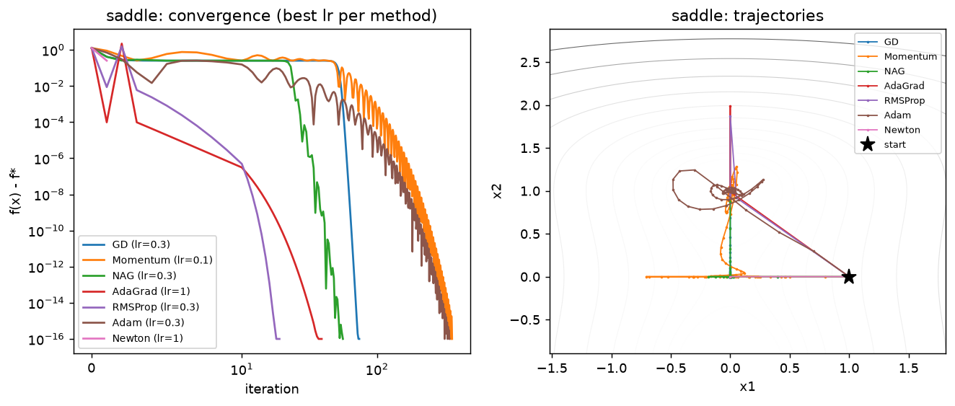
Figure 2: Track A, optimizer paths on the saddle function (results/trackA_continuous/a1_saddle.png)
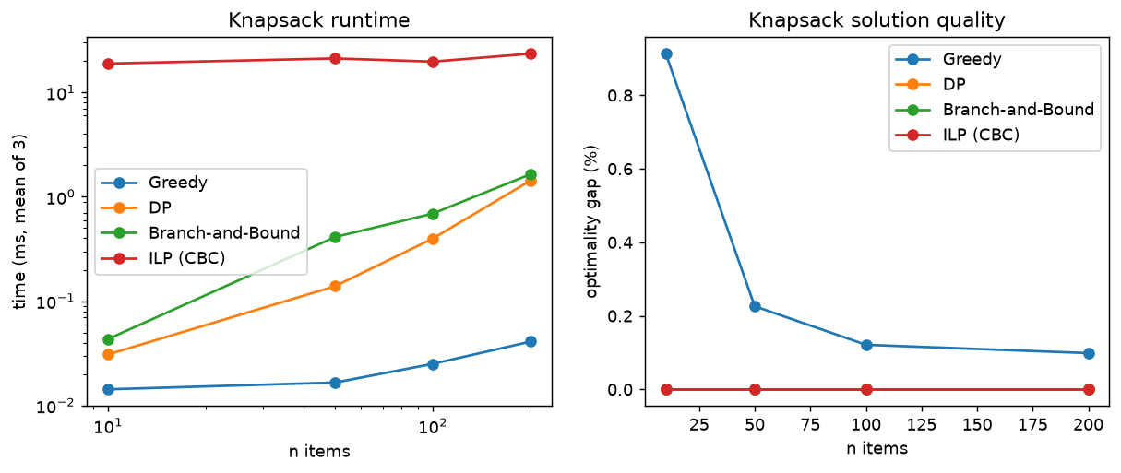
Figure 3: Track B, knapsack runtime and greedy gap vs n (results/trackB_discrete/b1_knapsack.png)
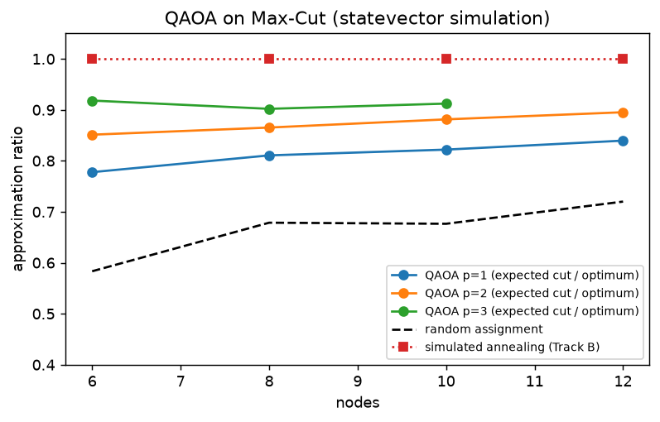
Figure 4: Track C, QAOA approximation ratio vs depth (simulated) (results/trackC_quantum_opt/c1_qaoa.png)
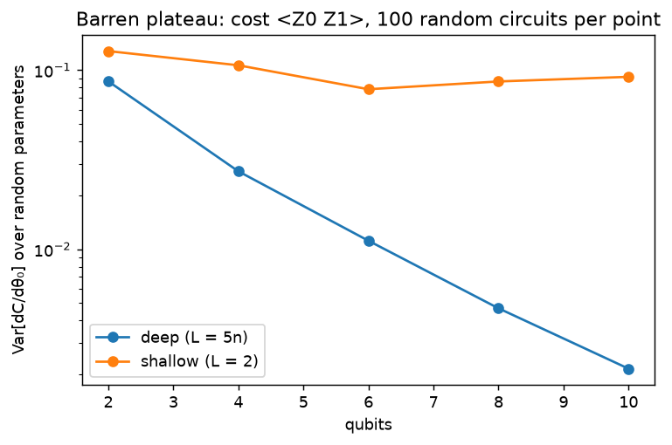
Figure 5: Track C, barren plateau (simulated) (results/trackC_quantum_opt/c2_barren_plateau.png)
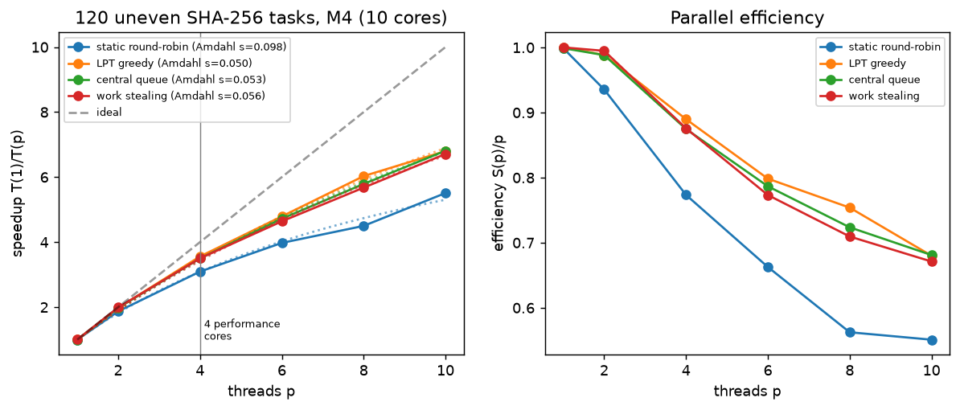
Figure 6: Track D, parallel speedup per strategy (measured) (results/trackD_submodular_parallel_distributed/d1_scheduling.png)
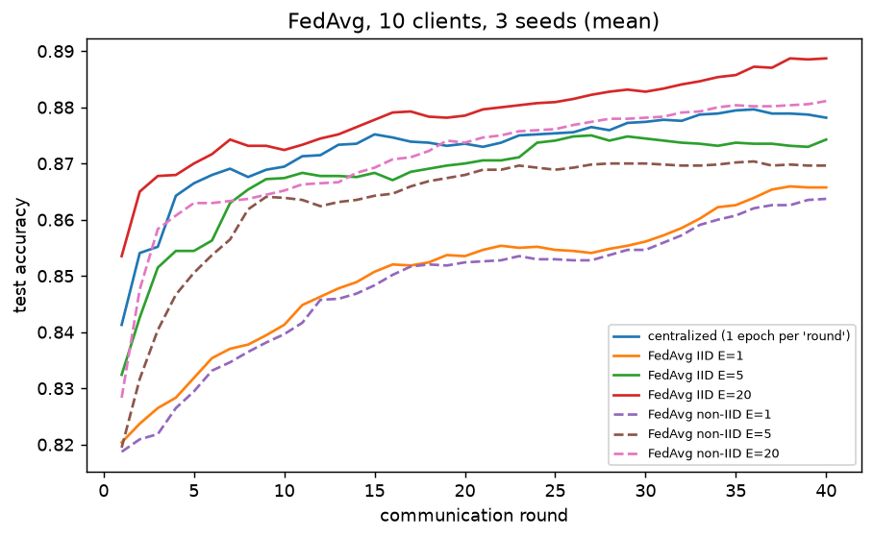
Figure 7: Track D, FedAvg vs centralized (simulated) (results/trackD_submodular_parallel_distributed/d2_fedavg.png)
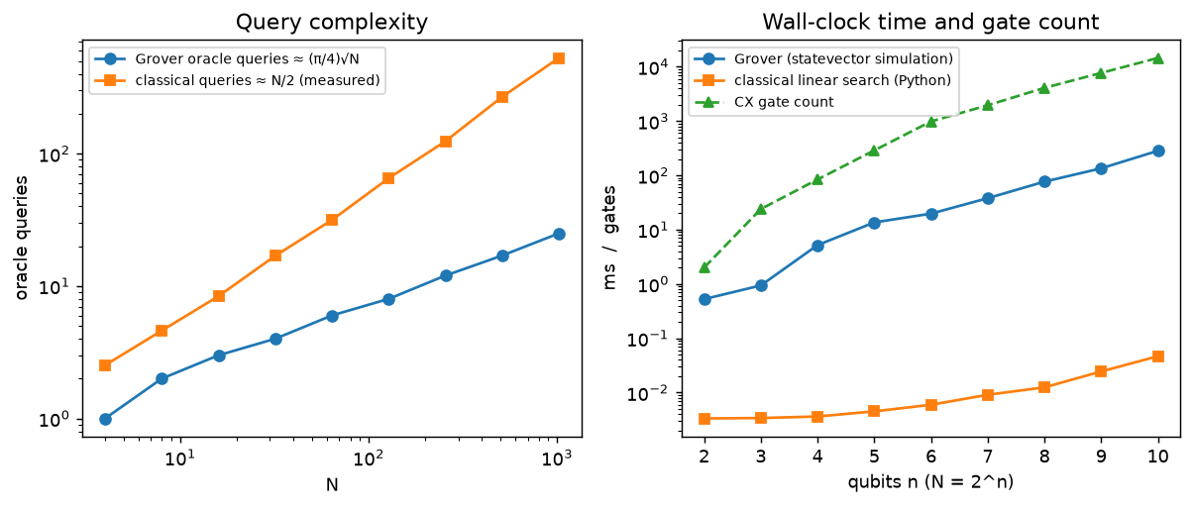
Figure 8: Track I, Grover vs linear search (results/trackI_quantum_algos_qml/i1_grover_vs_linear.png)
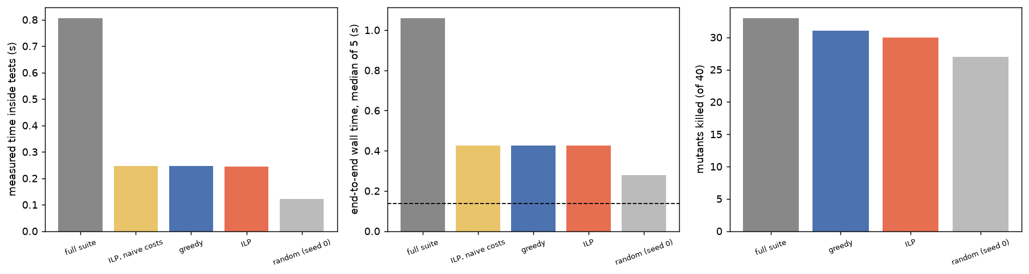
Figure 9: Track J, test-suite minimization (results/trackJ_software_eng/j_minimization.png)

