Figure for 1.d

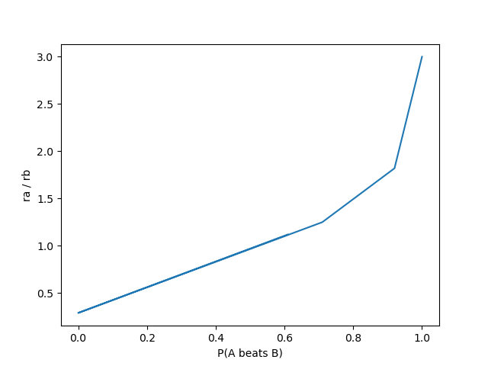

Answer to 1.e

**N = 2 games (best of 3)**

