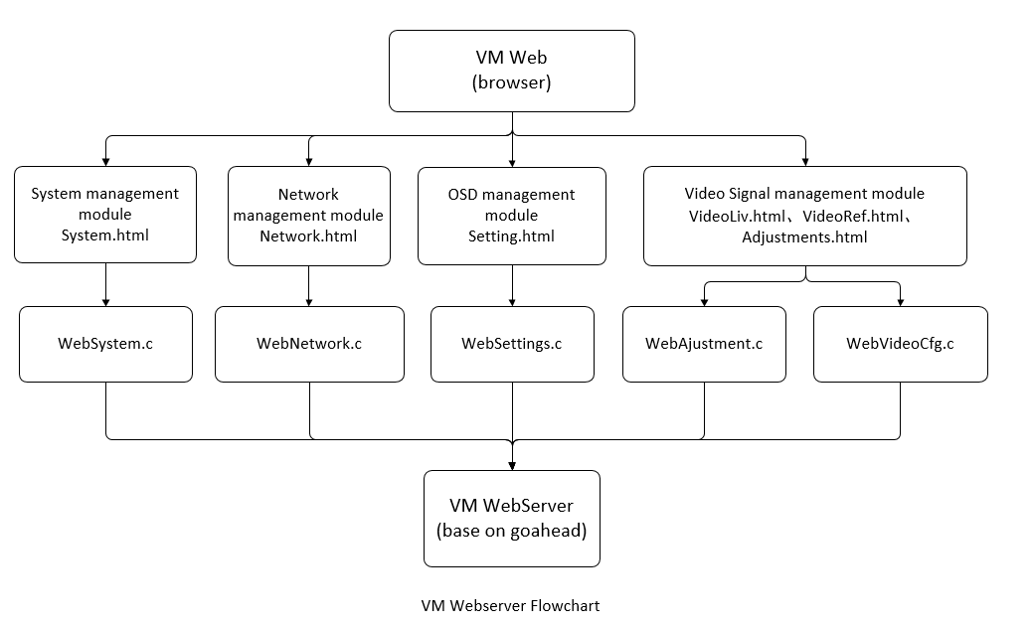

VM系统的websvr模块提供浏览器登录功能，为用户实现网页界面控制VM设备，界面包括系统运行状态信息实时显示界面、视频信号状态查看界面、视频路由界面、运行日志文件导出界面、系统参数配置界面、版本查看和在线升级界面。
VM websvr module provides browser login function, and realizes web interface for users to control VM equipment. The interface includes real-time display interface of system operation status information, video signal status view interface, video routing interface, operation log file export interface, system parameter configuration interface, version view and online upgrade interface.

GPL Declare
Our company independently developed "video manager system" V1.7, based on goahead developed video manager system webserver. The software follows the GPL License , including the full text of the GPL license, indicating the modification and the modification date in the place of change, and disclosing the source code on the open platform for 3 years.
hereby declare.
GPL 声明
我公司独立开发的“Video Manager系统”V1.7，基于goahead 开发了Video Manager系统webserver。软件遵循GPL协议，包含GPL许可证全文，在更改的地方标明了修改内容以及修改日期，并且在公共平台公开源代码3年。
特此声明。

