# Code: 2-1.cpp

/*  
Develop a C++ program that allows the user to enter a time in seconds. The output must show how far  
an object in freefall for that length of time. There is no friction or resistance in air. The acceleration of  
32 feet / second and this is to be defined as a constant variable. Equation to be used is distance = 0.5 *  
acceleration * time2  
*/  
  
#include <iostream>  
using namespace std;  
  
int main() {  
 const int acceleration = 32;  
 int time, distance;  
 cout << "Input the time in seconds: ";  
 cin >> time;  
 distance = 0.5 * acceleration * time * time;  
 cout << "The distance an object in freefall for " << time << " seconds is: " << distance << " feet" << endl;  
 return 0;  
}

## Output

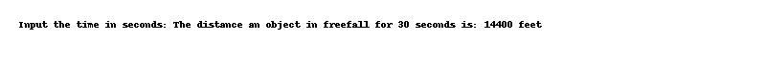

# Code: 2-10.cpp

/*  
Write a C++ program that will display if a students is pass or not in his exam.  
  
(50% or more is pass). If the student is Pass than your program should display  
which letter the student has obtained.  
?? 85% or more E for excellent  
?? 75% or more but less than 85% O for Outstanding  
?? 65% or more but less than 75% G for good  
?? Less than 65% S for satisfactory  
If however the student is Fail (below 50% marks) your program should display  
1  
whether the student should Resit or Redo depending on the following criteria.  
?? 33% or more Resit in exam  
?? Less than 33% Redo course  
*/  
  
#include <iostream>  
using namespace std;  
  
int main() {  
 double marks;  
 cout << "Enter the marks: ";  
 cin >> marks;  
 if (marks >= 50) {  
 if (marks >= 85) {  
 cout << "E" << endl;  
 } else if (marks >= 75) {  
 cout << "O" << endl;  
 } else if (marks >= 65) {  
 cout << "G" << endl;  
 } else {  
 cout << "S" << endl;  
 }  
 } else {  
 if (marks >= 33) {  
 cout << "Resit in exam" << endl;  
 } else {  
 cout << "Redo course" << endl;  
 }  
 }  
 return 0;  
}

## Output



# Code: 2-2.cpp

/*  
Ananya bought a model globe for a project work and that was medium sized. She found the radius of  
the globe. But she would like to know the volume of that globe. Can you help her in finding the  
Volume of the globe using the formula: (4.0/3.0) * Ï€* r^3, where Ï€ = 3.14 is a constant value.  
*/  
  
#include <iostream>  
#include <cmath>  
using namespace std;  
  
int main() {  
 double r, volume;  
 cout << "Input the radius of the globe: ";  
 cin >> r;  
 volume = (4.0 / 3.0) * 3.14 * pow(r, 3);  
 cout << "The volume of the globe is: " << volume << endl;  
 return 0;  
}

## Output

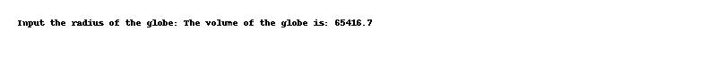

# Code: 2-3.cpp

/*  
ABC Corporation decides to give 11.5% for its workers as a compensation pay for a period of six  
months. Develop a program to read employeeâ€™s previous annual salary. Output the new annual salary,  
new monthly salary and old monthly salary. Also specify the exact amount received as compensation  
pay. Use a variable declaration with the modifier const to express the pay increase.  
*/  
  
#include <iostream>  
using namespace std;  
  
int main() {  
 const double compensation = 0.115;  
 double old_annual_salary, new_annual_salary, old_monthly_salary, new_monthly_salary, compensation_pay;  
 cout << "Input the employee's previous annual salary: ";  
 cin >> old_annual_salary;  
 new_annual_salary = old_annual_salary + (old_annual_salary * compensation);  
 old_monthly_salary = old_annual_salary / 12;  
 new_monthly_salary = new_annual_salary / 12;  
 compensation_pay = new_annual_salary - old_annual_salary;  
 cout << "The new annual salary: " << new_annual_salary << endl;  
 cout << "The new monthly salary: " << new_monthly_salary << endl;  
 cout << "The old monthly salary: " << old_monthly_salary << endl;  
 cout << "The exact amount received as compensation pay: " << compensation_pay << endl;  
 return 0;  
}

## Output

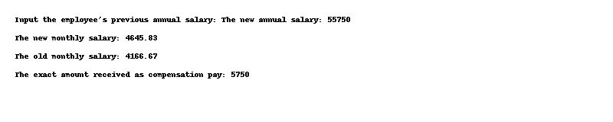

# Code: 2-4.cpp

/*  
Ganesh aims to become a police officer and so applies for the job of Inspector. When he appeared for  
physical test, he failed in the test due to overweight. Now Ganesh decides to do intense training to  
reduce weight. The trainer asks his BMI for deciding the level of training required. Help him to  
calculate the BMI using the formula: BMI = weight / height  
2  
*/  
  
#include <iostream>  
using namespace std;  
  
int main() {  
 double weight, height, bmi;  
 cout << "Input the weight of Ganesh: ";  
 cin >> weight;  
 cout << "Input the height of Ganesh: ";  
 cin >> height;  
 bmi = weight / (height * height);  
 cout << "The BMI of Ganesh is: " << bmi << endl;  
 return 0;  
}

## Output

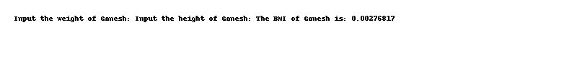

# Code: 2-5.cpp

/*  
Demonstrates dynamic memory allocation using new to create an array of integers. It assigns values to  
the dynamically allocated array, prints them, and deallocates the memory using delete[].  
*/  
  
#include <iostream>  
using namespace std;  
  
int main() {  
 int n;  
 cout << "Input the number of elements to store in the array: ";  
 cin >> n;  
 int* array = new int[n];  
 cout << "Input " << n << " elements in the array:" << endl;  
 for (int i = 0; i < n; i++) {  
 cin >> array[i];  
 }  
 cout << "The elements in the array are: ";  
 for (int i = 0; i < n; i++) {  
 cout << array[i] << " ";  
 }  
 delete[] array;  
 return 0;  
}

## Output

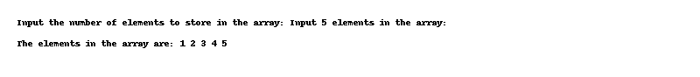

# Code: 2-6.cpp

/*  
A shop will give discount of 10% if the cost of purchased quantity is more than 1000.  
Ask user for quantity  
Suppose, one unit will cost 100.  
Judge and print total cost for user.  
*/  
  
#include <iostream>  
using namespace std;  
  
int main() {  
 int quantity, cost;  
 cout << "Enter the quantity: ";  
 cin >> quantity;  
 cost = quantity * 100;  
 if (cost > 1000) {  
 cost -= (cost * 0.1);  
 }  
 cout << "Total cost for user: " << cost << endl;  
 return 0;  
}

## Output

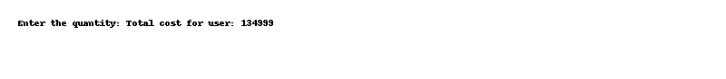

# Code: 2-7.cpp

/*  
A school has following rules for grading system:  
a. Below 25 â€“ F  
b. 25 to 45 â€“ E  
c. 45 to 50 â€“ D  
d. 50 to 60 - C  
e. 60 to 80 - B  
f. Above 80 - A  
Ask user to enter marks and print the corresponding grade.  
*/  
  
#include <iostream>  
using namespace std;  
  
int main() {  
 int marks;  
 cout << "Enter the marks: ";  
 cin >> marks;  
 if (marks < 25) {  
 cout << "F" << endl;  
 } else if (marks < 45) {  
 cout << "E" << endl;  
 } else if (marks < 50) {  
 cout << "D" << endl;  
 } else if (marks < 60) {  
 cout << "C" << endl;  
 } else if (marks < 80) {  
 cout << "B" << endl;  
 } else {  
 cout << "A" << endl;  
 }  
 return 0;  
}

## Output

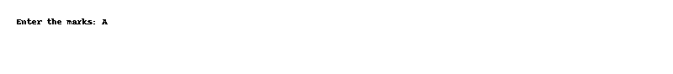

# Code: 2-8.cpp

/*  
As activity directory at Ocean Breeze Resort, it is your job to suggest appropriate activities to guests  
based on the weather:  
temp >= 80:  
swimming 60 <= temp < 80:  
tennis 40 <= temp < 60:  
golf temp < 40: skiing  
*/  
  
#include <iostream>  
using namespace std;  
  
int main() {  
 int temp;  
 cout << "Enter the temperature: ";  
 cin >> temp;  
 if (temp >= 80) {  
 cout << "swimming" << endl;  
 } else if (temp >= 60) {  
 cout << "tennis" << endl;  
 } else if (temp >= 40) {  
 cout << "golf" << endl;  
 } else {  
 cout << "skiing" << endl;  
 }  
 return 0;  
}

## Output

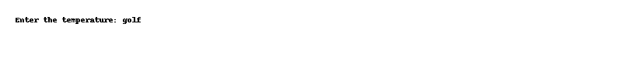

# Code: 2-9.cpp

/*  
Write the program to determine the raise and new salary for an employee to compute the raise. The  
input to the program includes the current annual salary for the employee and a number indicating the  
performance rating (1=excellent, 2=good, and 3=poor). An employee with a rating of 1 will receive a  
6% raise, an employee with a rating of 2 will receive a 4% raise, and one with a rating of 3 will receive  
a 1.5% raise.  
*/  
  
#include <iostream>  
#include <iomanip>  
using namespace std;  
  
int main() {  
 double current_salary, raise, new_salary;  
 int rating;  
 cout << "Input the current annual salary: ";  
 cin >> current_salary;  
 cout << "Input the performance rating (1=excellent, 2=good, 3=poor): ";  
 cin >> rating;  
 if (rating == 1) {  
 raise = current_salary * 0.06;  
 } else if (rating == 2) {  
 raise = current_salary * 0.04;  
 } else {  
 raise = current_salary * 0.015;  
 }  
 new_salary = current_salary + raise;  
 cout << "The raise is: " << raise << endl;  
 cout << "The new salary is: " << new_salary << endl;  
 return 0;  
}

## Output

