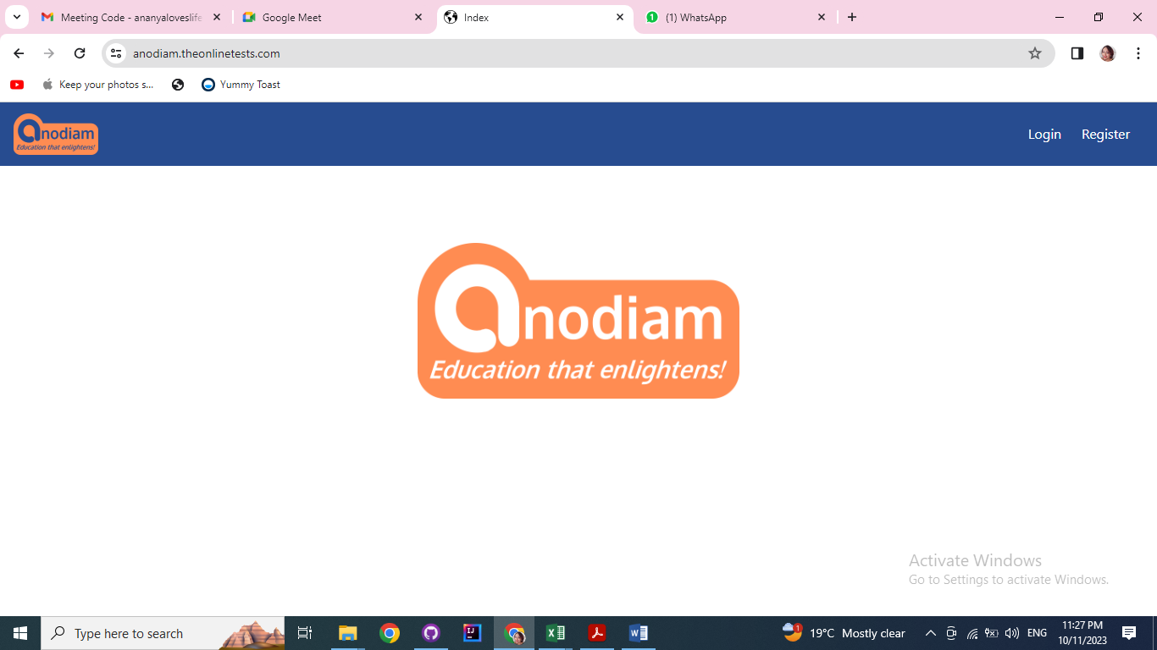

Left corner LOGO doesn’t have any function but appears to be a hyperlink. Need to change the colour scheme.

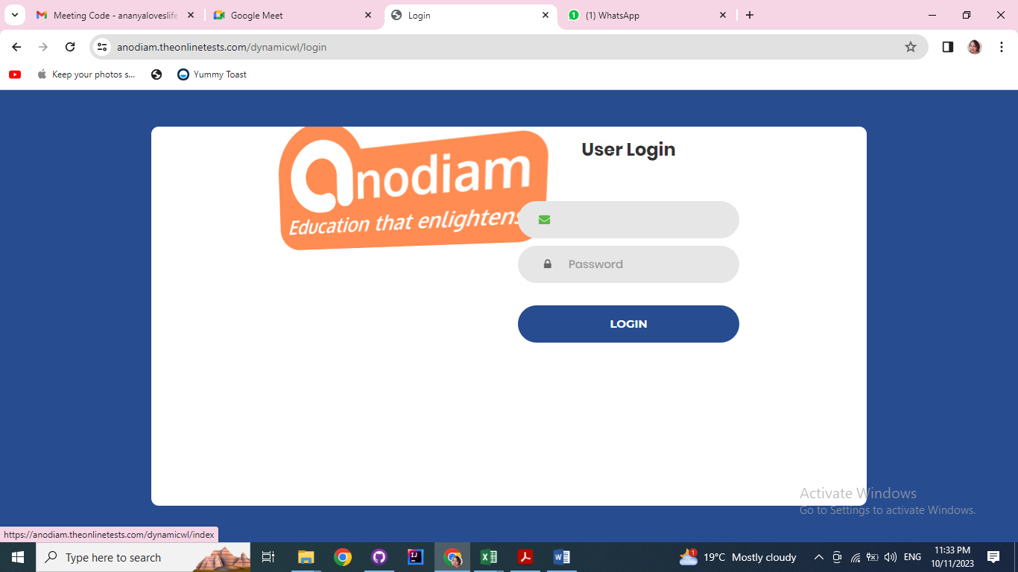

Logo doesn’t have to be dynamic.

Forget password button required

Password strength and complexity required to be displayed

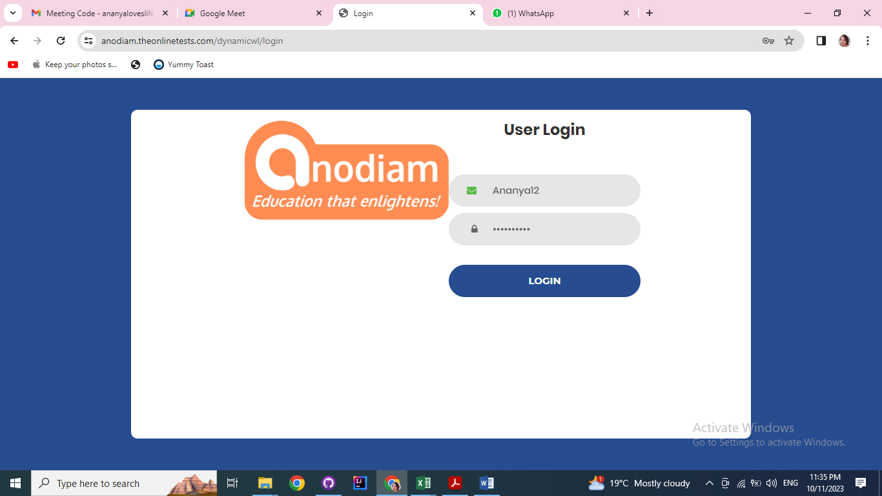

When clicking on the fields, green halo effect coming which is not required

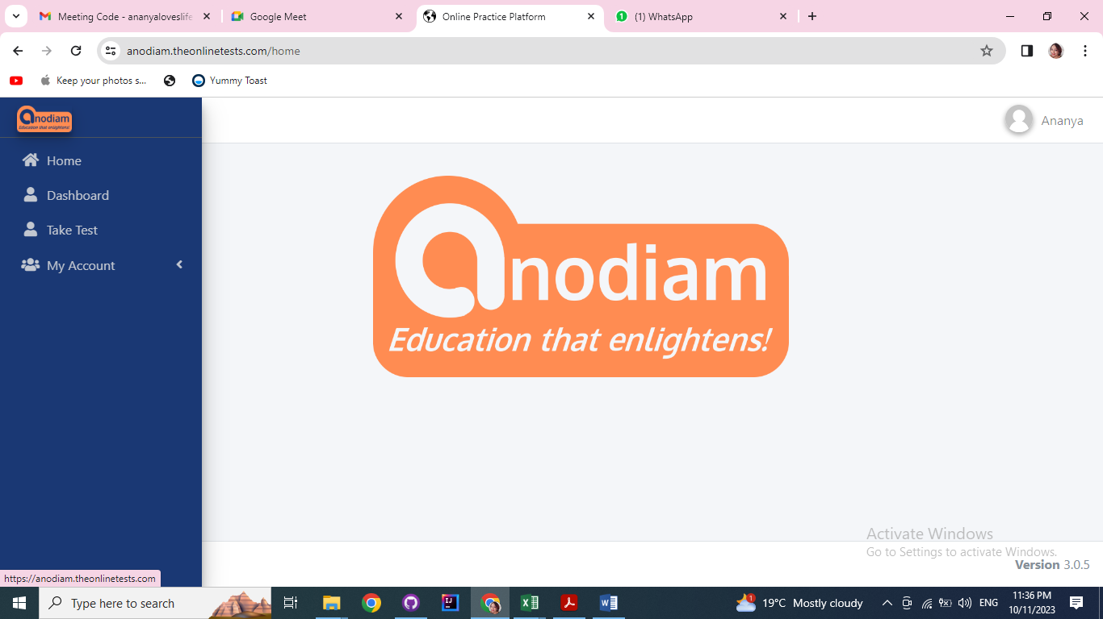

Top left logo appears to be hyperlink but not taking anywhere.

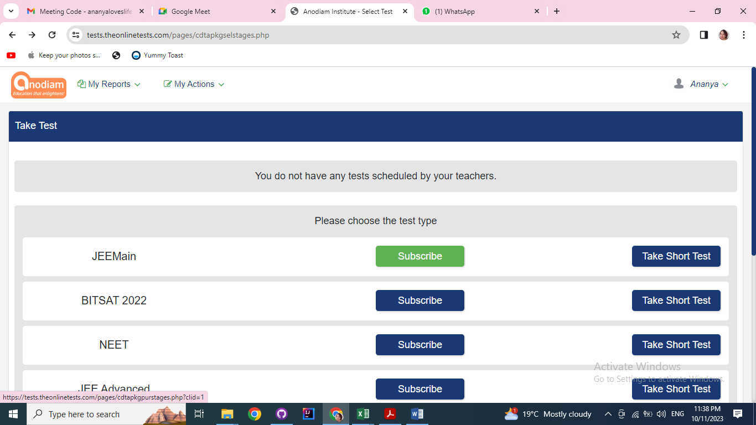

What is the function of the subscribe button? If clicked leading to 404 not found

1. **Not able to reproduce**

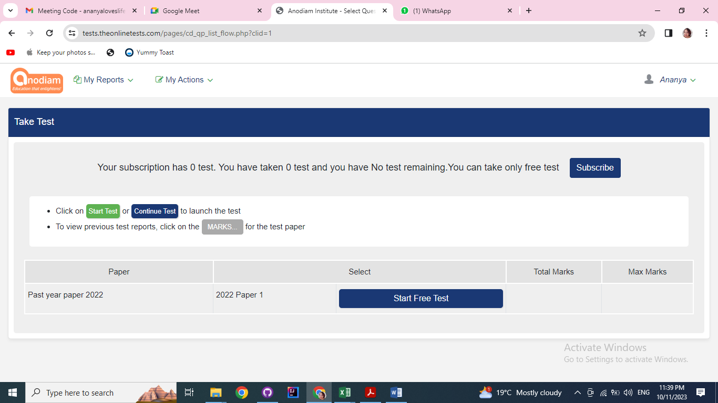

Click on “Start test” and “continue test” buttons don’t work

1. **Not able to reproduce**

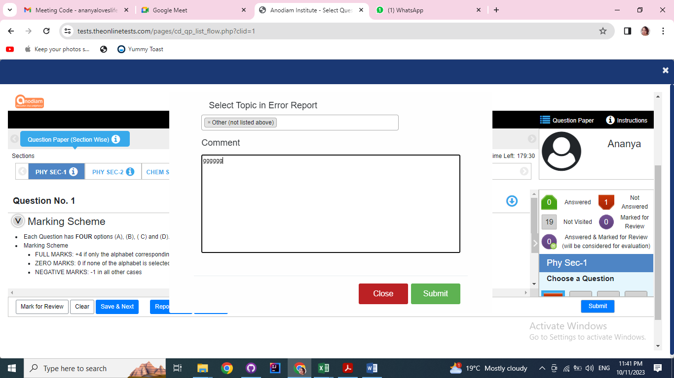

“Report error” button used. Who will see the comment and how to take action?

1. **Not able to reproduce**

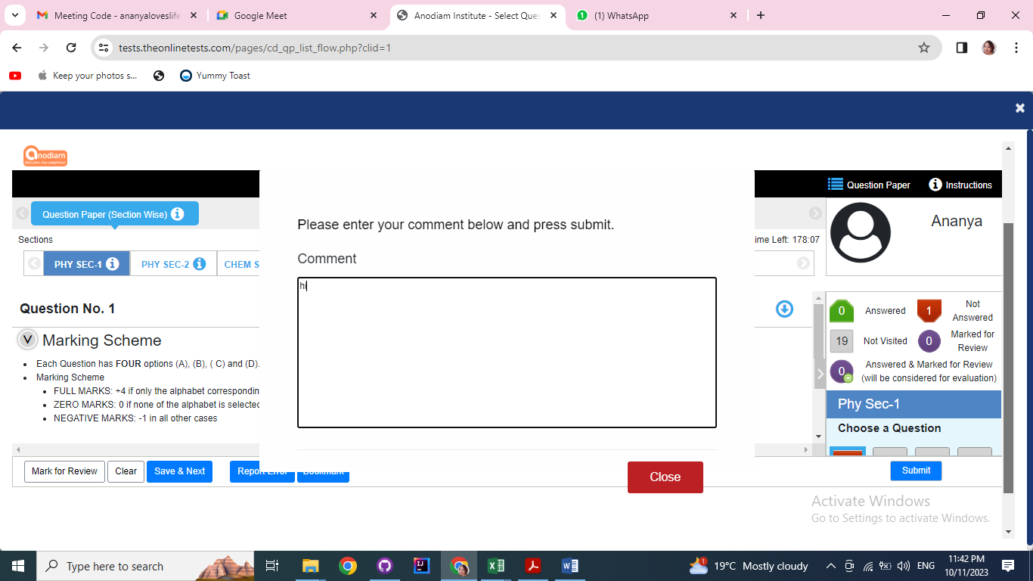

Functionality of the “Book mark button”. No submit button available. What’s the use of the button?

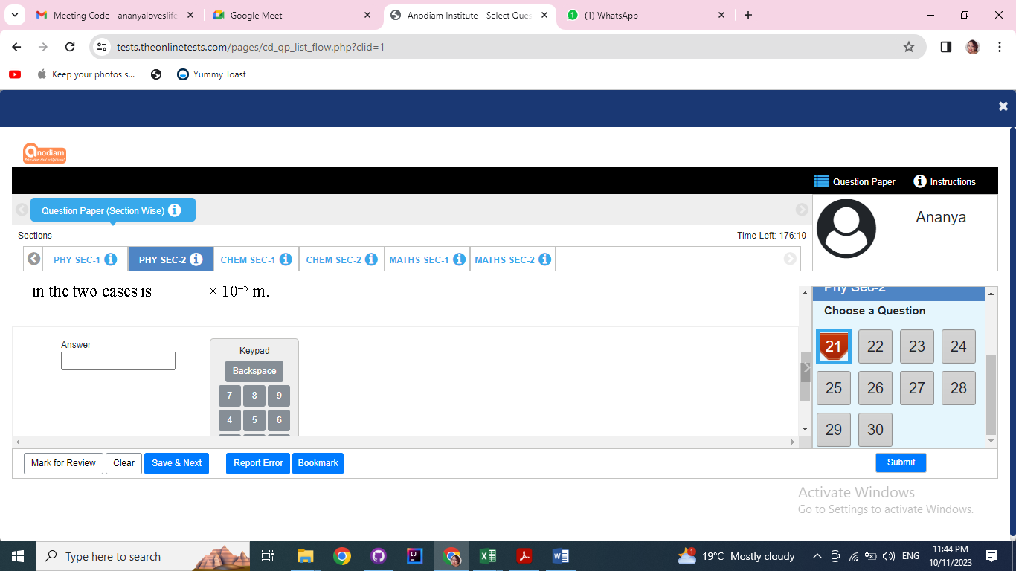

If want to come out of the test without submitting the paper, what’s the way? No back button available.

1. **Not able to reproduce error**

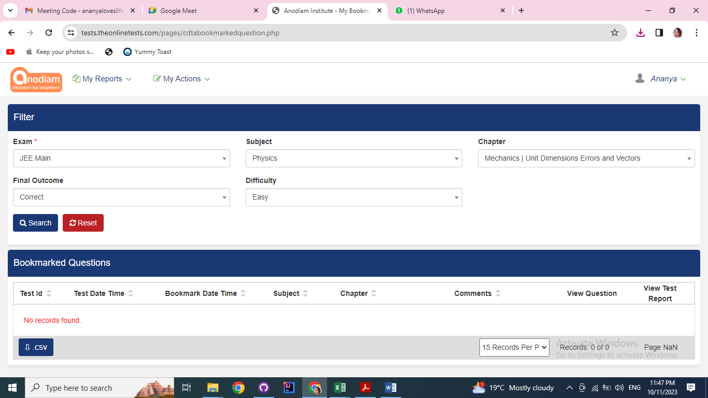

This page doesn’t have any correspondence

**6)**

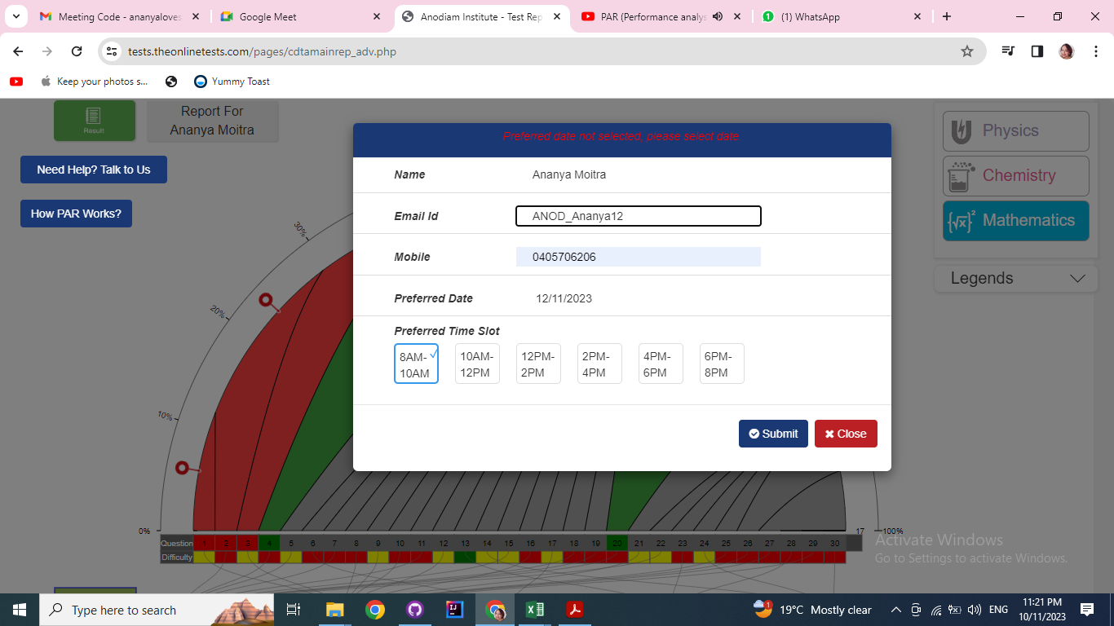

Who will receive the report and how to take action.